**15.1 Perform word count operation in local mode (In windows environment). Share the code, explain the execution steps, and attach the output screenshot.**

**DRIVER CLASS:**

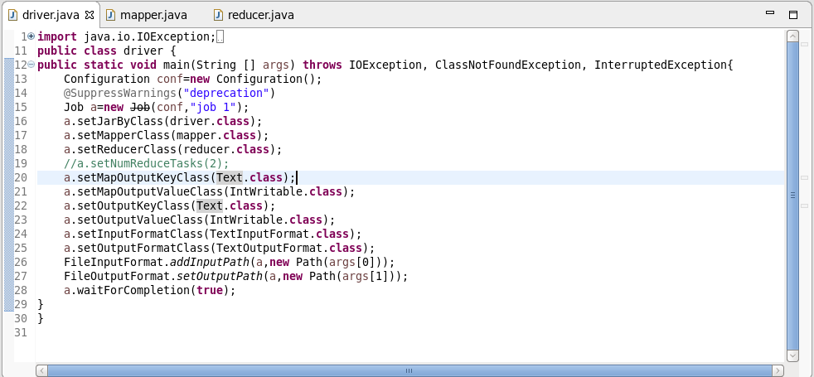

**MAPPER CLASS:**

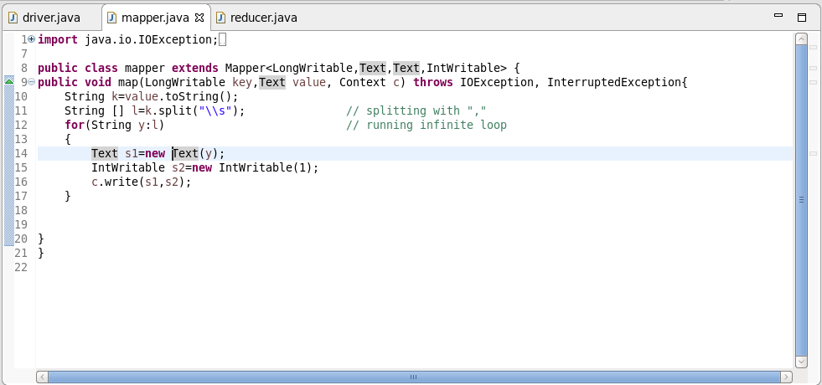

**REDUCER CLASS:**

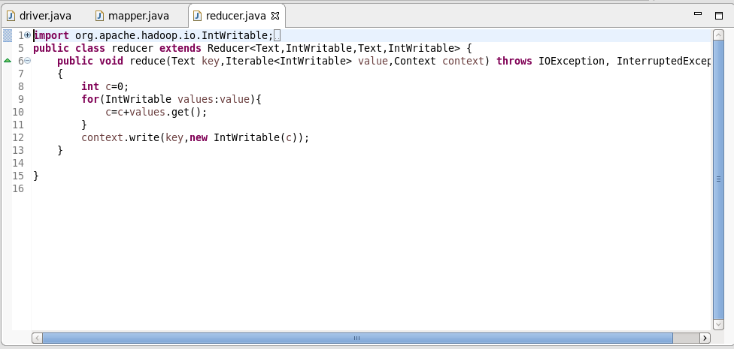

**RUN CONFIGURATIONS:**

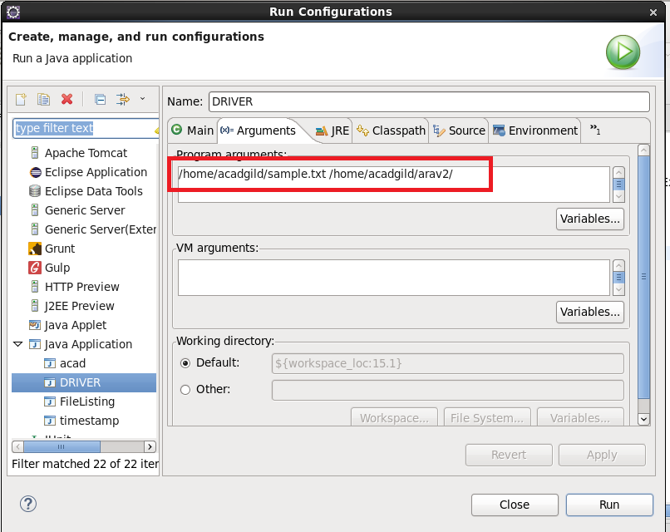

**OUTPUT:**

