**ASSIGNMENT16.2**

In many countries, the public telephone network has a single emergency telephone number

(sometimes known as the universal emergency telephone number or the emergency services

number) that allows a caller to contact local emergency services for assistance. This emergency

number differs from country to country and typically consists of three digits numbers that can

be easily remembered and dialed quickly. Some countries have a different emergency number

for each of the different emergency services.

Here we have two data sets; one is the data that the callers has given when they called the

emergency helpline number.

**You can download the 911 data from the below link.**

**Dataset**

**The other data set contains the details about the zip code**

**The data set description for the 911 data is as follows:**

lat: String variable, Latitude

lng: String variable, Longitude

desc: String variable, Description of the Emergency Call

zip: String variable, Zip code

title: String variable, Title

timeStamp: String variable, YYYY-MM-DD HH:MM:SS

twp: String variable, Township

addr: String variable, Address

e: String variable, Dummy variable (always 1)

**The data set description for the zip code file is as follows:**

zip: String variable, Zip code

city: String variable, City

state: String variable, State

latitude: String variable, Latitude

longitude: String variable, Longitude

timezone: String variable, Time zone

dst: String variable, district

**● Use reduce side join to join the two datasets and find What kind of problems are prevalent, and in which state?**

**DRIVER CLASS:**

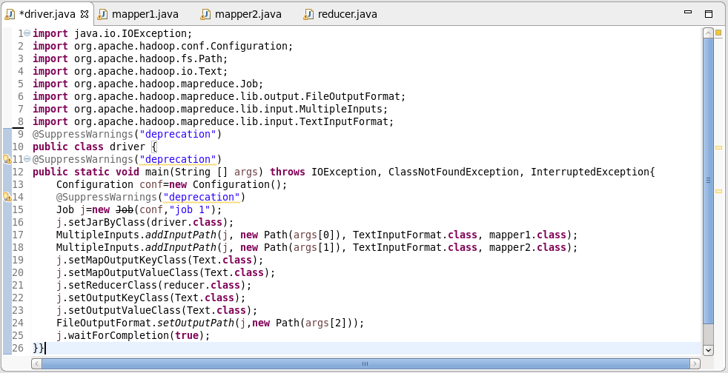

**MAPPER CLASS 1 :**

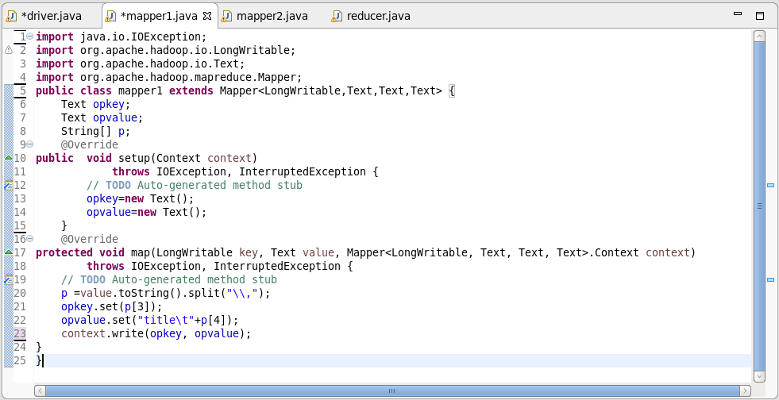

**MAPPER CLASS 2:**

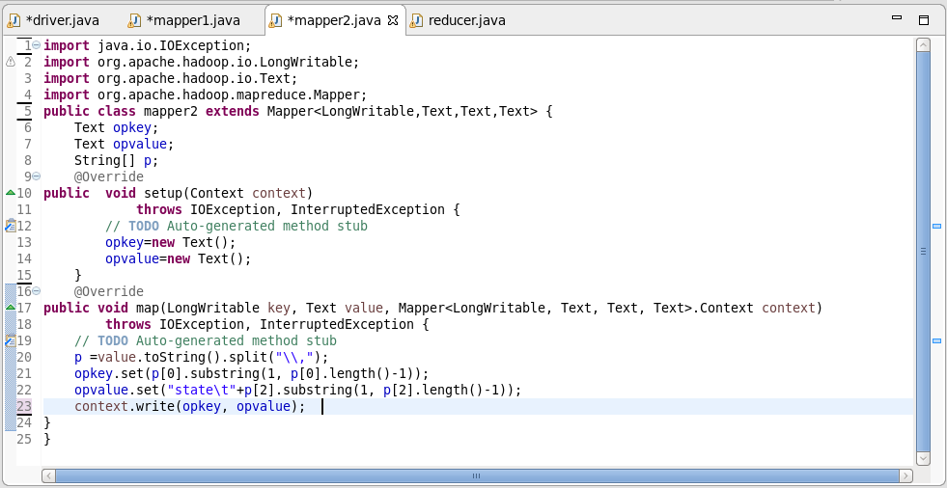

**REDUCER CLASS :**

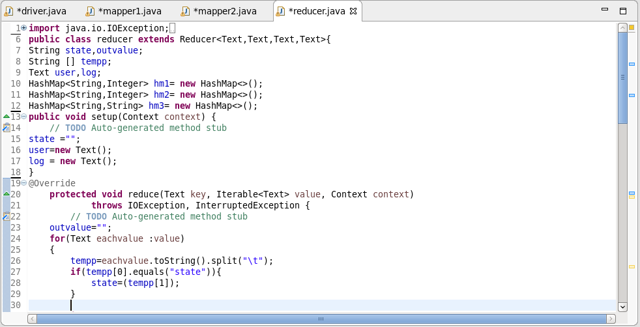

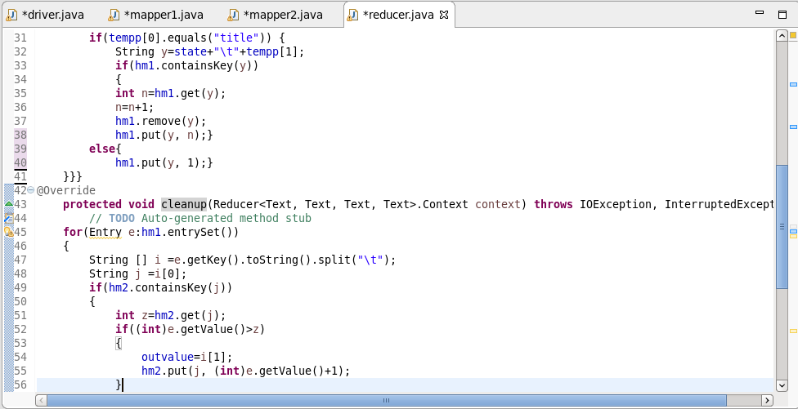

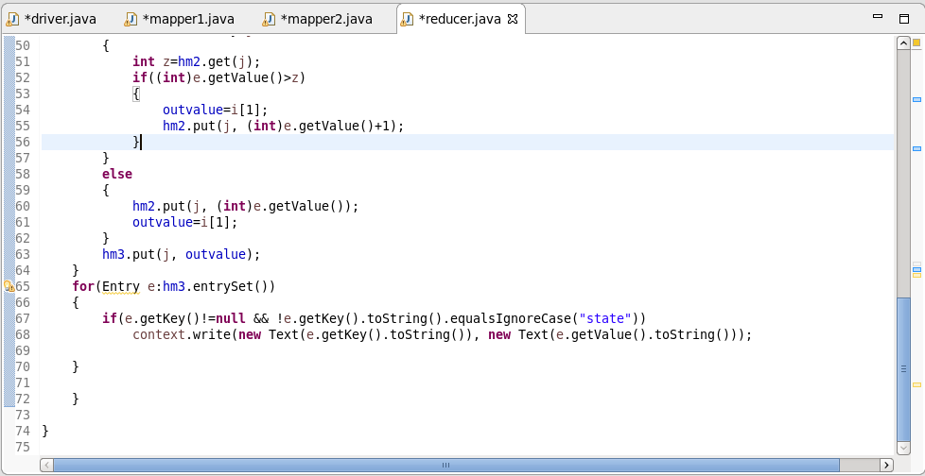

**RUNNING JAR:**

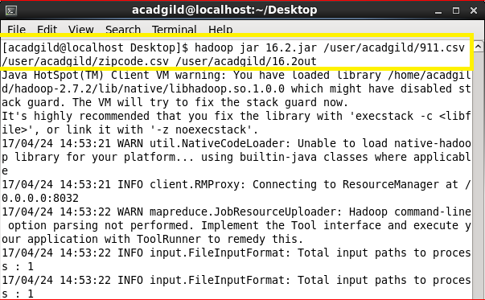

**OUTPUT:**

