**16.4 Write a mapreduce program use map side join to join the two datasets and find What kind of problems are prevalent, and in which state?**

**DRIVER CLASS:**

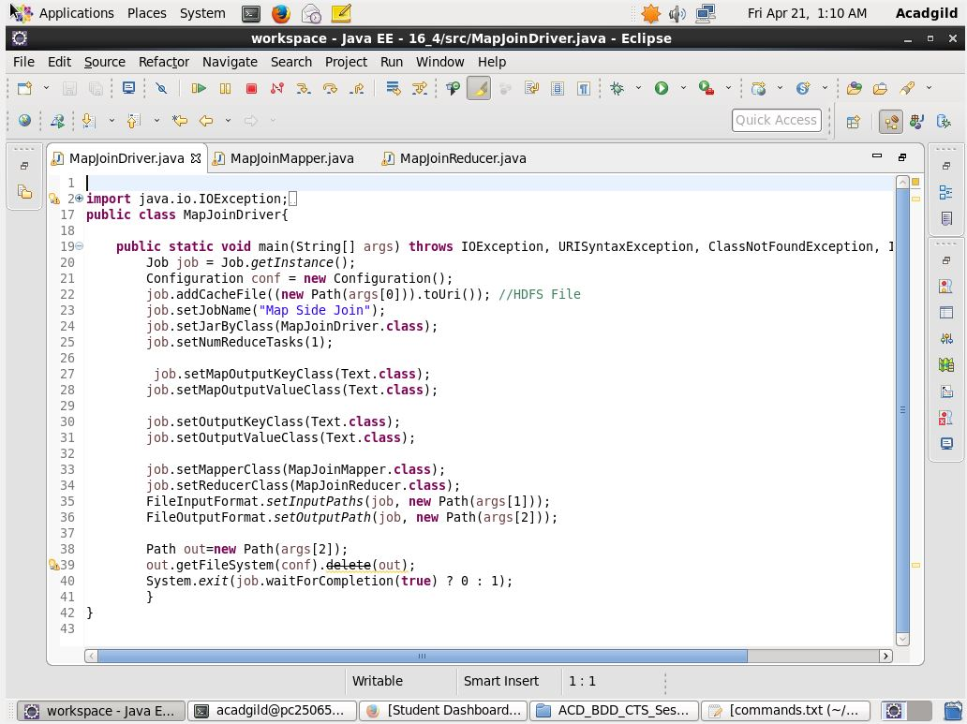

**MAPPER CLASS:**

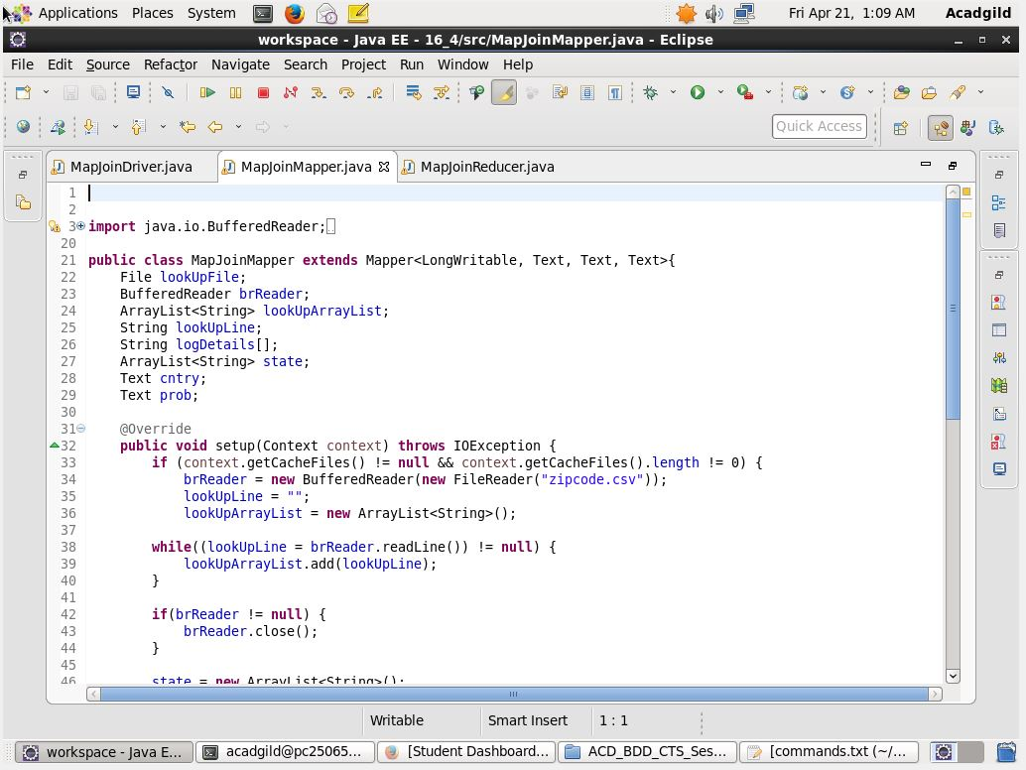

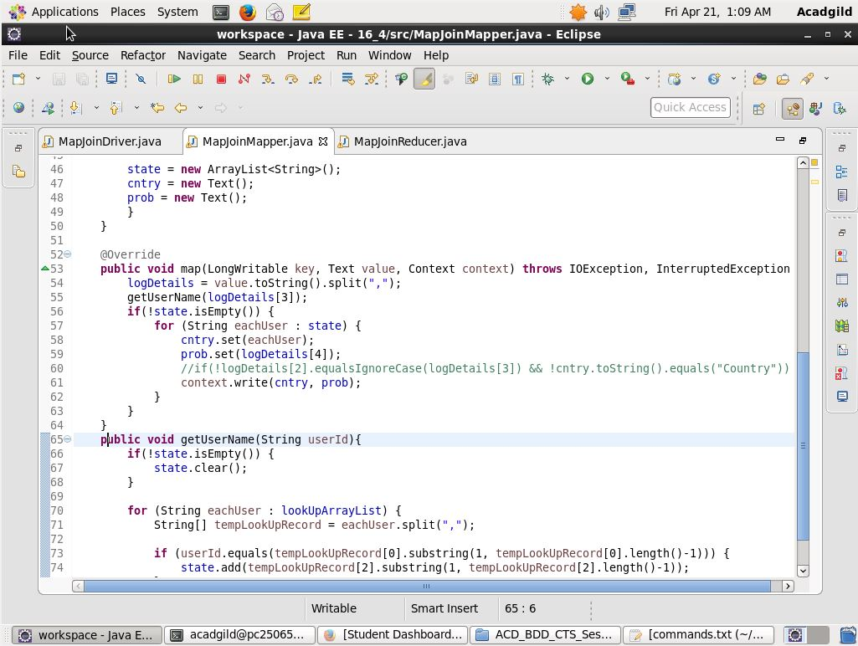

**REDUCER CLASS:**

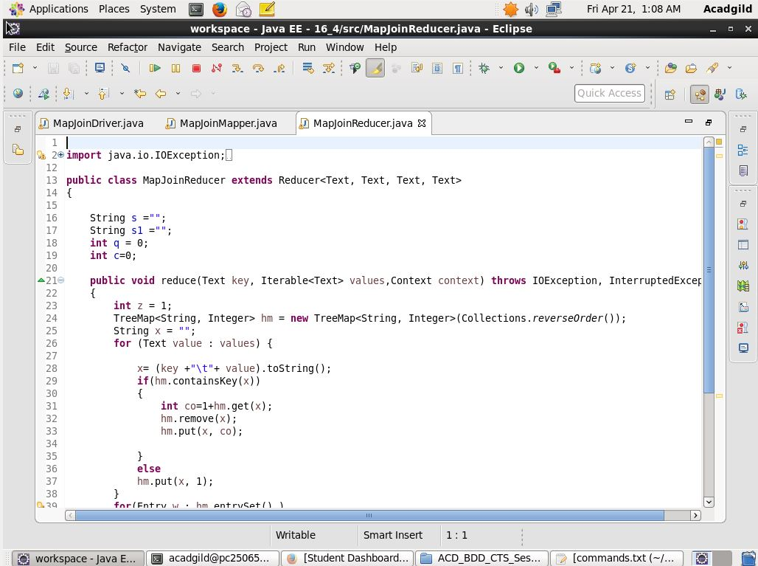

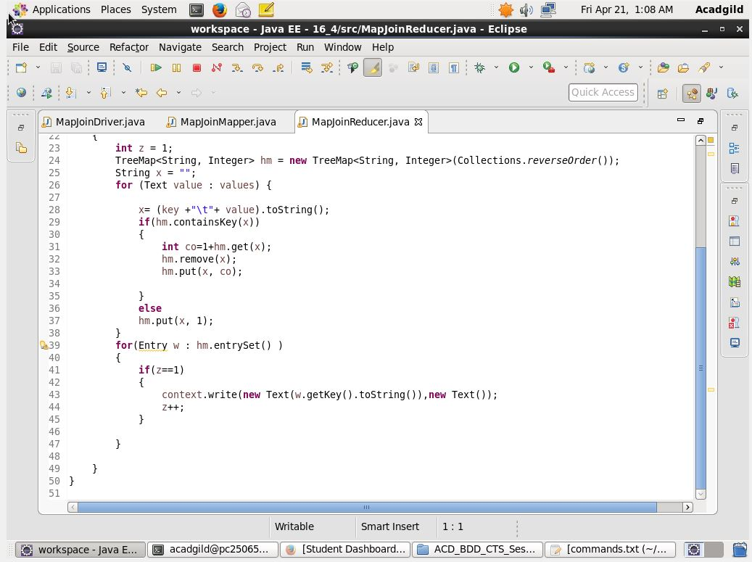

**OUTPUT:**

