**Write a map reduce program to join the below given two datasets**

**using map side join.**

**You can download the datasets from the below link**

**https://drive.google.com/open?id=0ByJLBTmJojjzSWhfXzI5NGh4RGM**

**Dataset description of dataset1.csv is as follows: id, first name, last name, email, gender, ip address**

**Dataset description of tdataset2.csv is as follows:**

**id, first name, last name.**

**DRIVER CLASS:**

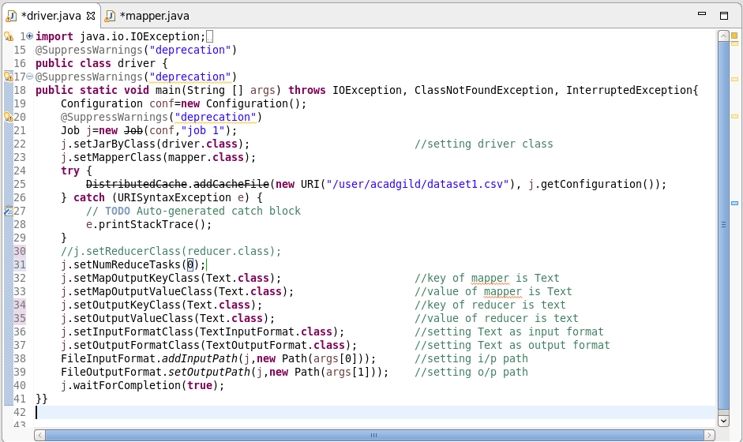

**MAPPER CLASS:**

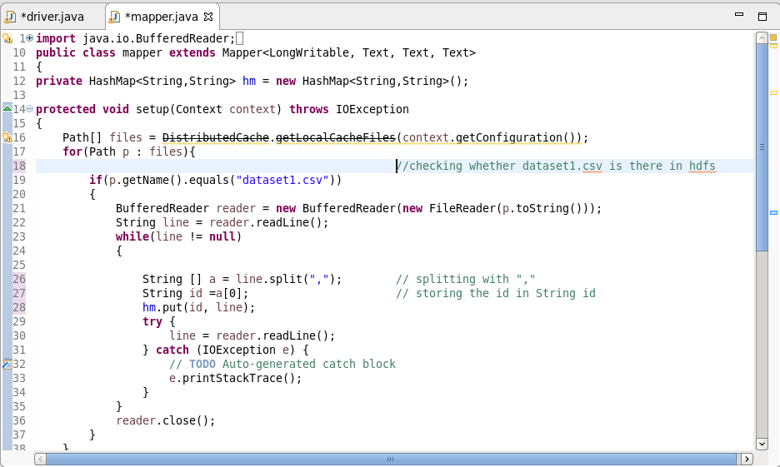

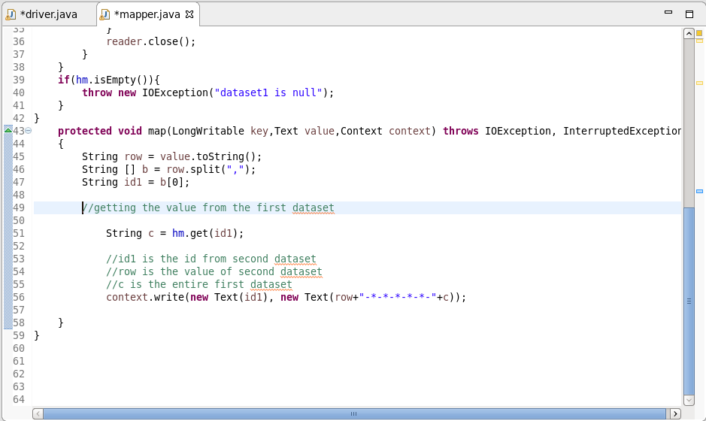

**SNAP OF OUTPUT:**

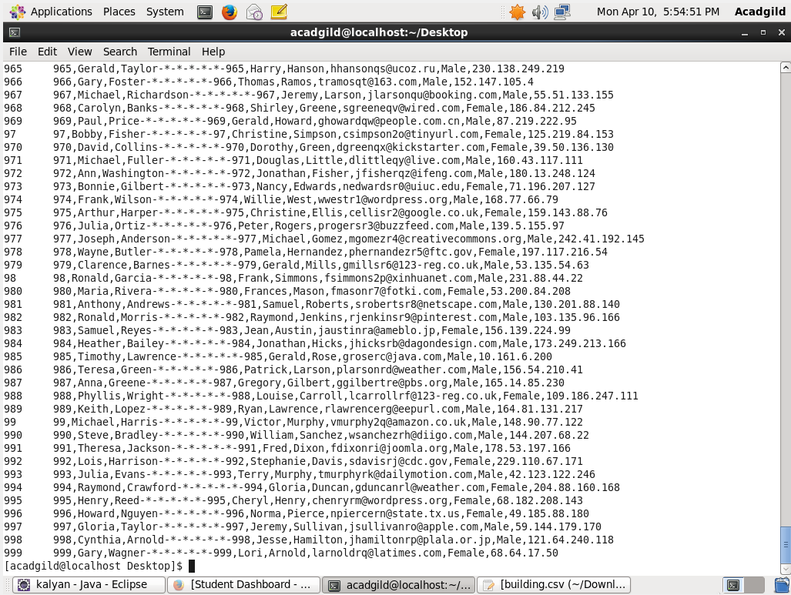

**Since I can’t attach the complete output, I’ve captured a portion of the output and attached it.**