**16.6. Write a map reduce program to join the below given two datasets using Reducer side join.**

**You can download the datasets from the below link https://drive.google.com/open?id=0ByJLBTmJojjzSWhfXzI5NGh4RGM**

**Dataset description of dataset1.csv is as follows: id, first name, last name, email, gender, Ip address**

**Dataset description of tdataset2.csv is as follows: id, first name, last name**

**Note : You can just join the datasets using reducer side join**

**DRIVER CLASS:**

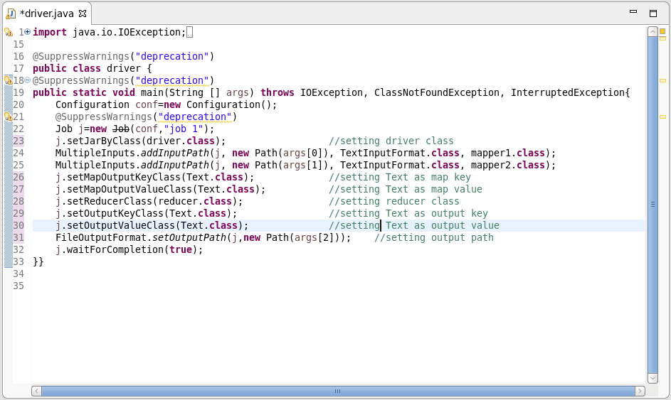

**1ST MAPPER CLASS:**

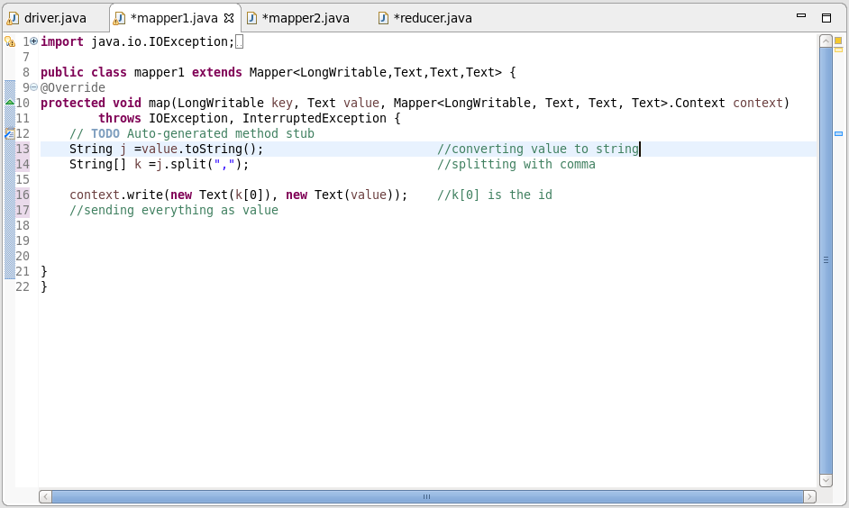

**2ND MAPPER CLASS:**

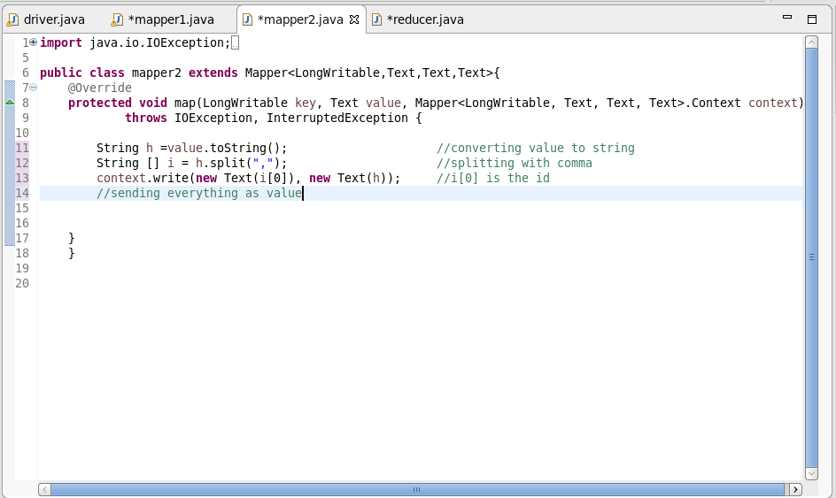

**REDUCER CLASS:**

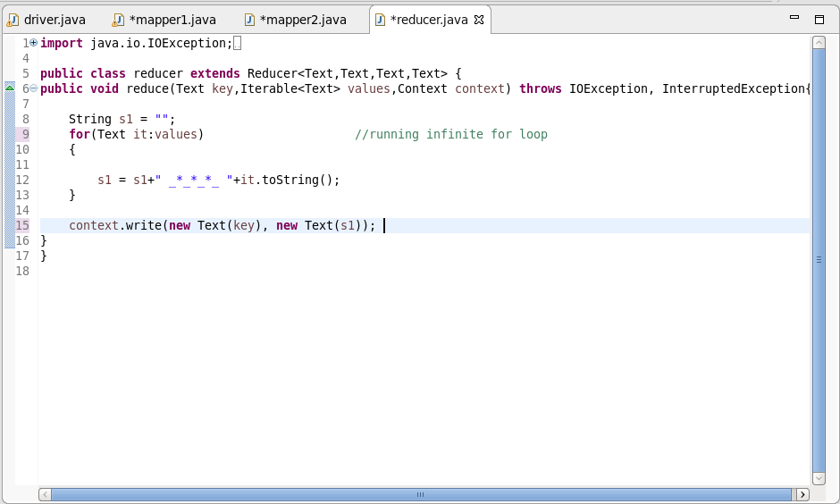

**OUTPUT:**

