**17.1 Write a program that accepts the job_id as argument and returns a custom counter and a system counter (total records input to the map tasks) associated with that job.**

**DRIVER CLASS:**

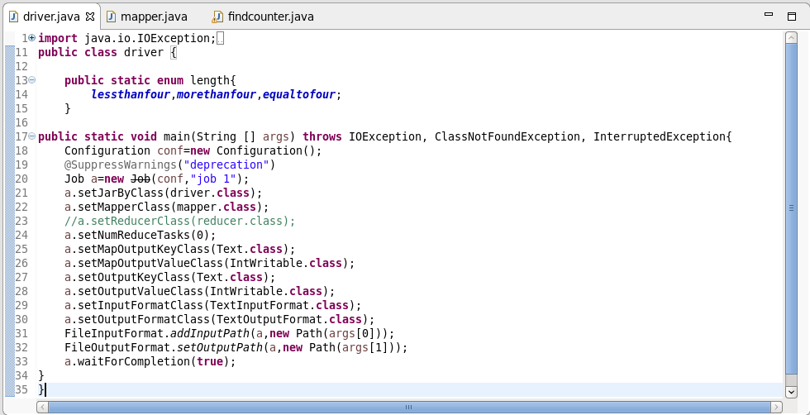

**MAPPER CLASS:**

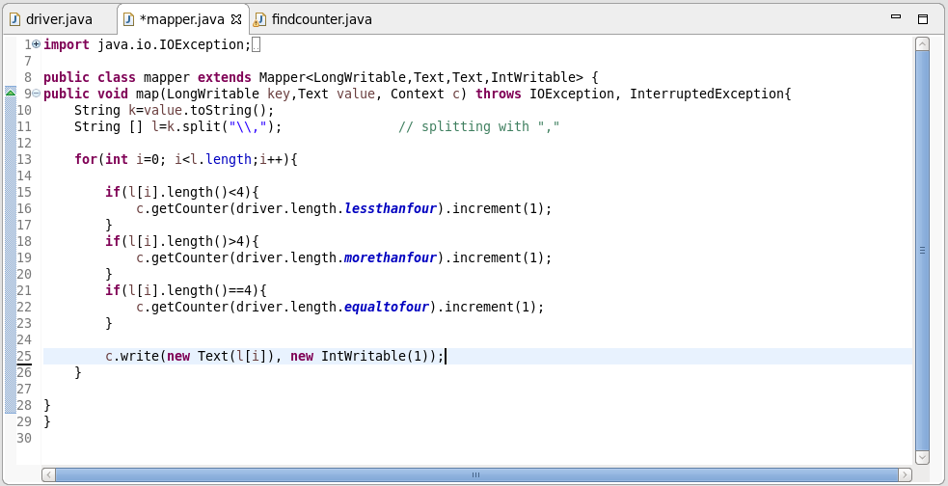

**FINDCOUNTER CLASS:**

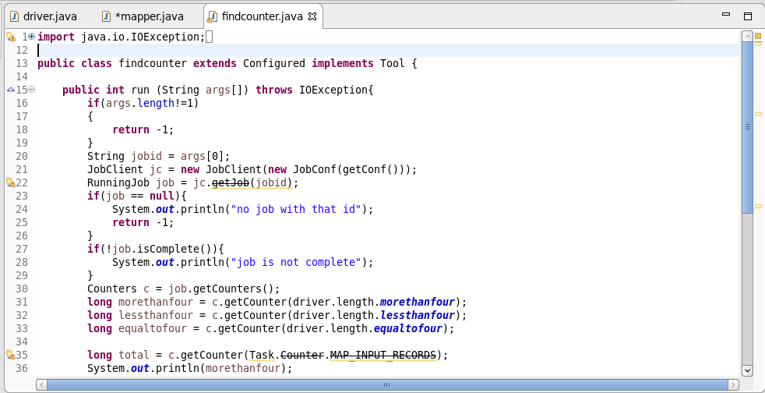

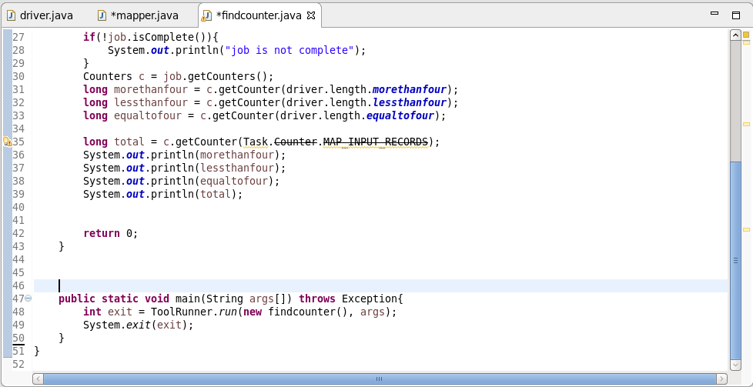

**LOGIC:**

* *if the length of the word is greater than 4, morethanfour gets incremented with 1.*
* *If the length of the word is less than 4, lessthanfour gets incremented with 1.*
* *If the length of the word is equal to 4, lessthanfour gets incremented with 1.*
* *WHILE RUNNING JAR FILE WITH DRIVER as main class and arguments as input text file and output path, we will get the first o/p*
* *While running jar file with job id as argument, we will get the second o/p*

**FIRST OUTPUT:**

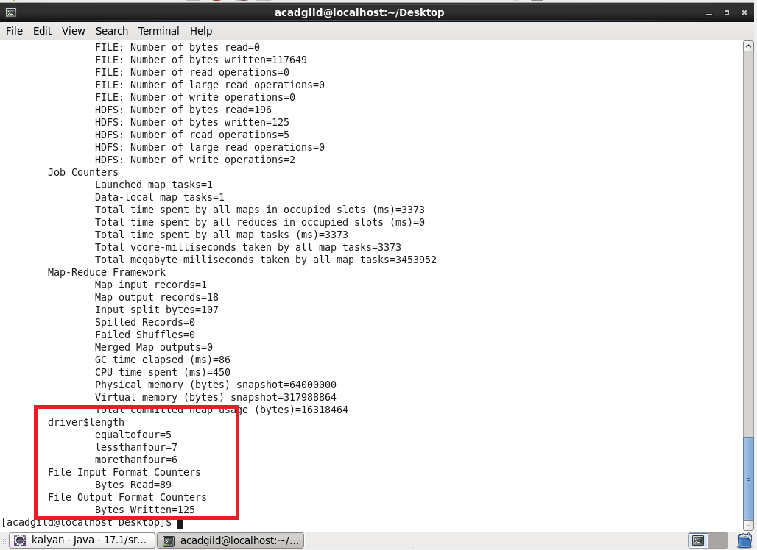

**SECOND OUTPUT:**

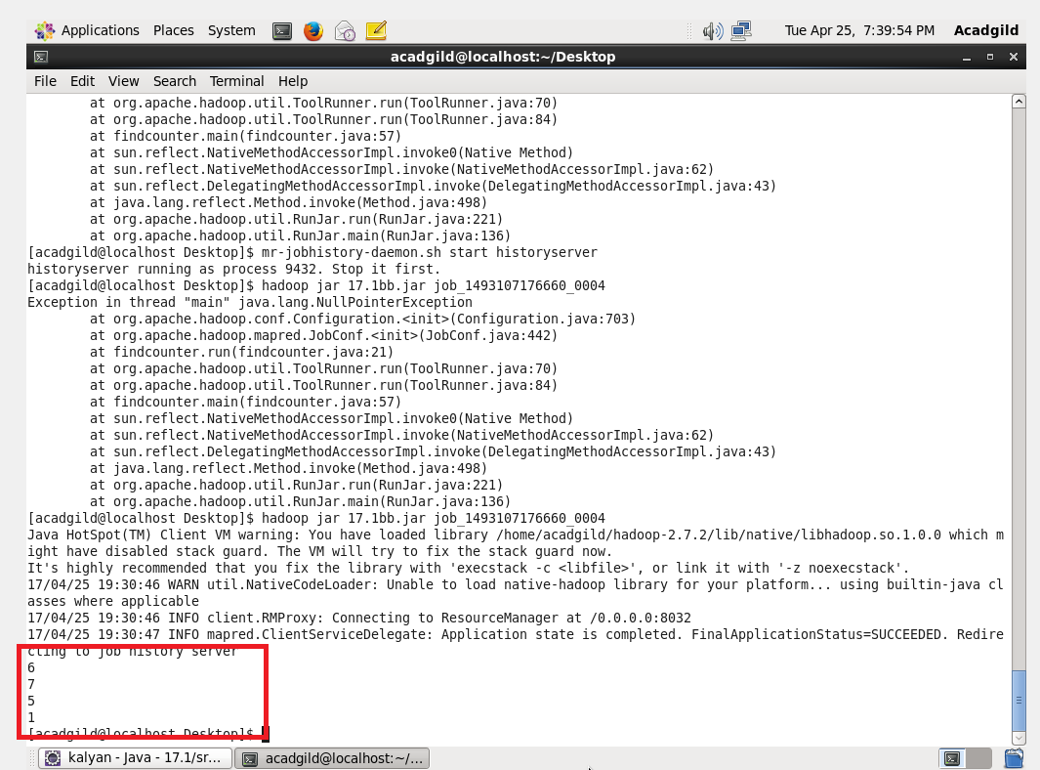

**Before running second jar file, I’ve switched history server ON using mr-jobhistory-daemon.sh start historyserver.**