**17.2 Write a secondary sort program to generate the top 2 maximum temperatures corresponding to every year from the temperature dataset.**

**DRIVER CLASS:**

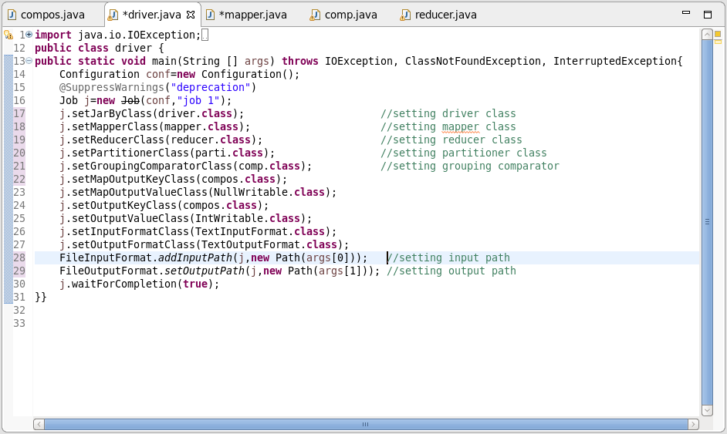

**MAPPER CLASS:**

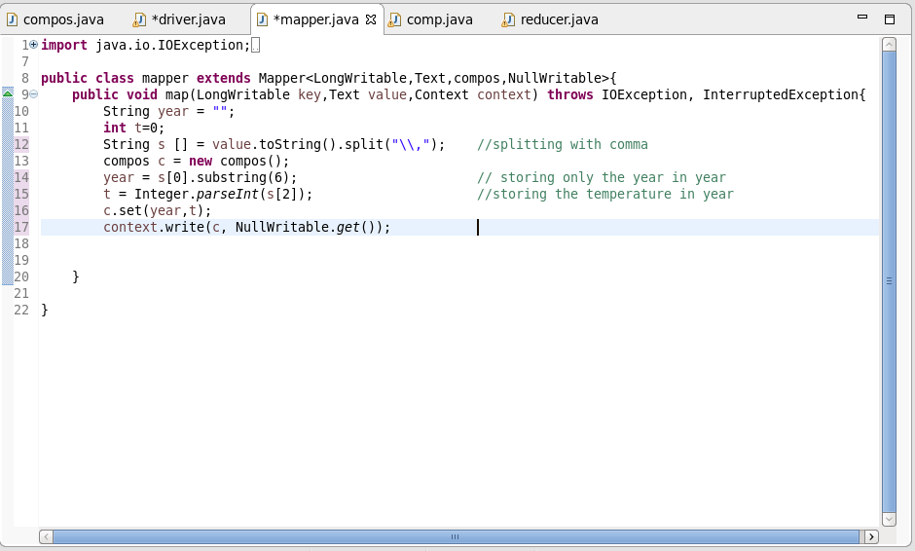

**COMPOSITE KEY CLASS:**

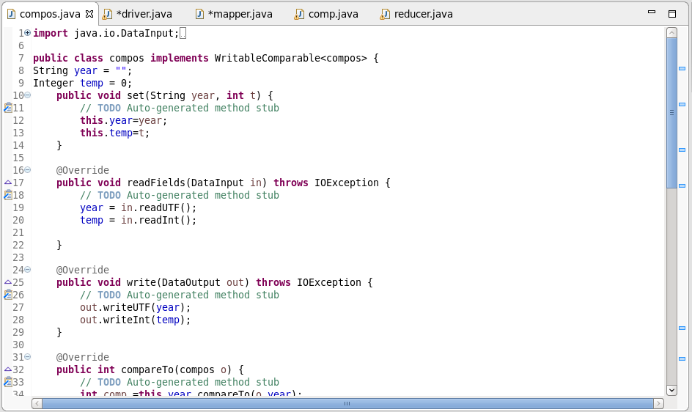

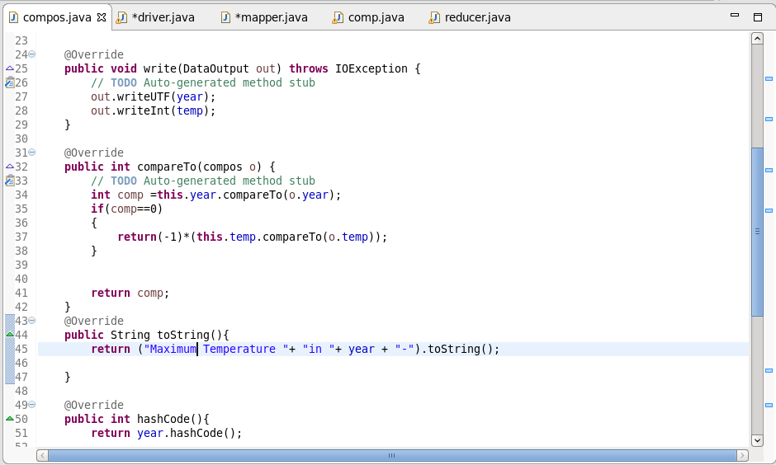

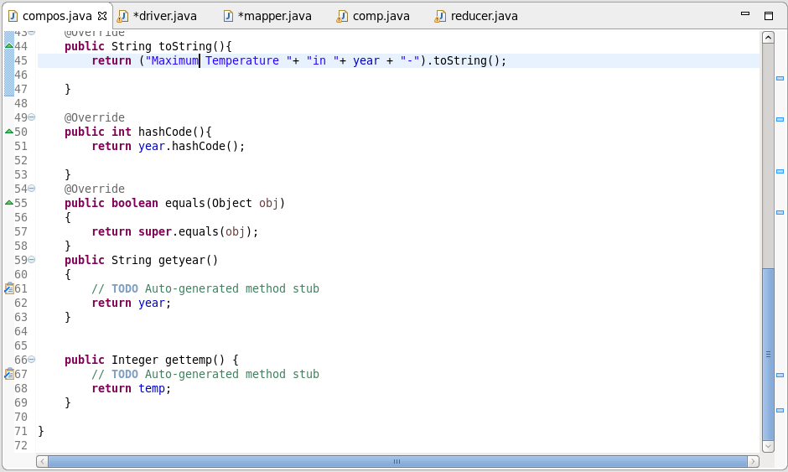

* **Overriding the compare Method**

Checking if year is same, if it is same then it will sort the temperature by descending

* **Overriding Tostring Method**

To change the way, the composite key should be displayed

* read and write fields is for serialization and deserialization

**PARTITIONER CLASS:**

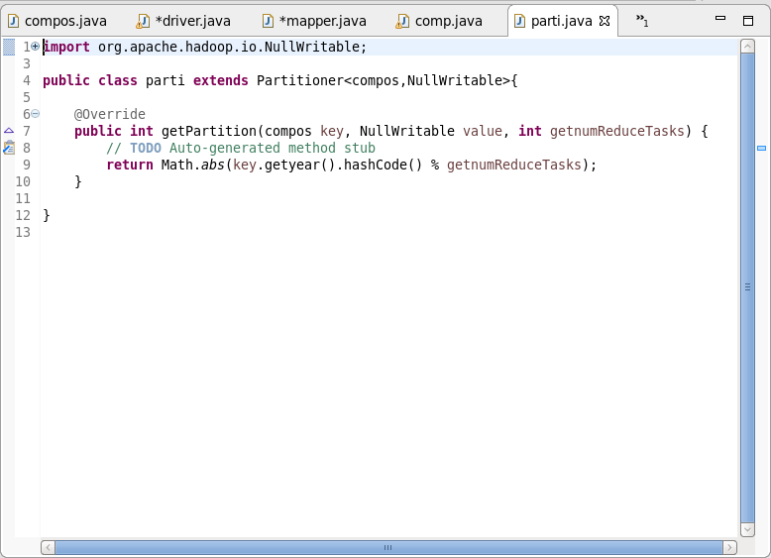

By setting a partitioner to partition by the year part of the key, we can guarantee that records for the same year go to the same reducer

**GROUP COMPARATOR CLASS:**

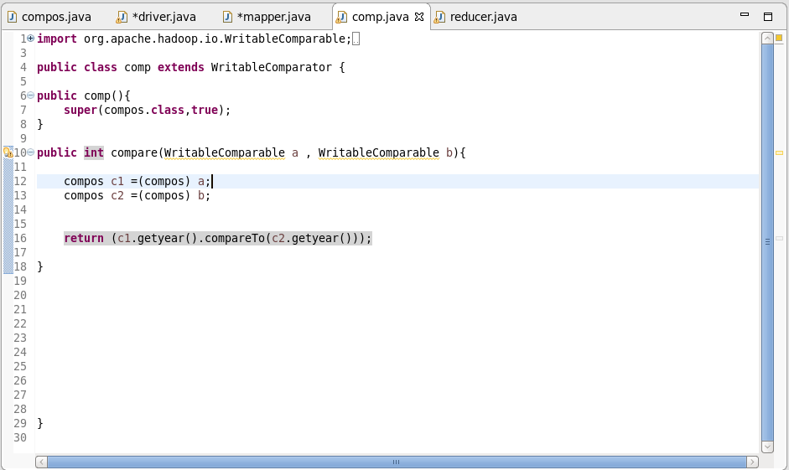

Group Comparator decides which map output keys within the Reducer go to the same reduce method call.

**REDUCER CLASS:**

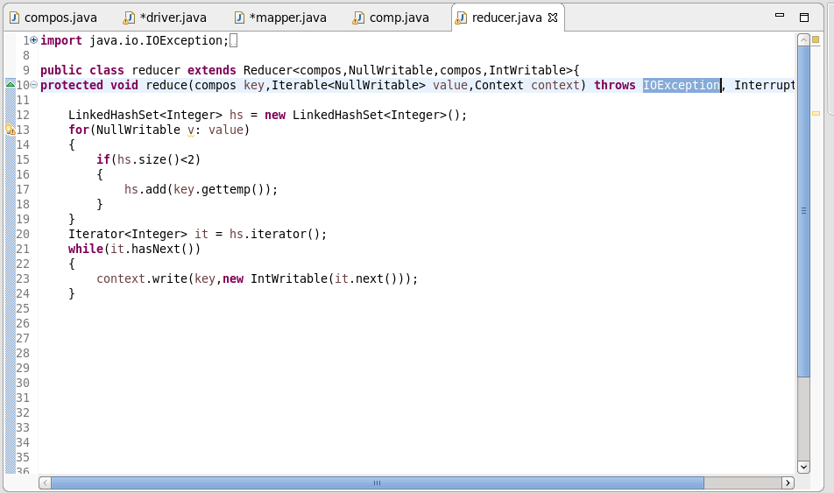

**OUTPUT:**

