**17.3 Write a mapreduce job that takes configuration from command line (min.word.count). Based on the configuration, it should perform count of words from a document and produce only those words in the output whose count is greater than or equal to the configuration.**

I’ve included mapper in driver class itself.

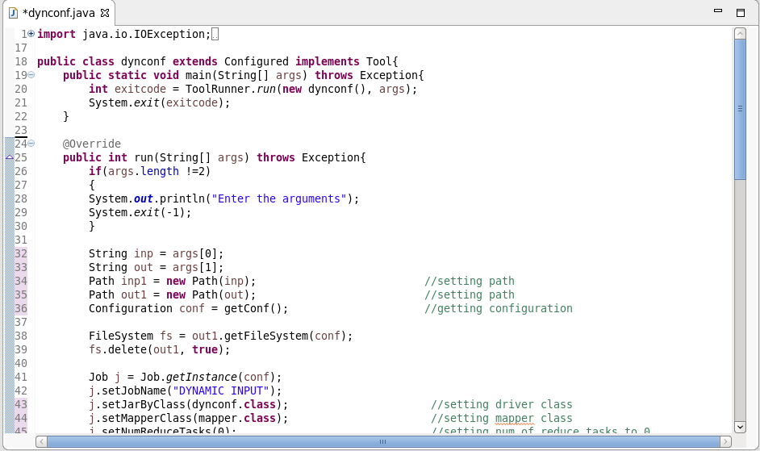

**CONSIDER A WORD ARAVIND**

**I’ve used Hash map in my code . First time when the word “ARAVIND” enters the mapper it goes directly to the else statement and gets written as (ARAVIND,1), when the word ARAVIND comes again it goes to the if statement since already ARAVIND is there in the hash map. In If statement the count gets increased and gets updated in the hash map**

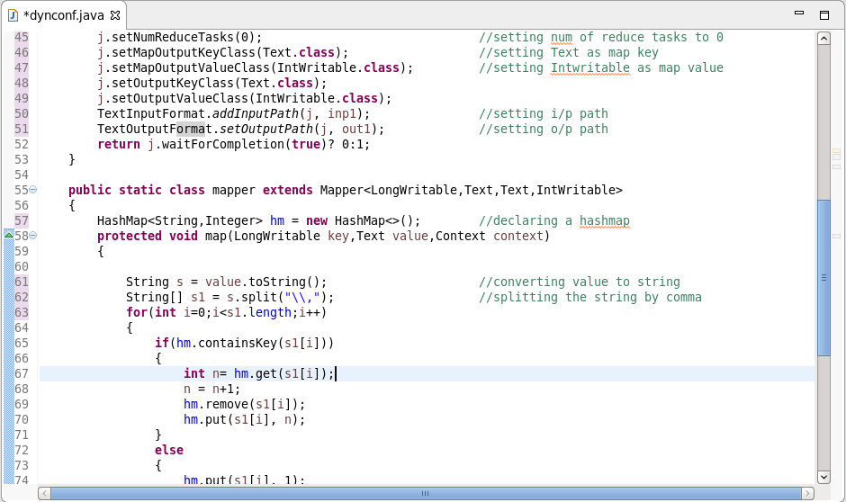

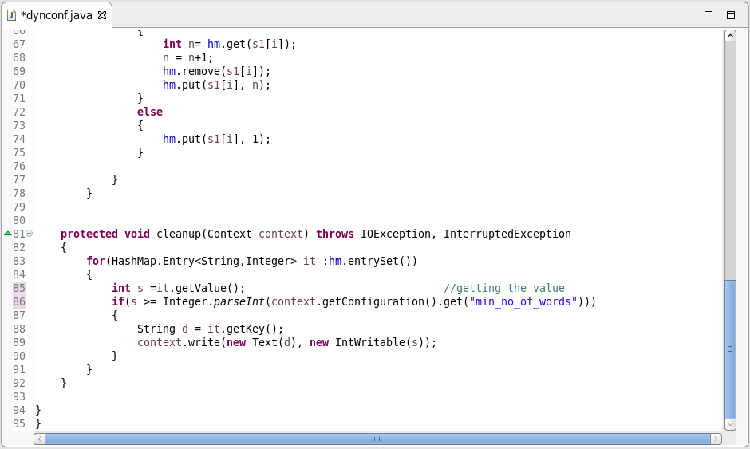

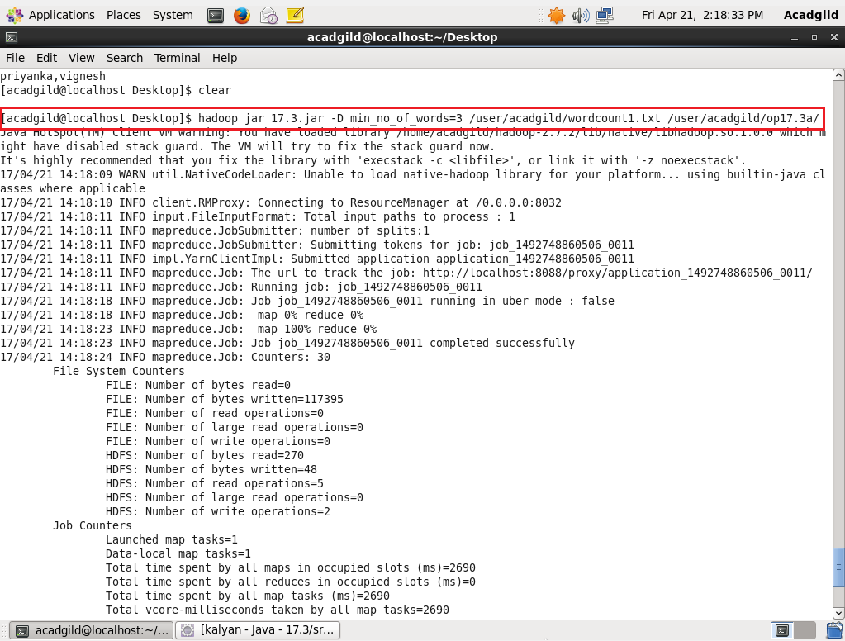

**INPUT FILE:**

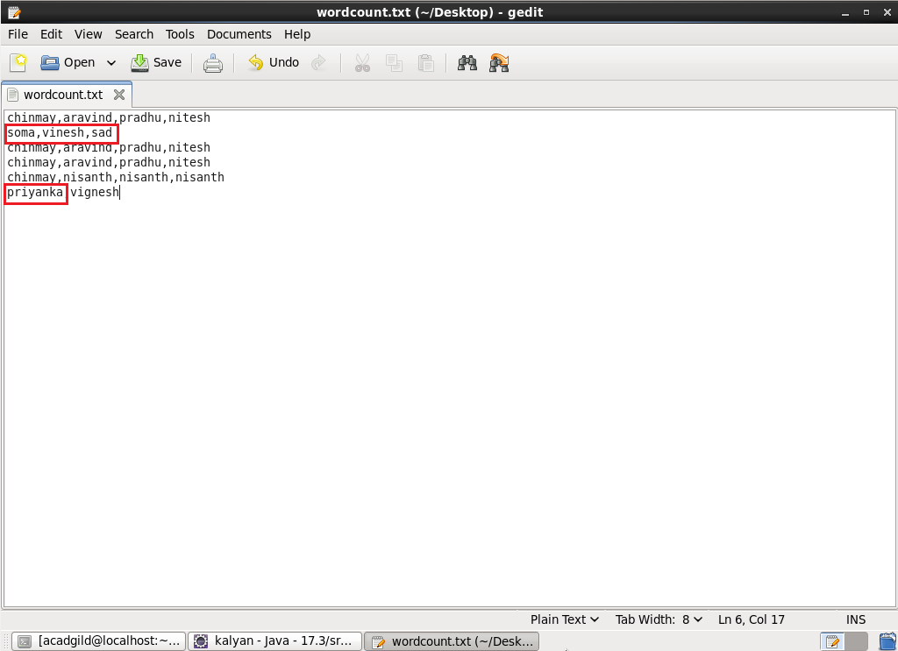

**In the Input file, soma ,vinesh , sad, Priyanka occurs only once.**

**So my code has eliminated it since I’ve set the min count as 3.**

**All other words occur thrice or more than that hence it comes in the output.**

**OUTPUT:**

