**18.1 a) Run a map only job on the word count program using static configurations.**

**DRIVER CLASS:**

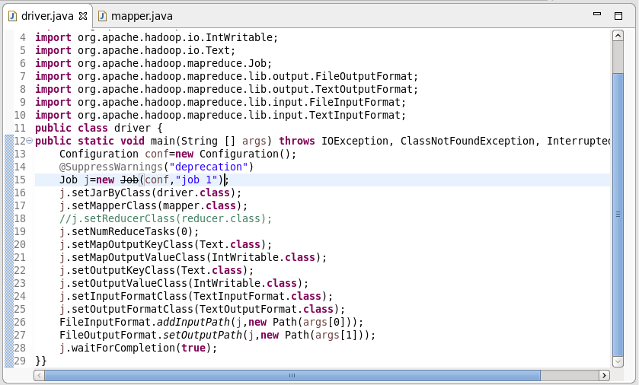

**Number of reducer is set as 0**

**MAPPER CLASS:**

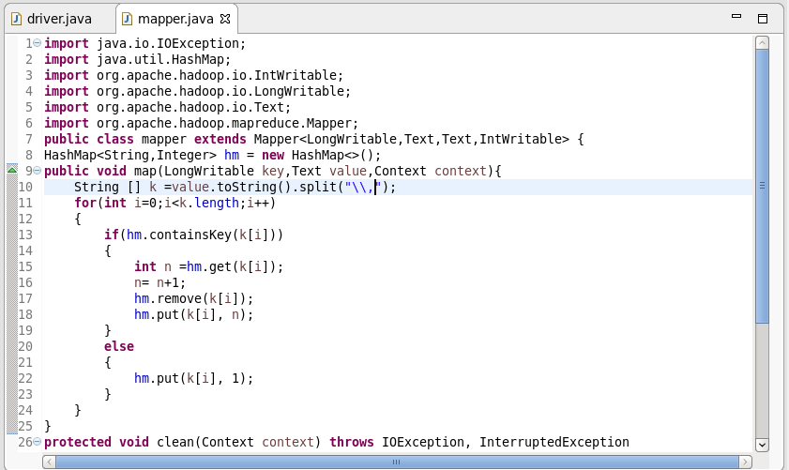

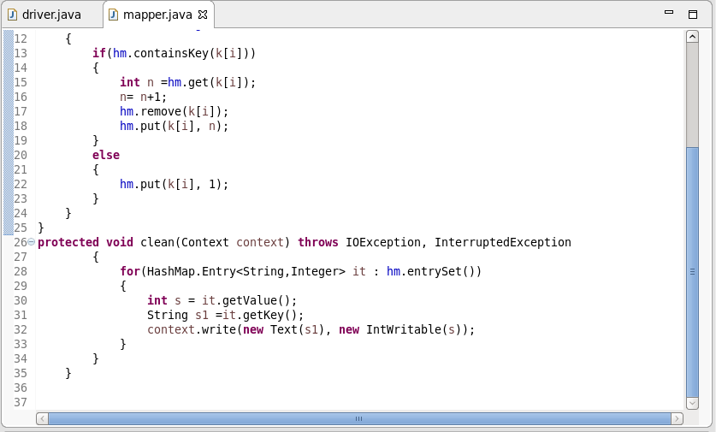

**CONSIDER A WORD ARAVIND**

**I’ve used Hash map in mapper. First time when the word “ARAVIND” enters the mapper it goes directly to the else statement and gets written as (ARAVIND,1), when the word ARAVIND comes again it goes to the if statement since already ARAVIND is there in the hash map. In If statement the count gets increased and gets updated in the hash map**

**OUTPUT:**

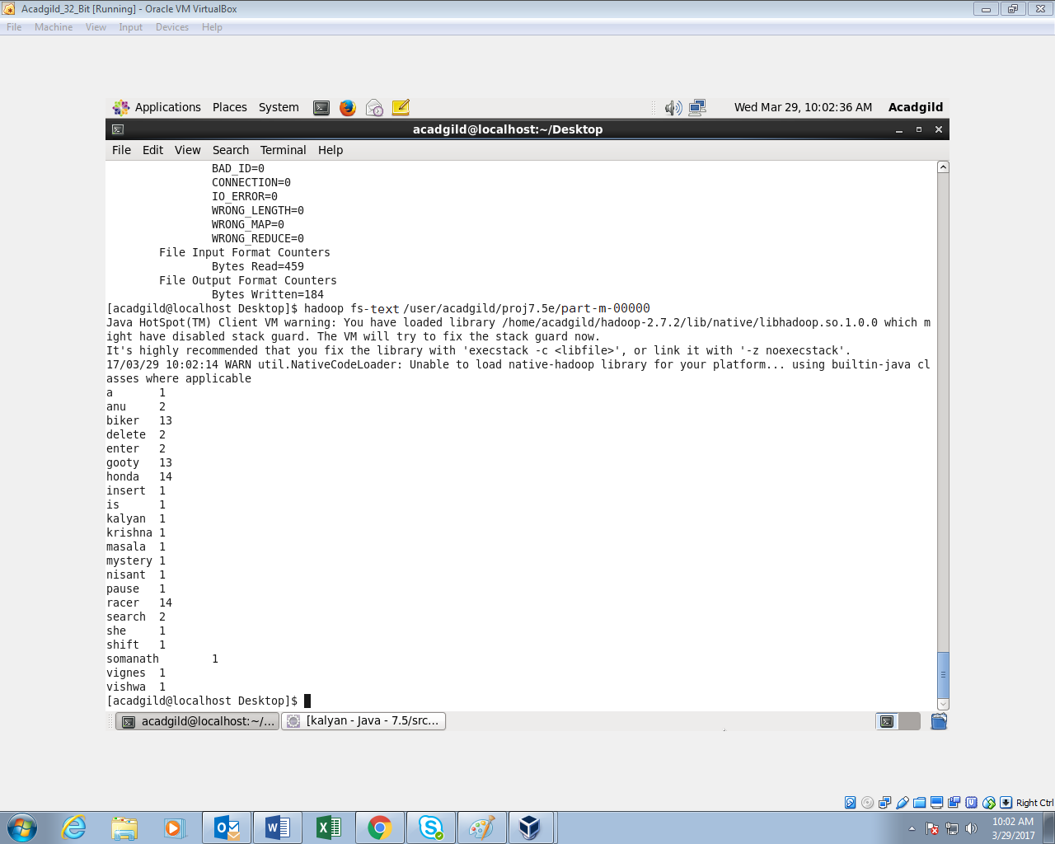

**18.1b) Run the map reduce word count program and set the number of reducers to 2 using static configurations.**

**INPUT FILE:**

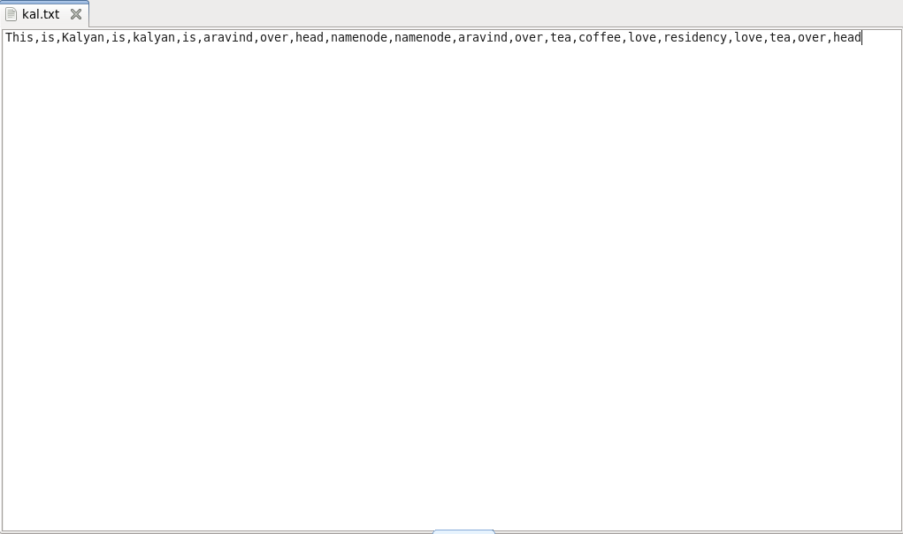

**DRIVER CLASS:**

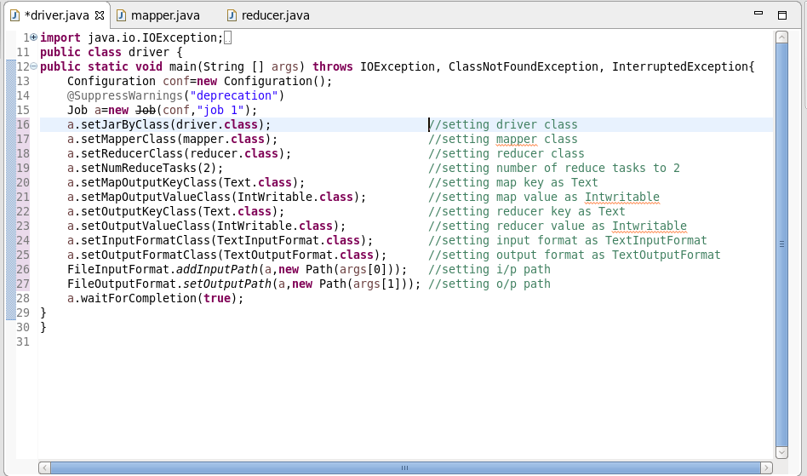

**MAPPER CLASS:**

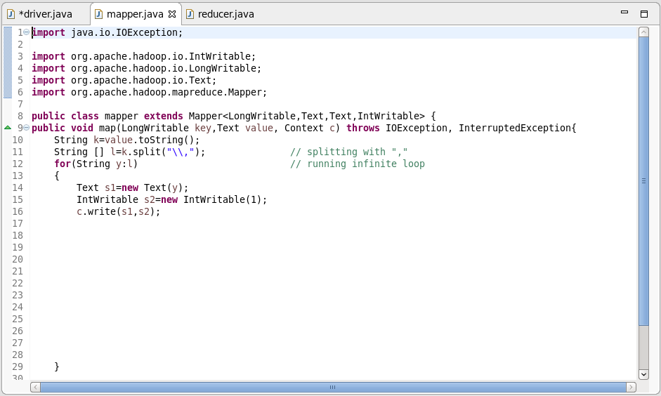

**REDUCER CLASS:**

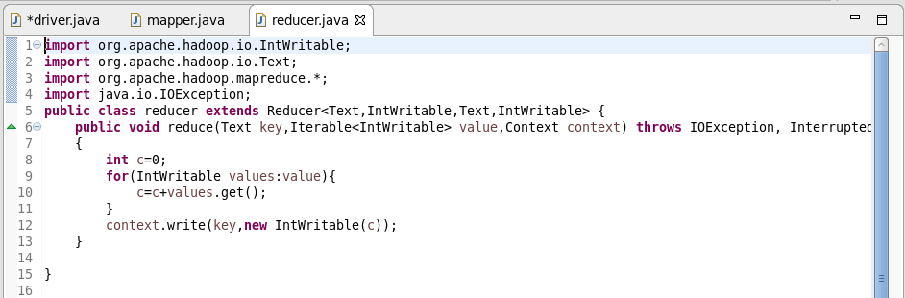

**OUTPUT:**

