**18.3 Merge the small files in hadoop by following the below blog.**

**STEP 1: I’ve listed all the files inside the directory merging.**

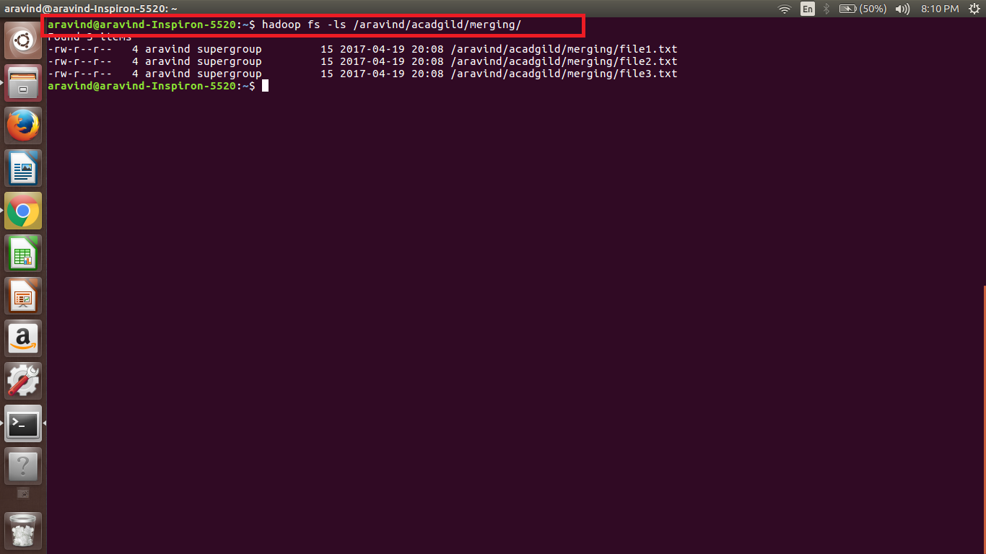

**STEP 2: I’ve opened the contents of the file using cat command**

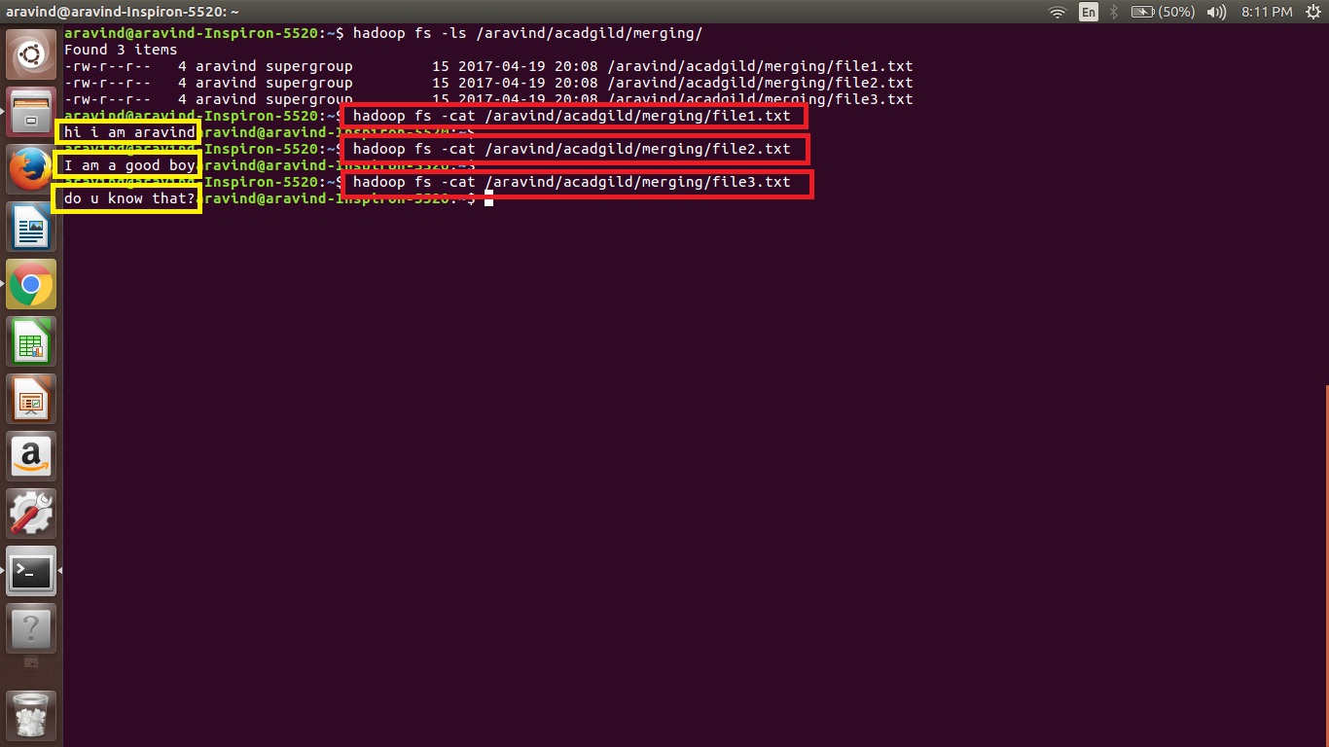

**STEP 3: Using getmerge command, contents of all the 3 files will be merged to form a new file called mergedtext.txt which will be in local system(not in hdfs)**

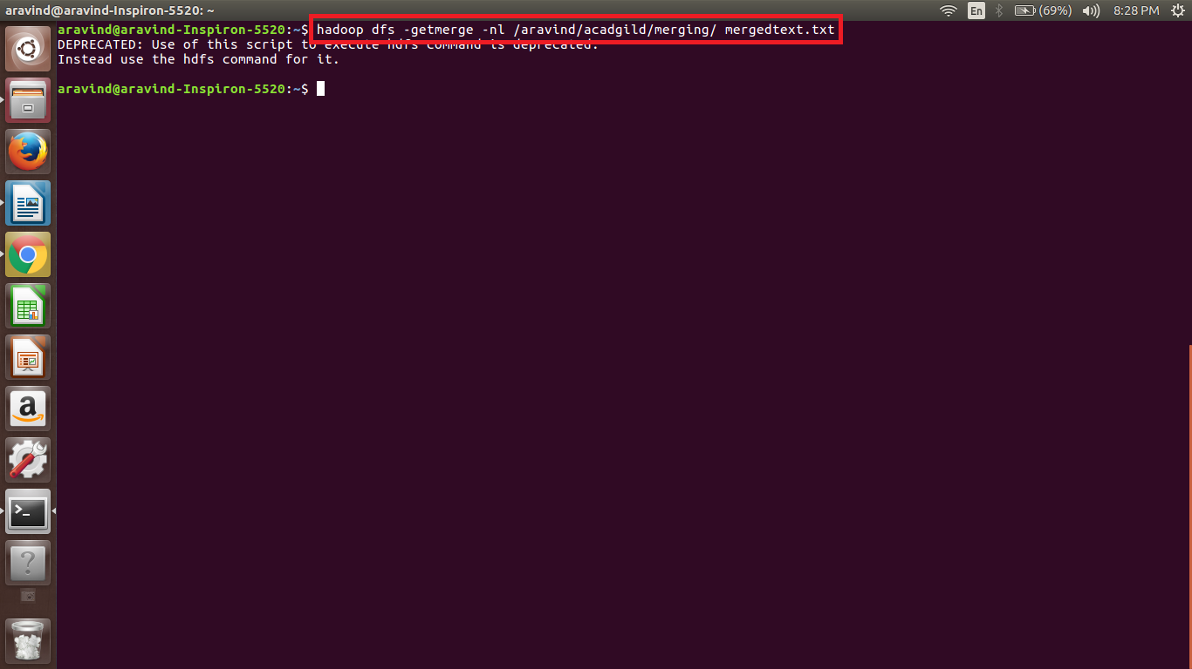

**Here –nl means new line**

**STEP 4: Reading the mergedtext.txt using cat command**

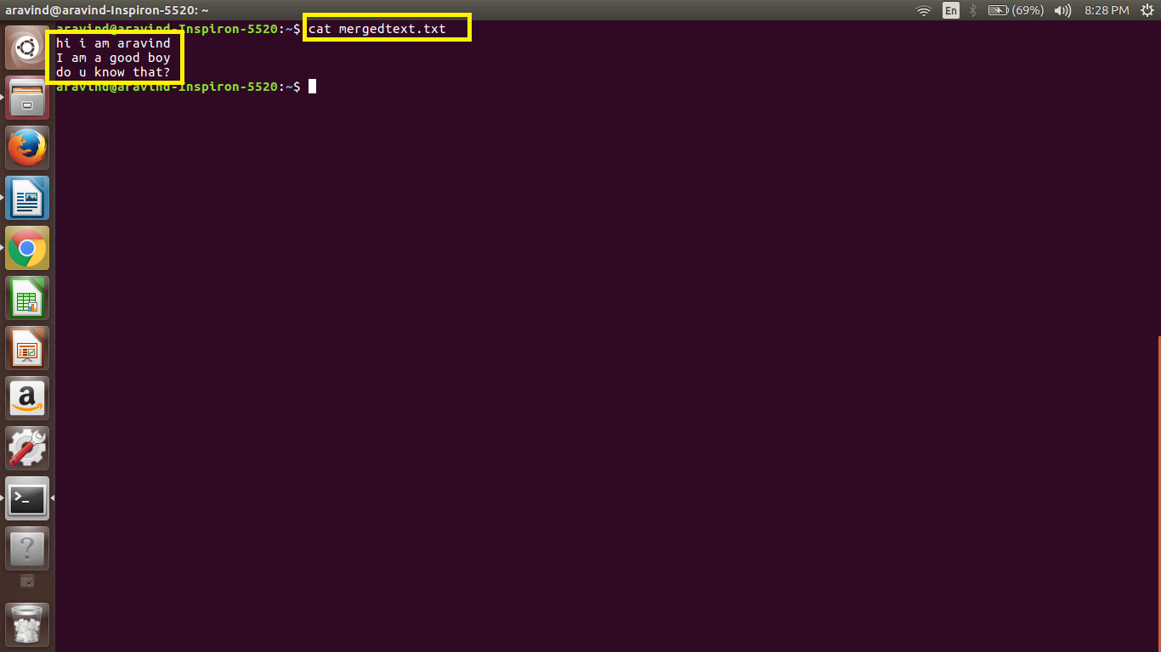

**Previously the above three lines were in 3 different files. After merging these 3 files into a single file, I got this output.**