**19.2 Convert XML File into Json File Format. You can consider below example XML, save it in the hdfs cluster and then to convert into Json File Format.**

**The following xml file has to be converted into JSon File format**

**INPUT FILE:**

***I’ve stored it as Sample.xml in hdfs***

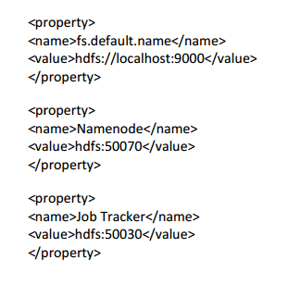

**LOGIC:**

* *Downloaded org.json jar file and imported it to the project and to the lib folder of Hadoop/common*
* *String xml_data will read an XML record and converts it into a String using the toString() method.*
* *This XML record is converted into JSON object using the XML to JSONobject() method present in the jar file which we have added.*
* *Now, the XML record will be converted into a JSON object.*
* *The obtained JSON object will be again converted into String using the toString() method*

**CODE:**

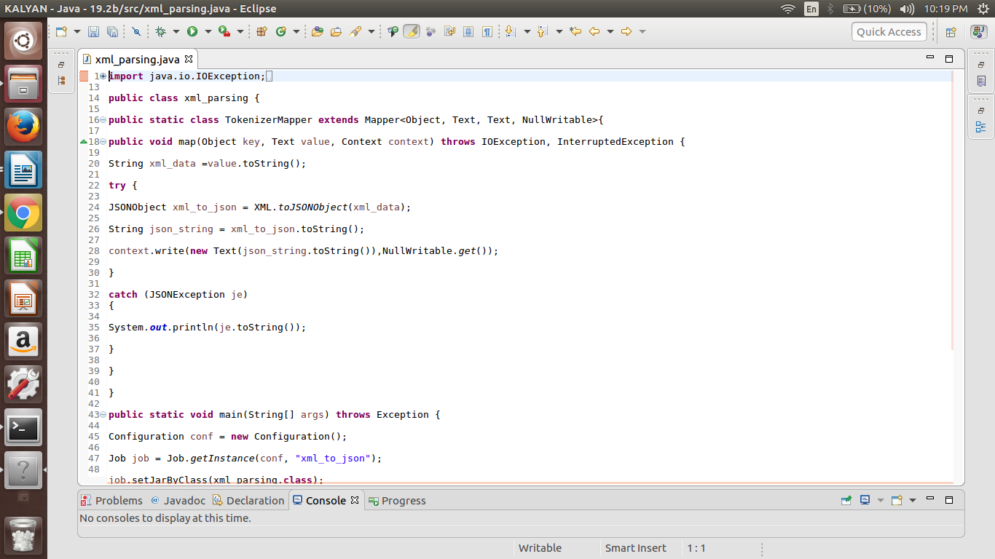

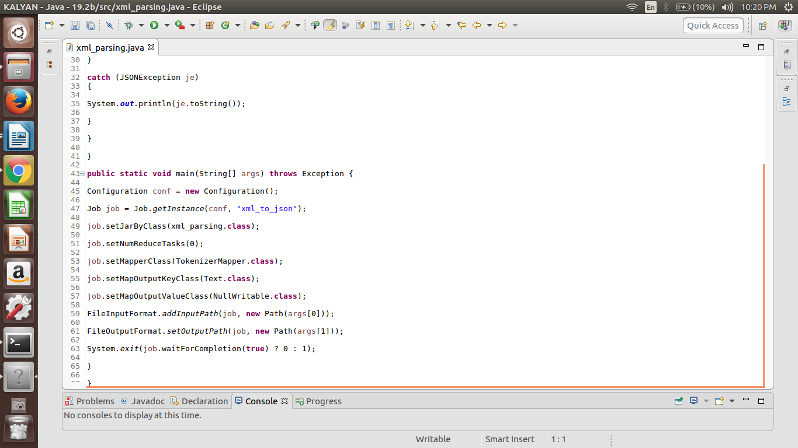

**RUNNING JAR:**

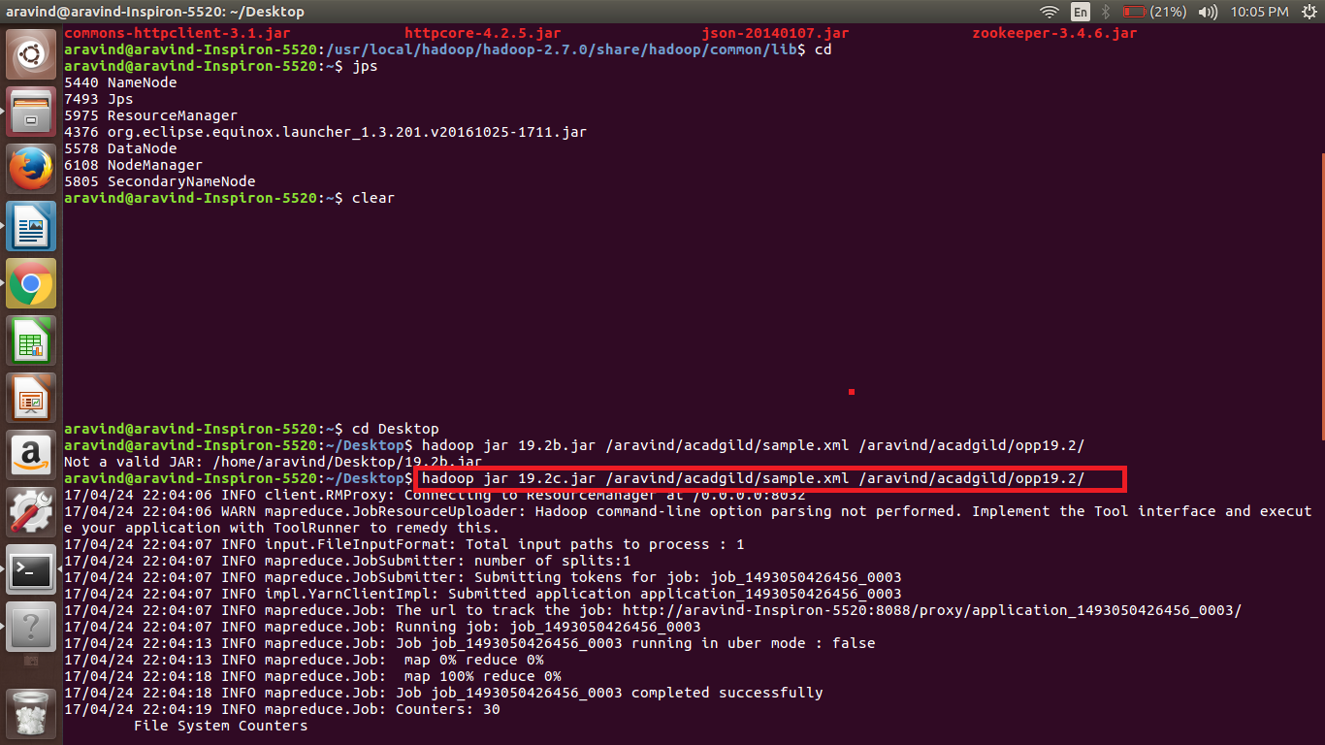

**OUTPUT:**

