**21.3 This dataset consists of two columns i,e., first_name & last_name &city use custom input format to read the key as the combination of first_name and last_name and arrange the output of the program should be the key sorted by last_name.**

* Since we want record reader to read first name and last name as key , define a composite key that contains first name and last name and then order last name by ascending.
* For reading the file by composite key , a custom Input format class is created which accepts the parameters key and value.
* Now, these values are passed to the Record reader, which does the actual formatting of the inputs.

**DRIVER CLASS:**

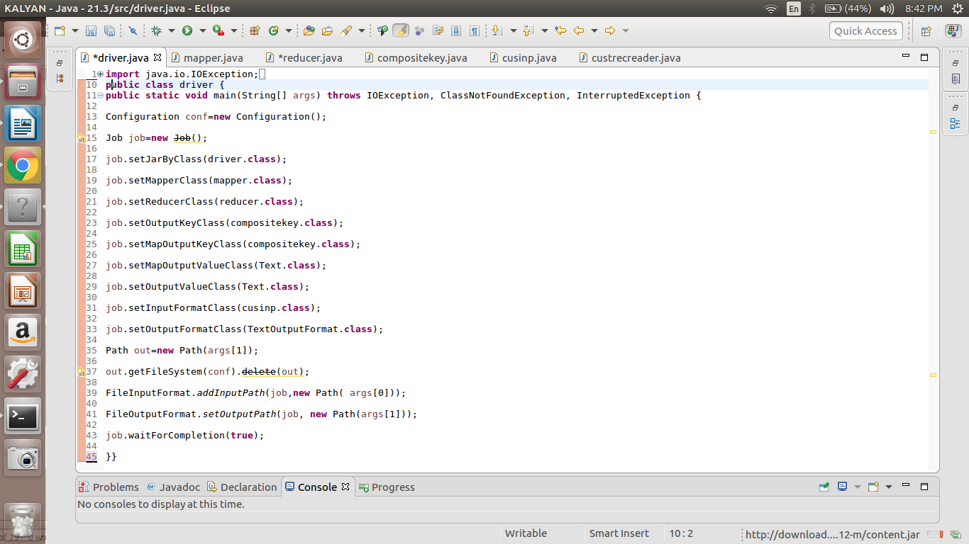

**MAPPER CLASS:**

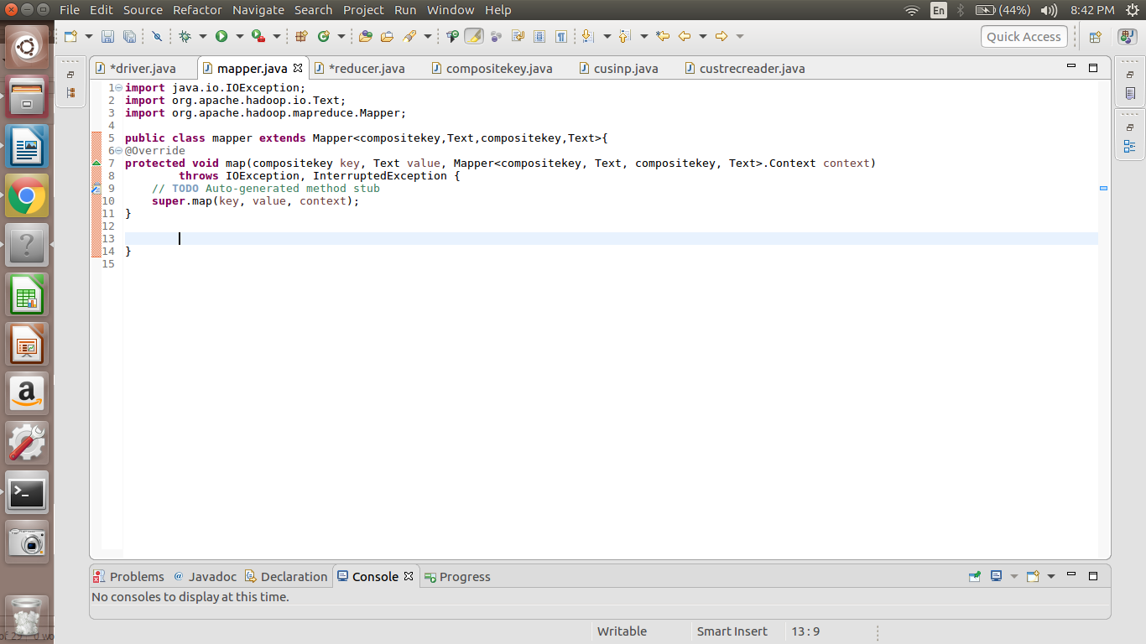

**REDUCER CLASS:**

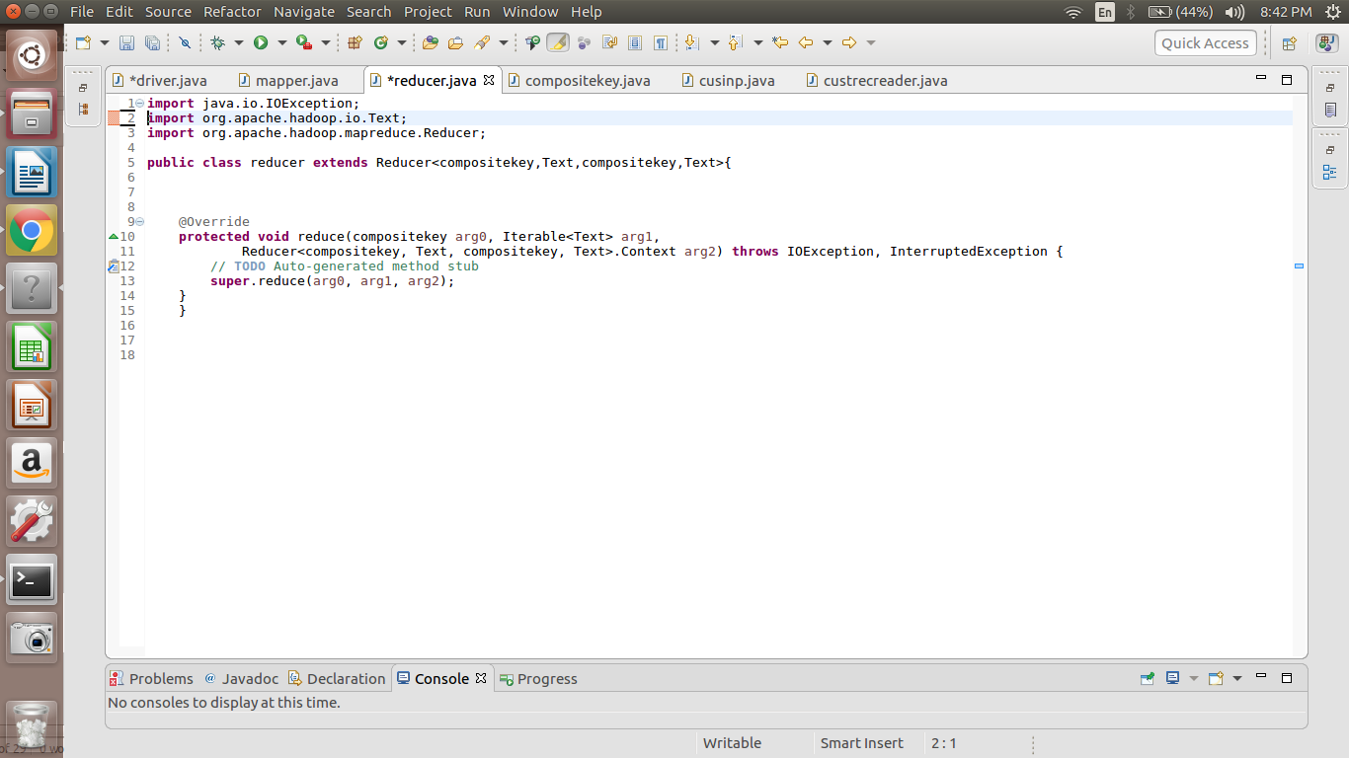

**COMPOSITEKEY CLASS:**

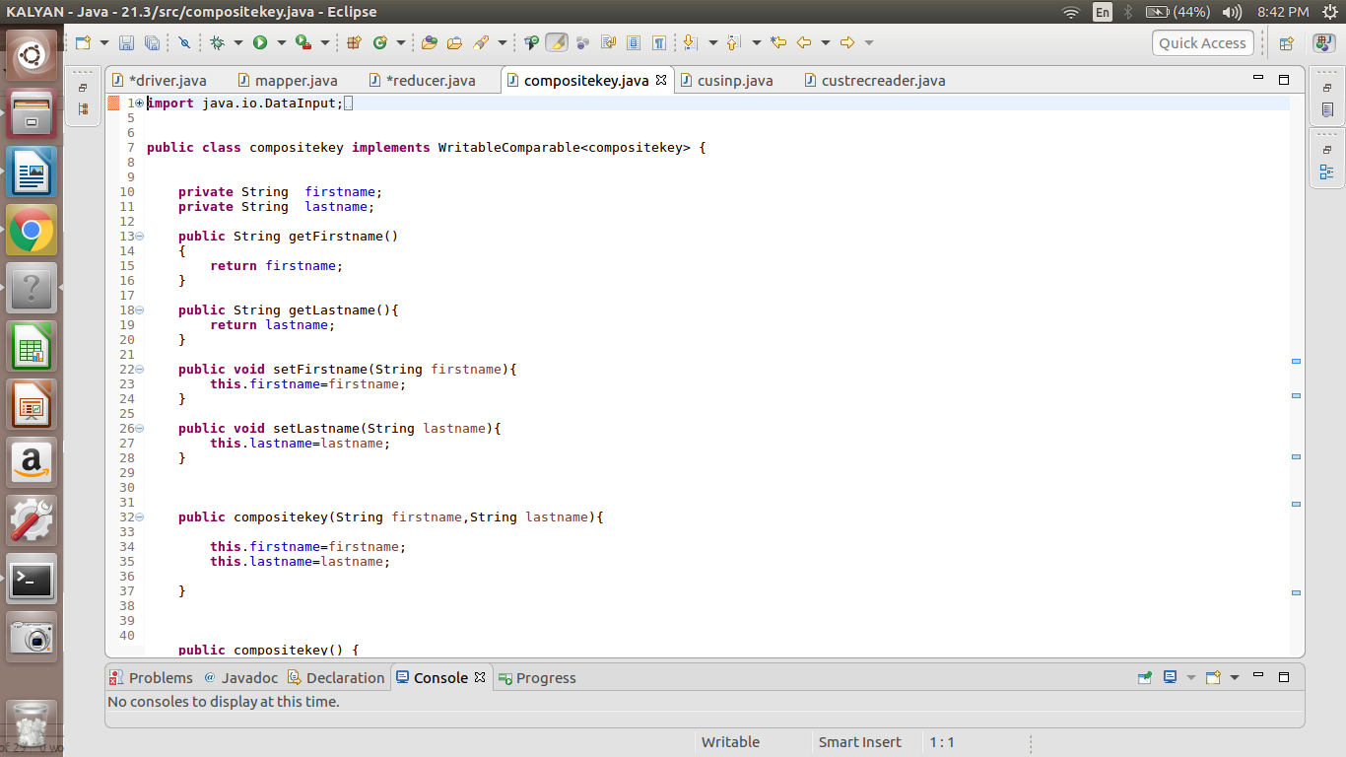

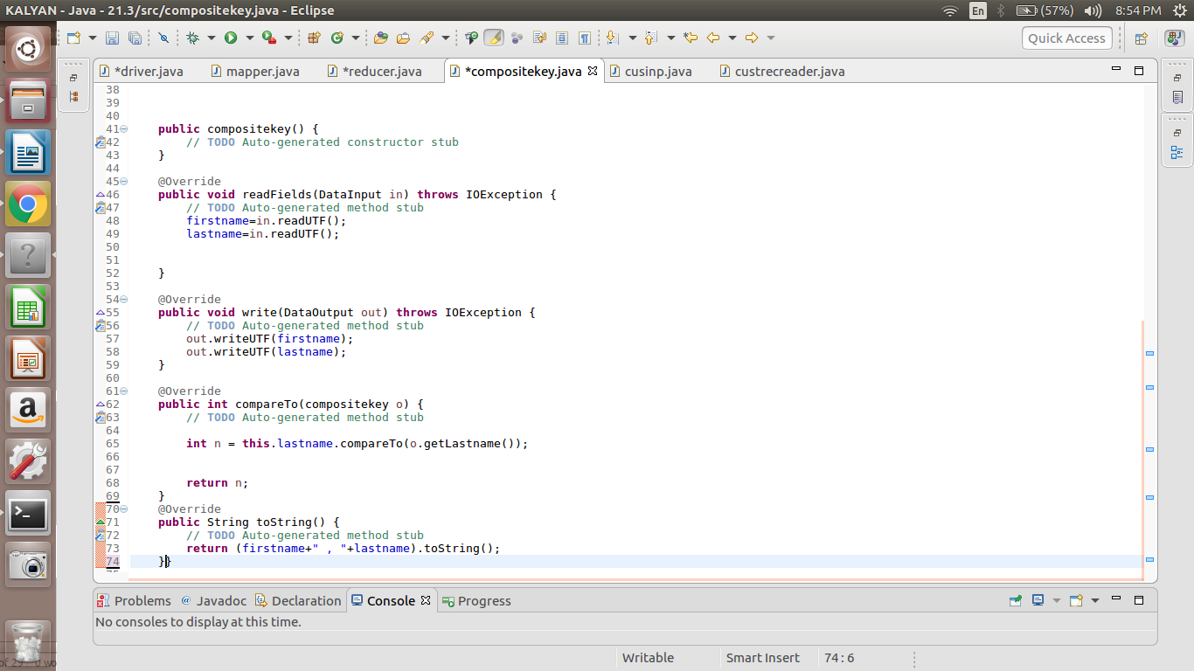

**CUSTOM INPUT CLASS:**

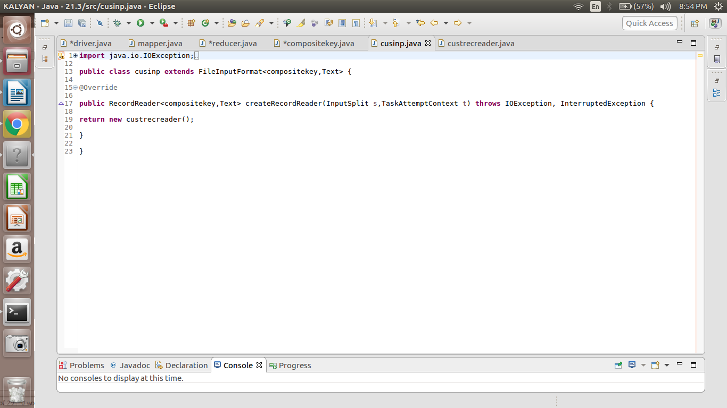

**CUSTOM RECORD READER:**

