**ASSIGNMENT 22.1**

**Write a Wordcount program and Store the result in Mysql db.**

**Driver class:**

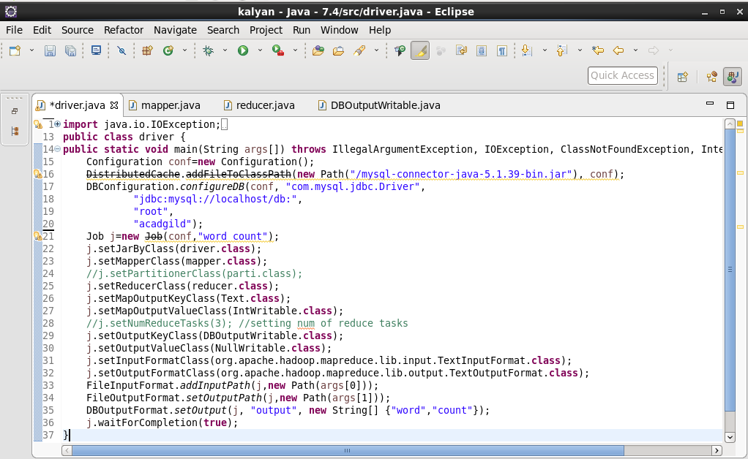

**Mapper class:**

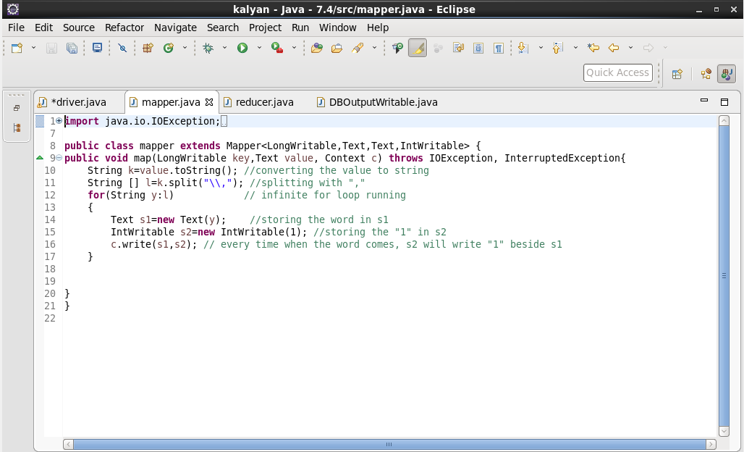

**Reducer class:**

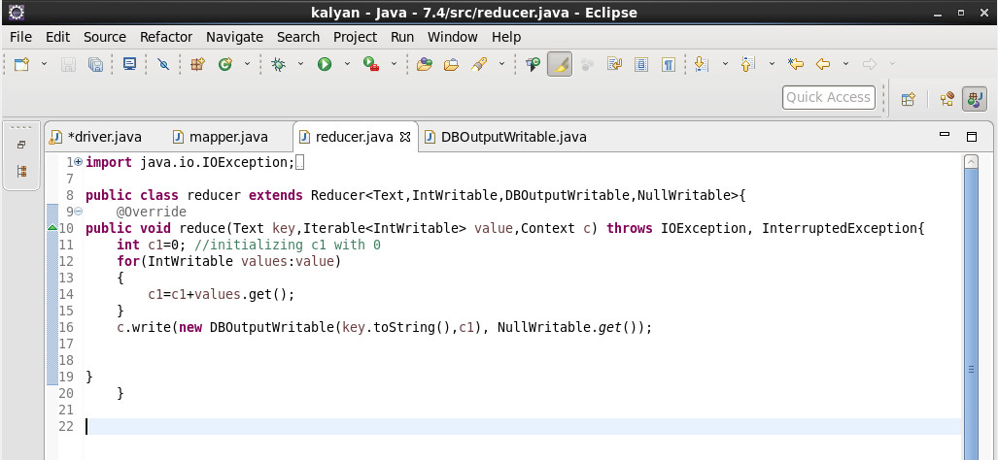

**DBOutputWritable class:**

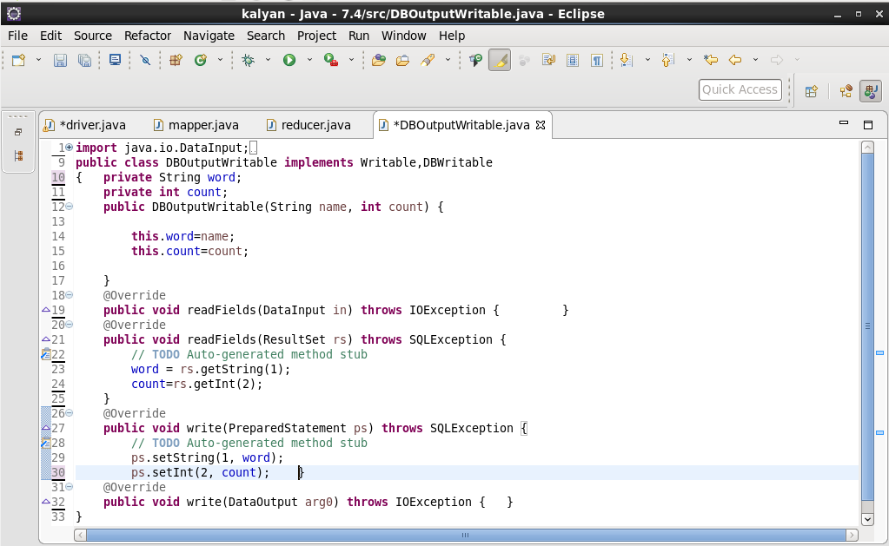

**OUTPUT: successfully saved the output in mysql**

