**ASSIGNMENT 23.1**

Problem Statement

Create a database named 'custom'.

Create a table named temperature_data inside custom having below fields: 1. date (mm-ddyyyy)

format 2. zip code 3. temperature

The table will be loaded from comma-delimited file.

Load the dataset.txt (which is ',' delimited) in the table.

**STEP 1: CREATING A DATABASE NAMED “CUSTOM” :**

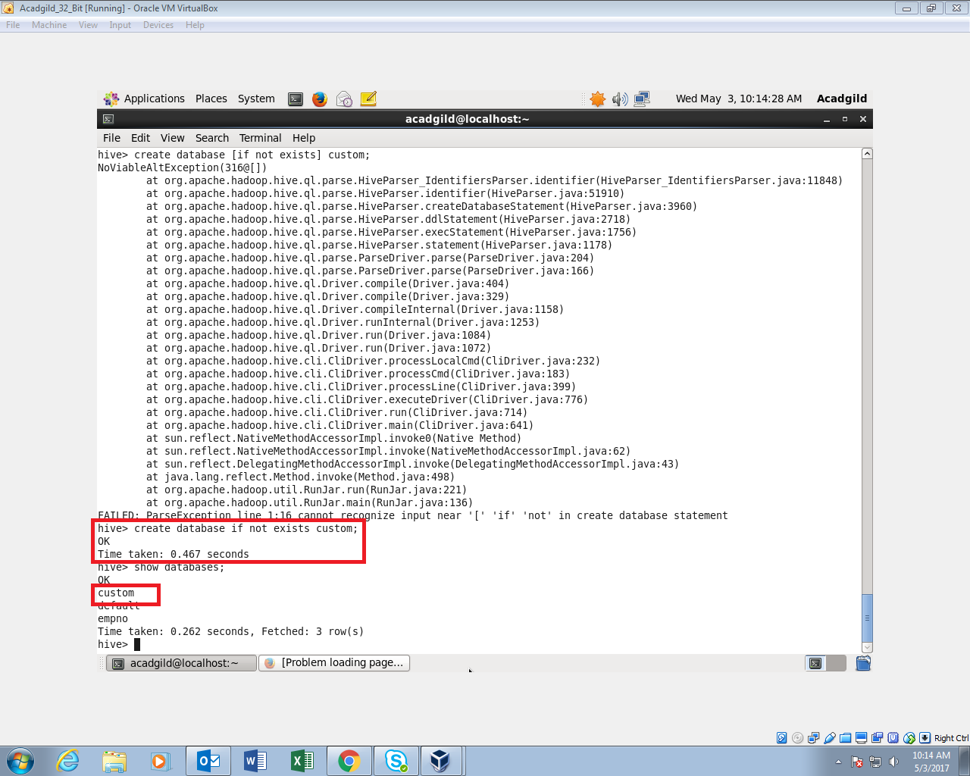

**STEP 2: CREATING A TABLE NAMED “TEMPERATUREDATA” INSIDE THE DATABASE CUSTOM :**

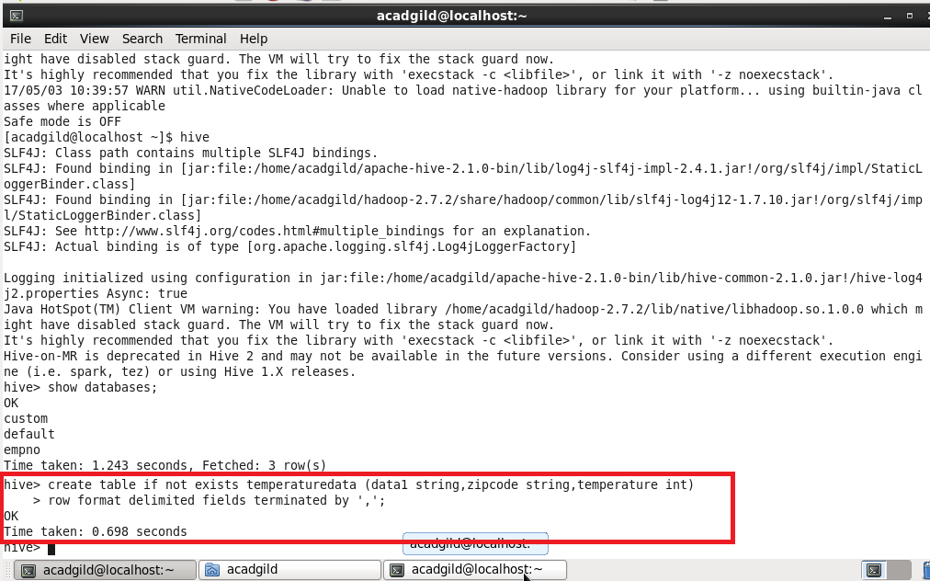

**STEP 3: LOADING THE DATA INTO THE TABLE USING LOAD COMMAND:**

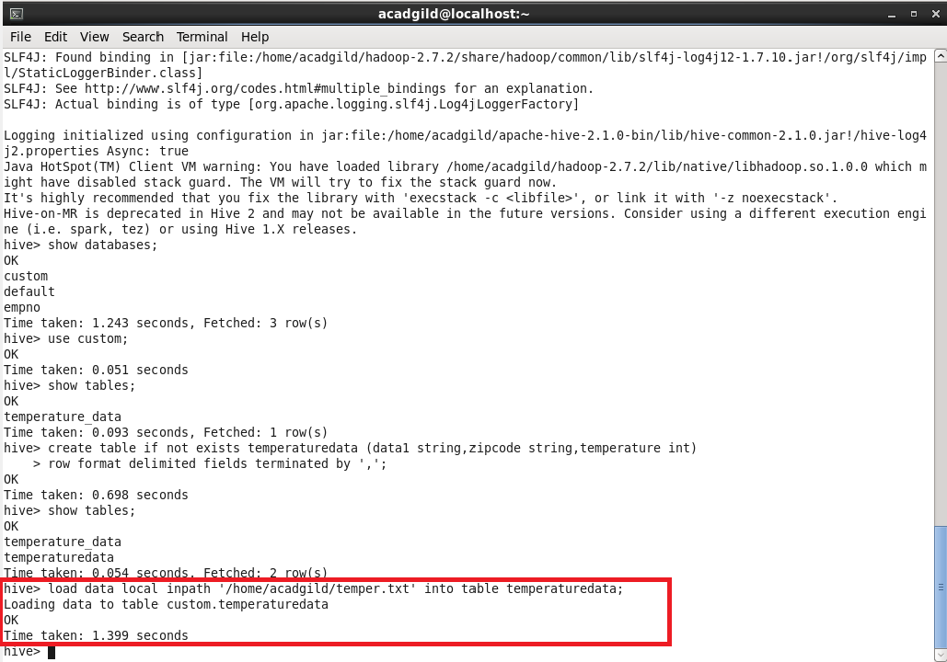

**STEP 4: USING SELECT COMMAND TO SEE THE CONTENTS:**

