ASSIGNMENT 24.3

**Calculate the number of employees corresponding to each skill from the table 'employee' which is loaded in the Demo**

***STEP 1: CREATING A TABLE NAMED EMP_DETAILS***

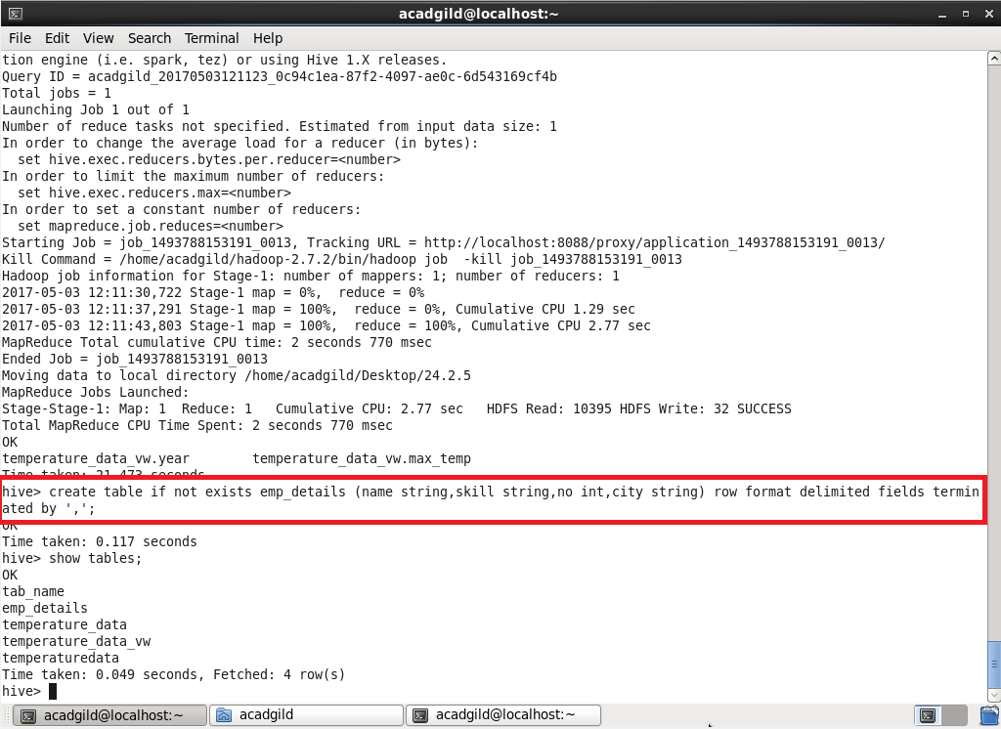

***STEP 2: LOADING THE DATA INTO THE TABLE AND CHECKING WHETHER IT IS LOADED OR NOT***

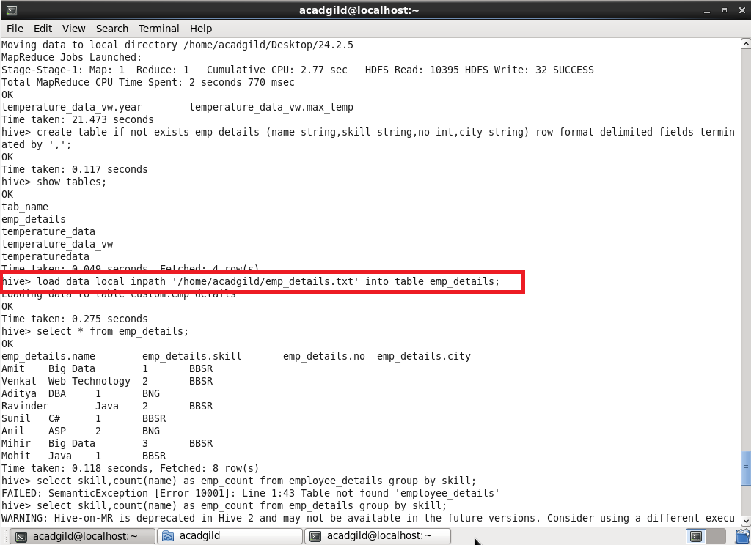

***STEP 3: QUERYING :***

