ASSIGNMENT 24.4

**CREATING THE TABLE AND LOADING THE DATA INTO THE TABLE**

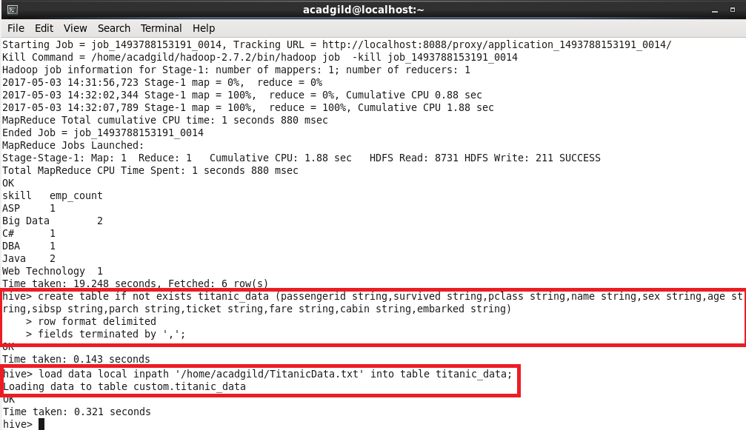

1. **Write a hive query find the average age of male and female persons died in the titanic tragedy**

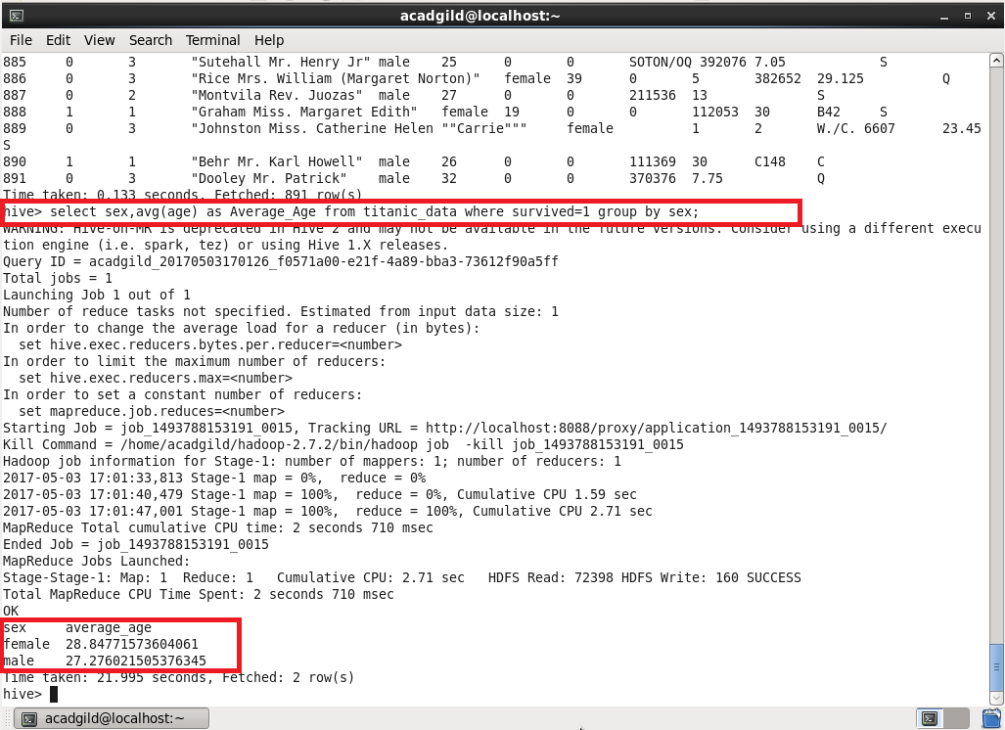

**2. Write a hive query to find the number of people died and survived in each class**

