**ASSIGNMENT 24.5**

**Create a hive table and load the dataset into the table and evaluate the below problem statements**

***CREATING THE TABLE AND LOADING THE DATA INSIDE THE TABLE***

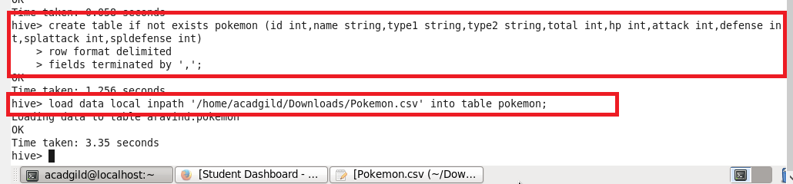

1. **Find out the average HP (Hit points) of all the Pokémons**

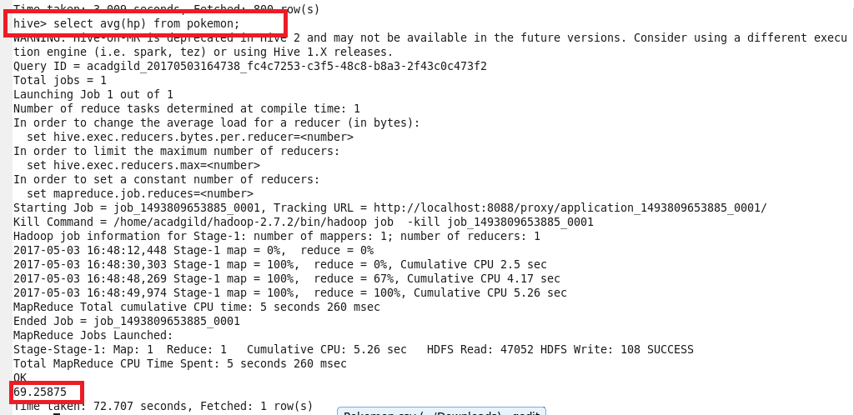

1. **Find out the average Defense of all the pokemon**

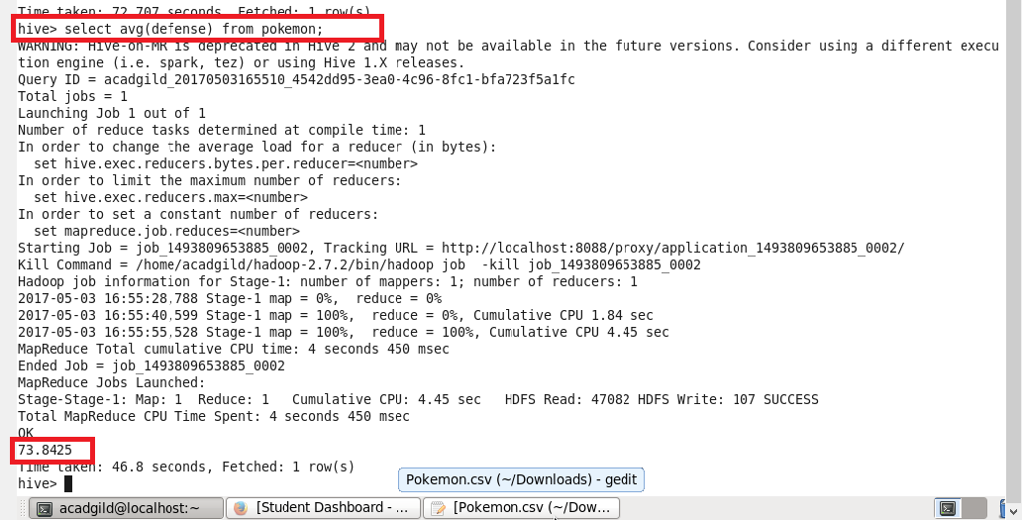

1. **Find out the average Sp.Atk of all the pokemons**

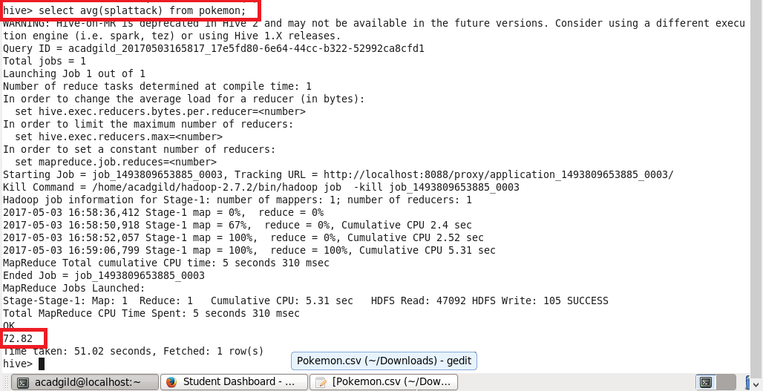

1. **Find out the average sp.Def of all the pokemons**

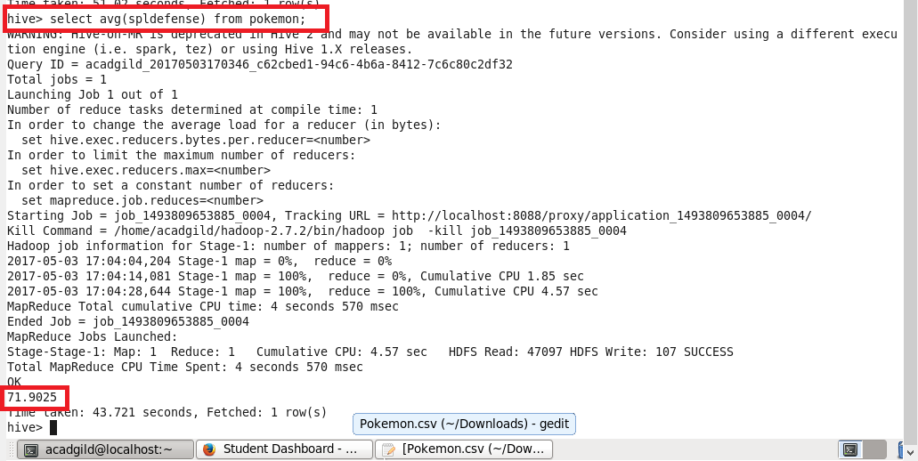

1. **Find out the average Speed of all the pokemons**

