**ASSIGNMENT 24.6**

**CREATING TABLE AND LOADING DATA INTO THE TABLE**

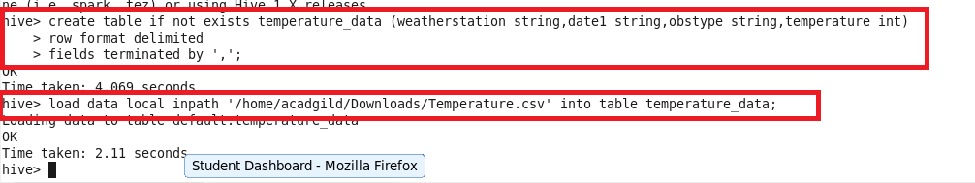

**Write a hive query to find the minimum temperature observed in a given weather station in a particular year.**

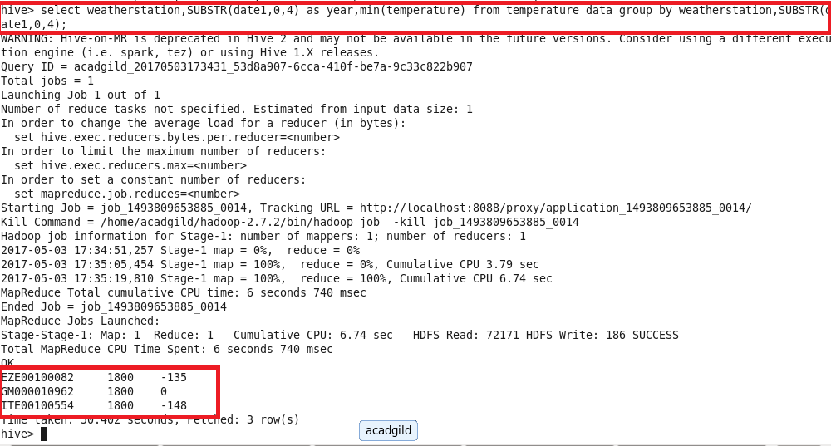

**Write a hive query to find the maximum temperature observed in a given weather station in a particular year.**

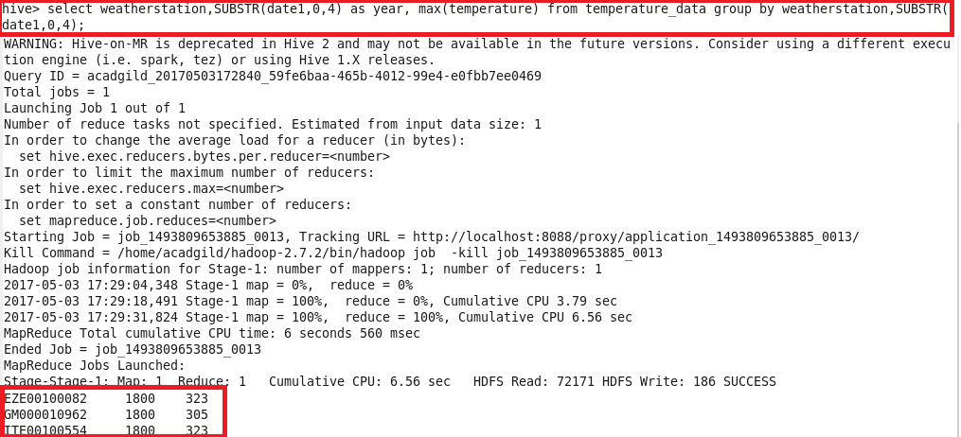

**Write a hive query to find the number of readings given by each weather station according to the dataset.**

