**ASSIGNMENT 25.1**

1. **Write a Hive program to find the number of medals won by each country in swimming.**

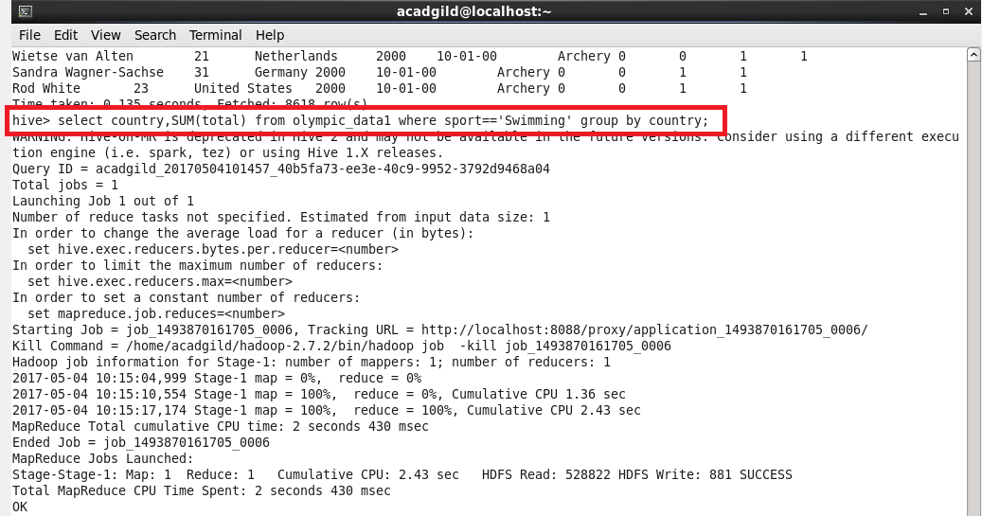

**Giving condition sport = swimming and grouping by country to get country wise medals won in swimming**

**OUTPUT:**

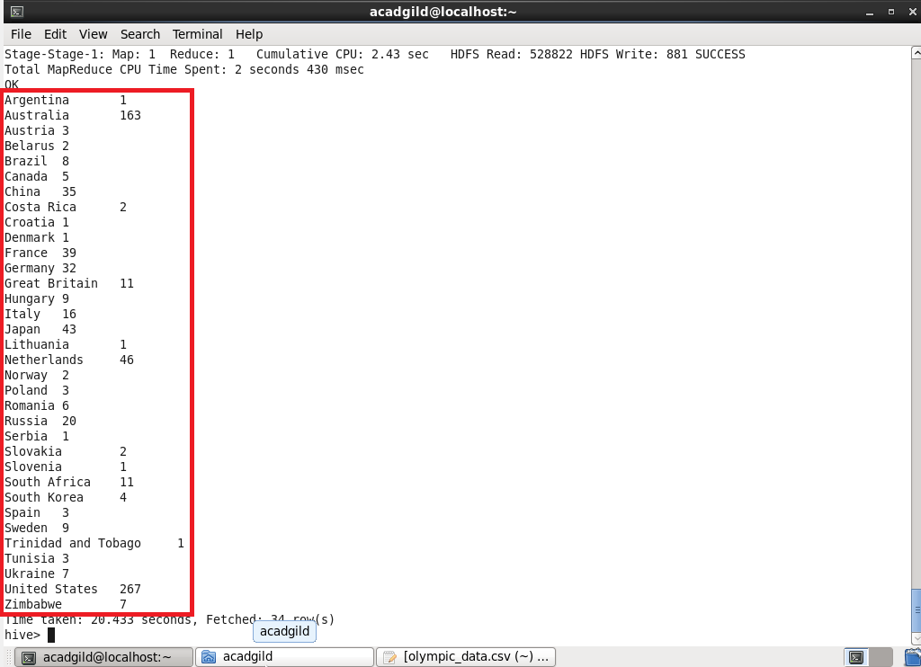

1. **Write a Hive program to find the number of medals that India won year wise.**

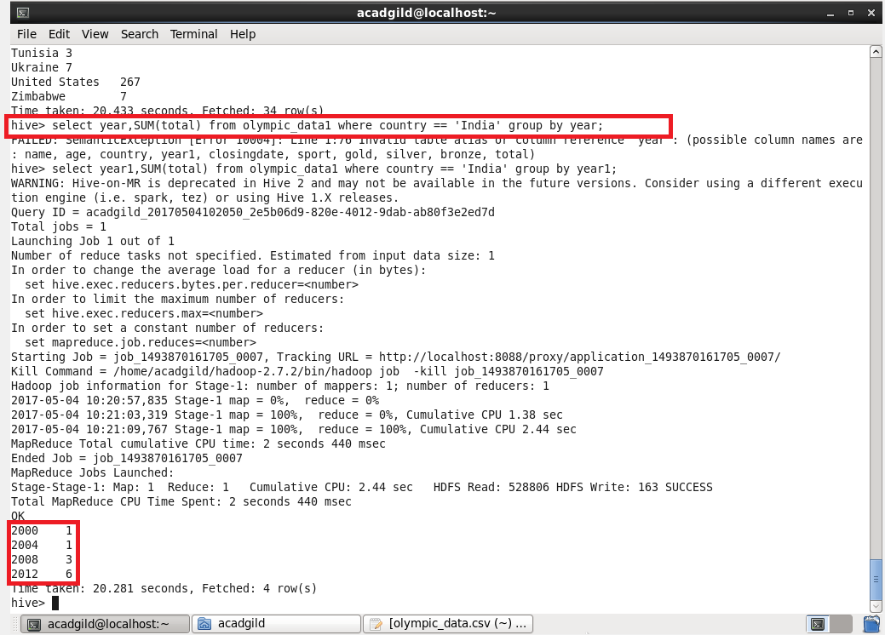

**Giving condition country = India and grouping by year to find out year wise total medals won by india**