**Write a Hive Program to find the total number of medals each country won**

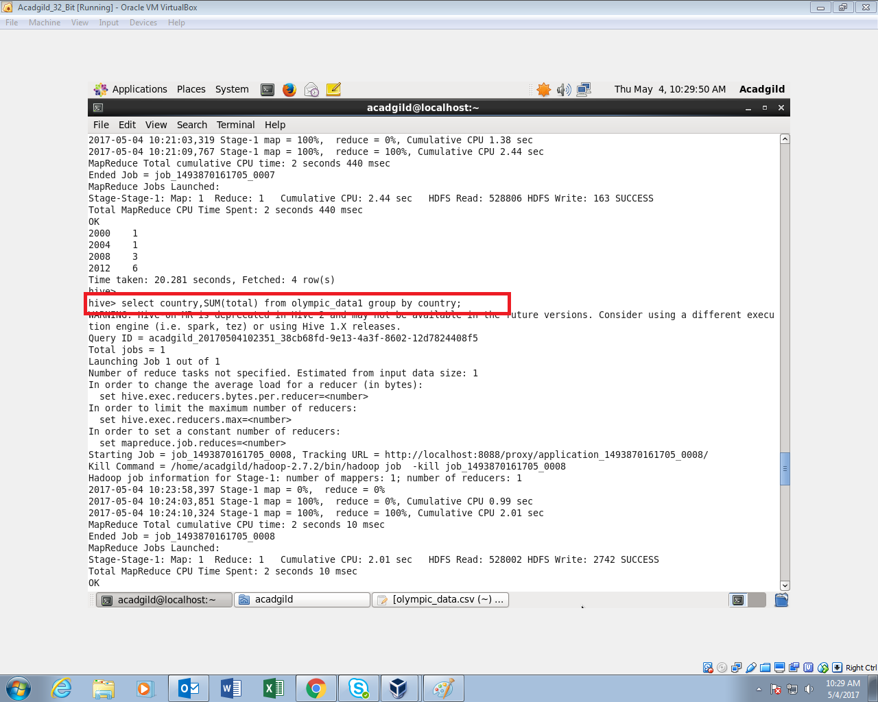

**Inorder to find the sum of total medals won by each country, sum the total and group by country to find out country wise total medals won**

**OUTPUT:**

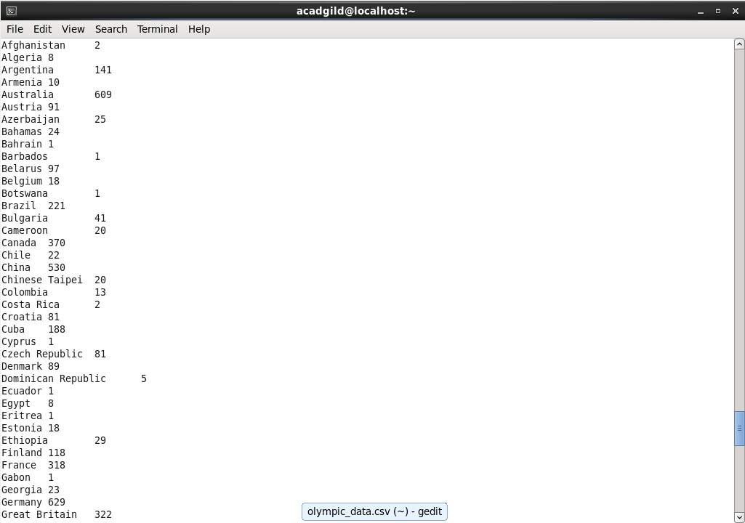

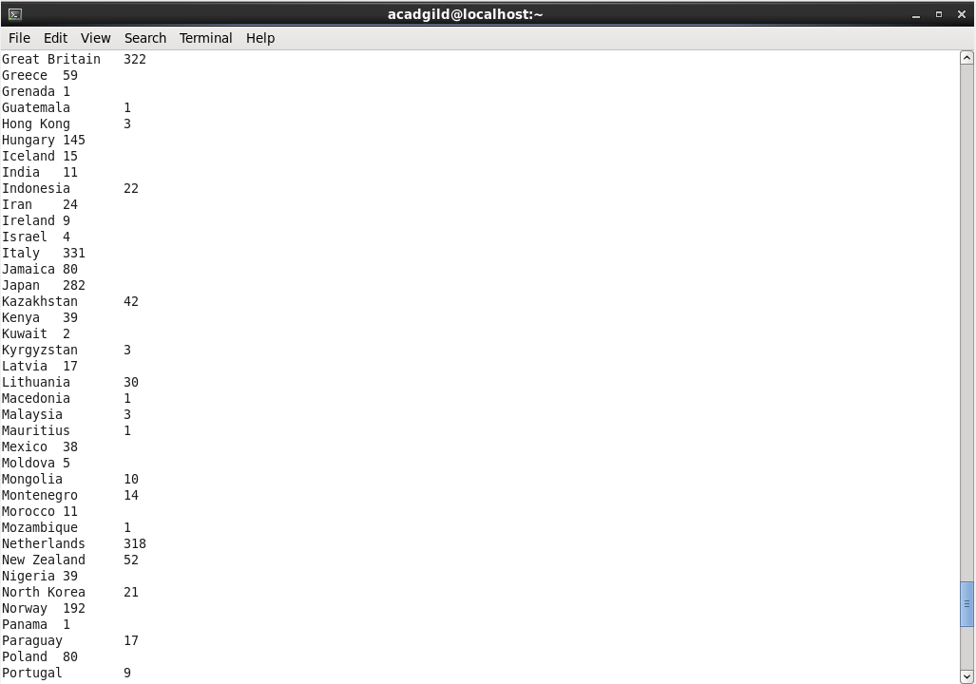

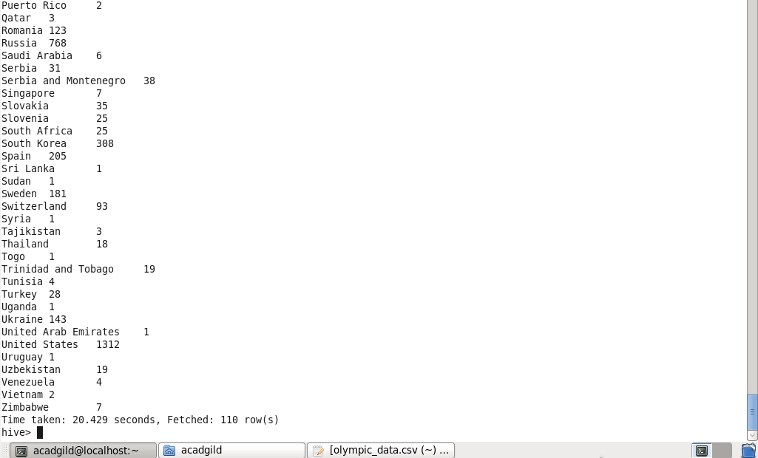

**Write a Hive program to find the number of gold medals each country won**

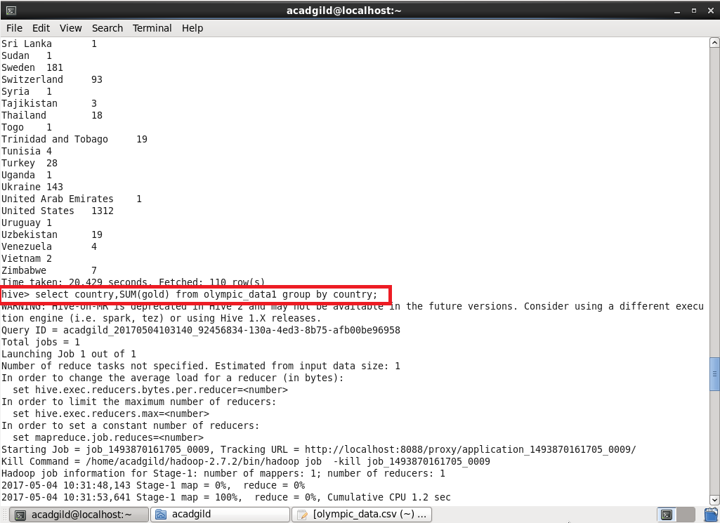

**Inorder to findout number of gold medals each country has won ,sum the gold medals and group it by country**

**OUTPUT:**

