**Write a hive query to find the top 20 destination people travel the most: Based on the given data**

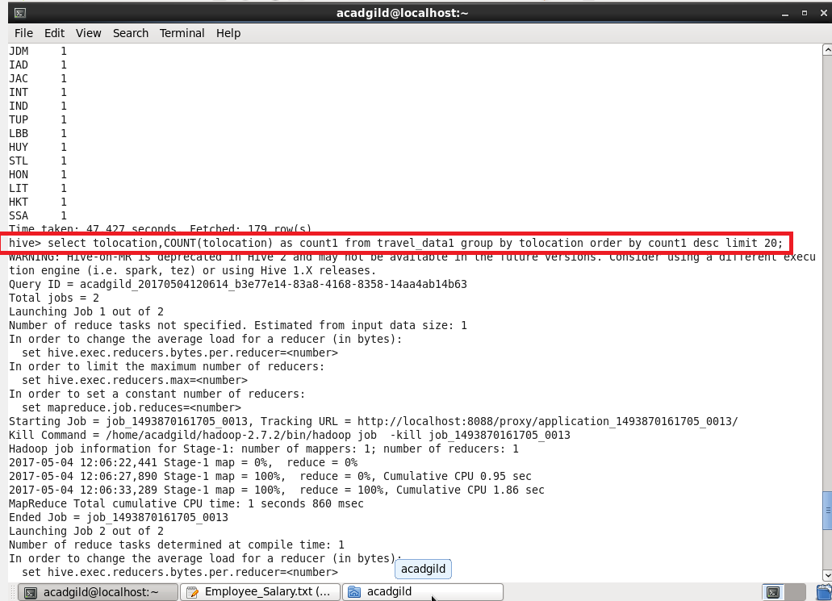

**Inorder to find top 20 destinations, count the frequency of the destinaions using count , group it by destination , order in descending order and limit 20 entries.**

**OUTPUT:**

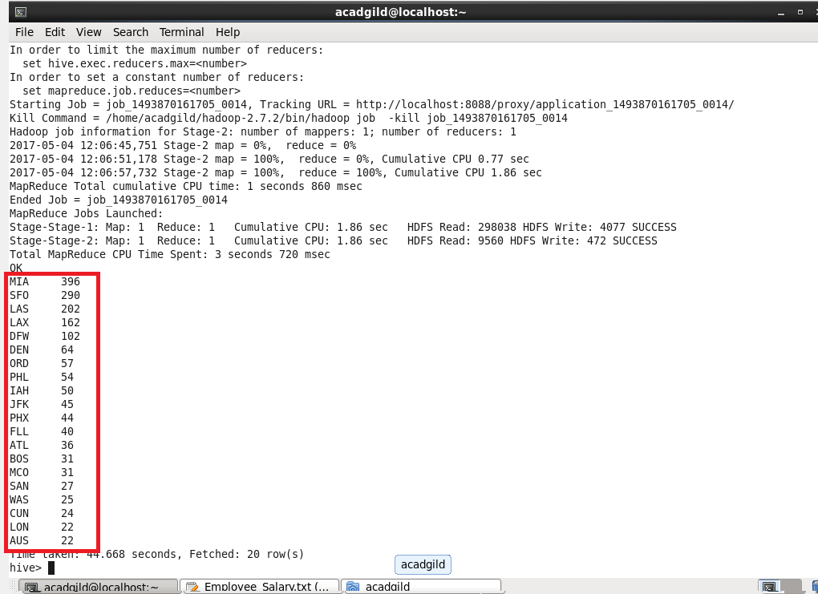

**Write a hive query to find the top 20 locations from where people travel the most**

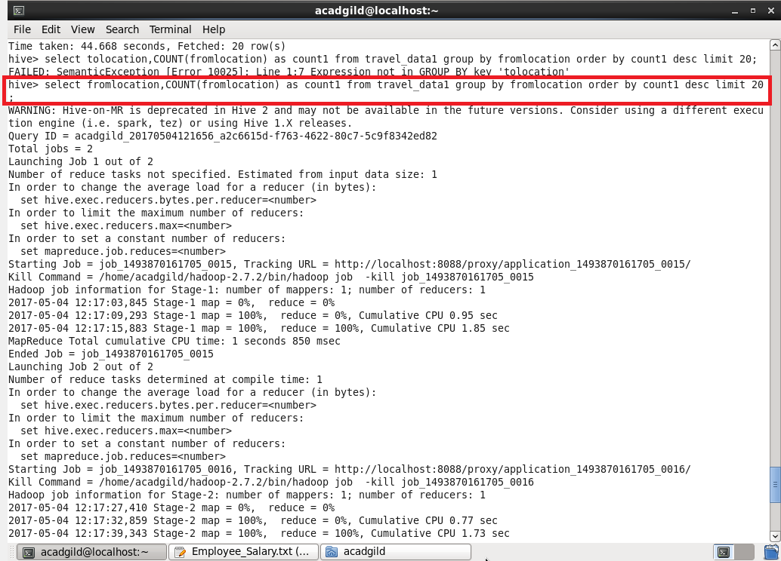

**Inorder to find top 20 fromlocations, count the frequency of the fromlocations using count , group it by fromlocation , order in descending order and limit 20 entries.**

**OUTPUT:**

