**ASSIGNMENT 25.5**

**Write a hive query to list top 5 residency details which lie in the budget of 60000-120000, an area more than 1450, sold after 17th may, min bedroom 3 and, min bathroom 2.**

**QUERY AND OUTPUT:**

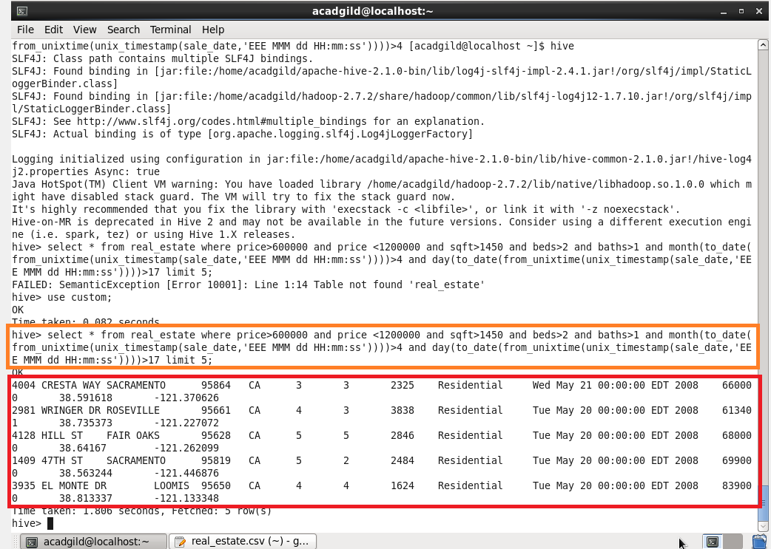

**Write a hive query to separate list of residential apartments with more than 2 beds. Also include columns in following order**

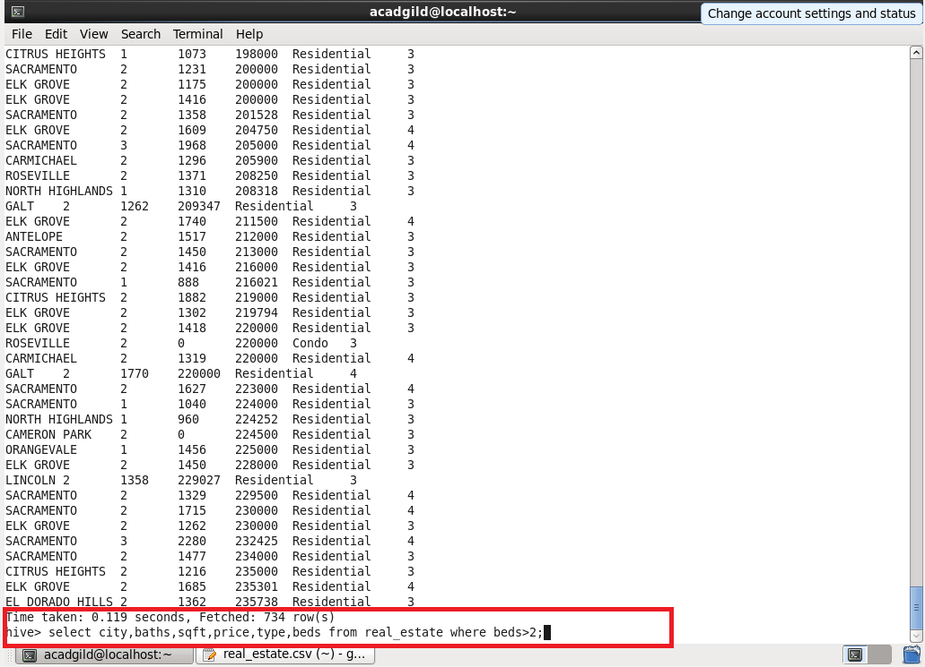**City,Baths,Sq_feet,Price,flat_type,Beds respectively.**

**Giving condition beds greater than 2 will display the city, baths, sqft, price, type and beds**

**OUTPUT:**

**Since I can’t include everything, I’ve attached random screen shots of the o/p.**



