**ASSIGNMENT 25.6**

**Write a hive query to find the city wise list all the Condos which is not less than ten thousand**

**QUERY:**

**Distinct city will eliminate duplicate entries.**

**Giving condition type=condo and price greater than 10000**

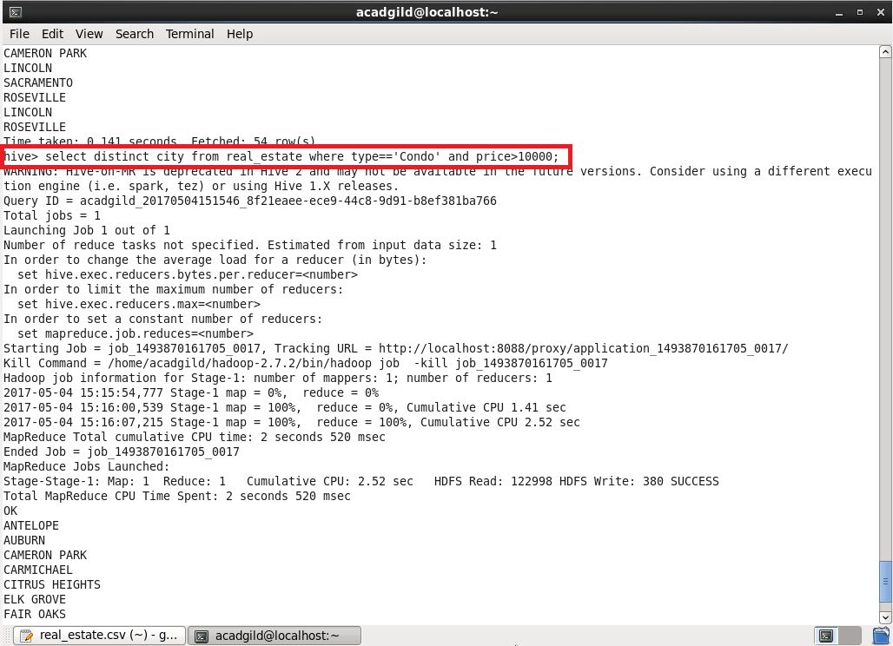

**OUTPUT:**

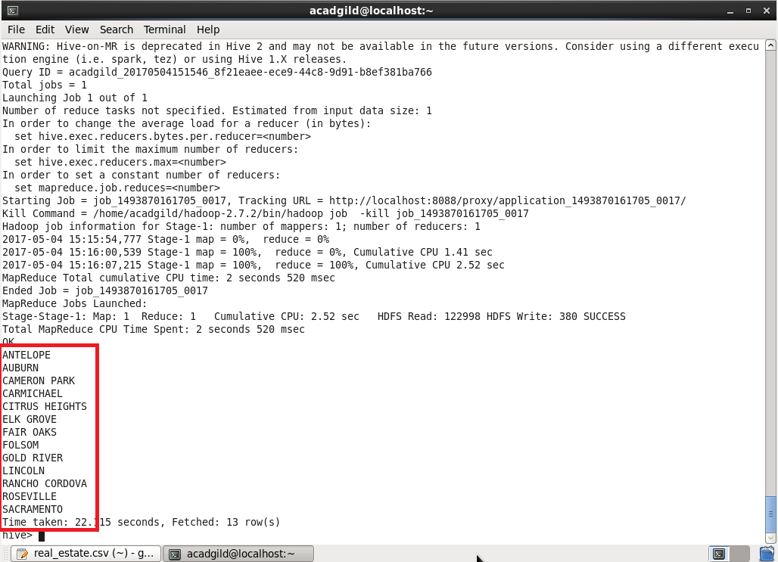

**Write a hive query to find which is the cheapest Condo in CA. name the city,street and price for the Condo.**

**LOGIC:**

**Giving condition state= CA and type = condo**

**Inorder to find cheapest condo order it by ascending order and limit 1**

**It will display the cheapest condo in CA**

**QUERY:**

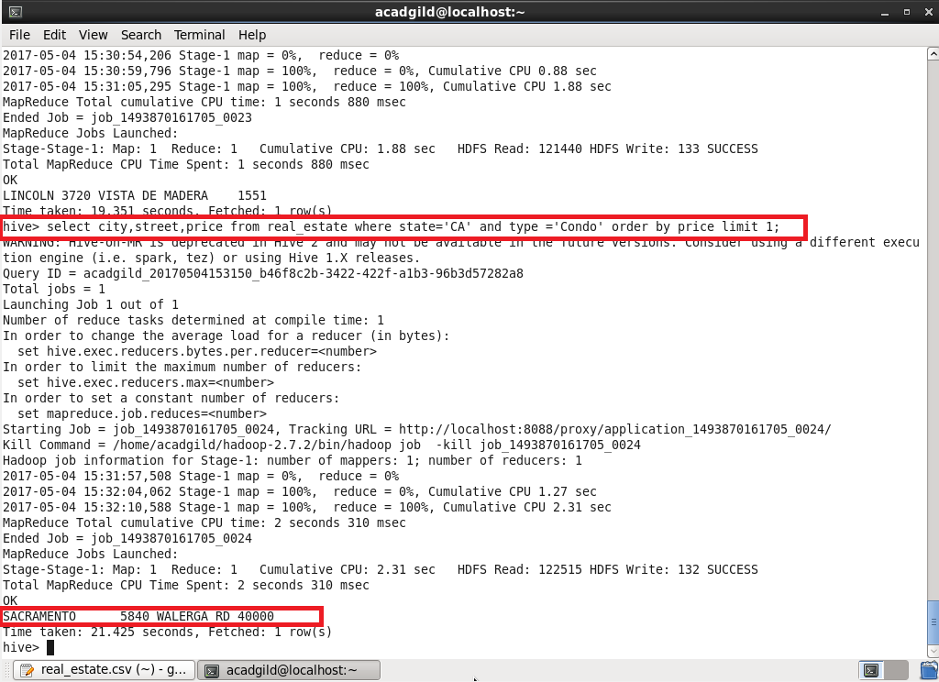

**Write a hive query to list top 5 residency details which lie in the budget of 60000-120000, an area more than 1450, sold after 17th may, min bedroom 3 and, min bathroom 2.**

**QUERY AND OUTPUT:**

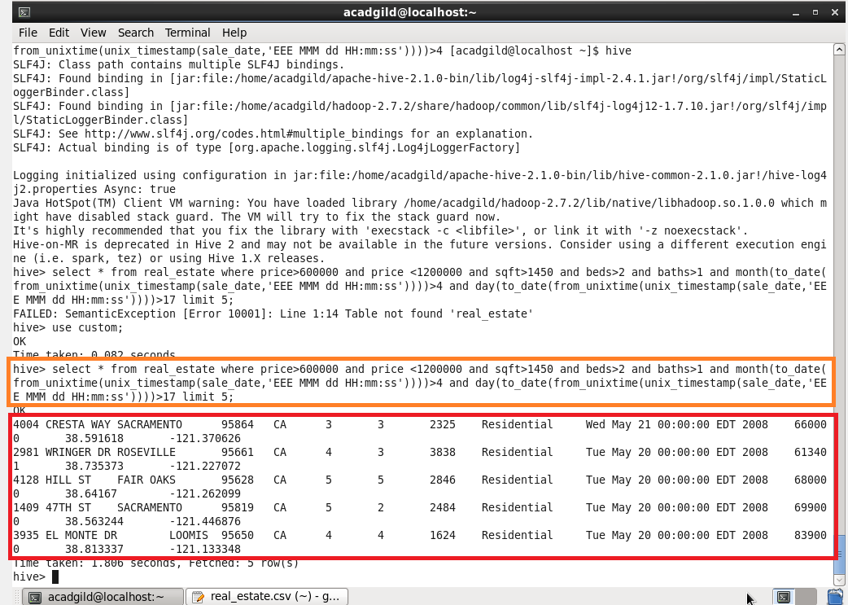

**Write a hive query to separate list of residential apartments with more than 2 beds. Also include columns in following order**

**City,Baths,Sq_feet,Price,flat_type,Beds respectively.**

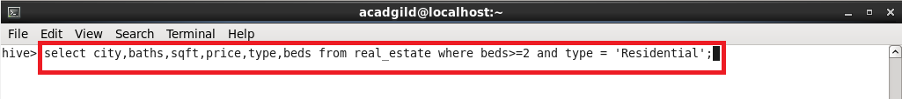

**Giving condition beds greater than 2 and type =Residential will display the city, baths, sqft, price, type and beds of residential apartments.**

**OUTPUT:**

**Since I can’t include everything, I’ve attached random screen shots of the o/p.**

