**ASSIGNMENT 26.3**

**Create table Real Estate in Hive database, with all the columns present in dataset.**

**● Load dataset into table real Estate.**

**● Using Dynamic partition get separate lists of residential apartments with more than 2 beds and include columns in following order City, Baths , Sq_feet ,Price, flat_type , Beds respectively.**

*Step 1 : creating a table real_estate1 and loading data into the table*

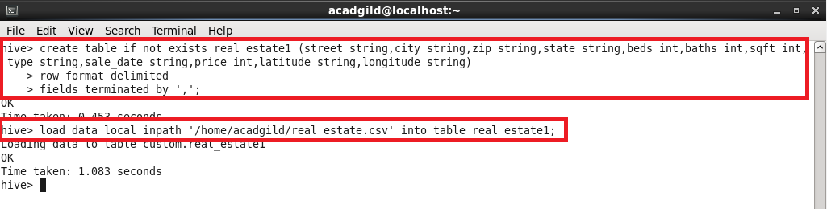

*Step 2: creating another table partitioned by beds.*

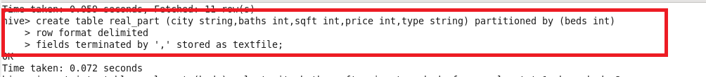

*Step 3: To use the dynamic partitioning in hive we need to set the below parameters in hive shell.*

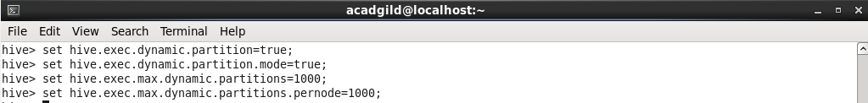

*Step 4: copying the data from normal table to the partitioned table*

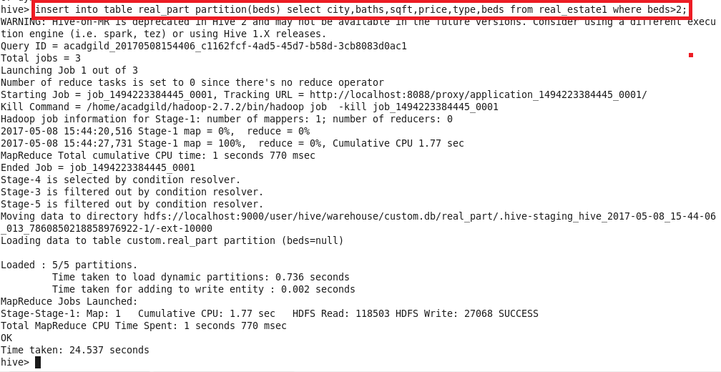

*Step 5:**checking the contents of the directory that got created*

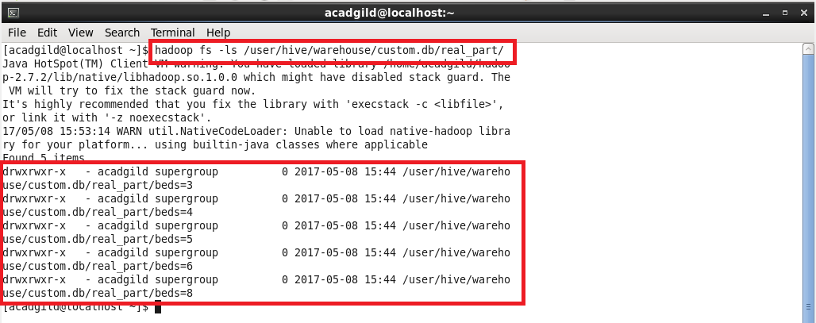

*Step 6:**Retrieving the data from the table by giving number of beds you want.*

*I’ve retrieved the list of apartments having 4 beds.*

