**ASSIGNMENT 27.4**

**Run parallel jobs in hive by following the steps in the below blog link.**

***Hive can converts a query into one or more stages and to save time executes multiple jobs parallely.***

**STEP 1: creating 4 tables for performing joins** 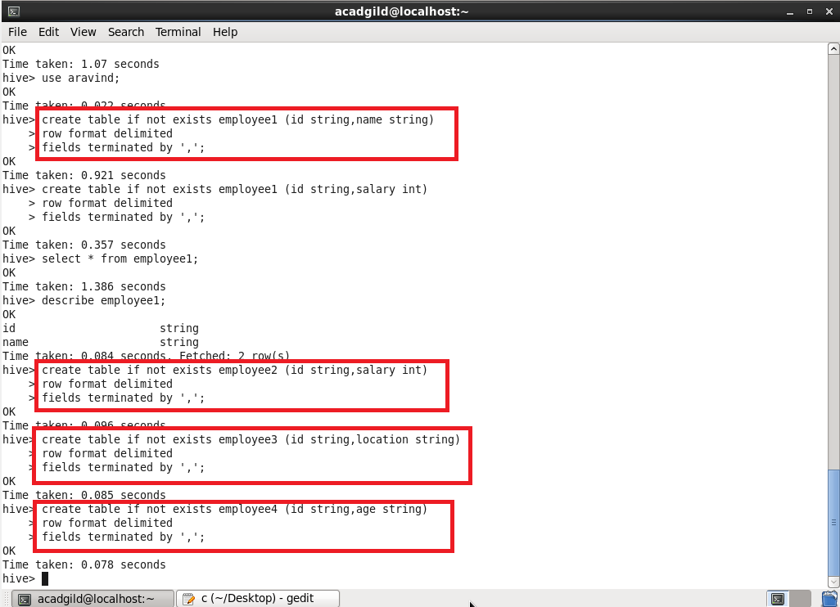

**Step 2: and loading data into the tables.**

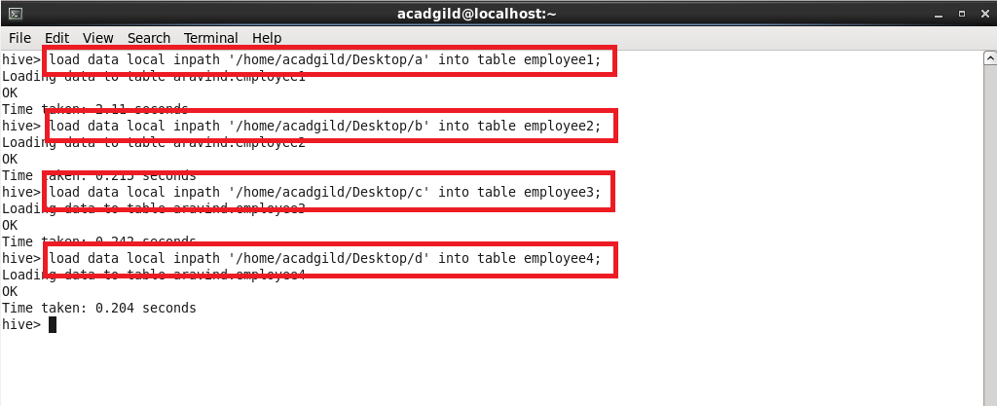

**Step 3: dumping all the contents of the tables that I’ve created**

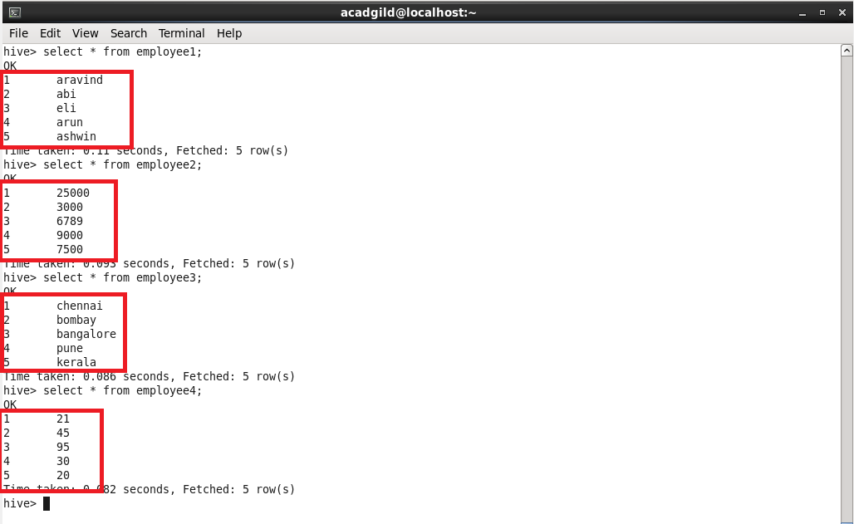

**Step 4: performing 4 joins at a time**

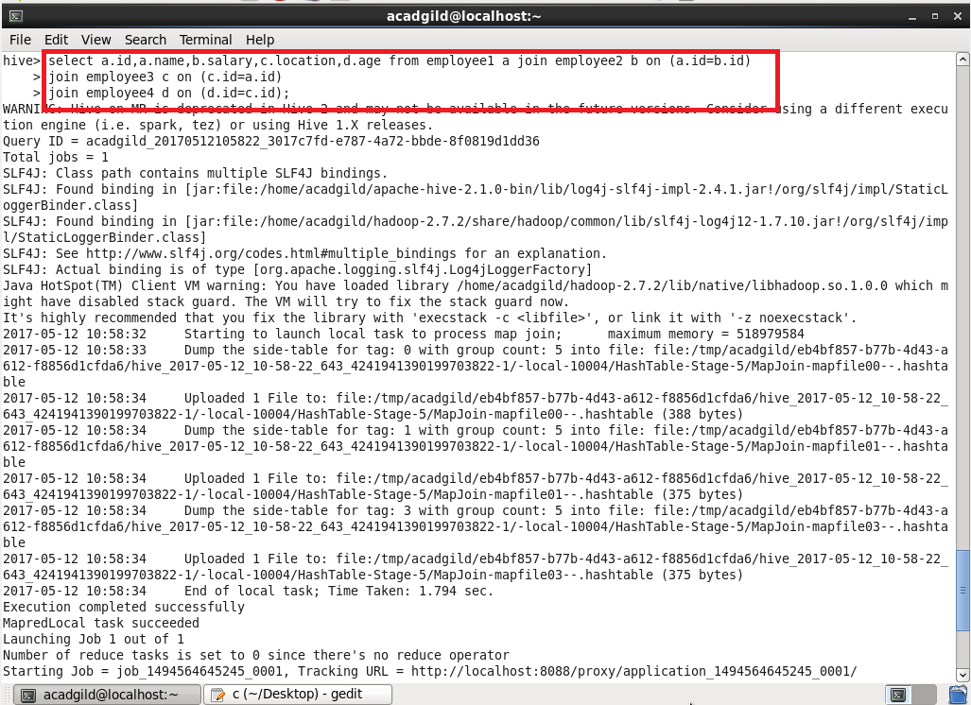

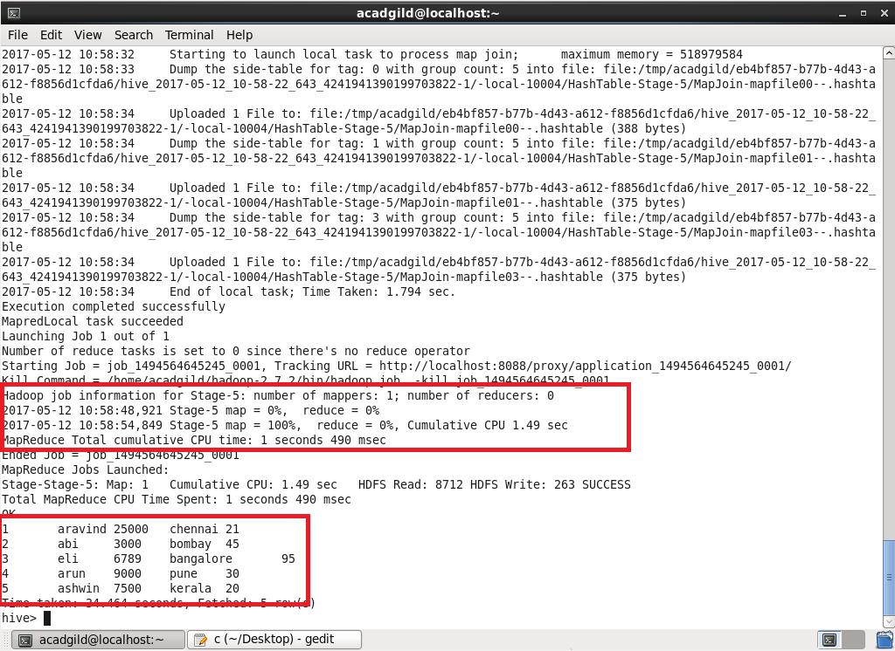

Thus all the 4 joins are made parallelly and it saved the time.