ASSIGNMENT 27.6

**Using the below given two datasets you need to give a demo on the below joins in hive.**

** Bucket Map join**

** Sort-Merge Bucket join**

** Sort-Merge Bucket Map join**

** Left semi join**

***BUCKET MAP JOIN:***

* ***Created 2 tables and loaded the data into the tables***

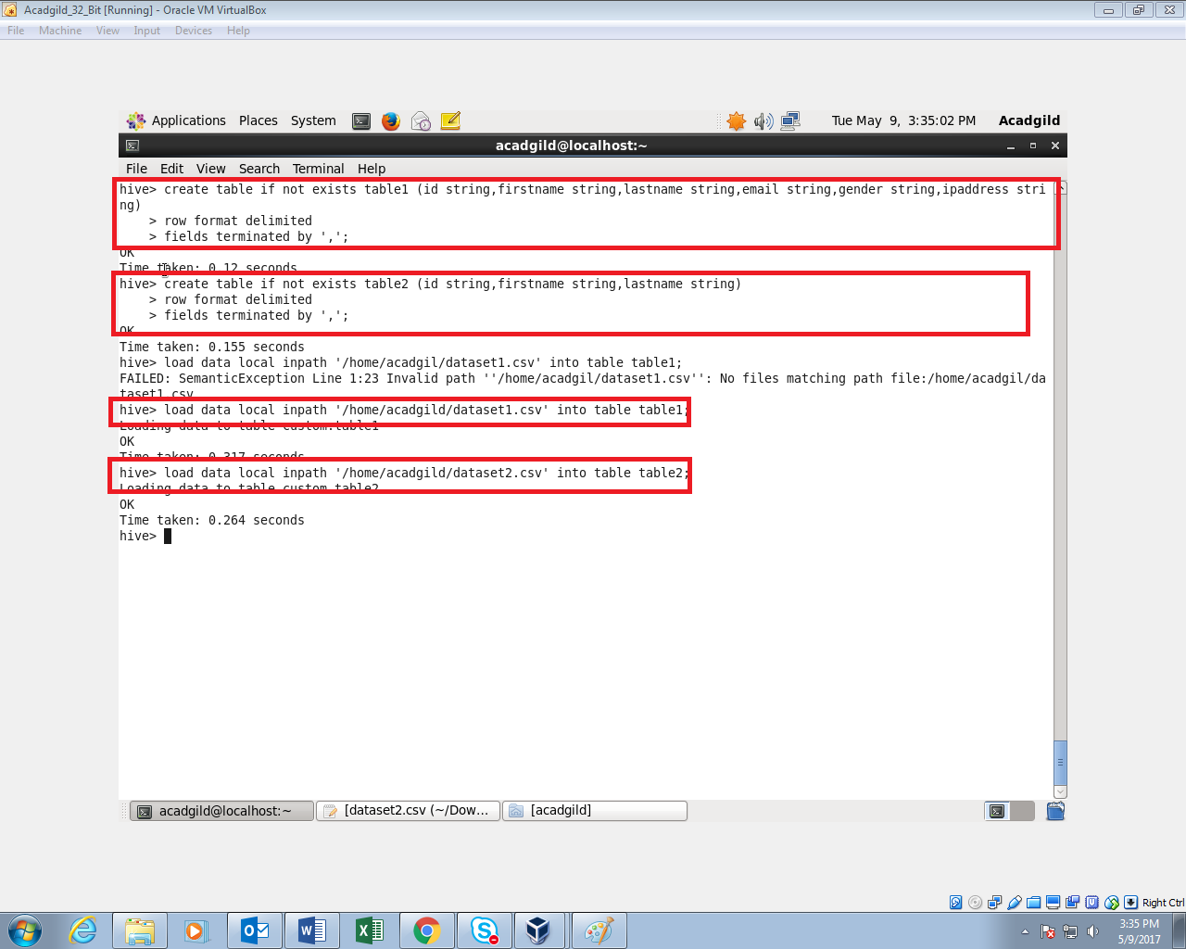***To perform bucketing, we need to have bucketed tables.so I’m creating 2 bucketed tables. One with 4 buckets and one with 8 buckets***

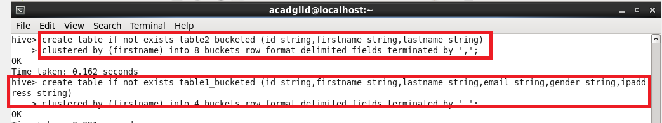

***Inserting the data in table1 into the bucketed table table1_bucketed***



***Inserting the data in table2 into the bucketed table table2_bucketed***

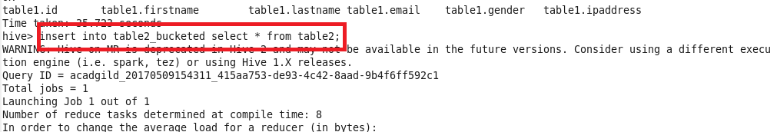

***For performing Bucket-Map join, we need to set this property in the Hive shell.***

***set hive.optimize.bucketmapjoin = true***

***and writing query for extracting data.***

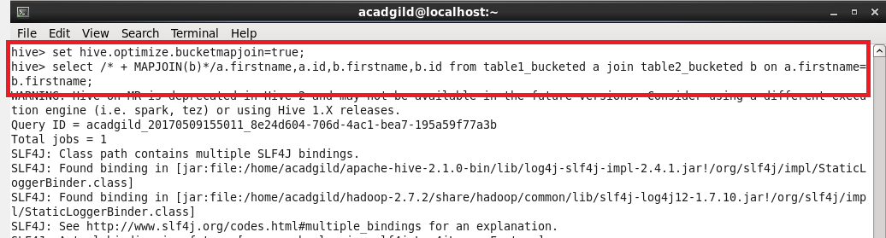

**OUTPUT:**

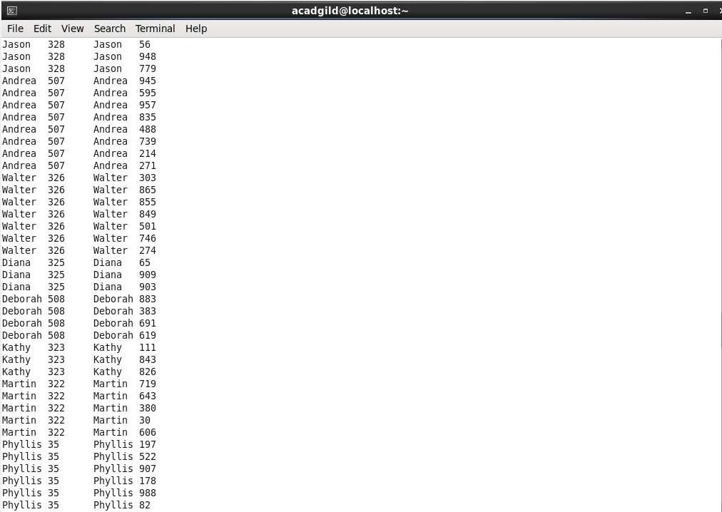

***SORT-MERGE BUCKET JOIN:***

***Sort-Merge bucket join is like reduce side join. Before joining we’ll have to sort the data and then only merge.***

***Moreover in this join we should set***

***set hive.auto.convert.join= false;***

***because we want reducer to run.***

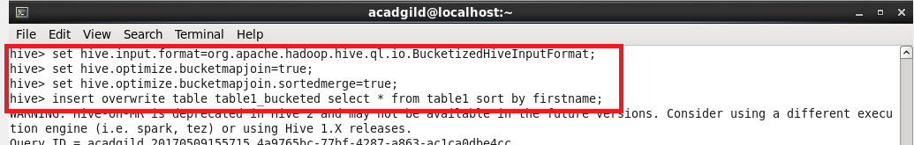

***Sorting the contents of bucketed table 2***



***Sorting the contents of bucketed table 1***



***Writing query for extracting data***

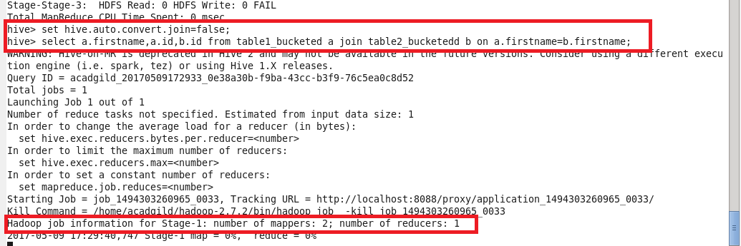

**OUTPUT:**

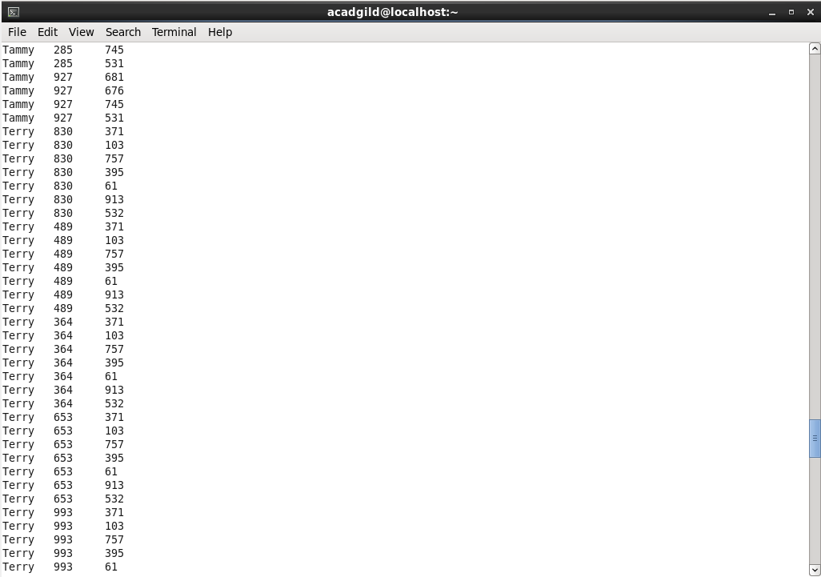

***SORT-MERGE BUCKET MAP JOIN:***

***since it is sort-merge bucket map join we need to set***

***set hive.auto.convert.join= true;***

***but without setting this also we can run a map only job by typing like this***

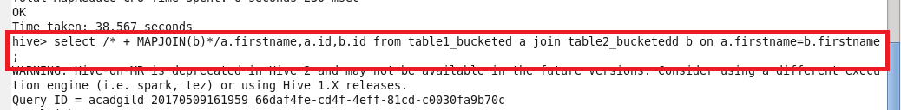

***This query runs a map only job. I’ve used the same bucketed tables that I’ve created previously for this join***

***The output will be like this,***

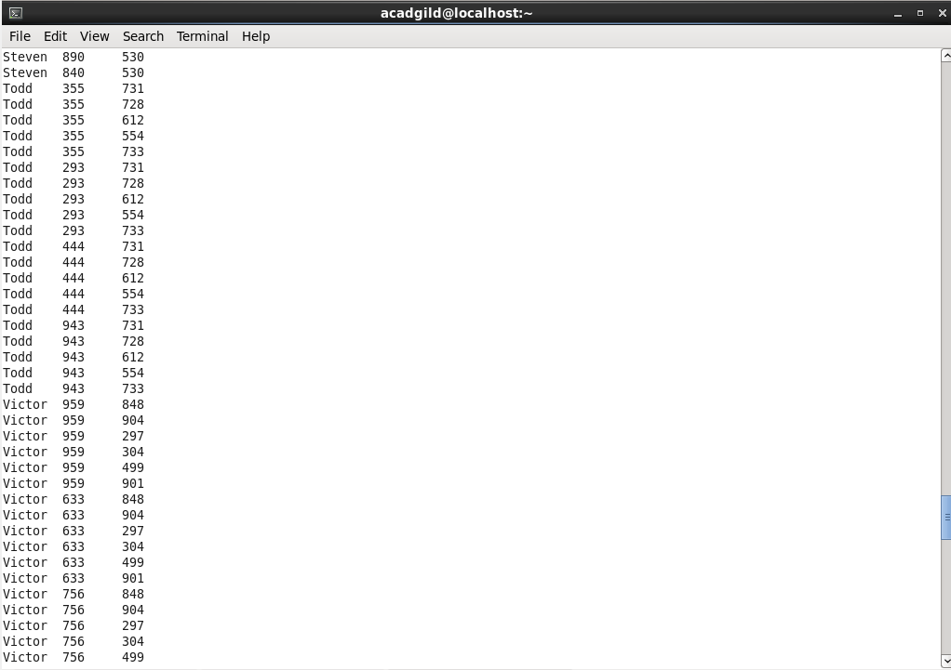

**LEFT SEMI JOIN:**

**Left semi join is more or less like sub query in sql.**

**The left semi join is used in place of the IN/EXISTS sub-query in Hive. In a traditional RDBMS, the IN and EXISTS clauses are widely used whereas in Hive, the left semi join is used as a replacement of the same.**

**Lef semi join eliminates the use of where and in keywords that we use in typical sub queries.**

**QUERY:**

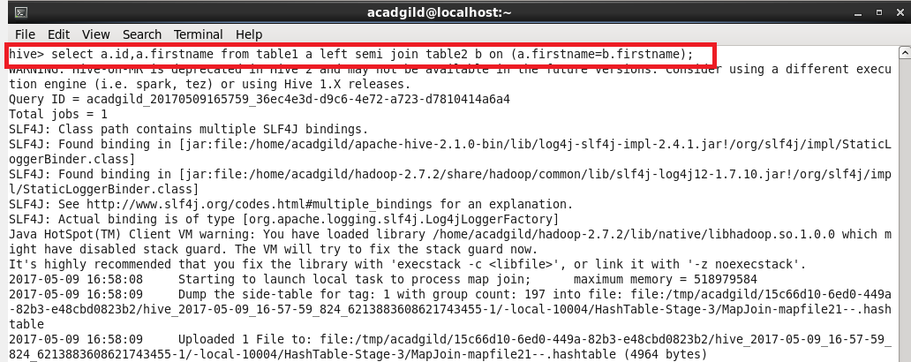

***OUTPUT:***

