**ASSIGNMENT 28.3**

**Get a list of employees who receive a salary less than 100, compared to their immediate employee with higher salary in the same unit.**

**QUERY:**

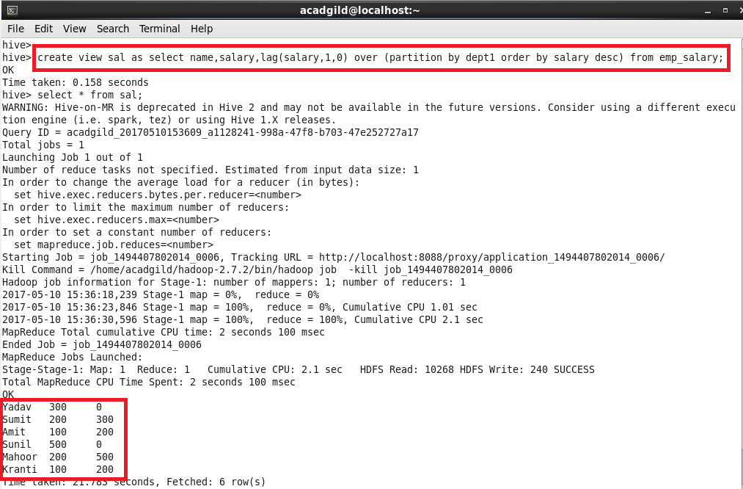

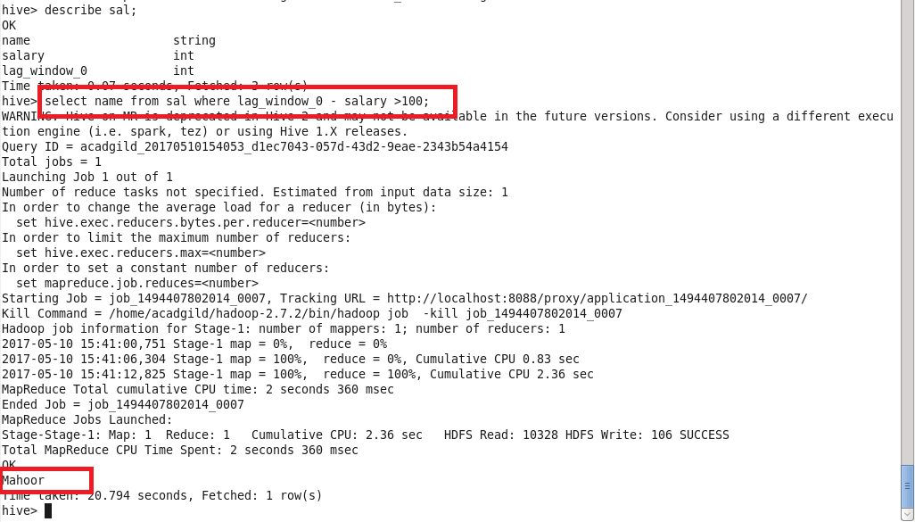

**List of all employees who draw higher salary than the average salary of that department.**

**Query:**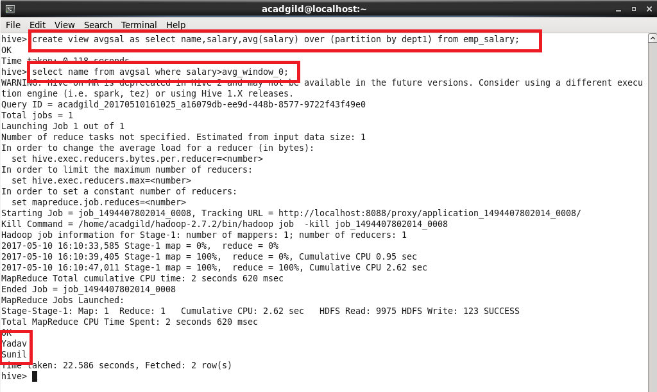

**Problem Statement: Link: olympic_data.csv Store the above dataset into the following file formats.**

**● SEQUECEFILE**

**● RCFILE**

**● ORC FILE**

**Share the commands used with their results.**

**SEQUENCE FILE FORMAT:**

**Creating table with sequence file as input.**

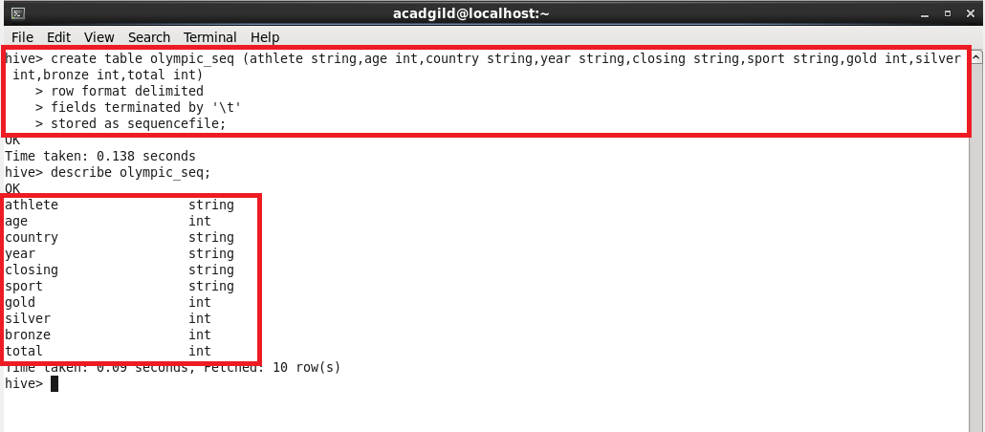

**Querying:**

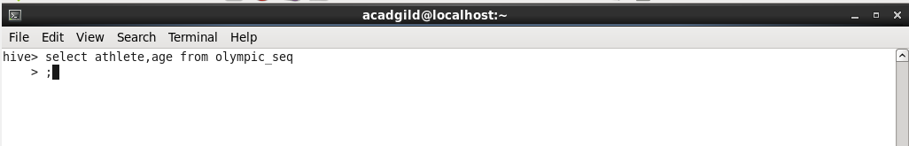

**Sample output:**

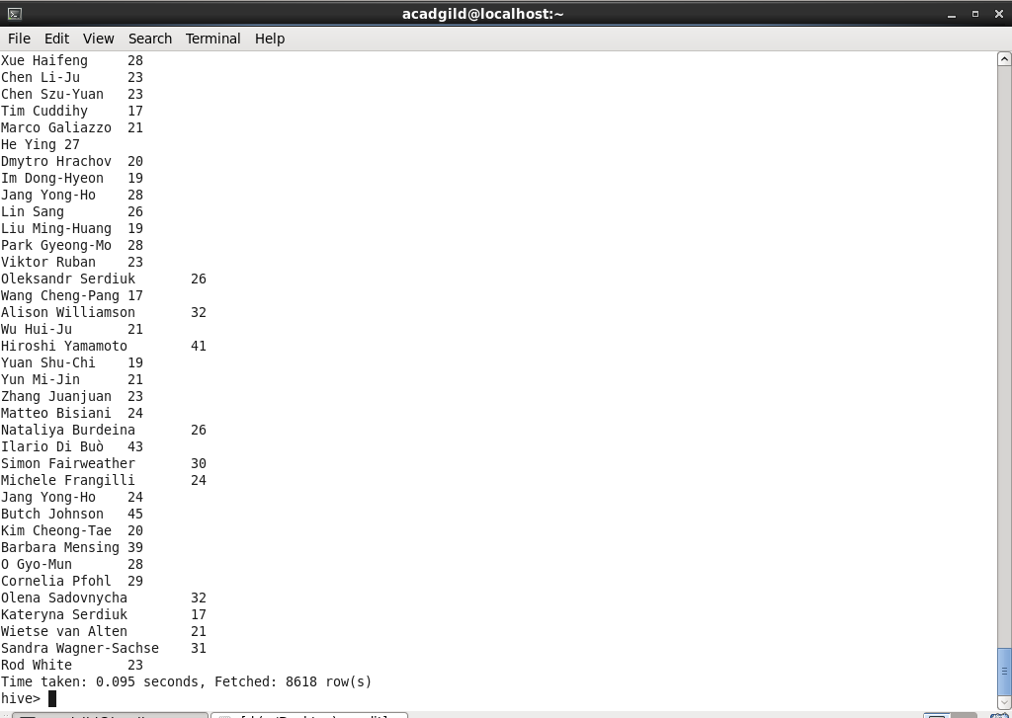

**RCFILE:**

**Creating a table and storing it as rc file**

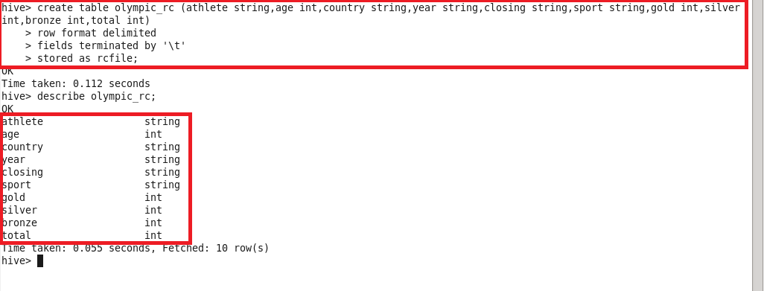

**Inserting into the table with insert command.**

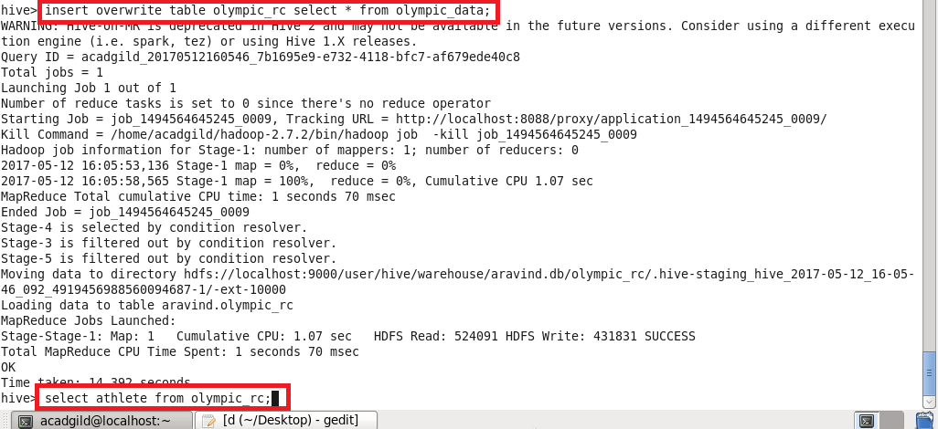

**Sample Output:**

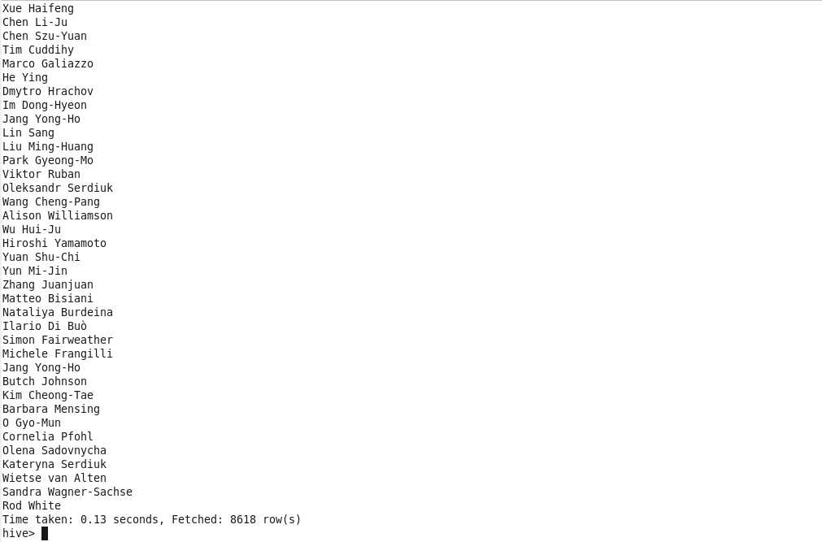

**ORC FILE:**

**Creating a table and storing it as orc file.**

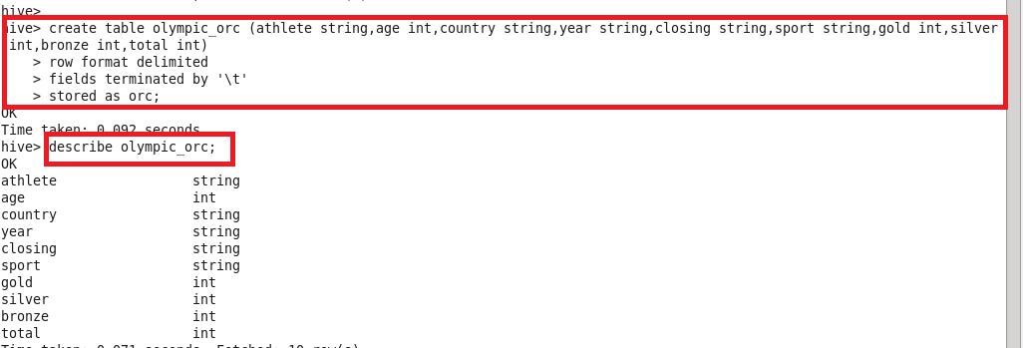

**Inserting into the table with insert command.**

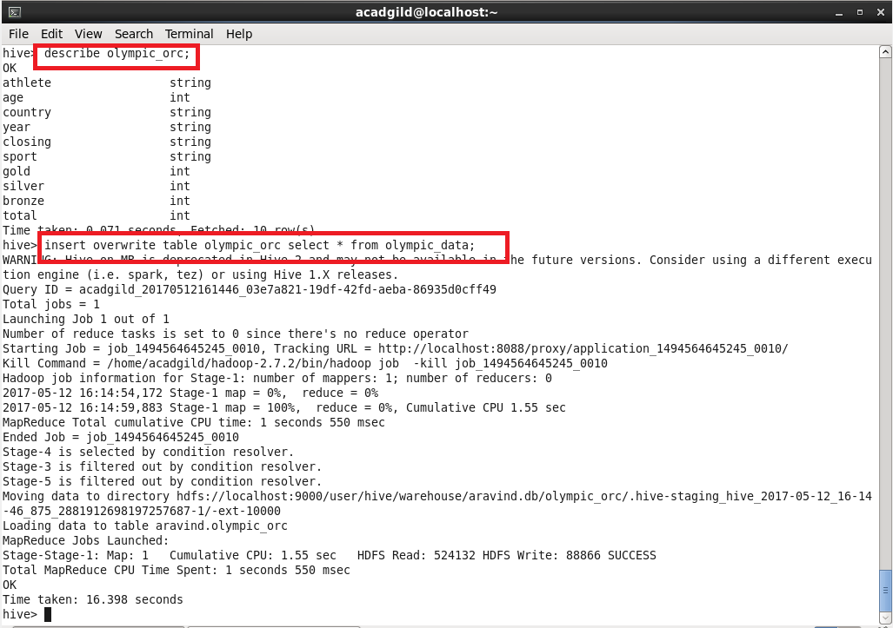

**Querying:**

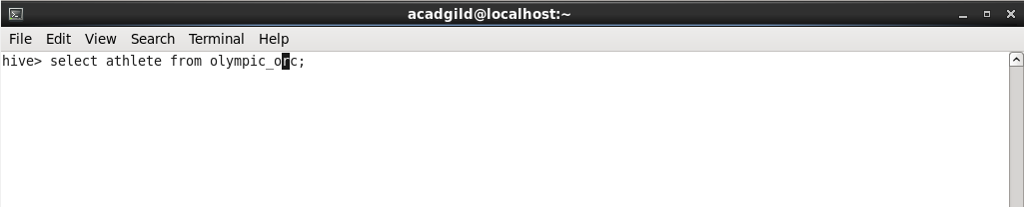

**Sample Output:**

