**ASSIGNMENT 29.1**

**Write a hive UDF that implements functionality of string concat_ws(string SEP, array). This UDF will accept two arguments, one string and one array of string. It will return a single string where all the elements of the array are separated by the SEP.**

**Step 1: java code to return all elements of the string separated by separator.**

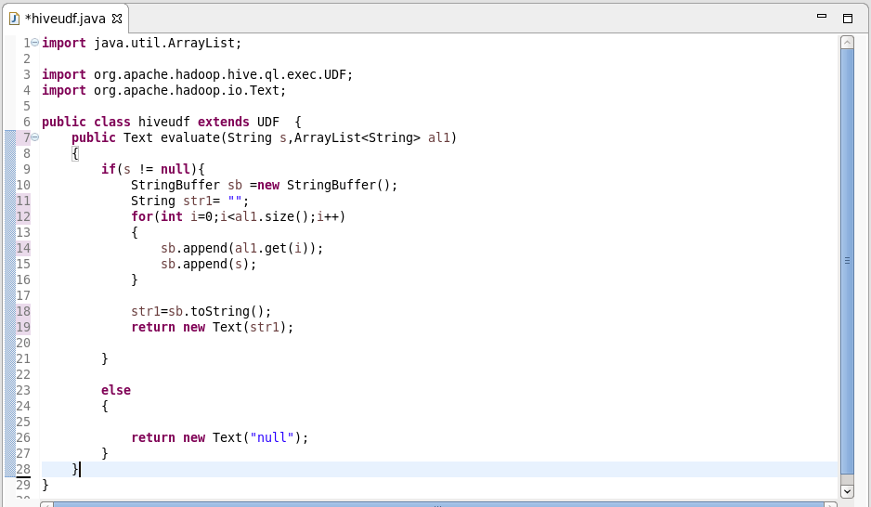

**Step 2: adding jar to the hive shell.**

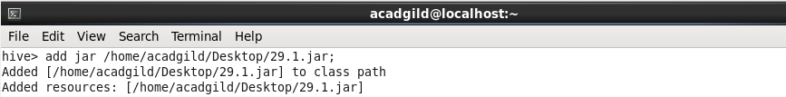

**Step 3: creating temporary function and a table with string and array as contents.**

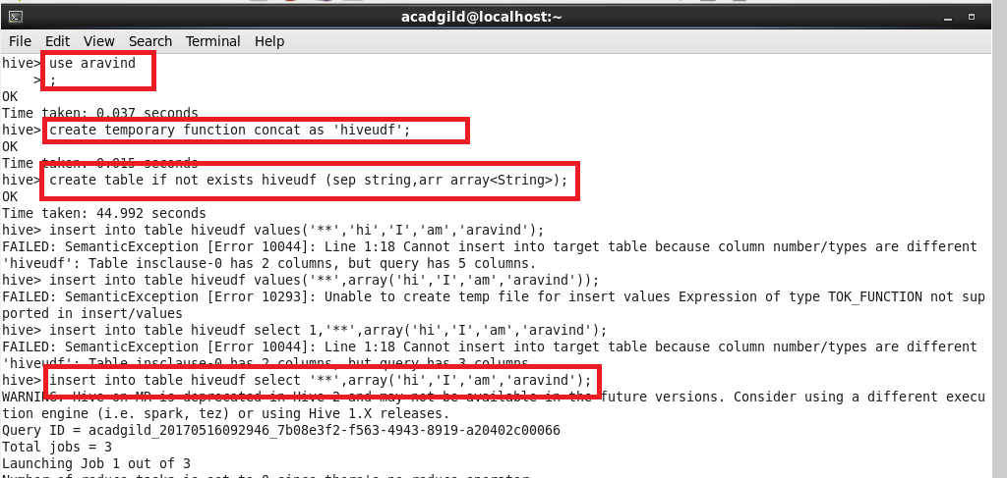

**Step 4: describing the table “hiveudf” :**

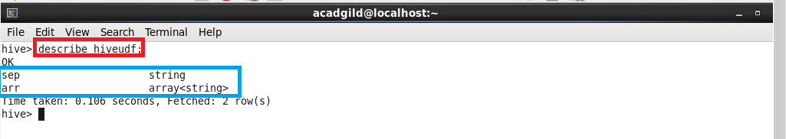

**Step 5: using the temporary function “concat” :**

