**ASSIGNMENT 30.2**

**WRITE A JAVA PROGRAM TO READ DATA FROM HIVE.**

**EDITING THE HIVE-SITE.XML FILE:**

Before doing all the steps, we should start the hiverserver2 by typing hiveserver2 start.

I have installed the mysql as the metastore for the hive and I have created a special user which has all the permissions.

For setting the mysql as the metastore we have to upload the above xml configurations in hive-site.xml.

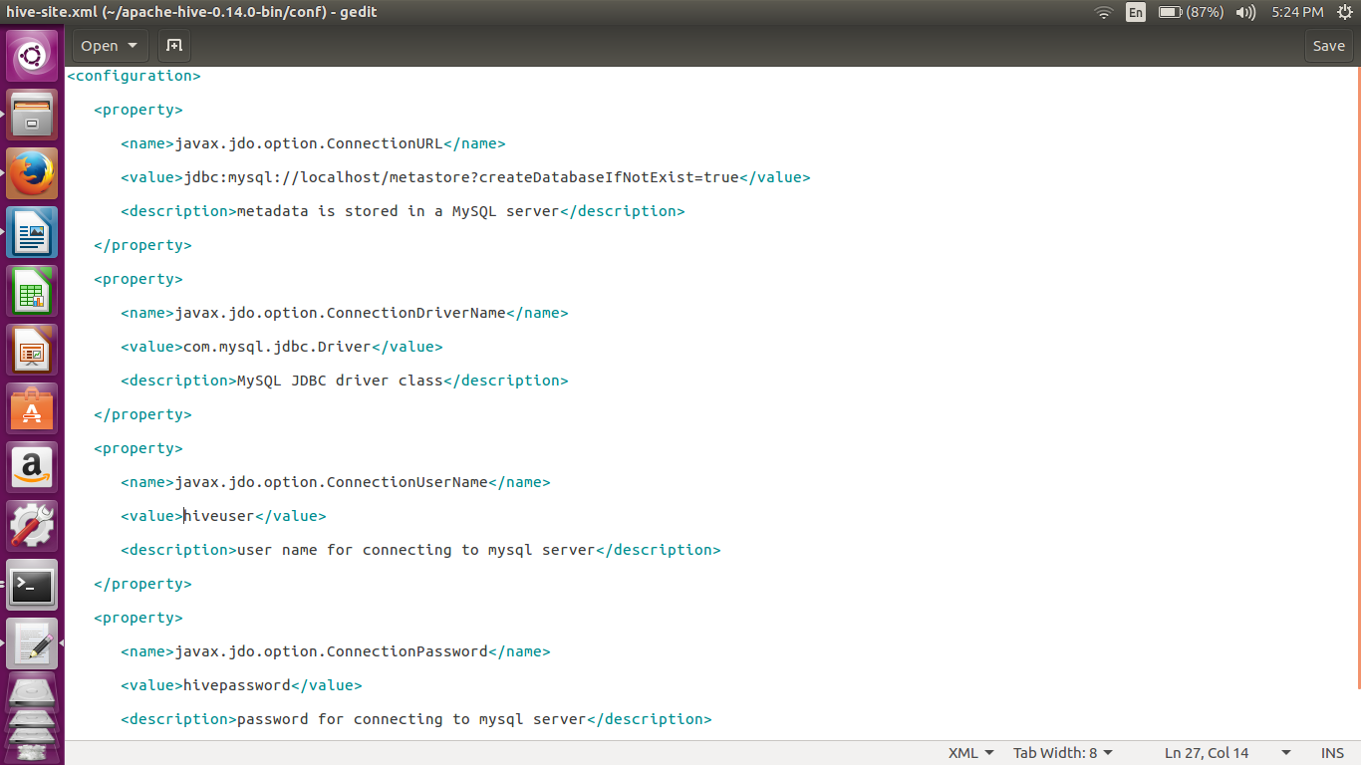

In the below code, connection has been made with the localhost port 10000

In the subsequent part we have listed all the tables.

For listing the tables, describing the tables and also displaying the contents in the table we are using the executequery in order to execute the query.

I have used the print statements for notifying the operation.

**JAVA CODE:**

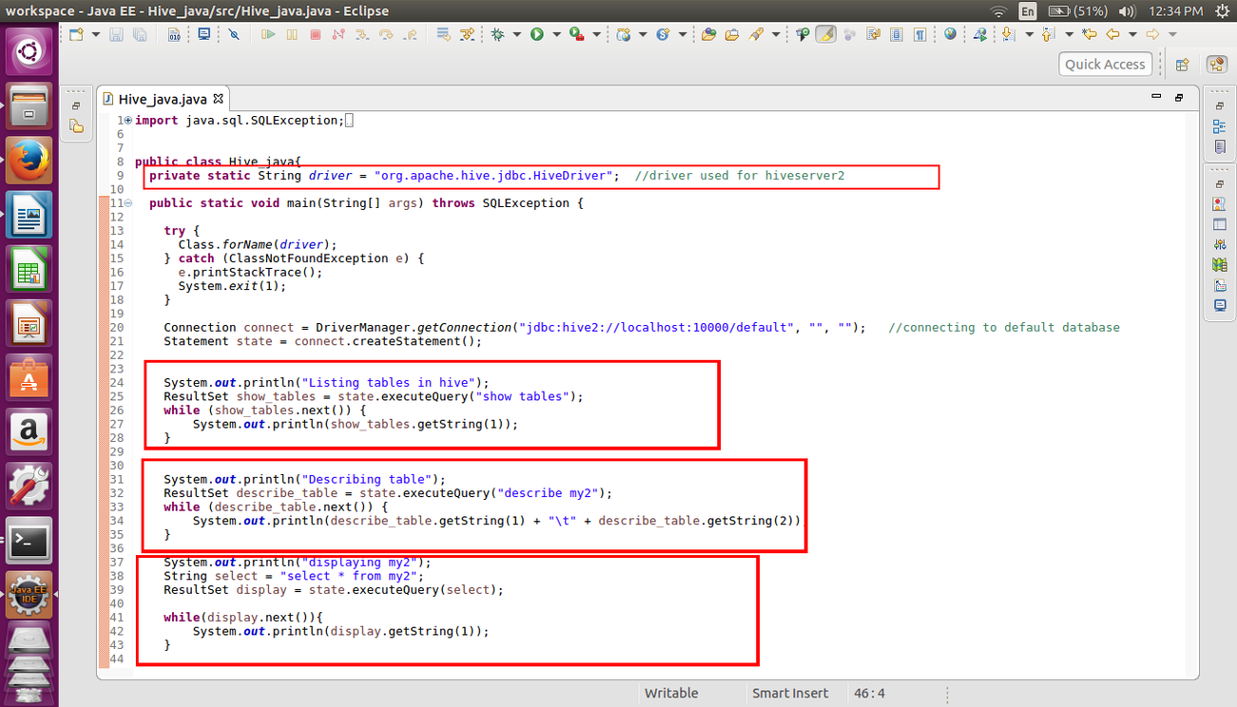

**OUTPUT:**

