**ASSIGNMENT 30.3**

**WRITE A JAVA PROGRAM TO WRITE DATA INTO AN HIVE TABLE.**

I have started the hiveserver 2. The configurations were done in the hive-site.xml file . Here we set the port number for the connection as 10000.

**HIVE-SITE.XML FILE:**

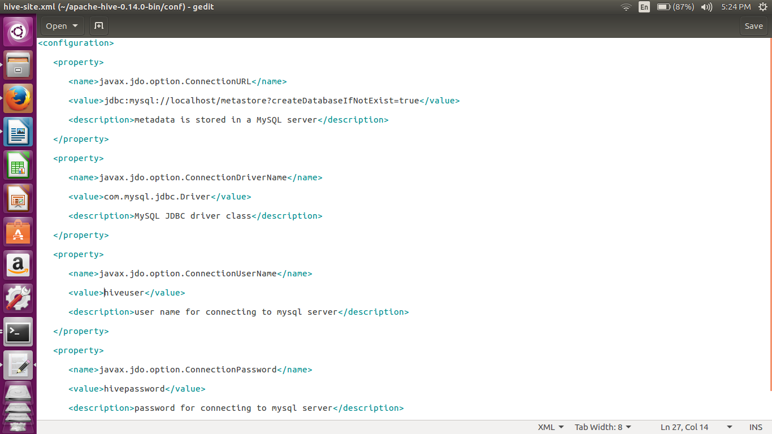

I have installed the mysql as the metastore for the hive. We have created a special user which has all the permissions.

For setting the mysql as the metastore we have to upload the above xml configurations in hive-site.xml

**JAVA CODE:**

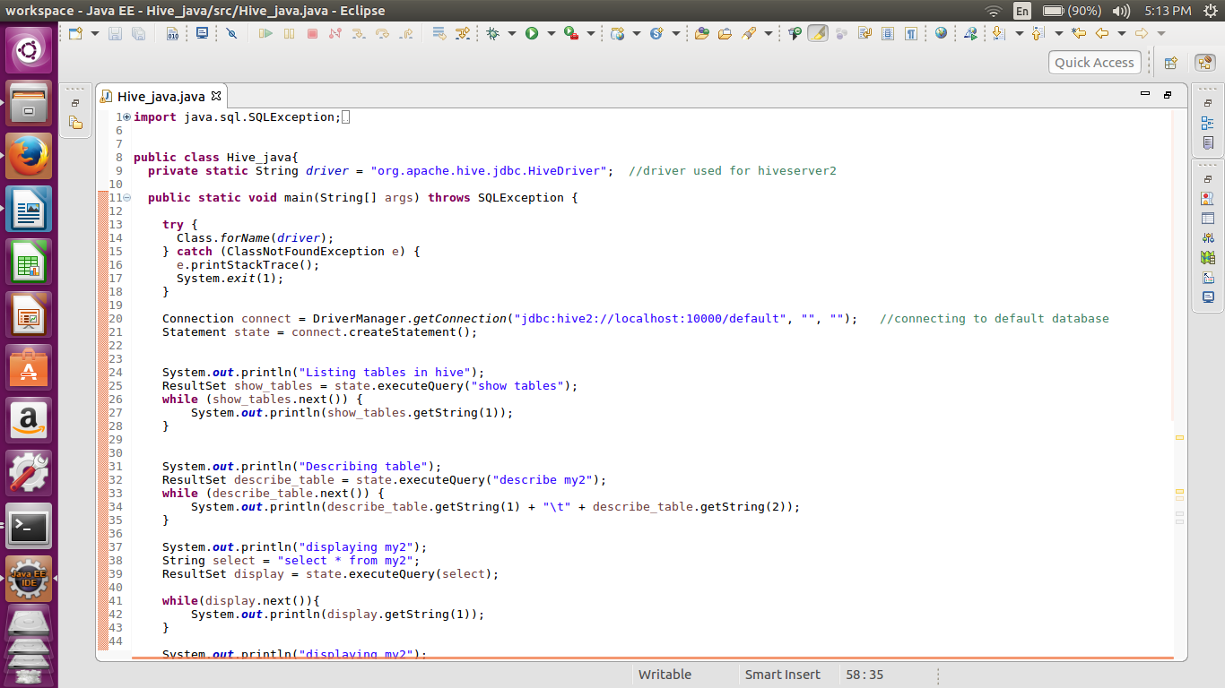

In this code we first displaying all the tables and then displaying the contents of the table my2.

After that we are inserting the value integer ‘10’ in the same table using the method of update query.

Again the displaying the same same table will give us the updated table having the value 10.

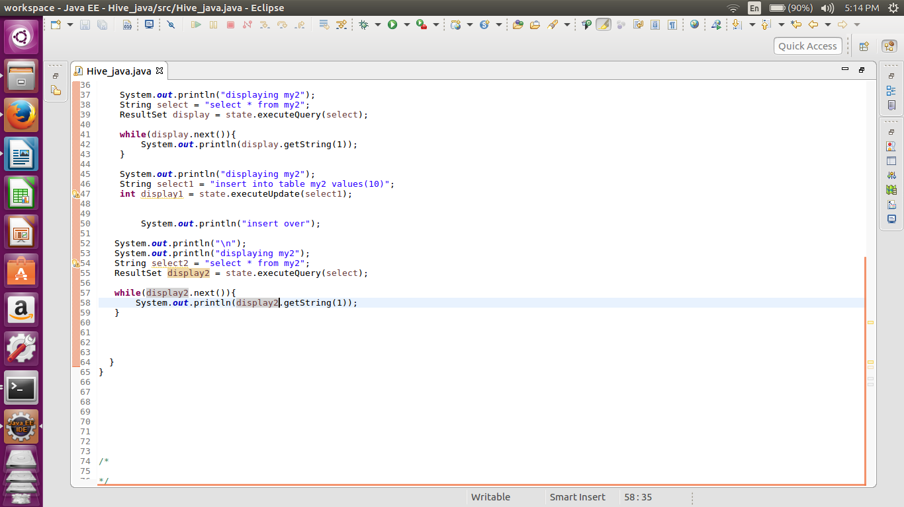

**OUTPUT:**

