|  |  |
| --- | --- |
| **HDFS** | **HBASE** |
| * HDFS is a Distributed file system abstracted on top of local file system by hadoop, suitable for storing huge files, it does not provide facility of tabular form of storage as such. * HDFS does not support fast individual record lookups * Large data files are stored in a distributed manner on cheap commodity hardware in a secure and cost-effective way. * The HDFS files are write once and read multiple times.HDFS does not support the option of random write or read. * In HDFS data is stored reliably. Files are broken into blocks and distributed across nodes in a cluster. After that each block are replicated, means copies of blocks are created on different machines. Hence if a machine goes down or get crashed, then also we can easily retrieve and access our data from different machines. By default 3 copies of a file are created on different machines. Hence it is highly fault tolerant. * HDFS provides faster file read and write mechanism, as data is stored in different nodes in a cluster. Hence user can easily access the data from any machine in a cluster. Hence HDFS is highly used as a platform for storing huge volume and different varieties of data worldwide. | * HBASE is a Column oriented distributed(on top of hadoop) data store which runs on top of hdfs for providing structural data models. stores data in table row column * It  provides faster data lookup in the tables * HBase is specifically designed for working with sparse data sets and provides low latency access to a single row of data among billions of data * Data is indexed by the row key and it has a very flexible data model and data is stored in a hashed table and access is available in a random manner * It adds transactional capability to hadoop, allowing users to update data records. Hadoop is designed for batch processing of large dataset, but with HBase on the top of Hadoop we can process real time dataset. * In HBase a master node manages the cluster and region servers store portions of the tables and perform the work on the data. An HBase system comprises a set of tables. Each table contains rows and columns, much like a traditional database. Each table must have an element defined as a Primary Key, and all access attempts to HBase tables must use this Primary Key. |

**ASSIGNMENT 31.1**

1. **Differences between HBASE and HDFS.**
2. **List and explain the main components of HBASE.**

HBase is composed of three types of servers in a master slave type of architecture.

• **Region servers** serve data for reads and writes.

• **HBase Master** process handles the Region assignment, DDL (create, delete tables) operations

• **Zookeeper** maintains a live cluster state.

**REGIONS:**

Regions are nothing but tables that are split up and spread across the region servers.

**REGION SERVER**:

The region servers have regions that -

* Communicate with the client and handle data-related operations.
* Handle read and write requests for all the regions under it.
* Decide the size of the region by following the region size thresholds.

The store contains memstore and HFiles. Memstore is just like a cache memory. Anything that is entered into the HBase is stored here initially. Later, the data is transferred and saved in Hfiles as blocks and the memory store is flushed.

**MASTER SERVER:**

The master server

* Assigns regions to the region servers and takes the help of Apache Zoo Keeper for this task.
* Handles load balancing of the regions across region servers. It unloads the busy servers and shifts the regions to less occupied servers.
* Maintains the state of the cluster by negotiating the load balancing.
* Is responsible for schema changes and other metadata operations such as creation of tables and column families.

## ZOOKEEPER:

* Zookeeper is an open-source project that provides services like maintaining configuration information, naming, providing distributed synchronization, etc.
* Zookeeper has ephemeral nodes representing different region servers. Master servers use these nodes to discover available servers.
* In addition to availability, the nodes are also used to track server failures or network partitions.
* Clients communicate with region servers via zookeeper.
* In pseudo and standalone modes, HBase itself will take care of zookeeper.
* HBase uses Zoo Keeper as a distributed coordination service to maintain server state in the cluster.
* Zookeeper maintains which servers are alive and available, and provides server failure notification.
* Zookeeper uses consensus to guarantee common shared state. Note that there should be three or five machines for consensus.

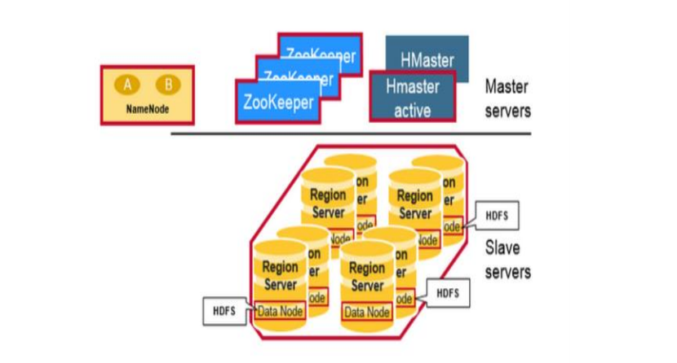

**HBASE ARCHITECTURE DIAGRAM**

1. **Does Hbase support sql?**

HBase non-relational (NoSQL) database that runs on top of HDFS

It is an open source NoSQL database that provides real-time read/write access to those large datasets. Native Hbase does not support Sql like advance queries, to have Sql like queries you need phoenix on top of hbase.