**Assignment 32.2**

● **Use Hbase shell for performing the following operations**

**● Create the table customer with two column families**

**● Personal details and order details as column families.**

**Create a unique number as row key (ssn/Aadhar no.,etc) Insert at least 10 records to each column Insert following values for personal details column family Name, age, city, state**

**● Insert following values for order details column family**

**● Order no., order quantity, and order amount**

**● Use put command to insert the values for each record. Use get command, to retrieve all the records of single customer.**

**STEP 1: CREATING TABLE “CUSTOMER” WITH TWO COLUMN FAMILIES**

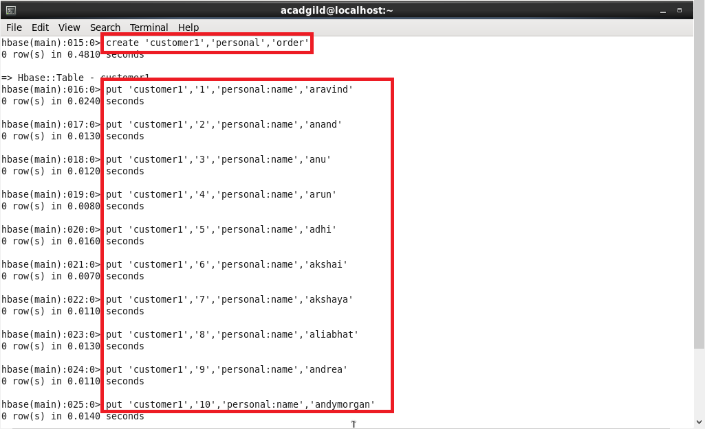

**STEP 2: INSERTING VALUES INSIDE THE COLUMN FAMILIES USING PUT COMMAND BY SPECIFYING THE COLUMN NAME AFTER THE COLUMN FAMILY.**

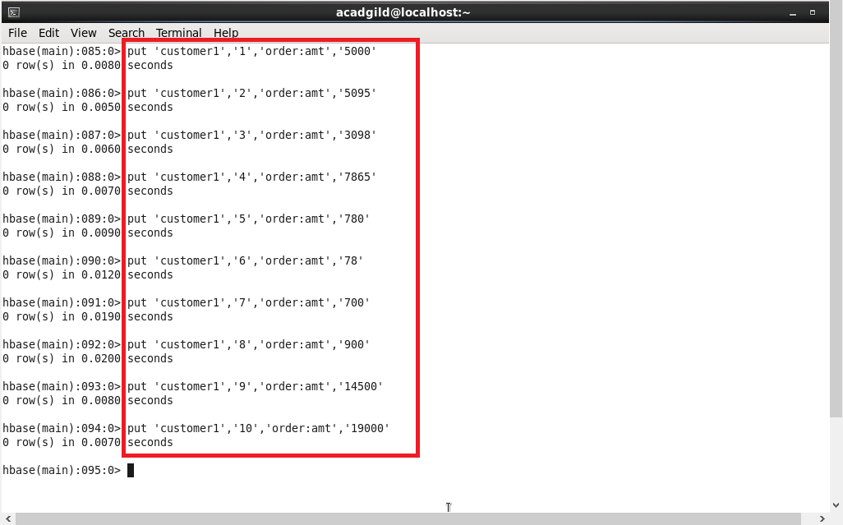

**STEP 3: FOR EXTRACTING DETAILS OF CUSTOMERS, TYPE THE TABLE NAME AND ROW KEY NUMBER**

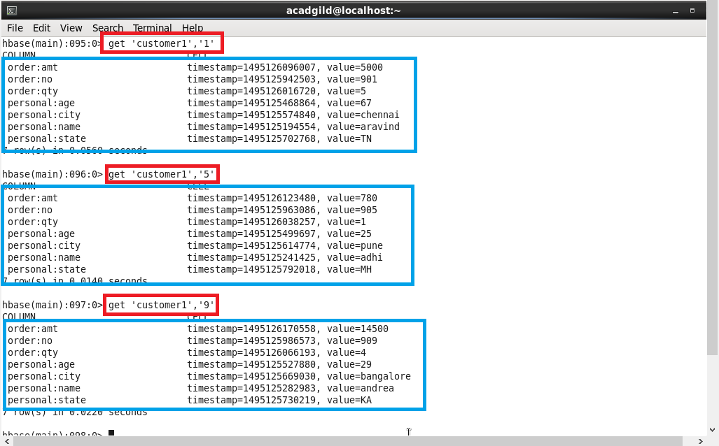

**STEP 4: TO GET FULL DETAILS ABOUT THE TABLE, USE SCAN COMMAND**

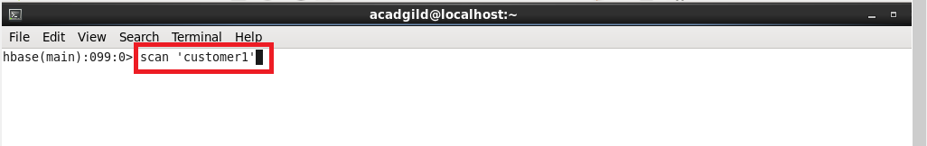

**STEP 5: FULL DETAILS ABOUT THE TABLE USING SCAN COMMAND**

