**ASSIGNMENT 32.3**

**Write a Java client API to perform following operations:**

**● Use HBaseAdmin class and create the table named company with one column family name details.**

**● Create the method name insert and use put class to insert records to company table.**

**STEP 1: WRITING JAVA CODE TO CREATE A TABLE IN HBASE**

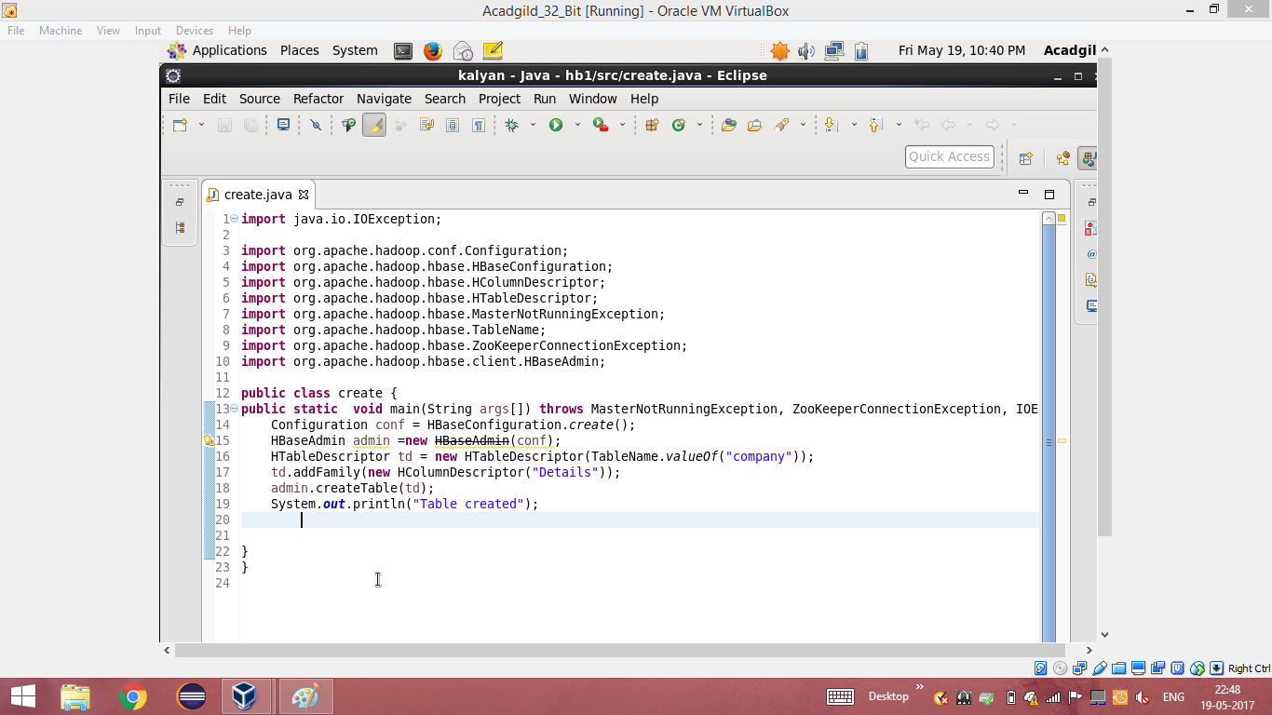

**STEP 2: TABLE CREATED IN HBASE BY RUNNING THE JAVA CODE (RUN AS APPLICATION) IN ECLIPSE**

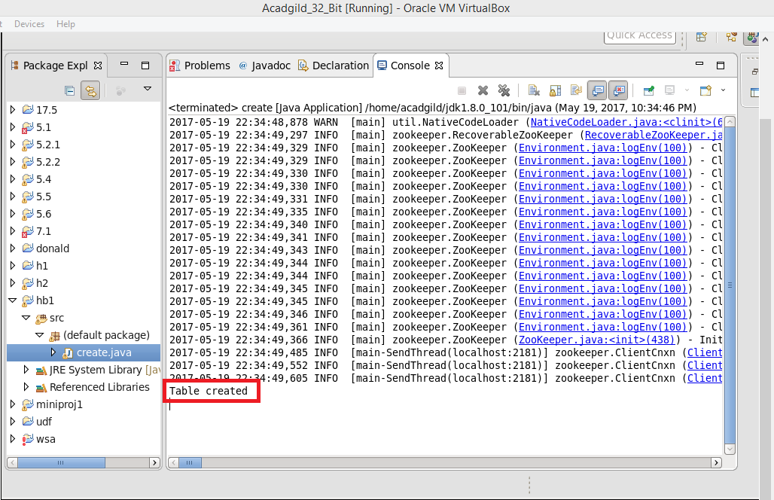

**STEP 3: USING ‘LIST’ COMMAND , SHOWING THE TABLES IN HBASE**

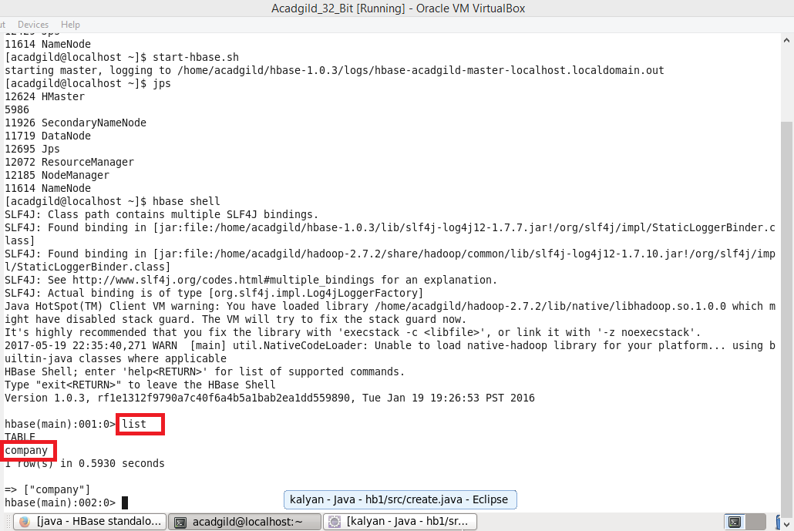

**STEP 4: WRITING JAVA CODE TO INSERT DATA INTO THE TABLE “COMPANY” THAT WAS CREATED**

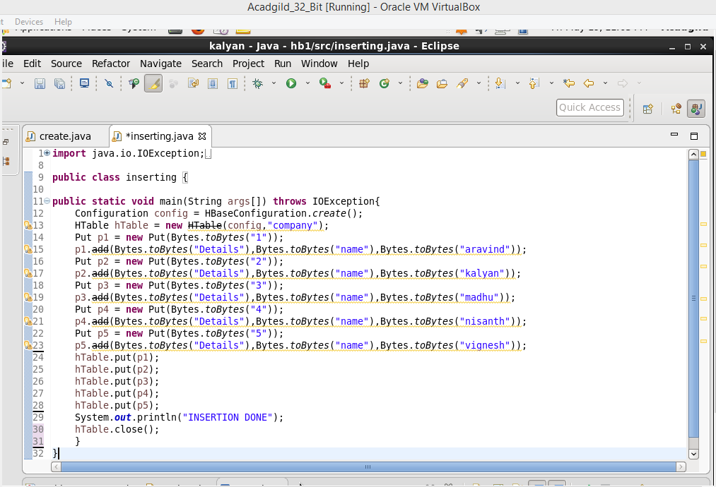

**STEP 5: RUNNING THE JAVA CODE IN ECLIPSE (RUN AS APPLICATION)**

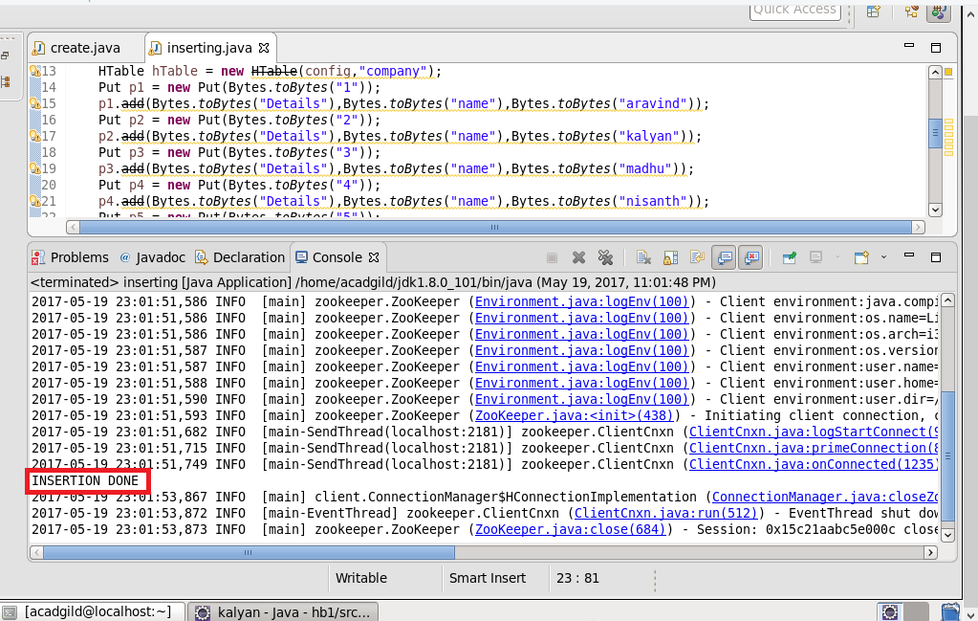

**STEP 6: INSERTION WAS SUCCESSFUL AND TO CHECK IT, SCAN COMMAND IS USED.**

