**ASSIGNMENT 33.3**

**● Integrate Hbase with Pig**

**● Load Data (Bulk Load) from HDFS to Hbase Table using Pig.**

**● Explain the procedures and code implemented with screenshots.**

**● Note: Candidates should Load their own data into Hbase table**.

**STEP 1: LOADING DATA INTO THE PIG USING LOAD COMMAND AND DUMPING USING DUMP COMMAND**

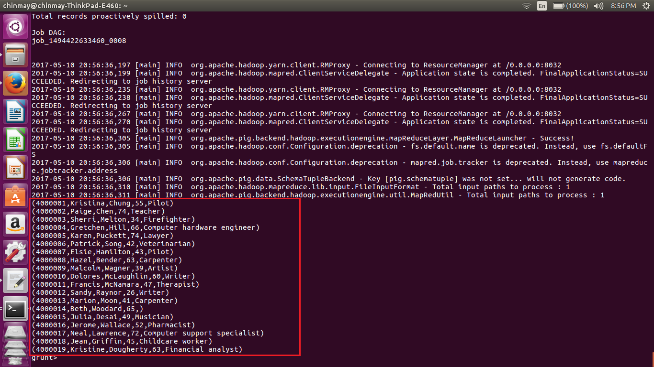

**STEP 2: STORING THE LOADED DATA INTO THE HBASE USING STORE COMMAND IN PIG**

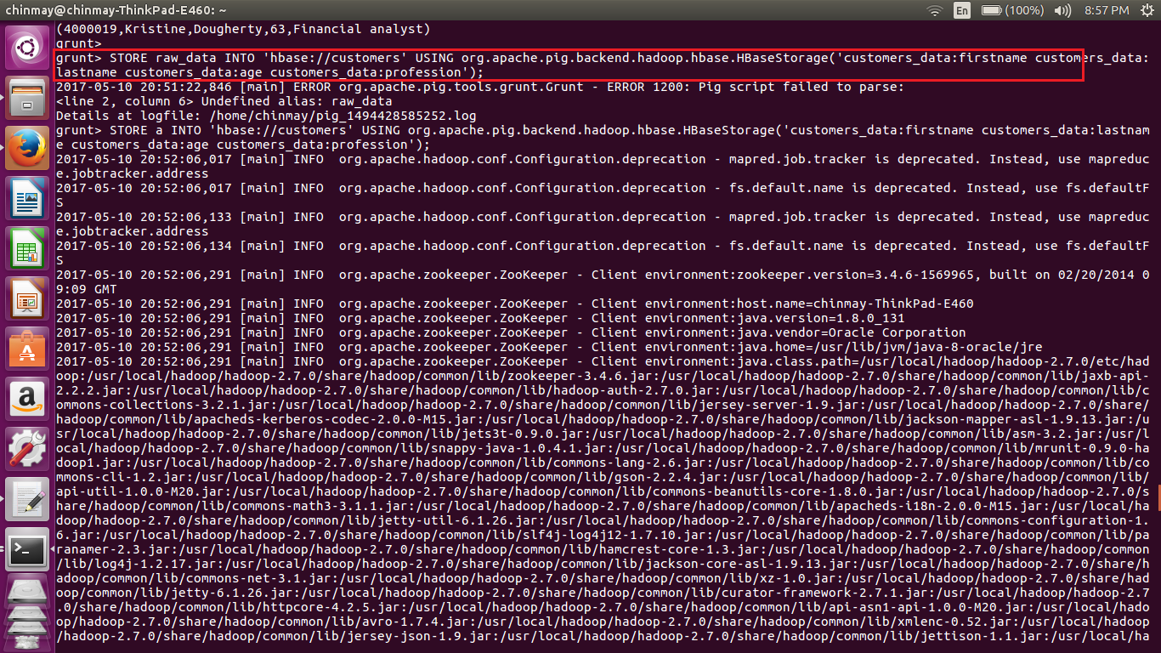

**STEP 3: DATA SUCCESSFULLY LOADED FROM HDFS TO HBASE USING PIG**

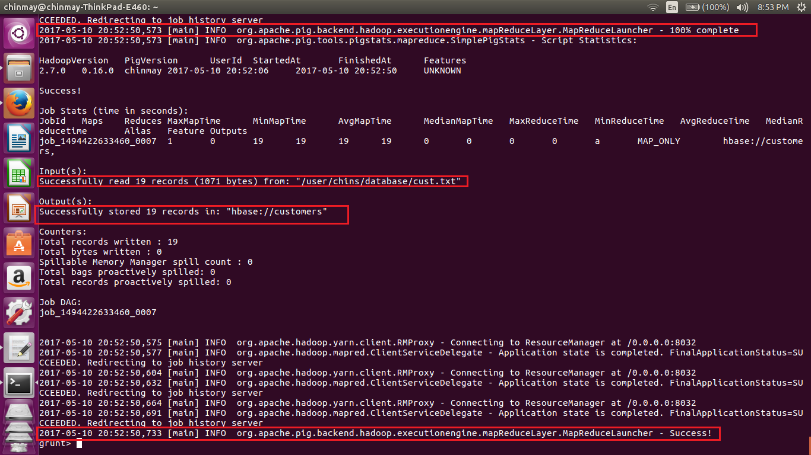

**STEP 4: USING SCAN COMMAND TO CHECK THE CONTENTS OF THE TABLE THAT HAS BEEN LOADED INTO HBASE FROM HDFS USING PIG**

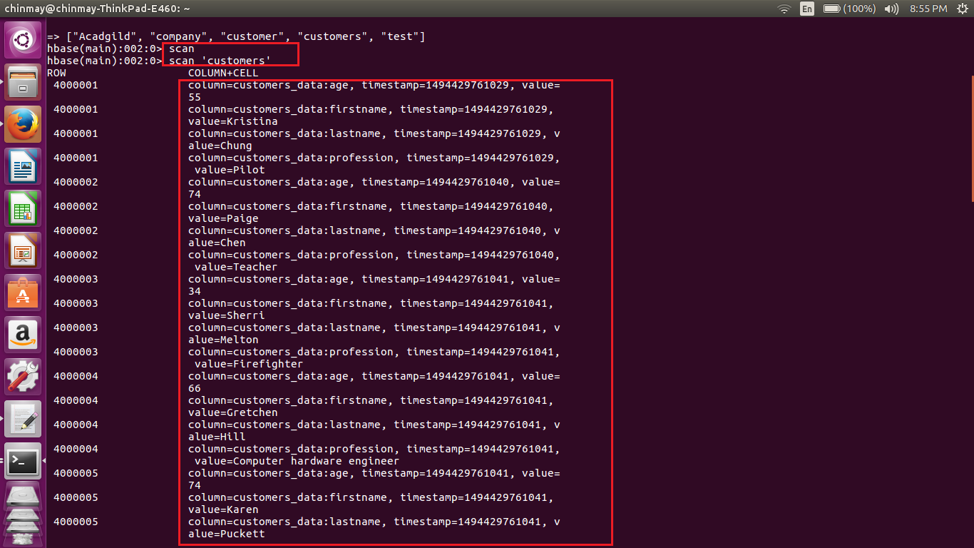

DATA HAS BEEN LOADED SUCCESSFULLY FROM HDFS TO HBASE USING PIG