**ASSIGNMENT 35.3**

1. **Explain and perform Importing table contents from Mysql to Hive using Sqoop.**

**STEP 1: CREATING A TABLE IN HIVE**

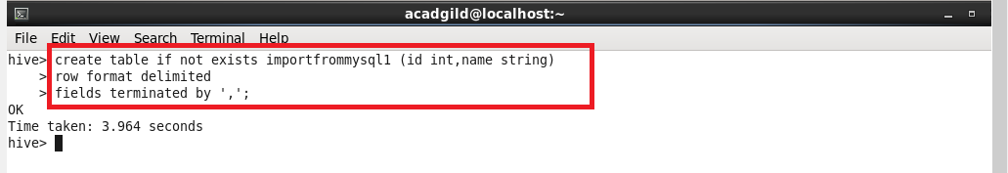

**STEP 2: CREATING A TABLE “SAMPLE1” AND INSERTING INTO THE TABLE “SAMPLE1” in MYSQL**

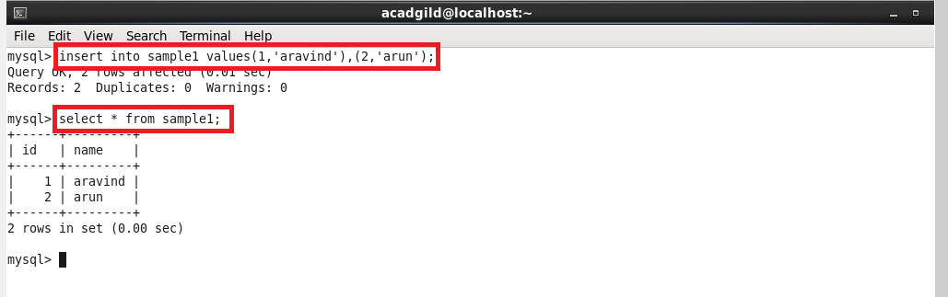

**STEP 3: PERFORMING IMPORT USING SQOOP(we have to transform the data from mysql to hive )**

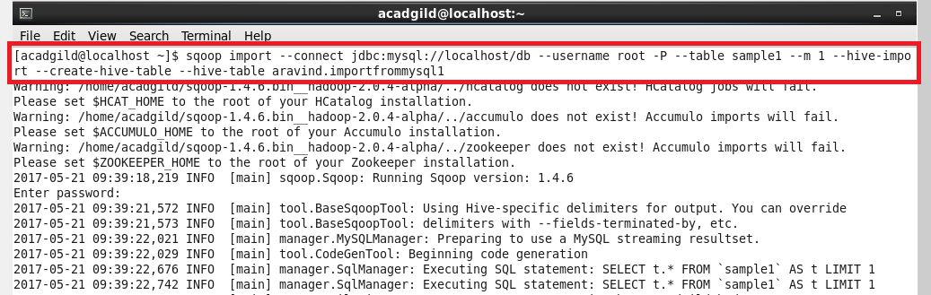

**Step 4: Before running the import command we should close the hive shell, otherwise we’ll get an error**

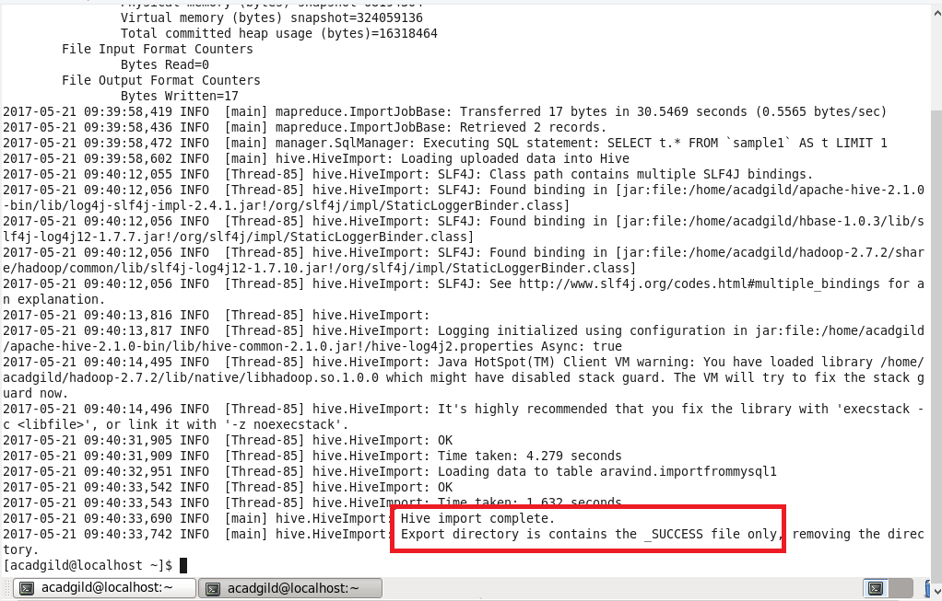

**Step 5: previously “importfrommysql1” is empty, now after running import command it is loaded with data**

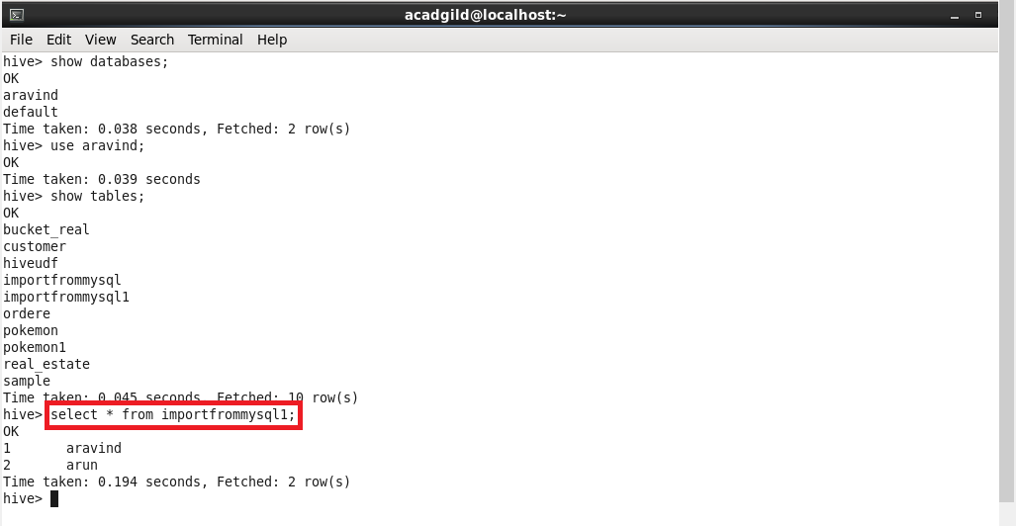

**2) Explain and perform Importing table contents from Mysql to HBase using Sqoop.**

**Step 1: create a table “importfrommysql” with “details” as column family in HBASE**

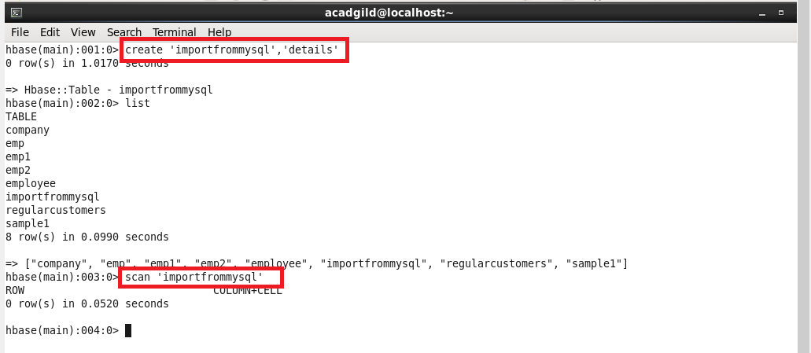

**Step 2: performing import from mysql to hbase**

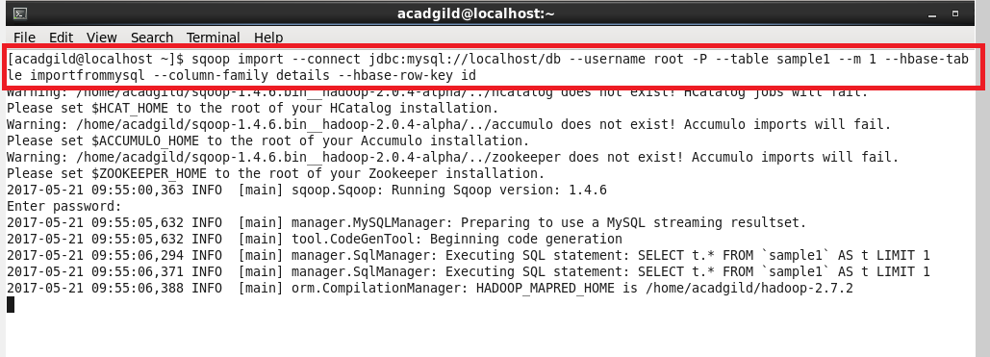

**Step 3: successfully transferred data from mysql to hbase**

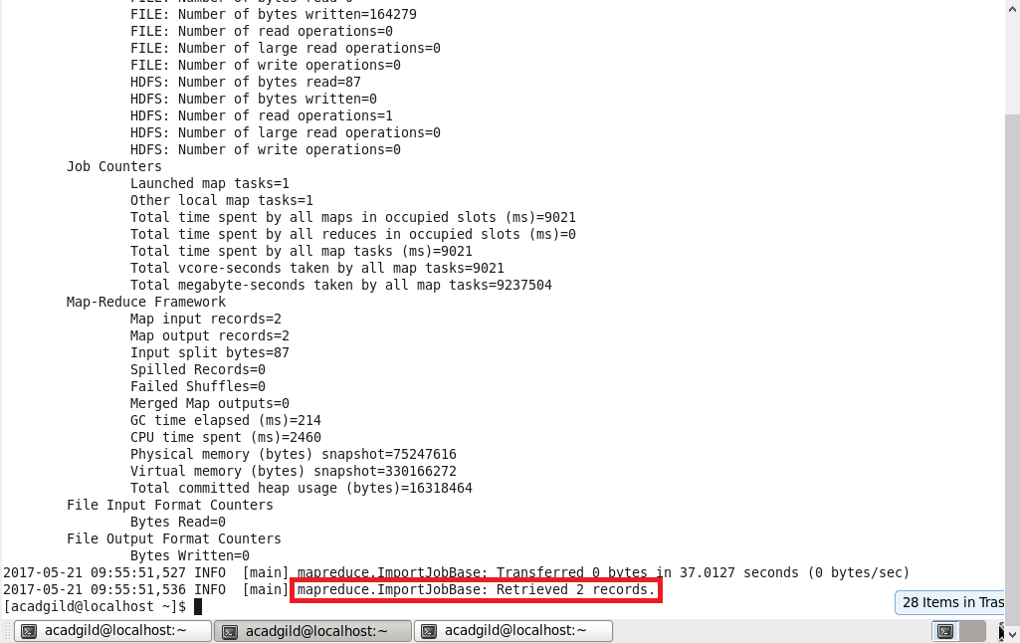

**Step 4: scan ‘importfrommysql’ gives the full details about the table(transferred data)**

