**12.2. Create a flume agent that streams data from Twitter and stores it in the HDFS cluster.**

**STEP 1: creating a directory using mkdir command.**

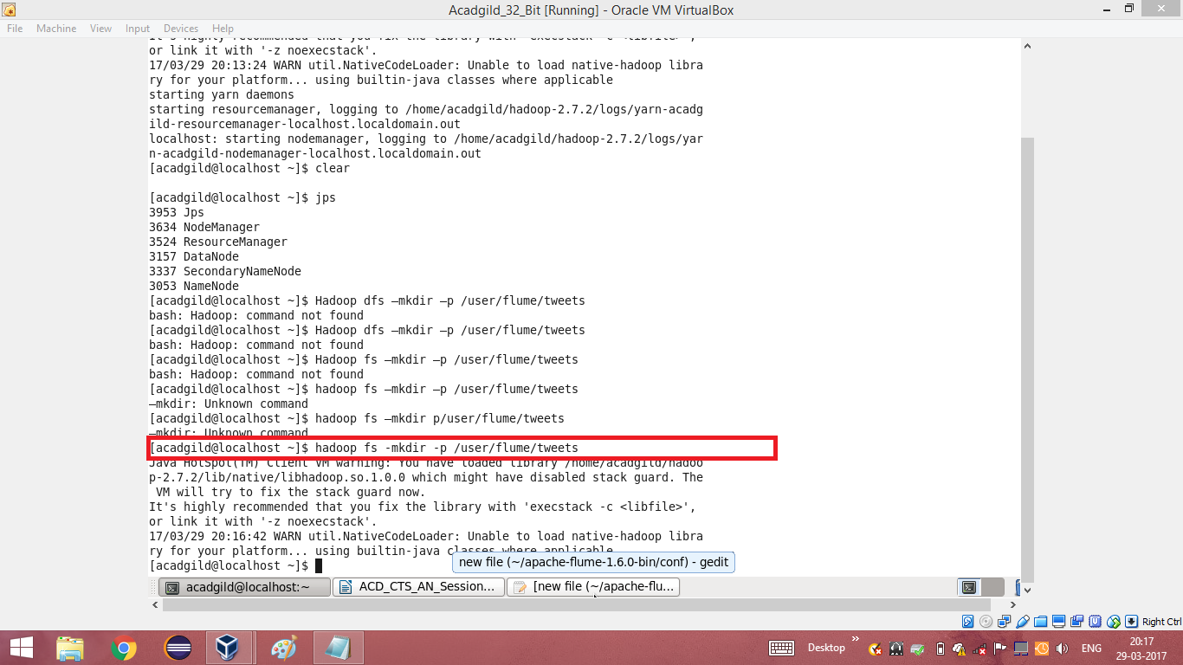

**STEP 2:**

**Editing the configuration file with the generated key, consumerSecret, accessToken and accessTokenSecret.**

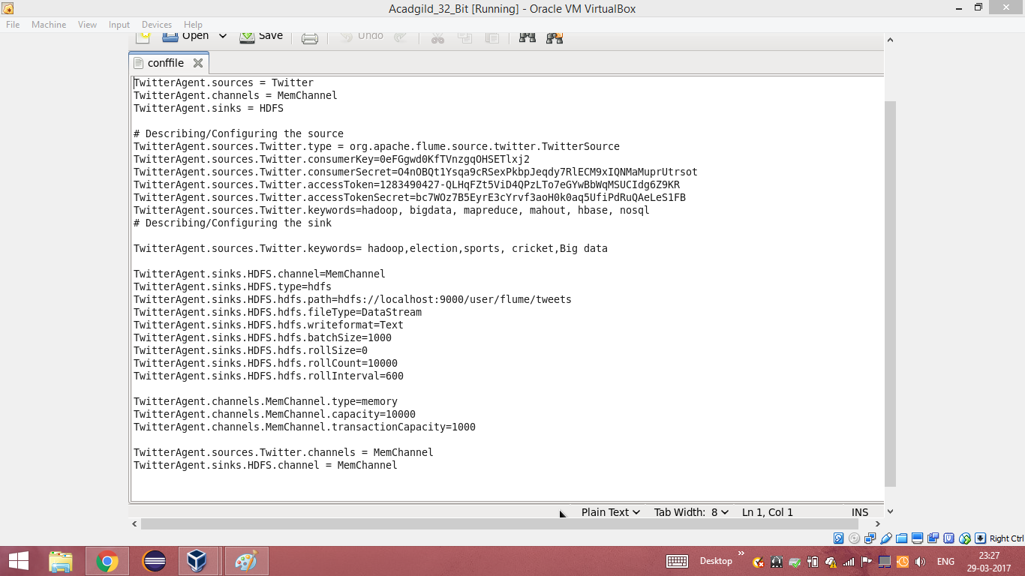

**STEP 3: Running flume**

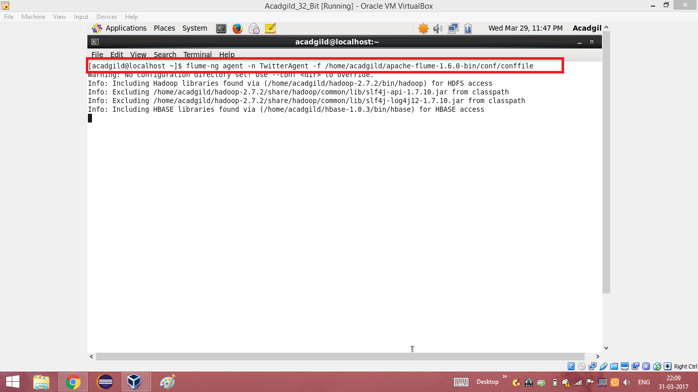

**STEP 4: Listing the contents of the tweets folder**

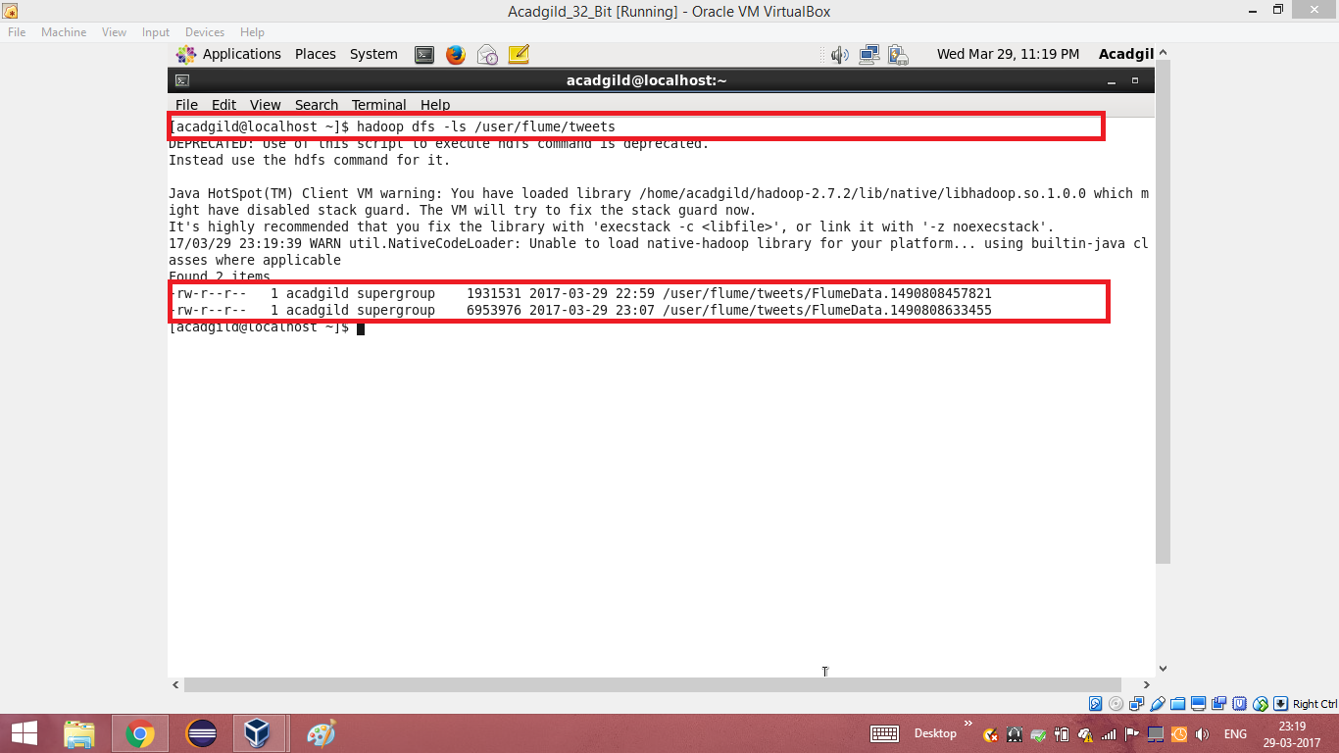

**STEP 5:Reading the extracted data from twitter using cat command**

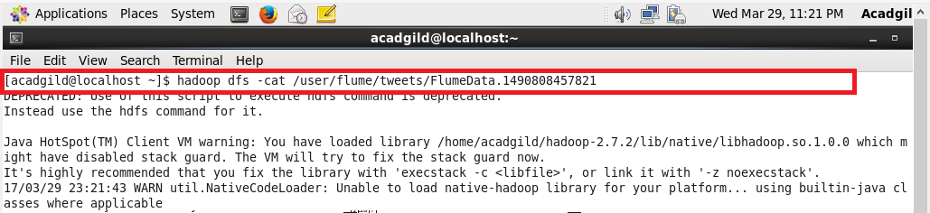

**STEP 6: Extracted data from twitter**

