http://af23551dc57534e1da3f81625038d5fc-419912146.us-east-1.elb.amazonaws.com:5000/

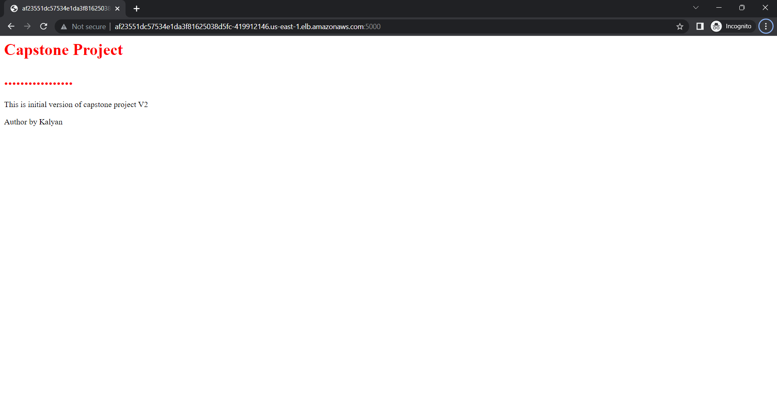

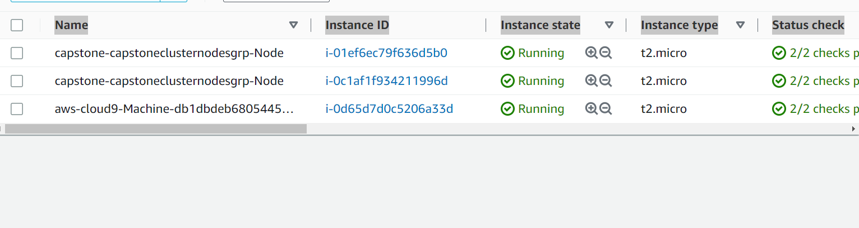

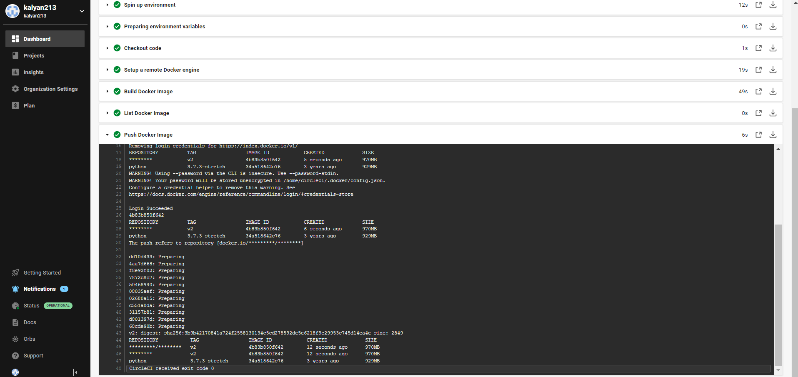

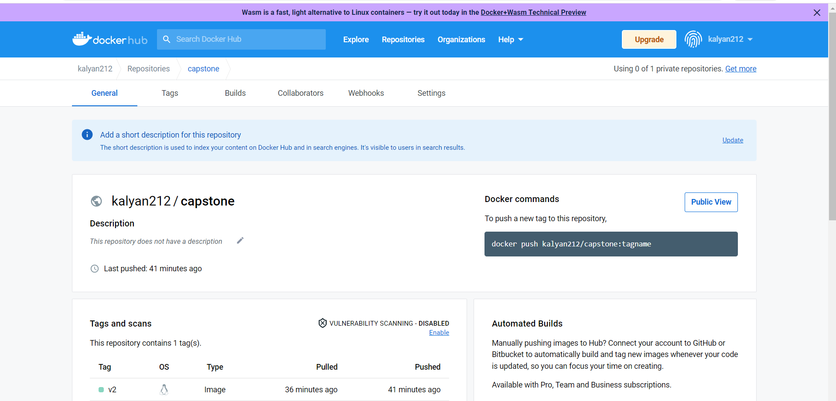

<https://app.circleci.com/pipelines/github/kalyan213/capstone_project5/83/workflows/49994f51-71df-4f83-aeec-86967a4cb486>

