STUDENT PERFORMANCE PREDICTION
Author: Kalyan Mahata
Project Type: Python Data Analytics and Machine Learning Project

1. Executive Summary
This project analyzes the real student data file in the workspace. The dataset contains 15 rows and 13 columns, and the target variable is PreviousGrade. The analysis explores academic and demographic variables associated with final grades and builds machine learning regression models for prediction.

2. Dataset Description
The dataset includes actual student records with academic, attendance, and behavioral information. The target variable is PreviousGrade.

3. Data Cleaning and Preprocessing
The project removes duplicate records, handles missing values, standardizes categorical text, and uses train-test splitting with random_state=42. This reduces leakage and keeps the process reproducible.

4. KPI Analysis
KPI | Value | Interpretation
Total Students | 15 | Number of records analysed
Average Score | 78.6 | Mean final grade
Average Attendance | 84.64% | Mean attendance rate
Pass Rate | 100.0% | Students scoring at least 60
High Performer % | 33.33% | Students scoring 85 or above
At-Risk % | 0.0% | Students below 60

5. Model Evaluation
Model | MAE | RMSE | R2
LinearRegression | 3.1426 | 3.3170 | 0.2141
RandomForest | 0.5611 | 0.6956 | 0.9654
GradientBoosting | 0.4297 | 0.4705 | 0.9842

Figure: Performance Distribution
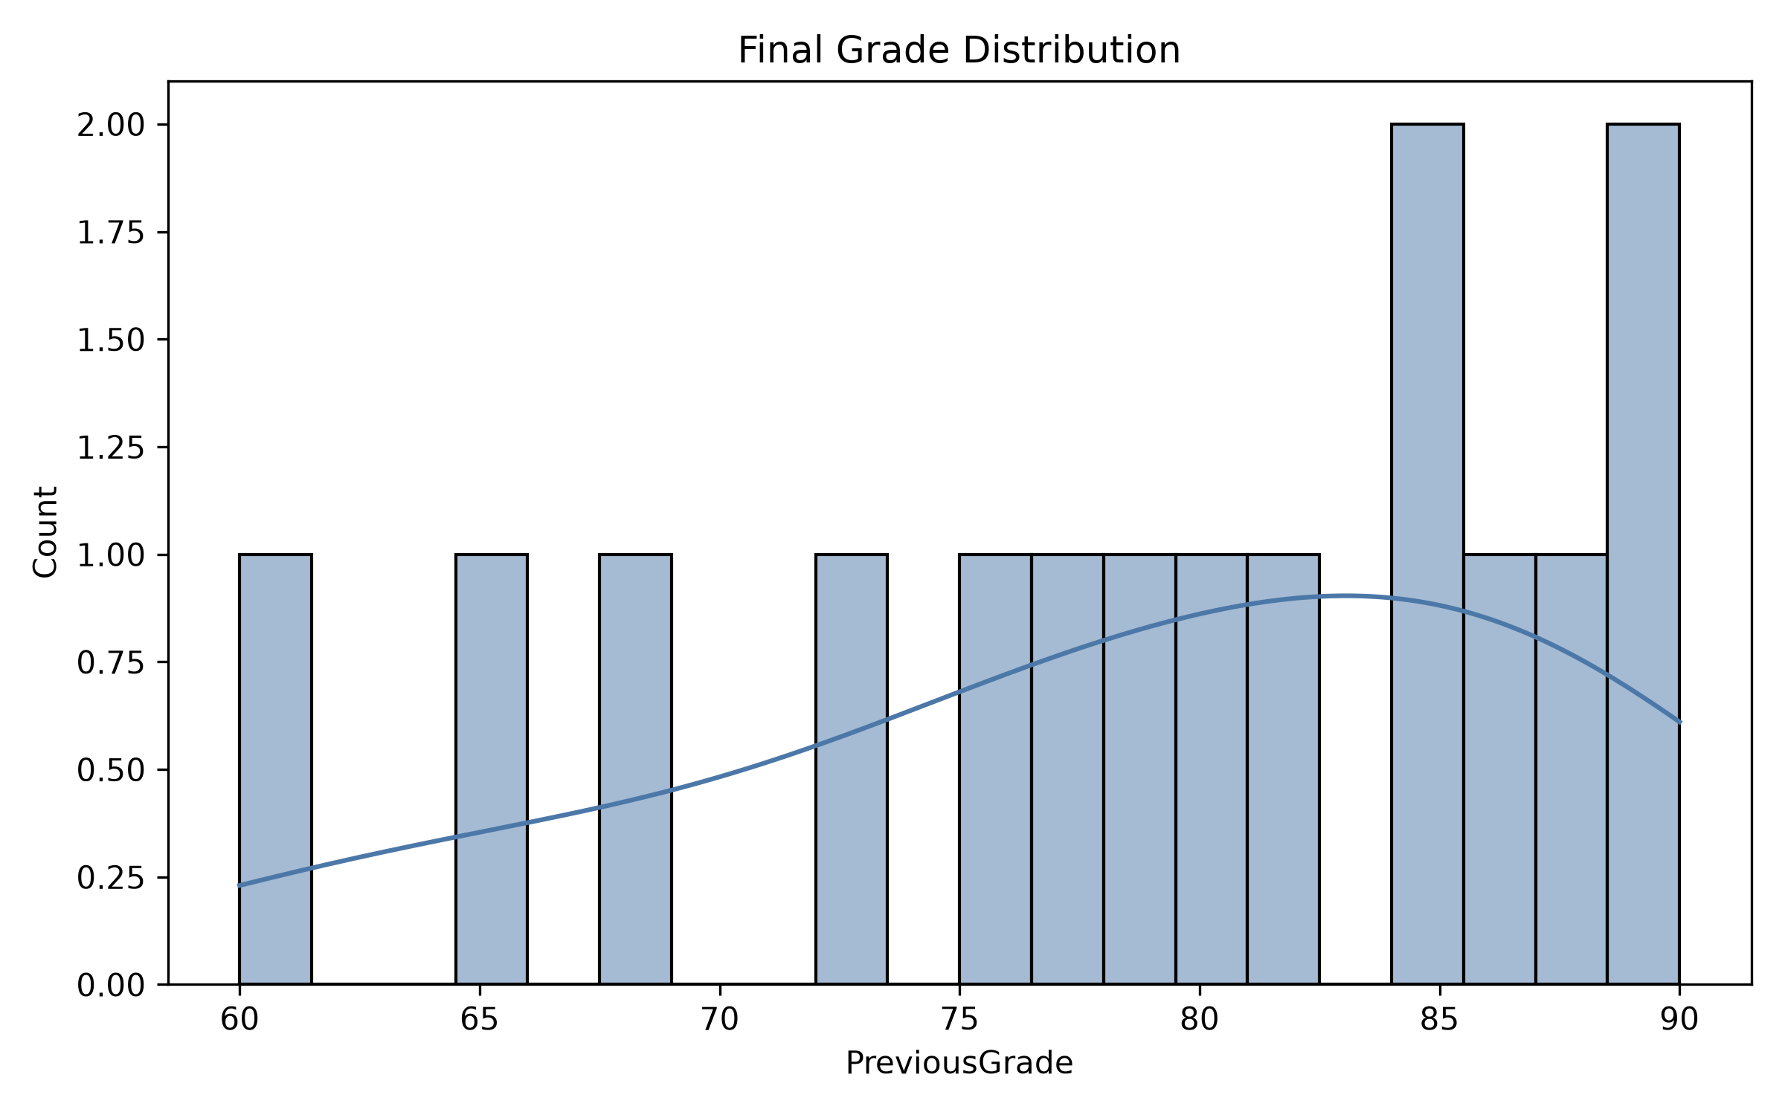

Figure: Gender Performance
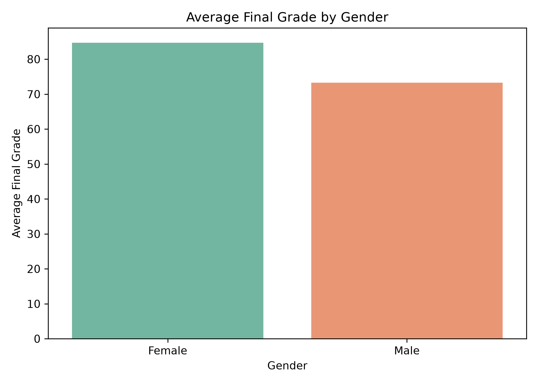

Figure: Attendance Performance
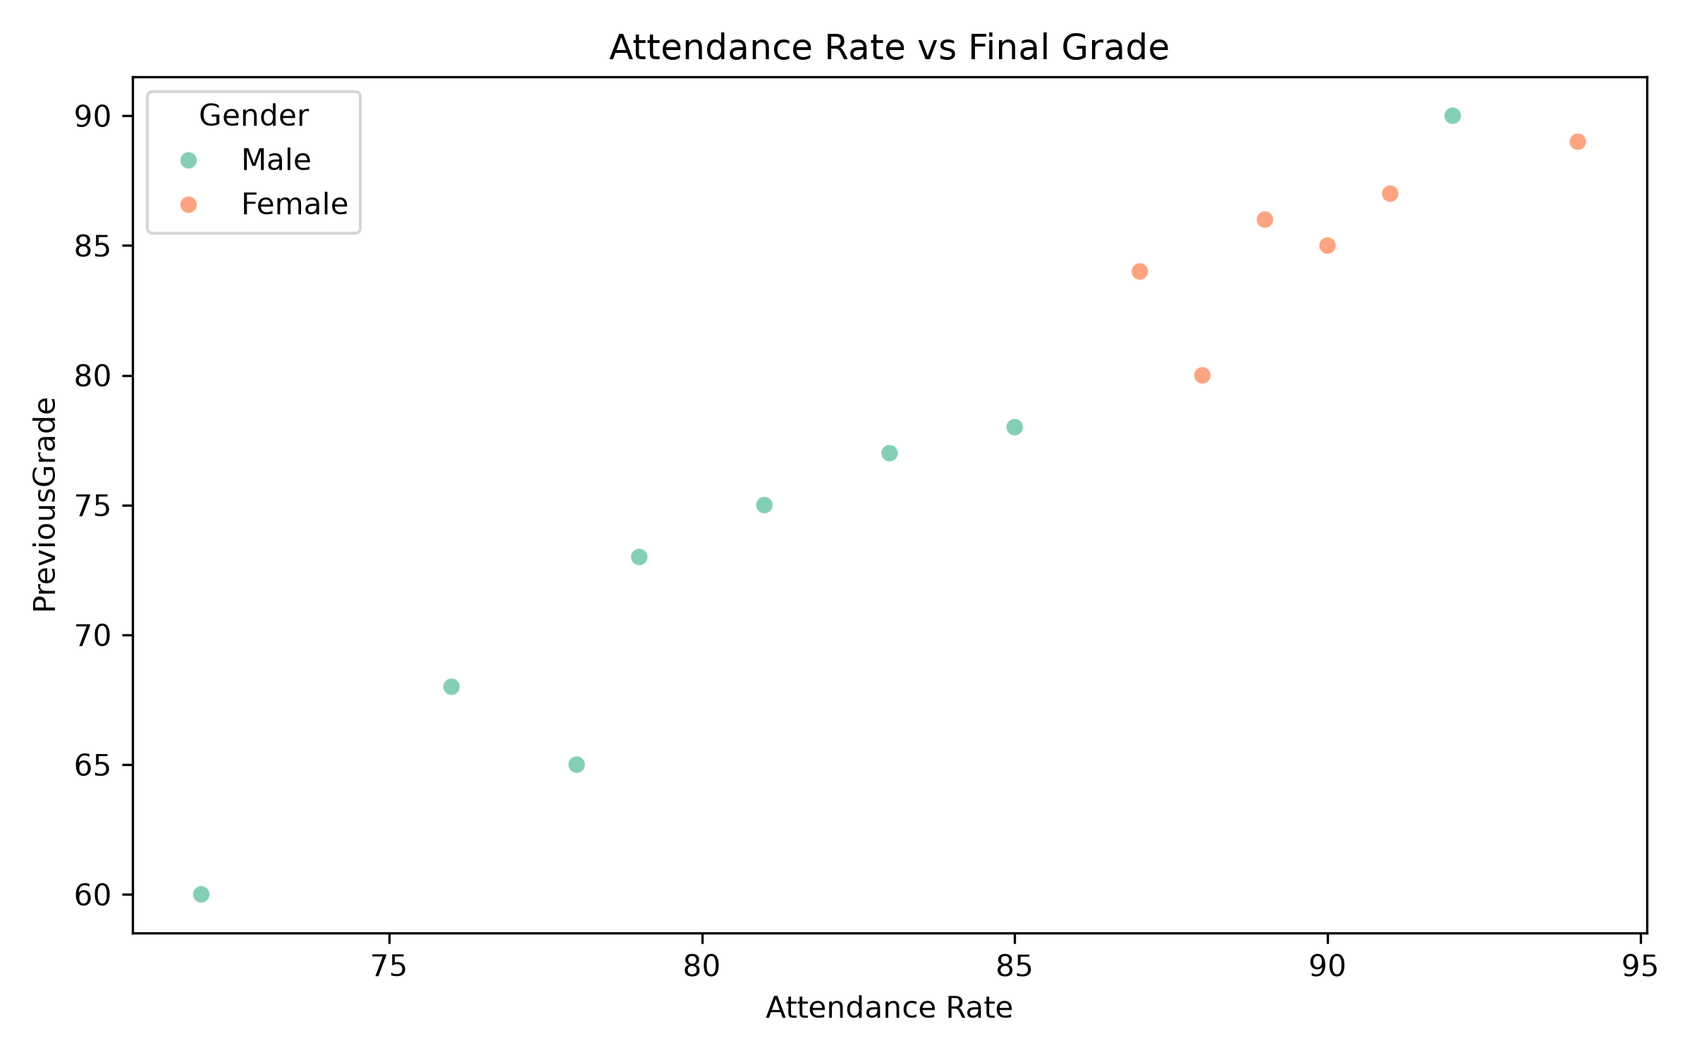

Figure: Study Hours Performance
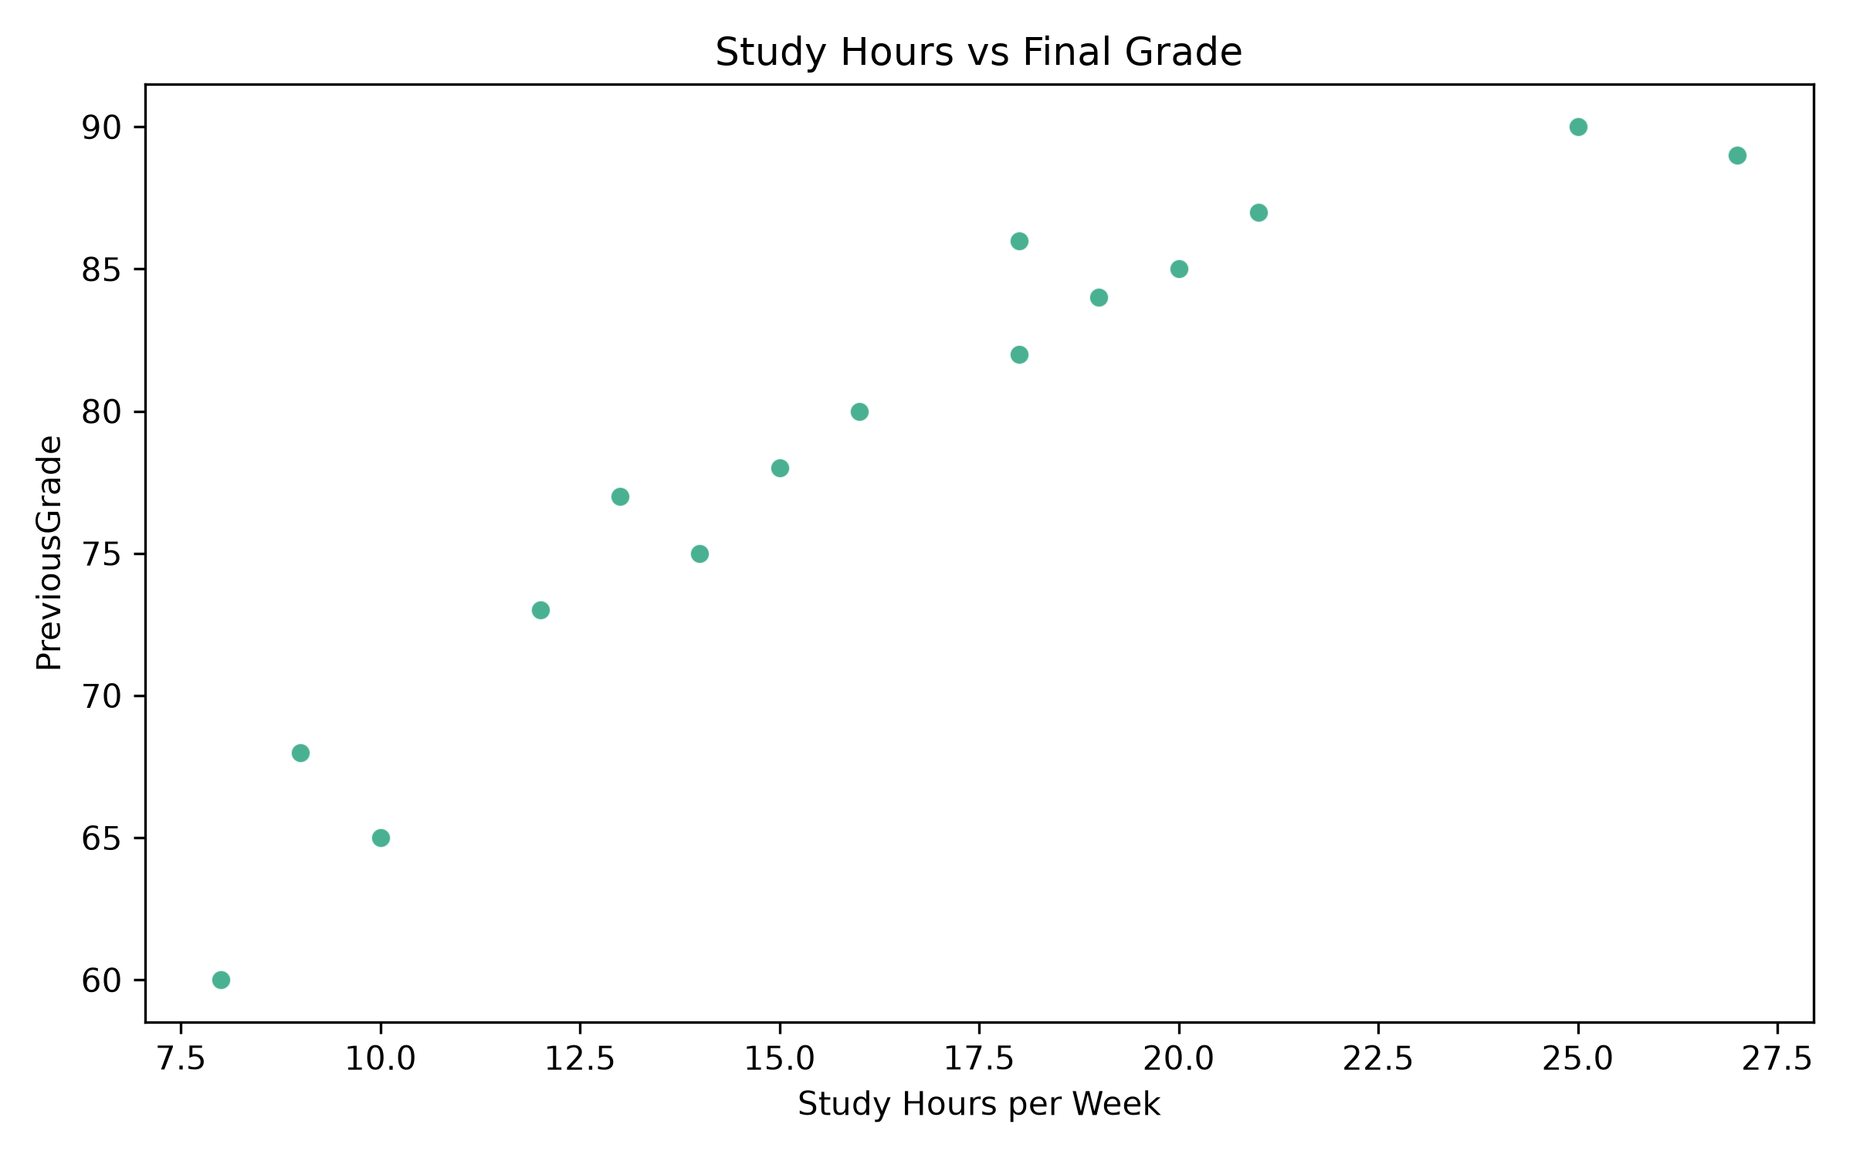

Figure: Correlation Heatmap
