As per the given assignment I have developed a console application using C#.Net.

Uploaded the code into Github.

Please find the below Github link for the code.

[https://github.com/kalyan7728/SystemTest29August/](https://github.com/kalyan7728/SystemTest29August/blob/master/AccentureSystemTest/Program.cs)

Below is the screenshot for the Outputs of all the assignments.

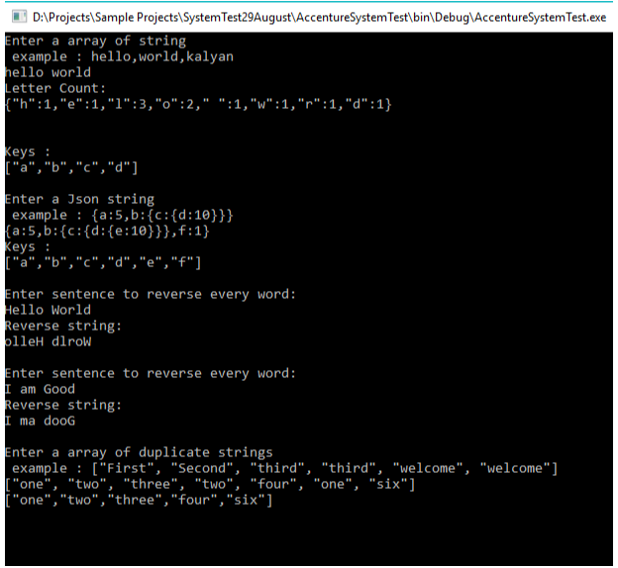

**Difference between 'let' and 'this'**

'let' allows us to define variables in block scope.   
Previously we declare our variables using “var” keyword.

But it has some limitations when it comes to scope as it does not offer .

'this' allows us to access the variables with respect to the object which contains in the method being invoked.  
  
**Example**:

<script>   
var y = 2;  
if (y === 2) {   
let y = 3;  
document.write("Inside the if condition:"+ y + "<br/>");  
document.write("Inside the if condition:"+ this.y + "<br/>");  
}   
document.write("\n Outside the if condition:"+ this.y);  
</script>