**Student Name:**

**Student Id:**

**Repo-Link**

**Abstract**

This study compares Germany and France in terms of population growth, arable land, forest area, greenhouse gas emissions, and energy sources. Germany shows stable population growth and a significant forest area, while France exhibits rapid growth and a lower arable land percentage. Germany faces challenges in reducing greenhouse gas emissions, while France successfully decreases emissions. The heat maps highlight France's reliance on hydroelectric power and Germany's urbanization and agricultural sectors. These findings contribute to understanding the dynamics and sustainability efforts of both countries.

**Comparative Analysis of Germany and France: Population, Land, Emissions, and Energy**

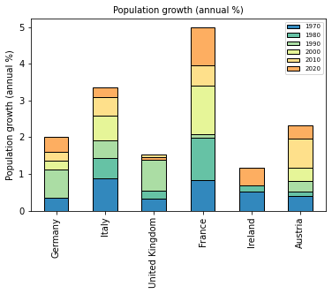

*Fig 1: Population growth % of European Countries from 1970-2020*

The presented graph depicts the annual population growth percentage for several European countries from 1970 to 2020. In 1970, France and Italy exhibited the highest population growth rates. However, Italy displayed a consistent upward trend in population growth throughout the years. In contrast, France experienced a rapid increase and maintained the highest population growth among the countries. Germany, while initially experiencing a rise in population growth in 1980, demonstrated a more stable growth pattern over the following years.

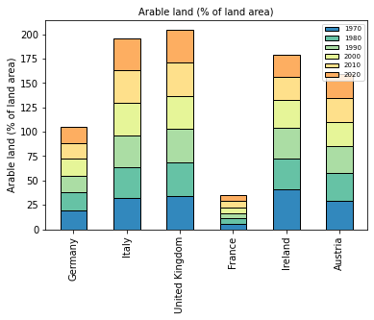

*Fig 2: Arable Land % of European Countries from 1970-2020*

The presented graph illustrates the relationship between population growth and arable land percentage for the mentioned European countries from 1970 to 2020. France and Italy, which exhibited the highest population growth rates in 1970, experienced different trends in terms of arable land. Italy showed a consistent upward trend in population growth, but its arable land percentage remained relatively stable over the years. In contrast, France, with its rapid population increase, had the lowest arable land percentage among the countries analyzed. Germany, despite initially experiencing a rise in population growth in 1980, demonstrated a more stable growth pattern and maintained a moderate level of arable land percentage.

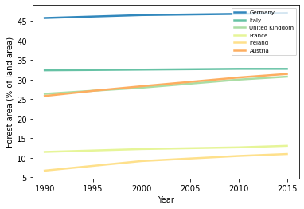

*Fig 3: Forest area % from 1990-2015*

The multiline graph presented above illustrates the percentage of forest area in various countries, indicating that Germany possesses the highest proportion of forested land. In contrast, France ranks second to last in terms of forested area. Although the population in France has increased throughout the years there hasn’t been any change in its forest land.

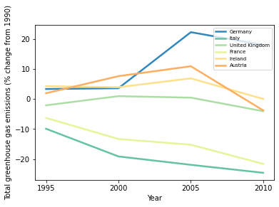

*Fig 4: Total Greenhouse emissions over 10 years*

The presented line plot highlights the disparities in greenhouse gas emissions among the analyzed countries. Germany emerges as the country with the highest emissions, exhibiting a notable surge in emissions starting from 2000. Conversely, despite an increase in population, France demonstrates a significant decrease in greenhouse gas emissions between 1995 and 2010. These findings show that Germany is facing challenges in mitigating emissions while France successfully curbing its greenhouse gas output during the specified period.

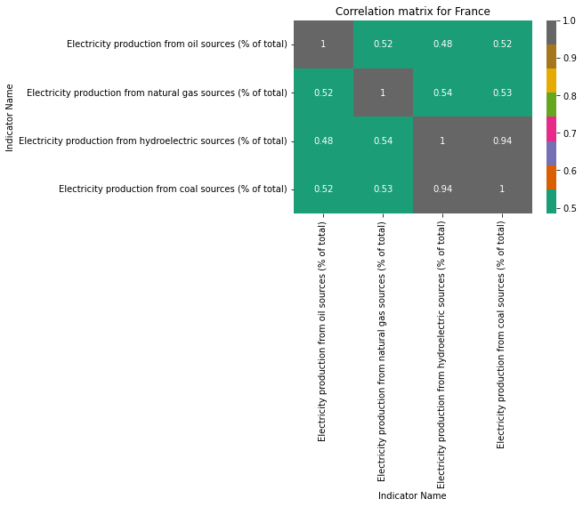

*Fig 5: Heatmap of France*

The heat map of France offers valuable insights into the country's energy generation sources. The analysis reveals that France relies significantly on hydroelectric power, as evidenced by high values in the hydroelectric category. This indicates a strong capacity for generating electricity from water resources. Furthermore, France demonstrates a moderate reliance on natural gas for electricity production, while showing lower values for coal and oil sources. These observations suggest a shift towards cleaner energy sources and a commitment to reducing reliance on fossil fuels which is why it has lower greenhouse emissions.

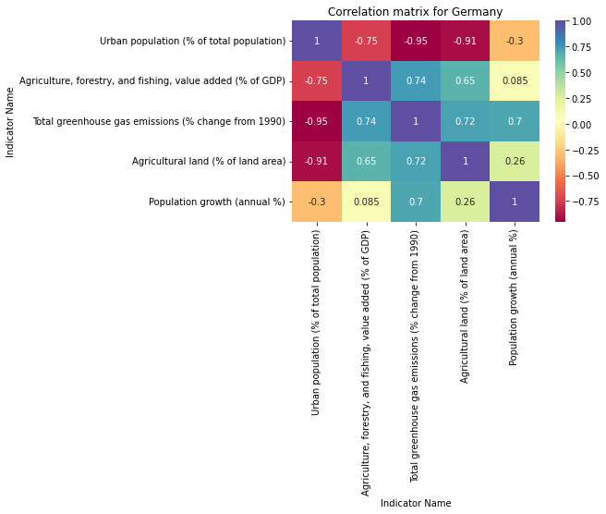

*Fig 6: Heatmap of Germany*

The heat map of Germany shows a significant urbanization trend, with a large proportion of the population residing in urban areas. This suggests the concentration of economic activities and a growing emphasis on urban development. The map highlights the importance of agriculture, forestry, and fishing sectors in Germany's economy, as they contribute a significant portion to the country's GDP. Moreover, Germany has made notable progress in reducing greenhouse gas emissions, with negative values indicating a decrease in emissions compared to the baseline year of 1990. This demonstrates the country's commitment to environmental sustainability and transitioning to cleaner energy sources. The map also provides insights into the allocation of land for agricultural purposes, showcasing the significance of the agricultural sector in Germany.