SilkTest Functional Tester (STFT) Test Automation Framework
Version 1.0

Table of Contents
Preface 3
ABOUT THIS GUIDE 3
AUDIENCE 3
Chapter 1 Framework Design 4
1.1 OVERVIEW 4
1.2 ARCHITECTURE 4
1.3 HIGH LEVEL FRAMEWORK ARCHITECTUER 6
1.4 AUTOMATION ENGINE 8
1.5 RESULT LOG ENGINE 10
1.6 FUNCTION LIBRARIES AND CLASSES 12
Chapter 2 Features 15
2.1 FEATURES AND BENIFITS 15

Preface
ABOUT THIS GUIDE
This document is the design document for the SilkTest Functional Tester (STFT) based GUI test automation framework. It comprises of the framework architecture and design and implementation details.
AUDIENCE
This document is intended for the following:
- Test Managers who are looking for a generic GUI test automation solution.
- Test Engineers who will adopt the framework to an application under test (AUT). Basic functional knowledge of C/C++ and OOP’s with hands on experience with the SilkTest tool is expected here.

- Framework Design

OVERVIEW
The SilkTest Functional Tester (STFT) based GUI test automation framework is a generic test automation solution for testing Windows/Web based applications.

ARCHITECTURE
The test automation framework for SilkTest Functional Tester consists of three main areas.
- Utility Functions on different verification and validations area from the core area of the automation framework.
- Wrapper classes for objects which are overloaded/overridden depending on general requirements.
- Logging utility, which provides .txt logging, .log logging and smart logging (High level) rich test report generation.
Following diagram shows an architectural overview of the framework. The building blocks of the framework include common utilities (Database Library Functions, File Library Functions, Recovery Library Functions, System Library Functions, Utility Library Functions, Verification Library Functions, etc) and wrapper classes.
The following sections describe the architecture details for each building blocks of the STFT framework.

Low Level Architecture:
As shown in below Low Level Architecture, Generic services for AUT are ready to use. These services not only provide most generic services but also having verification and validation points at appropriate sessions.

LOW LEVEL FRAMEWORK ARCHITECTIRE
GENERIC SEVICES
AUT LAYER
RECOVERY SYSTEM
GENERIC LIBRARY
DATA DRIVEN
ERR HANDLERS
RES REPORTING
MISC SERVICES
UI OBJECTS
TEST CASES
RESULT REPORTING

Basic generic services provided by STFT are,
Generic Library which provides generic functions on the different areas like File handling, Database operations, String operations, IU Verifications and validations, System Library, Utility function library etc.
Recovery System works internally and making sure that failure of one testcase because of unexpected popup, should not affect execution on next testcase.
Data Driven service provides smooth flow of data at script level as well at test case level.
Error Handling services of framework making sure that while Starting and Ending point of script there is no any window exists other than main window of AUT. If any window/MessageBox/DialogBox founds, error handler closing it by looking into its IU.
Result Reporting service reports results in .txt, .log and smart logging rich text format. Result reporting service of STFT framework takes all the required test attributes in result reporting with respect to script and every testcase. Log file shows test execution result with each verification/validation status for each testcase.
Misc Services provides services like, configuration data and global data which are used throughout the framework.

HIGH LEVEL FRAMEWORK ARCHITECTURE
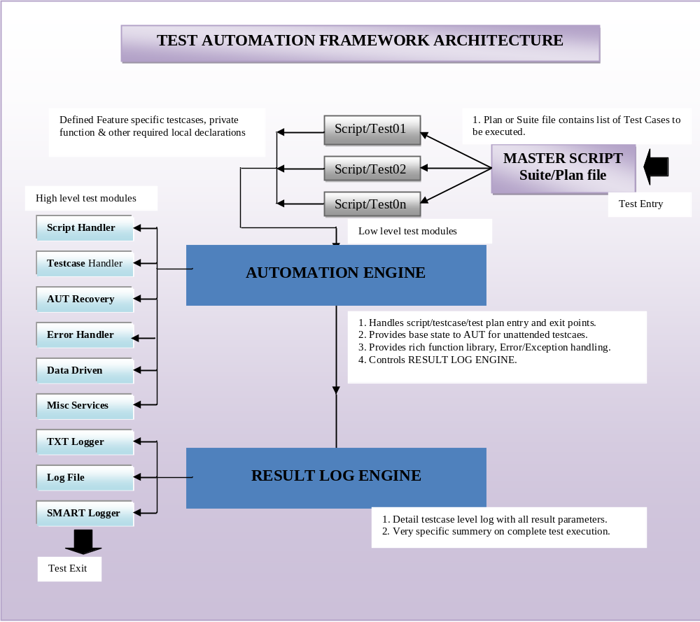

AUTOMATION ENGINE
Automation Engine is the CU (Control Unit) for all the STFT framework activities running at the time of Test Suite execution. Following are some jobs controlled by Automation Engine,
    - Control Over Test Execution
    - Provides recovery to AUT
    - Provides required Utilities while Test Execution
    - Handles Unexpected Errors
    - Controls RESULT LOGGING ENGINE etc

RESULT LOG ENGINE
The STFT framework result reporting engine is able to generate three different reports as below,
- TXTLogger: Individual Test Case Result is shown in this log file
- LOGFile: Detail Result reporting with date appended to log file name (.log format)
- SMARTLogger: High level test execution summary report (Text format)

RESULT LOG ENGINE

Log File

TestCaseResult
TXT Logger

SMARTLogger

TXTLogger: TestCaseResult.txt gives overall summary status for every Test Case executed. This log file includes each testcase name and status of the testcase i.e. PASSED/FAILED/NOT RUN.
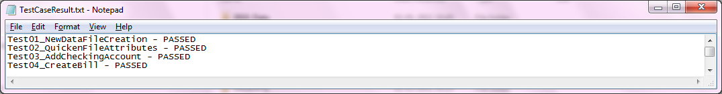
LOGFile: Log file contains complete test execution result with each verification/validation status. Log file name is appended with execution date. Following are the details captured for every Test Case:
- Testcase Name as Header
- Step Name
- Status
- Description
- Testcase Name with overall status
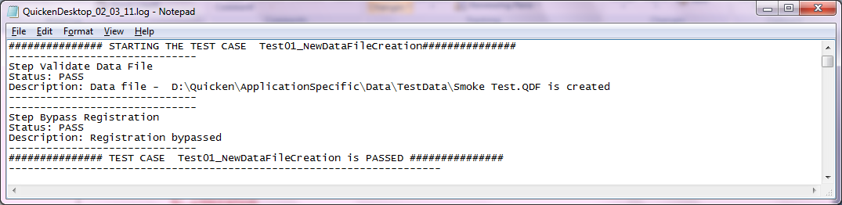

- SMARTLogger: SMART Logger gives summery information about complete test execution in text file. Following are the contents for SMART logger,
  - Script Name
  - Product Name
  - Mile Stone
  - Script Started
  - Script Ended
  - Testcases Executed
  - Testcase Passed
  - Testcases Failed
  - Passing Percentage
  - Failing Percentage etc.
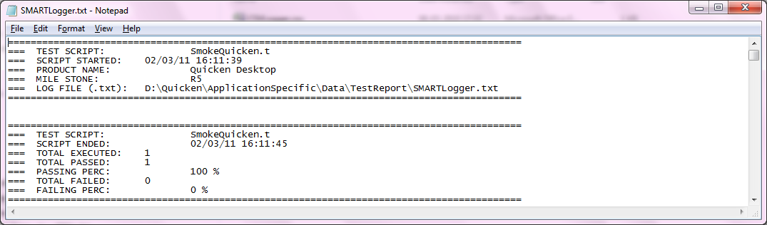

(Note - As per requirement, Displayed information can be Added/Removed)

FUNCTION LIBRARIES AND CLASSES
Generic functions of STFT provide generic utilities which works on AUT pages, Objects on the pages, common utilities that can be used across the test automation project. These utilities are independent of any application under test. Below is the list of utilities that are part of this set:

1.6.2 File Library: File Library provides file operations related with file handling. Currently this library supporting following operations,
- Comparing Files/Dir
- Delete file/Dir
- Copy files/Dir
- Verify file/Dir exists
- Get File Size, Date for creation, File Name
- Make Dir
- Find Files
- Get File Names of any Dir
- Compare File Lists
- Set/Get File attributes etc

1.6.3 System Library: System Library offers system related operations. Currently this library supporting following operations,
- Get System Path
- Get System name
- Close any running application
- Close not responding Application/Service
- Get Device drivers and their properties
- Set/Get/Copy/Delete/Update windows registry values
- Change system date-time
- Get free Physical/Page/Virtual memory
- Get total Physical/Page/Virtual memory
- Get percentage of Physical/Page/Virtual memory
- Start/Stop/Pause/Disable windows services

1.6.4 Utility Library: Utility Library provides general utilities functions to the user defined functions and testcases. Currently this library supporting following operations,
- Find number in line
- List sorting
- Item Remove/Add/Missing/Difference
- Start/Pause/Stop/Resume/Set timer
- Convert list items to Upper/Lower/Remove Duplicates etc
- Convert string to number/ string to Boolean

1.6.5 Verify Library: Verify library consists of verification functions available for user defined functions and testcases. Currently this library supporting following operations,
- Verify window objects (Come out if verification failed)
- Verify all (object and properties of window)
- Verify Properties
- Verify Enable/Disable/Value
- Verify fuzzy
- Wait while window exists
- Verify exists etc
1.6.6 Recovery Library*: Recovery library functions are used internally by STFT framework in case of any unexpected event occurrence. Currently this library supporting following operations:
- Error Handling
- Log Exception
- Testcase Enter
- Testcase Exit
- Update Results

1.6.7 Classes and Methods: STFT Framework providing some useful classes for result logging as well as methods for UI objects classes like, TextField, Text, PushButton, Table, etc. wherever applicable, properties are also defined for objects.
1.6.8 Generic Library: Generic Library provides general utilities functions to the user defined functions and testcase. Currently this library supporting following operations,
- Crete log file
- Log message/exception
- Report status (Logs Result to Silk Result file and User Defined log file )
- Write Testcase Header
- Write Testcase Footer

- Features

FEATURES AND BENIFITS
- Ready-to-use, scalable GUI test automation framework.
- High productivity because of basic UI verification methods ready for use.
- Reliable, as every verification method and function written by considering manual user actions.
- Portability considered while developing framework, it can be used on any Windows-XP, Windows-Vista and Windows-7 operating systems.
- Highly reusable if specified coding standards used at Application Layer end.
- Application independent layer including generic functions, wrapper classes, and enhanced test results reporting.
- Savings on test automation architecture/design effort.
- Strong recovery system which invokes application and sets it to its base state.
- Savings on development effort for creating a generic layer of common utilities and features.
- Txt/log/Summarized results report generation, with provision of setting the logging levels for different needs of different users.
- Dynamic verification points for UI widgets in functions and methods, which eliminate the process of recording and maintaining verification points in SilkTest. This provides more flexibility to the user in terms of verifying the widget’s state in application under test.
- Global error handling at suite level to allow users to run multiple test cases in batch mode.
- Error handling in low level methods, which deal with actual test objects in application under test. This makes user free of handling such errors and allows making calls to this methods directly.

