Real Estate Price Prediction System
An End-to-End Machine Learning Project
Data → Model → API → Frontend → Testing → Docker → Documentation

1. Project Objective
This project builds a machine learning system that predicts the price of a property based on its features: Area, Bedrooms, Bathrooms, Age, Location, and Property Type. The system demonstrates the complete ML lifecycle, from data analysis and model training to deployment through a FastAPI backend, a Streamlit frontend, testing, Docker, logging and documentation.

2. Dataset
The dataset (data/house_prices.csv) contains 300 property records with 8 columns.
Column | Description | Type
Property_ID | Unique property identifier (dropped) | Identifier
Area | Property area (square feet) | Numerical
Bedrooms | Number of bedrooms | Numerical
Bathrooms | Number of bathrooms | Numerical
Age | Property age in years | Numerical
Location | Rural / Suburb / City Center | Categorical
Property_Type | House / Villa / Apartment | Categorical
Price | Target variable (PKR) | Target
Data quality: 300 rows, no missing values, no duplicate records.

3. Exploratory Data Analysis
Key observations from the EDA:
- Price ranges from ~3.7M to ~58.7M PKR with a mean of ~24.9M PKR.
- Area has the strongest positive linear relationship with Price.
- City Center properties command higher prices than Suburb and Rural.
- Villas and Houses generally price higher than Apartments.
- Bedrooms and Bathrooms show a mild positive relationship with Price.
- Older properties tend to be cheaper (negative impact of Age).
Visualizations generated (outputs/eda/):
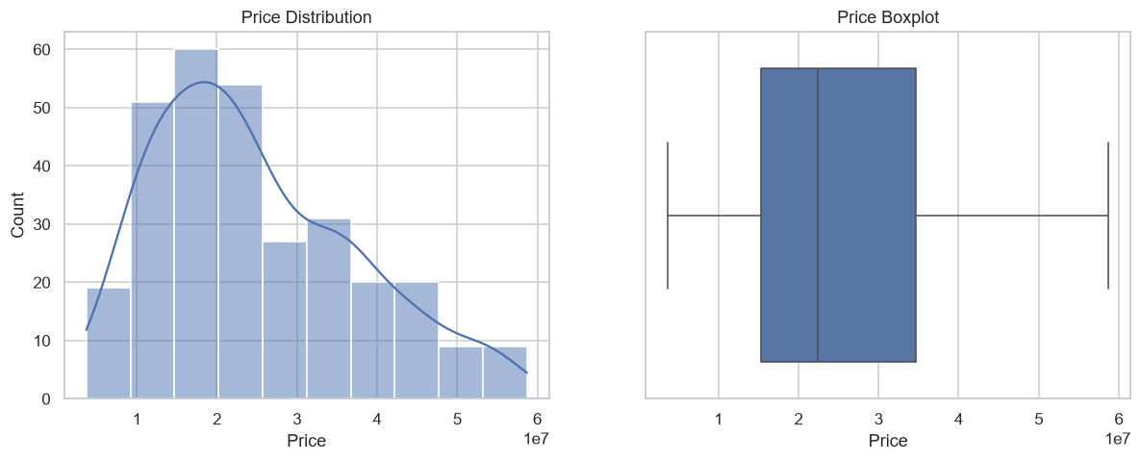
Figure 1 - Price distribution
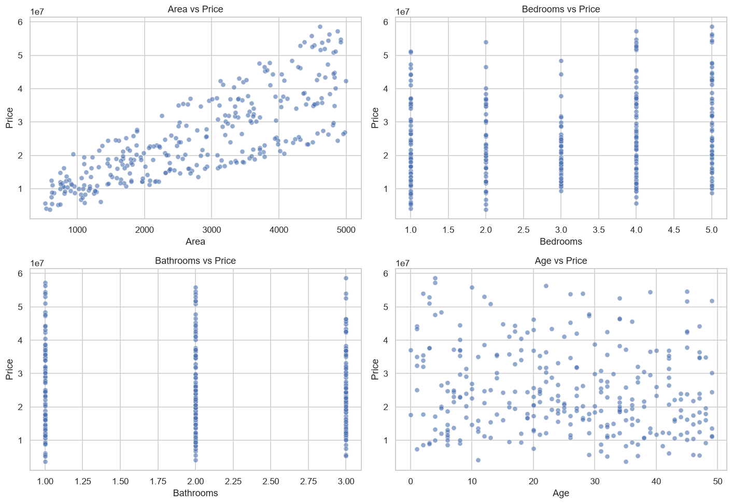
Figure 2 - Numerical features vs Price
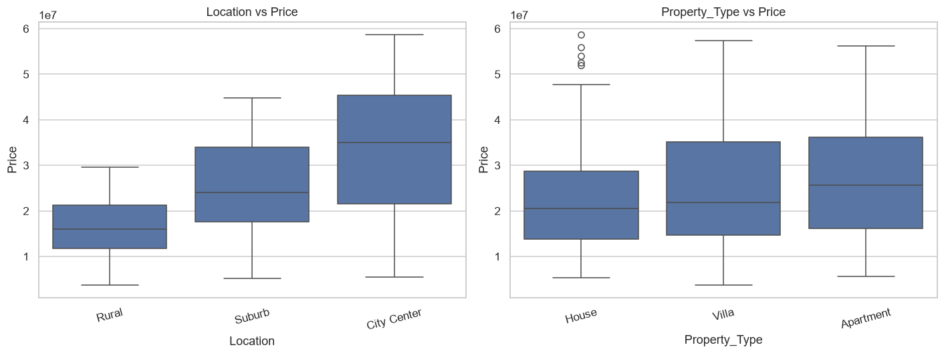
Figure 3 - Categorical features vs Price
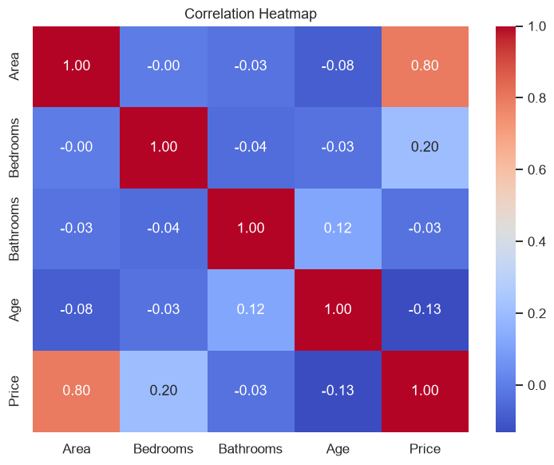
Figure 4 - Correlation heatmap

4. Data Preprocessing
- Dropped the Property_ID column (identifier only).
- No missing values or duplicates found, so no imputation was required.
- Numerical features (Area, Bedrooms, Bathrooms, Age) scaled with StandardScaler.
- Categorical features (Location, Property_Type) one-hot encoded with handle_unknown='ignore'.
- Data split into 80% training / 20% testing (random_state=42).
- A reusable scikit-learn pipeline ensures the same transformations apply during training and prediction.

5. Feature Engineering
Additional features were engineered and evaluated for predictive value:
Feature | Formula / Definition
Area_per_Bedroom | Area ÷ Bedrooms
Total_Rooms | Bedrooms + Bathrooms
Age_Group | New (0–10), Moderate (11–25), Old (26–49)
Has_Garden_Room_Budget | 1 if Area > 2500 and Bathrooms ≥ 2, else 0
These features improved the tree-based models (Random Forest and XGBoost) and are used in the final pipeline.

6. Model Training and Evaluation
Three regression models were trained, each with and without feature engineering: Linear Regression, Random Forest Regressor, and XGBoost. Every model was evaluated on the held-out test set using MAE, RMSE, R² and MAPE.
Model | Engineering | MAE | RMSE | R² | MAPE
Linear Regression | no | 2,188,736 | 2,907,633 | 0.9406 | 13.16%
Linear Regression | yes | 2,280,105 | 2,978,351 | 0.9377 | 13.48%
Random Forest | no | 1,470,070 | 1,971,481 | 0.9727 | 6.76%
Random Forest | yes | 1,387,287 | 1,853,888 | 0.9759 | 6.17%
XGBoost | no | 1,258,976 | 1,608,064 | 0.9818 | 5.97%
XGBoost (best) | yes | 1,196,390 | 1,574,489 | 0.9826 | 5.02%
XGBoost with feature engineering performed best and was selected as the final model.

7. Hyperparameter Tuning
GridSearchCV (5-fold cross-validation, optimising negative RMSE) was applied to the best candidate. Selected parameters:
Parameter | Value
n_estimators | 300
learning_rate | 0.1
max_depth | 3
Tuned XGBoost final test metrics: R² = 0.9876, MAE = 971,991, RMSE = 1,326,720, MAPE = 5.14%.

8. Saving the Model
The complete preprocessing + model pipeline is serialised with joblib and saved to models/house_price_model.pkl. The saved pipeline accepts raw property information and returns a predicted price. Model metadata and test metrics are stored in models/metrics.json.

9. Prediction API (FastAPI)
A FastAPI backend (app/main.py) loads the saved model on startup and exposes two endpoints:
- GET /health - service health check and model availability.
- POST /predict - accepts Area, Bedrooms, Bathrooms, Age, Location, Property_Type and returns {"predicted_price": ...}.
Example request:
curl -X POST http://localhost:8000/predict -H "Content-Type: application/json" -d '{"area": 3000, "bedrooms": 3, "bathrooms": 2, "age": 10, "location": "City Center", "property_type": "Villa"}'
Response: {"predicted_price": 34829620.0}

10. Frontend (Streamlit)
A simple Streamlit interface (app/app.py) lets the user enter property details and click Predict to see the estimated price. It calls the FastAPI backend when available and falls back to in-process prediction otherwise.

11. Testing
A pytest suite (tests/) covers data loading, missing/duplicate checks, feature engineering, pipeline fitting, model prediction, API health, valid and invalid predictions. All 19 tests pass.

12. Docker Deployment
The application is containerised with a Dockerfile and docker-compose.yml providing two services:
- api - runs uvicorn on port 8000 with a health check.
- frontend - runs Streamlit on port 8501 and depends on a healthy API.
Run with: docker compose up --build

13. Logging and Monitoring
API requests, prediction requests, errors and model loading are logged to logs/api.log (rotating) and the console. The /health endpoint reports live counters for total predictions and total errors.

14. How to Run
- Create and activate a virtual environment, then: pip install -r requirements.txt
- Train the model (notebook): jupyter notebook notebooks/training_pipeline.ipynb
- Train the model (script): python -m src.train --tune
- Run the API: uvicorn app.main:app --host 0.0.0.0 --port 8000
- Run the frontend: streamlit run app/app.py
- Run tests: pytest tests -v

15. Conclusion
The project delivers a complete, production-oriented real estate price prediction system. Starting from raw data, it performs cleaning, EDA, feature engineering and builds a preprocessing pipeline, trains and compares multiple regression models, tunes the best performer, and saves a ready-to-use pipeline. A FastAPI backend and a Streamlit frontend expose the model end-to-end, supported by a passing test suite, Docker configuration, logging, monitoring and full documentation. The final XGBoost model achieves an R² of 0.9876 with a MAPE of 5.14% on the held-out test set.

