BREINBOX

Version 1.0

User Manual

|  |  |  |  |  |
| --- | --- | --- | --- | --- |
| **S. No** | **Document Version** | **Updated By** | **Reviewed By** | **Release Date** |
| 1 | 1.0.1 | Vishnu Moorthy K | Selva | 21-May-16 |
|  |  |  |  |  |
|  |  |  |  |  |
|  |  |  |  |  |
|  |  |  |  |  |
|  |  |  |  |  |
|  |  |  |  |  |
|  |  |  |  |  |

***Breinbox***

**Description:**

Breinbox is a web application to process the Resumes who are looking for their respective jobs. Here we get the resumes from the corresponding admin Email and extract the resume file to get the all details about the candidate. After that we can assign the processed resume to their relevant job positions. We can assign the job order and resume to user for process them.

**Breinbox Process Flow Diagram:**

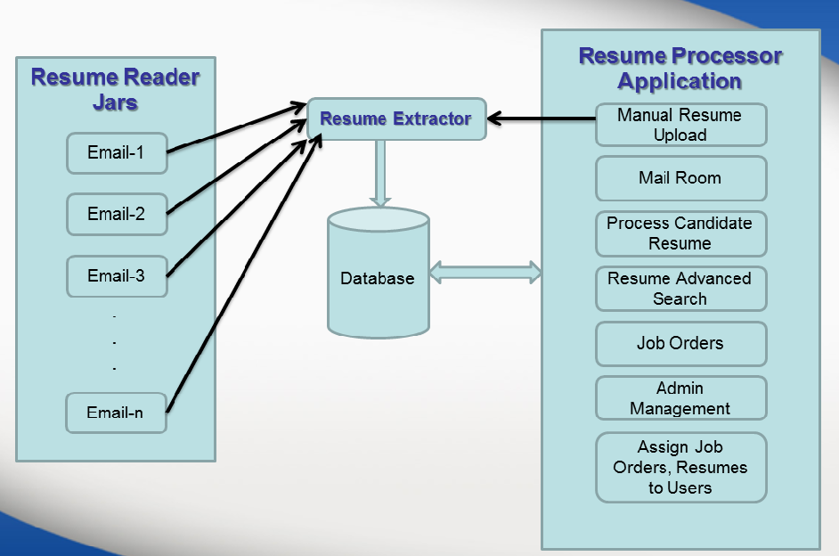

**MODULES:**

* Login/Logout
* Roles
* Mail Room
  + Keep In View
  + Upload Resume
* Resume Processor
* Job Orders
* Resume Folder
* Advance Resume Search
* Admin Management
  + User Management
  + Assign Email URN
  + Assign User URN
  + Company Management

**Login / Logout:**

* We Providing the Secure login with user password encryption.
* Providing the Forget Password.
* While logout we clear the temporary files from cache for the corresponding user for saving the server space.

**Breinbox Login UI Image:**

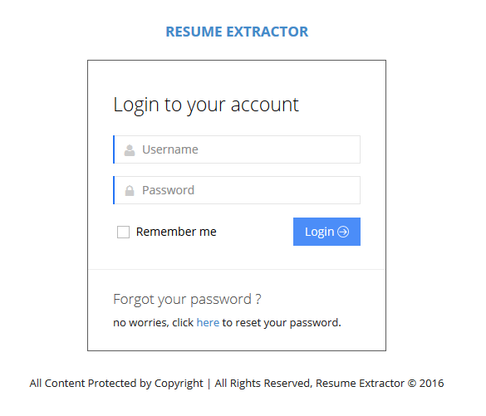

**Login Process Flow Diagram:**

Password Match

Password Not Match

User Found

User Not Found

Authenticate

Check Password Match

Login Success

Database

Login Page (User Id , Password)

Get User by User Id

**Breinbox Forget Password UI Image:**

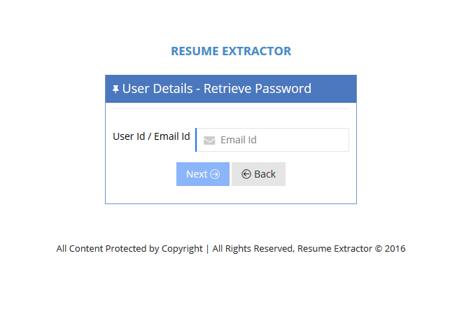

**Roles:**

Here we are using the roles are,

* SuperAdmin
* Admin
* Manager
* Executive

**Roles Flow Diagram:**

Super Admin

Admin

Executive

Manager

**Mail Room:**

* Admin can view the all Incoming Attachment Email in Mail Room.
* Here Admin can Upload the Resume as Manually also.
* Here each Resume have the unique “Resume URN(Unique Resume Number)”
* Here Admin can View, Delete and Move the Resumes to “Keep In View ” or “Archive”
* Admin can click the Resume URN to view the Resume Candidate Information.

**Process Flow Diagram:**

Request

Action

Database

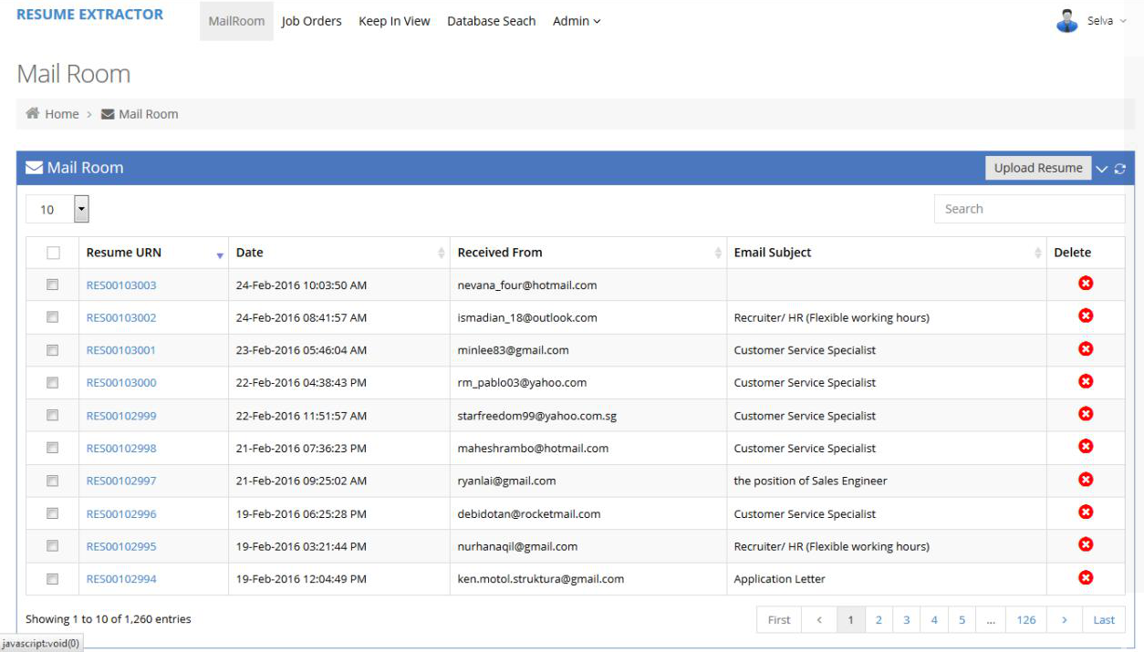

**Mail Room UI Image:**



**Mail Room – Keep In View / Archive:**

* Admin can select a single or multiple Resume to move to “Keep In View” or “Archive”
* “Keep In View” means, these Resumes are processed later, until these are keep in view.
* “Archive” means, these Resumes are processed immediately.
* And also can “Delete” the selected Resumes.

**Keep In View / Archive Resume UI Image:**

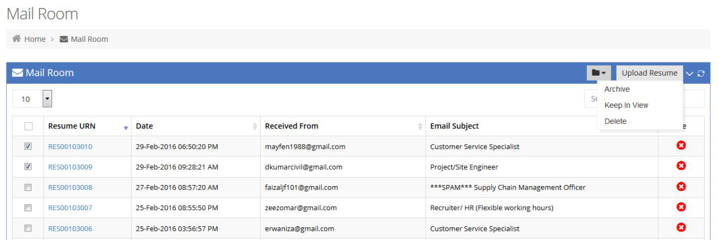

**Mail Room – Upload Resume:**

* Admin can upload the Resume Manually.
* While uploading Resume admin can provide the information like Candidate Email, Name & etc..,

**Resume Upload Process Flow Diagram:**

Upload Resume

Action

Database

Copy File to Repository location

Save Resume and repository location to DB

**Resume Upload UI Image:**

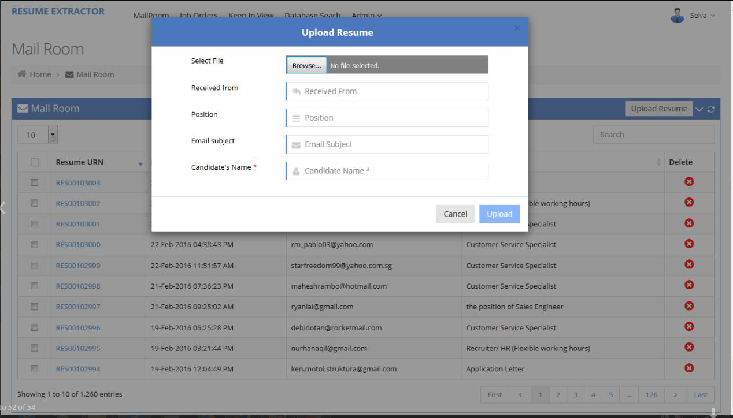

**Resume Processor:**

The Resume Processor is nothing but, View the Candidate Resume Information.

* + Candidate Basic Information
  + Candidate Contact Information
  + Candidate Professional Experience
  + Candidate Education
  + Candidate Interview History
  + Candidate Contact Logs
  + Assign Job Orders to the Candidate
  + View the Resume

**Resume Candidate Information UI Image:**

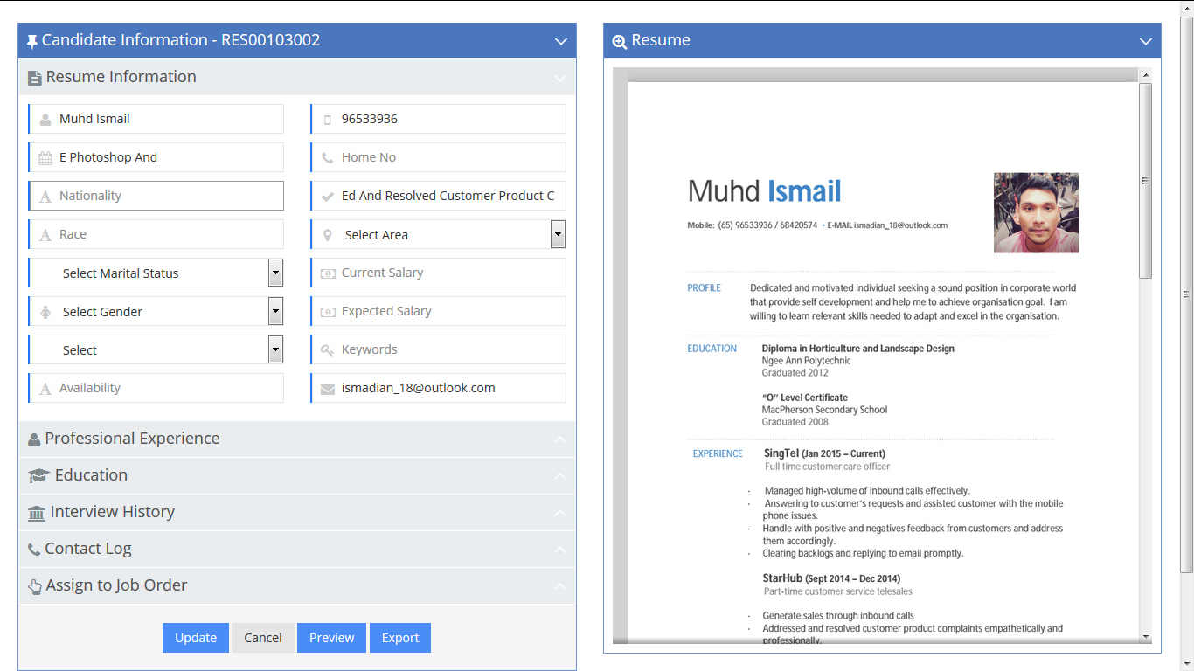

**Job Orders:**

* Job Orders have the Unique Job Id.
* Admin can Create, Update and Delete the Job Orders and Assign it to other Employees.

**Job Orders UI Image:**

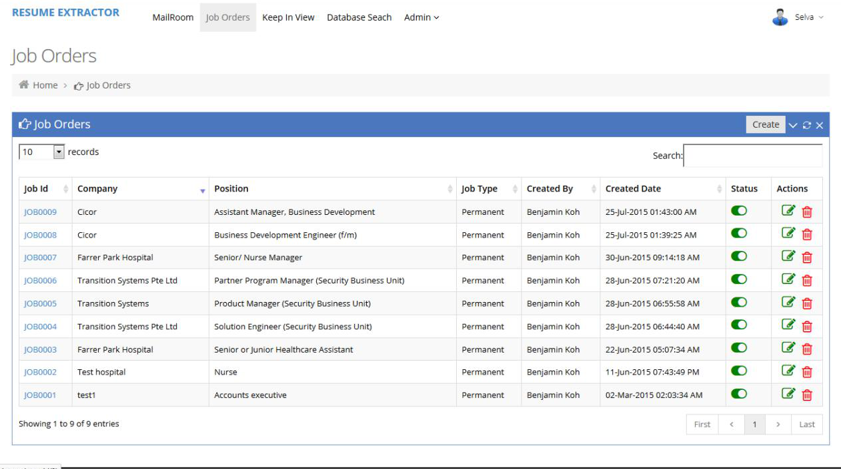

**Job Order - Create & Update:**

* Admin can create and update the job order.

**Job Position Create UI Image:**

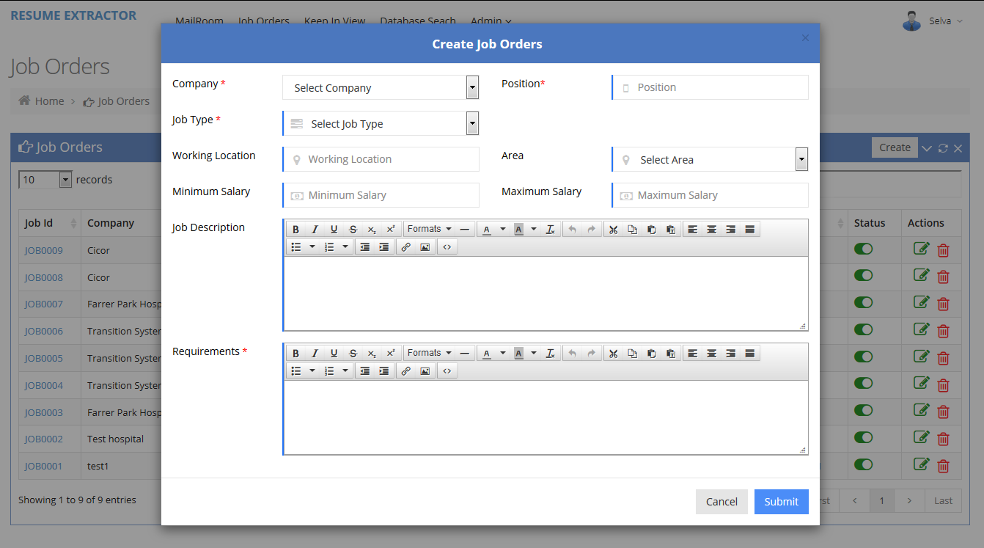

**Job Order - Assign Job Order:**

* Admin can assign the selected job order to other users.

**Job Order Assign UI Image:**

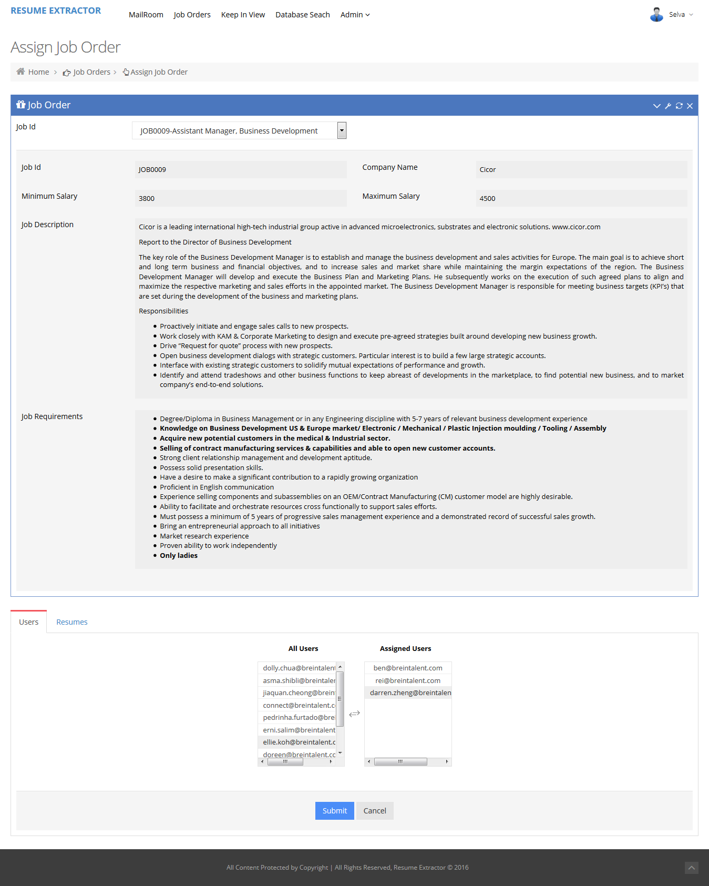

**RESUME FOLDER:**

* Admin can create the Folder to hold the Resumes.
* Admin can Assigns any Resumes to any Folder

**Resume Folder & Add New Resume Folder UI Image:**

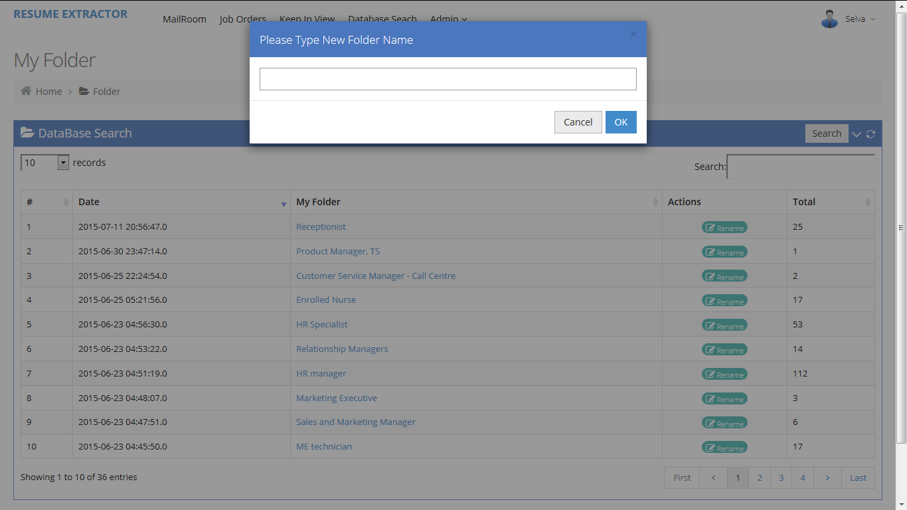

**Advance Resume Search:**

Admin can Search and Filters the Resumes by,

* + Keyword
  + Positions
  + Company
  + Area and Highest Qualifications
  + Gender and Race
  + Expected Salary Minimum & Maximum
  + Current Salary Minimum & Maximum
  + Resume Folder

**Advanced Resume Search UI Image:**

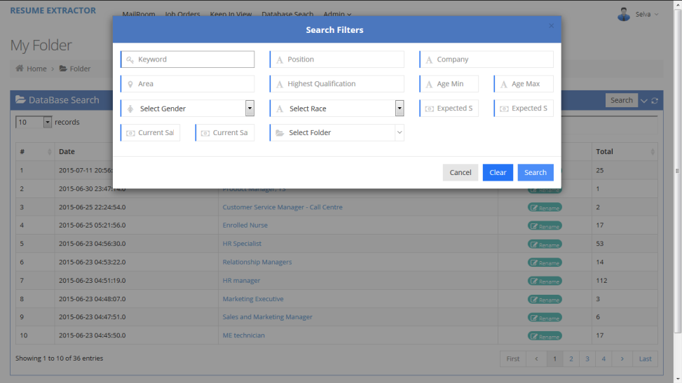

**Advanced Resume Search Flow Diagram:**

Resume Advance Search with Keywords

Action

Database

Generate sql query as per keywords



Request

**Admin Management:**

In Admin Management, Admin can do below rights,

* + User Management
  + Assign Resume Reader Jar Email
  + Company Management

**User Management:**

* Admin can Create, Update & Delete the Users
* Admin can Edit the User Roles as Admin or Manager or Executive
* Admin can reset the any user password.

**User Management UI Image:**

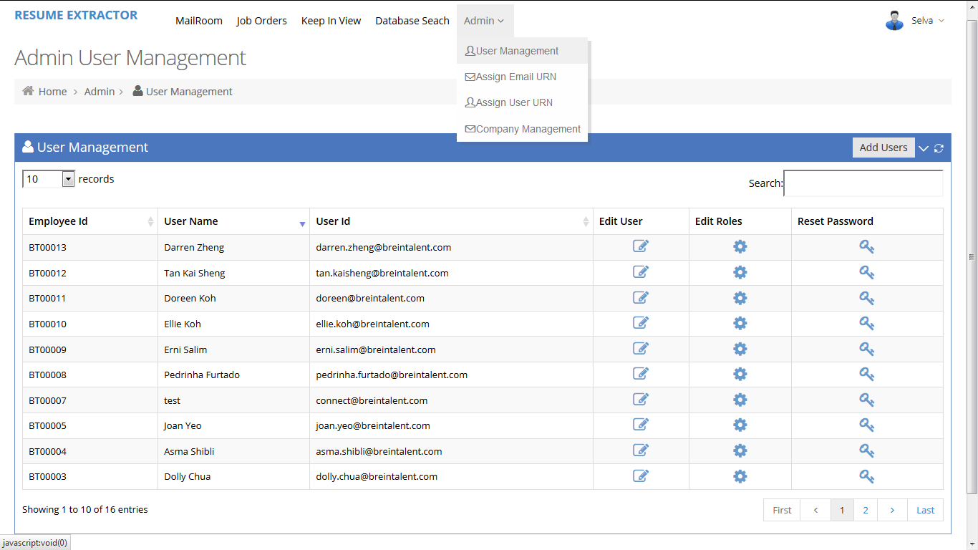

**Assign Mail Reader Email To ResumeURN:**

* Admin can Create Mail Reader Emails and assign the mail with unique Resume URN.
* Admin can Activate & Deactivate the Emails in mail reader.

**Mail Reader Email UI Image:**

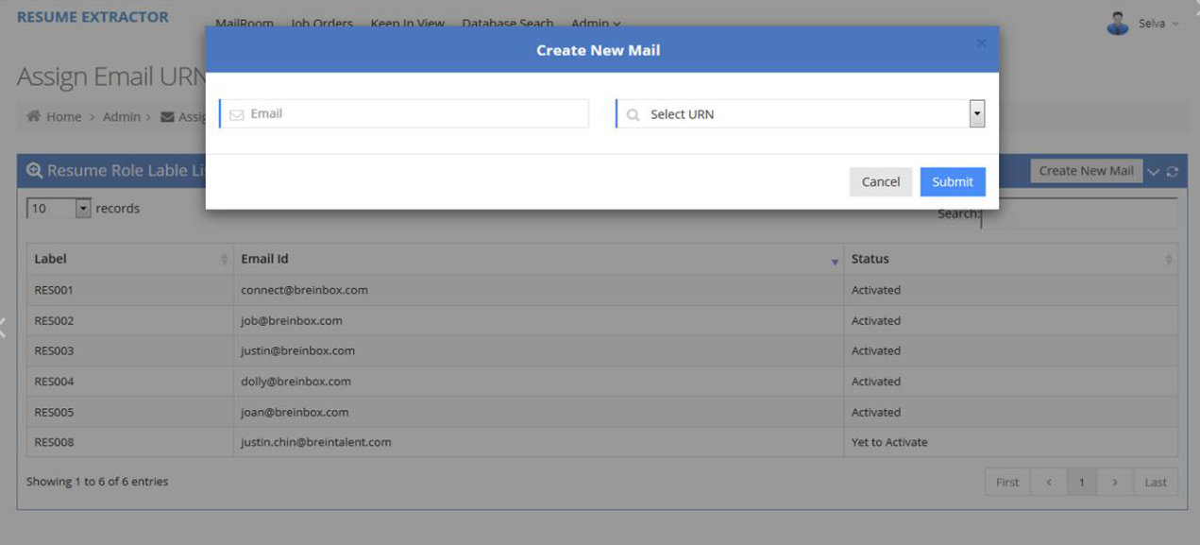

**Assign Mail Reader Email To User:**

* Admin can Assign & Remove any User to the mail Reader Jar Email
* It shows the Assigned and unassigned user list of email account.

**Assign Mail Reader Email to User UI Image:**

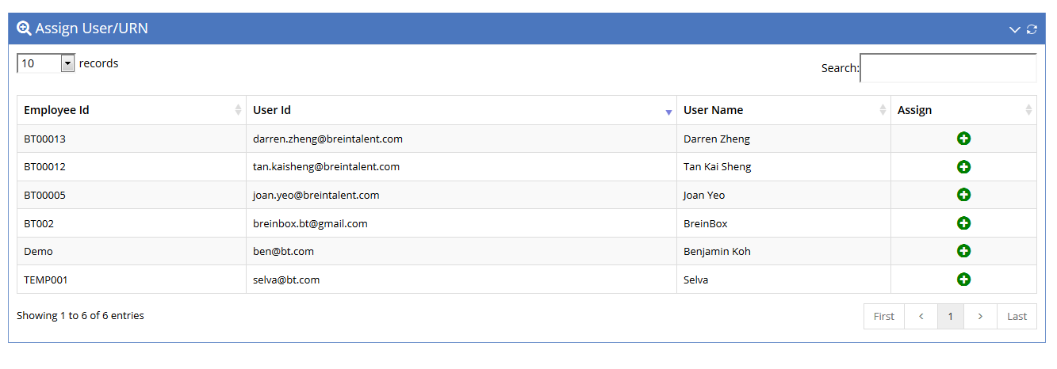

**Remove Mail Reader Email to User UI Image:**

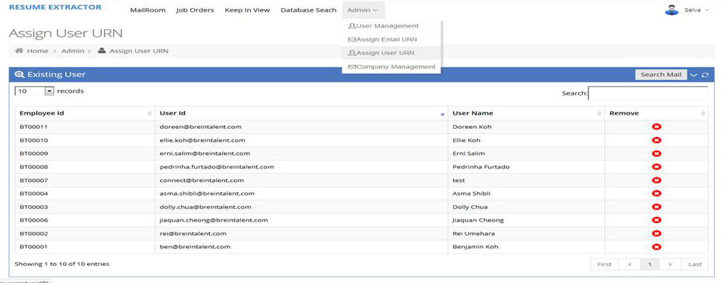

**Company Management:**

* Admin can Create, Update & Delete the Company.
* Each company has the unique Company Id.
* These Companies are used to create a job orders.

**Company Management UI Image:**

