Disys PDF Generate

Version 1.0.1

User Manual

|  |  |  |  |  |
| --- | --- | --- | --- | --- |
| **S. No** | **Document Version** | **Updated By** | **Reviewed By** | **Release Date** |
| 1 | 1.0.1 | Raja N |  |  |
| 2 |  |  |  |  |
|  |  |  |  |  |
|  |  |  |  |  |
|  |  |  |  |  |
|  |  |  |  |  |
|  |  |  |  |  |
|  |  |  |  |  |

***Disys***

Thymeleaf Templates with Spring Boot using Editor Spring Tool Suite(STS)

Latest workspace path : **E:\User\Raja\Suresh_Disys_WorkSpaces\HBS_DISYS** 🡪 selva Dell Laptop,

DataBase : MySql /localhost:3306/disys_test

**Description:**

Disys Pdf generate is

Home page

Project Page

Assign Job Title

Assign Job Title with List

**Home Page**

Home page is Job Description and Project’s details input page, Project name is dropdown used already defined names get from Database. Then Job Title is job position names this show dropdown value from Database, Experience and Grade viewed based on choosed Project name and Job Title name, Location and Reports To is enter the values, Shift timings is Predefined values used dropdown,Type of Position is enter the value, Working Hours is enter the value, Reviewed By is enter the value, Approved By is Enter the value That all submit button based on viewing PDF file generate about the project details.

Home page is home.html designed, Project List, Job Title List, Shift Timing List, Grade List

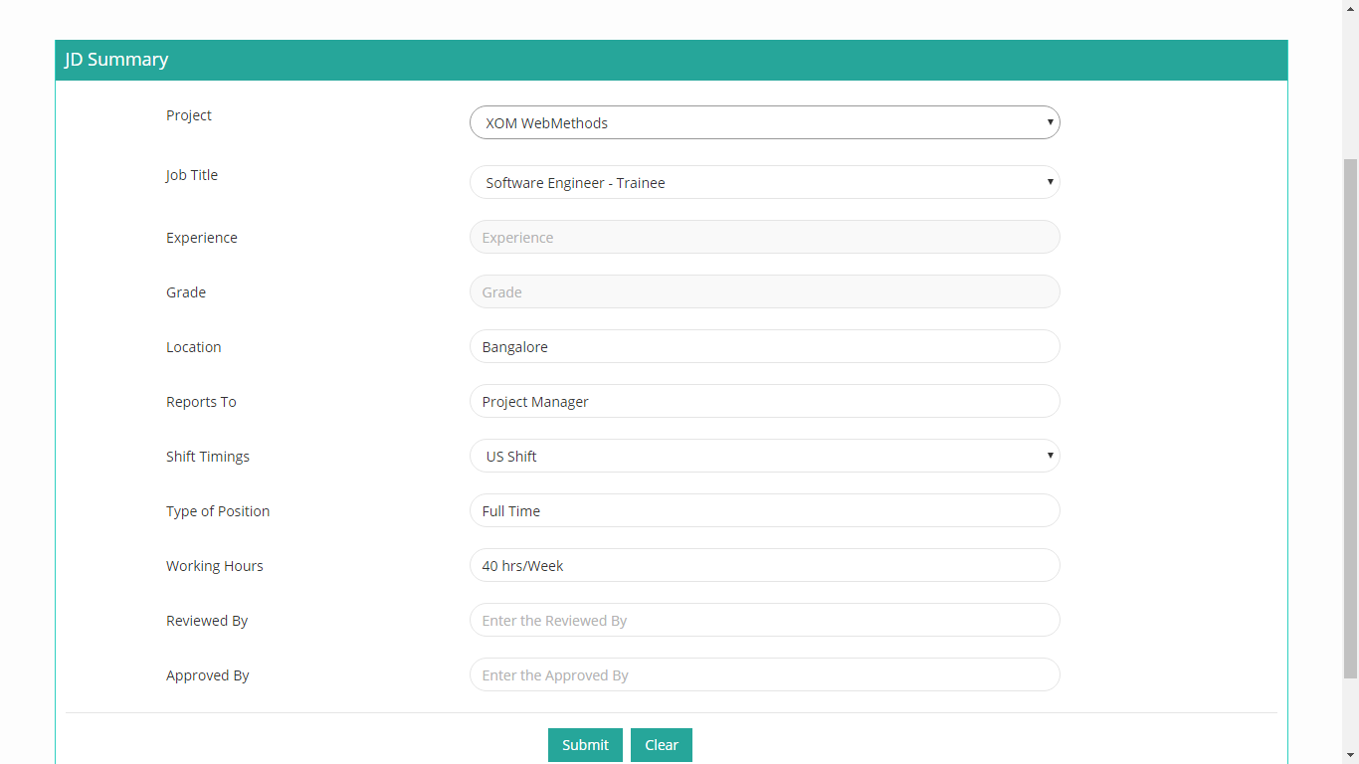

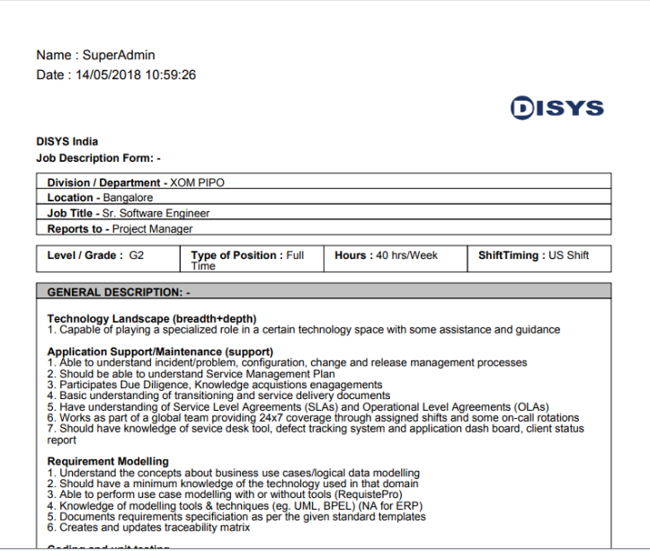

**Log Button,** This are view already generate Job Descript summary logs are PDF file name, Created Date, User Id, User Name Logs show it.

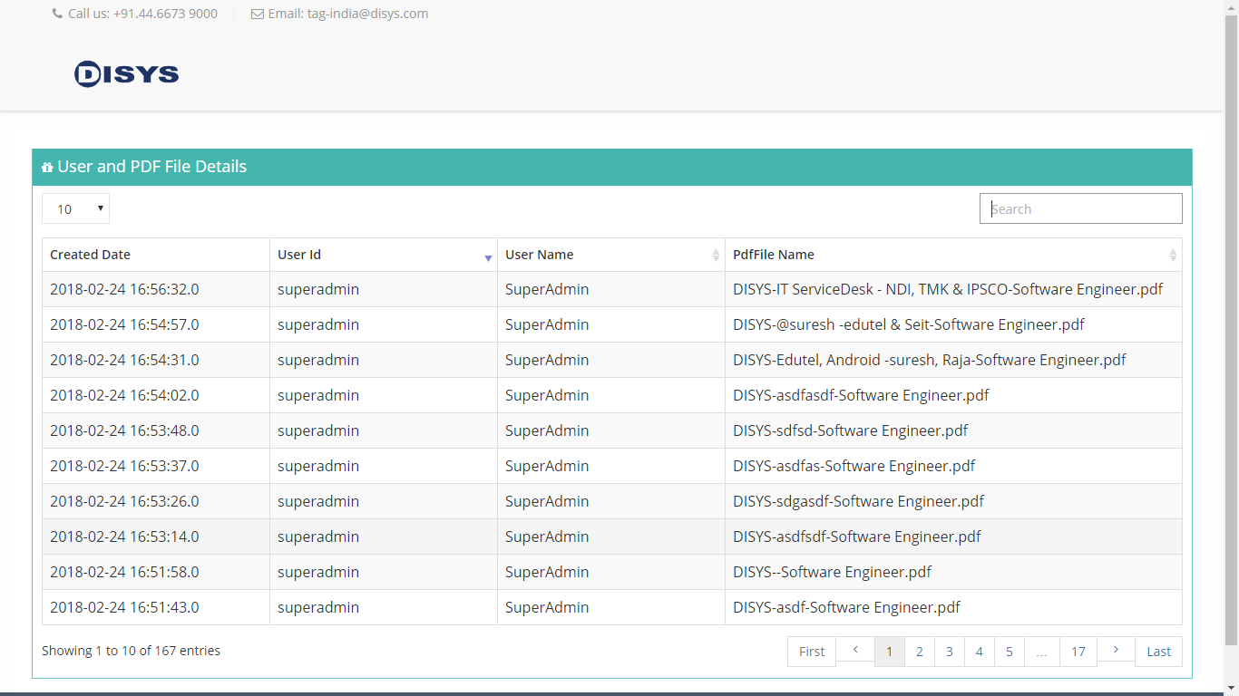

**Project Page**

http://localhost:8090/disys/f86faa6bbf9ac94a7e459509a20

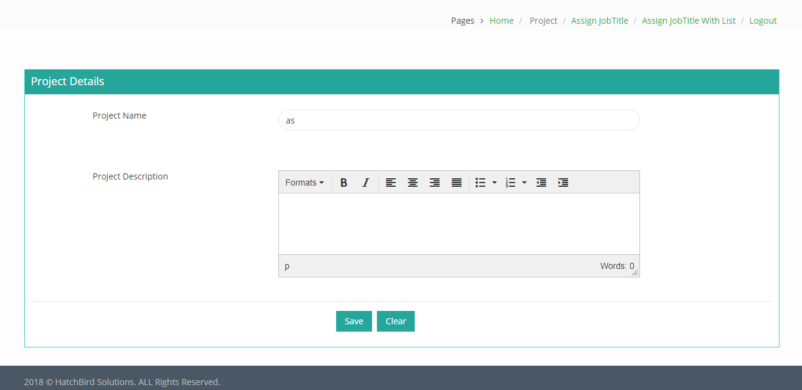

Project Page is Project’s details put on fields, saved, we are try already defined name show the warning message.

**Assign Job Title Page**

**http://localhost:8090/disys/f91709c28e7e1a9127df3d234cc**

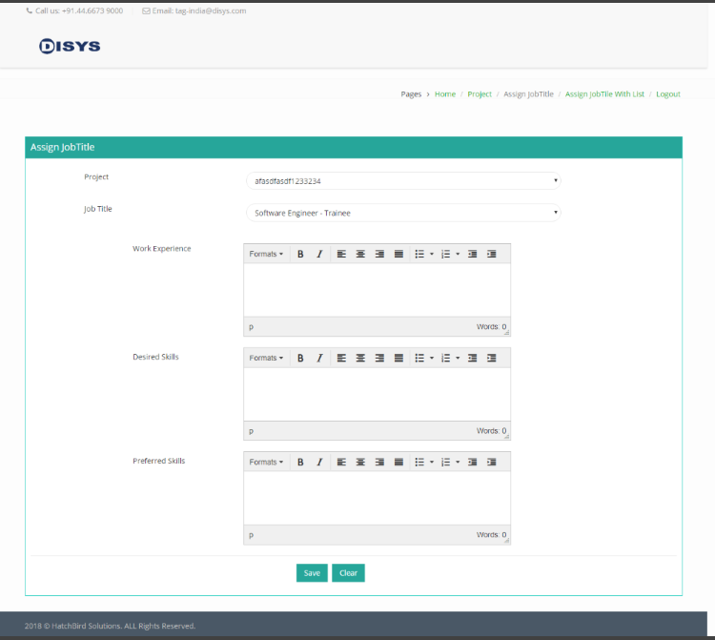

Assign job Title page is already defined project to assign job title and skills added such as Work Experience, Desired Skills, Preferred Skills using editor input fields saved to Assign job title in DataBase.

**Assign JobTitle With List Page**

**http://localhost:8090/disys/c832398520c6db9d8dd62cf17353**

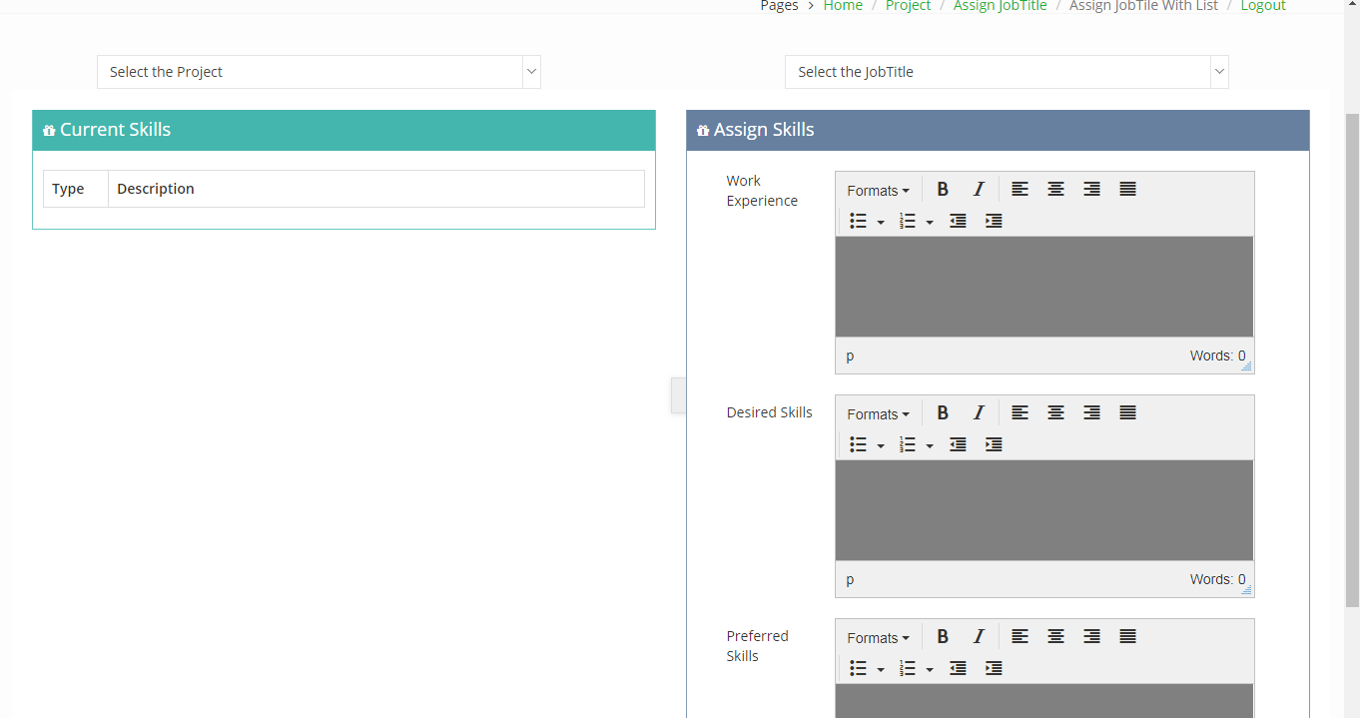

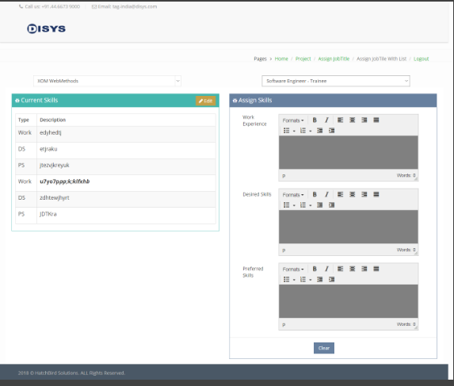

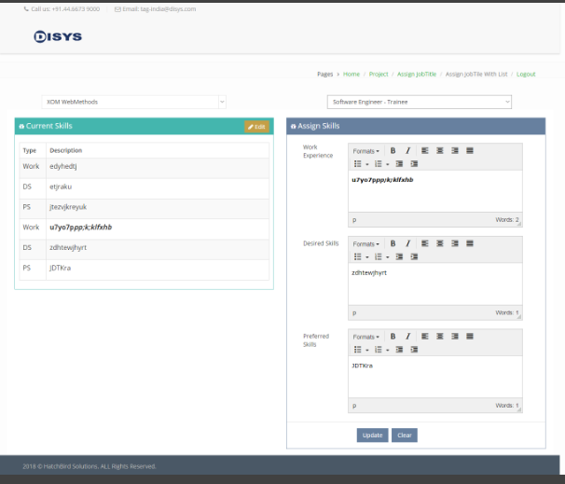

Assign Job Title List page is Project and Job title based on Current skills is editing operation, add or update skills are work experience, Desired skills, Peferred skills are update to DataBase