[ec2-user@ip-172-31-37-215 share]$ **yum install wget**

**ERROR :**You need to be root to perform this command.

[**http://stackoverflow.com/questions/26958741/extract-tar-the-tar-bz2-file-error**](http://stackoverflow.com/questions/26958741/extract-tar-the-tar-bz2-file-error)

root user used this installed

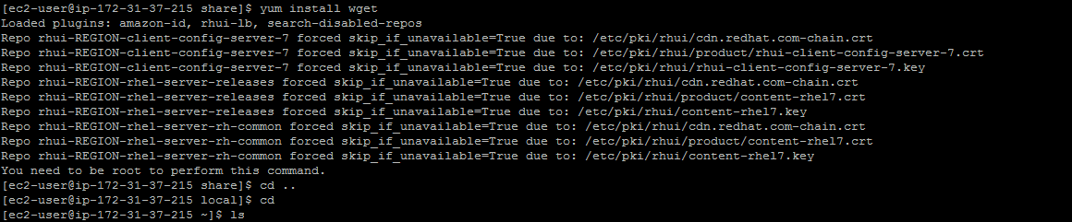

**Sudo Su - used in root user**

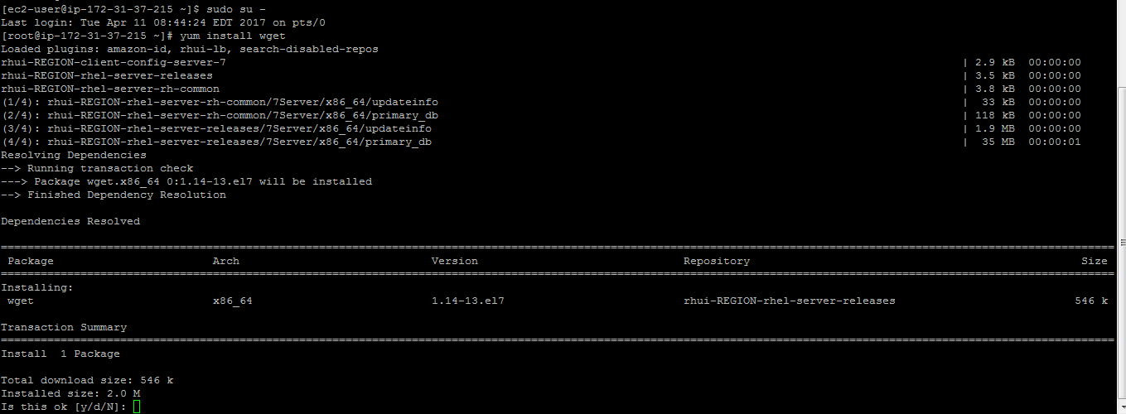

**After installed**

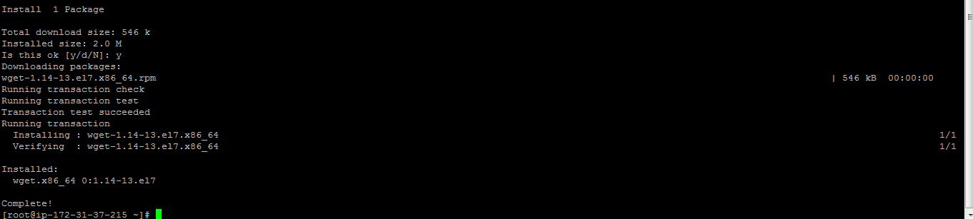

[**https://www.bonusbits.com/wiki/HowTo:Install_PhantomJS_on_CentOS**](https://www.bonusbits.com/wiki/HowTo:Install_PhantomJS_on_CentOS)

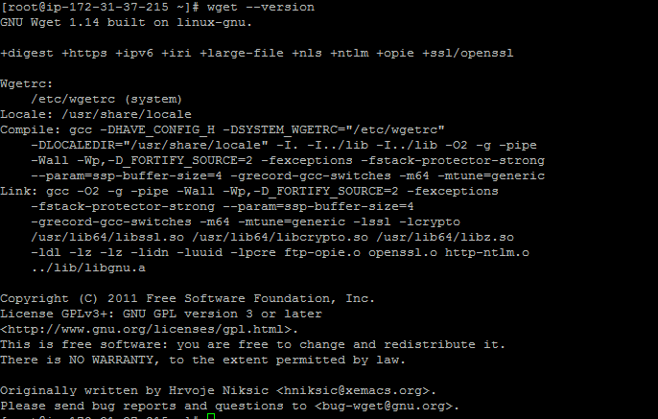

**Phantom js install**

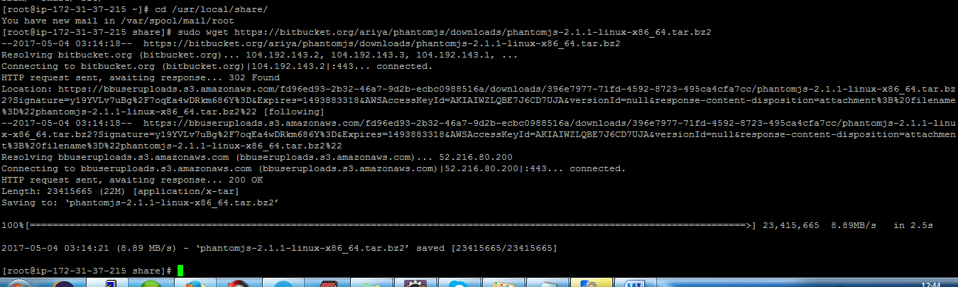

**https://bitbucket.org/ariya/phantomjs/downloads/phantomjs-2.1.1-linux-x86_64.tar.bz2**

[**http://stackoverflow.com/questions/26958741/extract-tar-the-tar-bz2-file-error**](http://stackoverflow.com/questions/26958741/extract-tar-the-tar-bz2-file-error)

we used **tar** command first used this **–xvf**

Using this URL follow:

https://www.dvdheiden.nl/2013/07/30/installing-phantomjs-and-casperjs-on-linux/

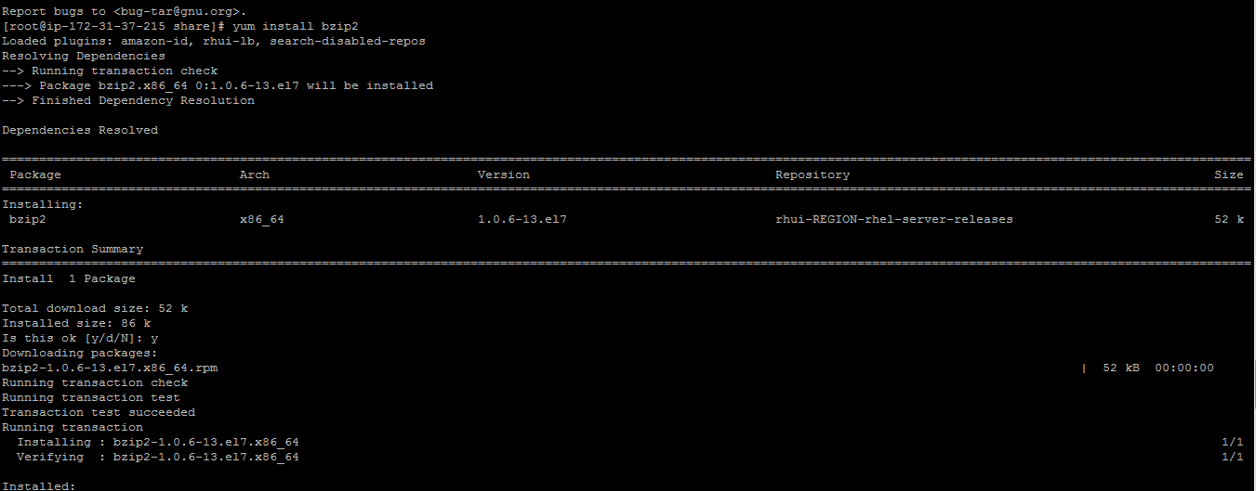

**http://stackoverflow.com/questions/26958741/extract-tar-the-tar-bz2-file-error**

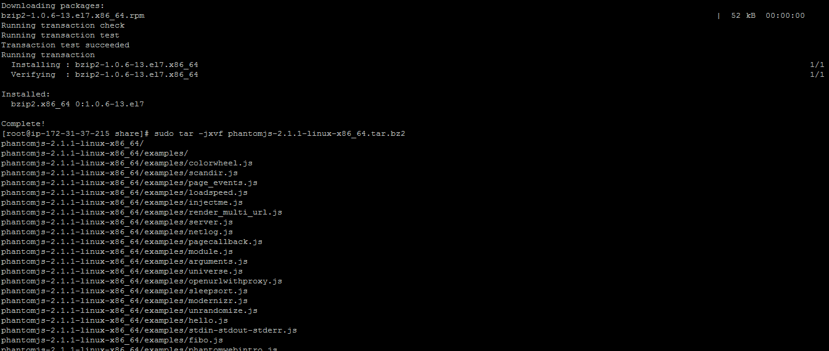

**Rename that**

[root@ip-172-31-37-215 share]# **sudo mv** phantomjs-2.1.1-linux-x86_64phantomjs-2.1.1

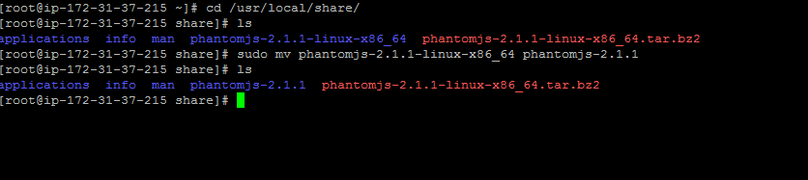

[ec2-user@ip-172-31-37-215 share]$ **sudo ln -s** /usr/local/share/phantomjs-2.1.1/ **/usr/local/share/phantomjs**

[ec2-user@ip-172-31-37-215 share]$ **sudo ln -s** /usr/local/share/phantomjs/bin/phantomjs **/usr/local/bin/phantomjs**

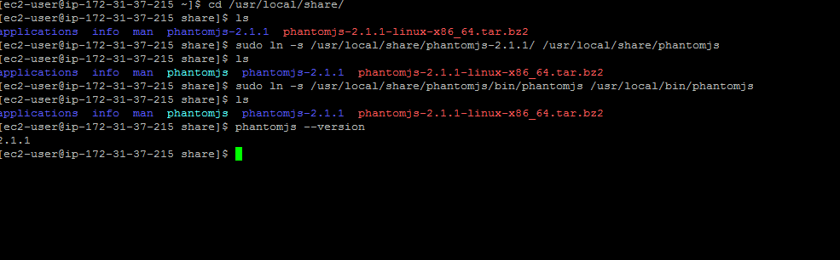

**sudo wget -O casperjs.tar** [**https://github.com/casperjs/casperjs/tarball/1.1.0**](https://github.com/casperjs/casperjs/tarball/1.1.0)

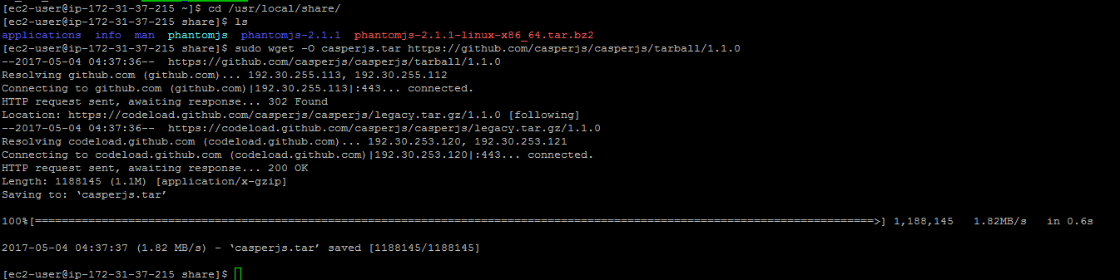

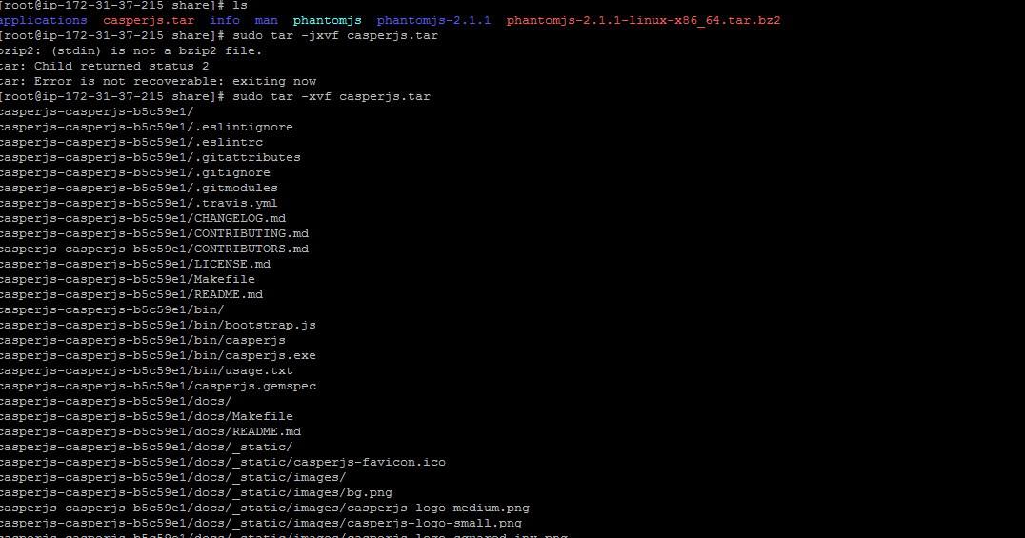

[root@ip-172-31-37-215 share]# **sudo mv** casperjs-casperjs-b5c59e1 **casperjs-b5c59e1**

[root@ip-172-31-37-215 share]# **sudo ln -s** /usr/local/share/casperjs-b5c59e1/ **/usr/local/share/casperjs**

[root@ip-172-31-37-215 share]# **sudo ln -s** /usr/local/share/casperjs/bin/casperjs **/usr/local/bin/casperjs**

