MAGNET

Version 1.0.2

User Manual

|  |  |  |  |  |
| --- | --- | --- | --- | --- |
| **S. No** | **Document Version** | **Updated By** | **Reviewed By** | **Release Date** |
| 1 | 1.0.1 | Vishnu Moorthy K | Hariharan | 21-May-16 |
| 2 | 1.0.2 | Raja N |  |  |
|  |  |  |  |  |
|  |  |  |  |  |
|  |  |  |  |  |
|  |  |  |  |  |
|  |  |  |  |  |
|  |  |  |  |  |

***Magnet***

**Description:**

Magnet is a web application to process the Resumes who are looking for their respective jobs. Here the each customer has an unique account to create the Job Positions for their company and search the candidates for the corresponding job positions. The Customer can choose the candidates from the available resumes, which are assigned for the corresponding customers.

New Frontend Themes designed pages in before login page

Home page

About Us Page

How IT Works Sign Up

Login Page

**NEW_INDEX**

http://localhost:8080/magnet/index.psg;jsessionid=A3912EEA6831E161B6B3935360C452B0

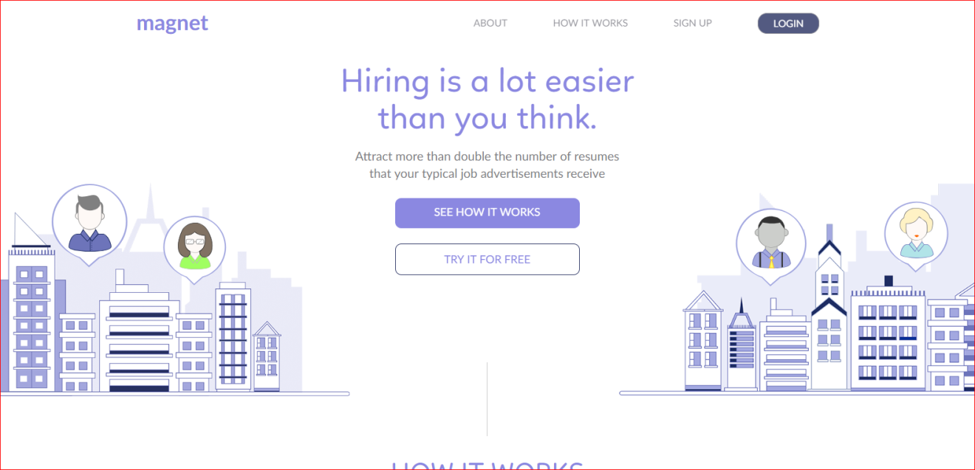

http://localhost:8080/magnet/aboutUs.psg

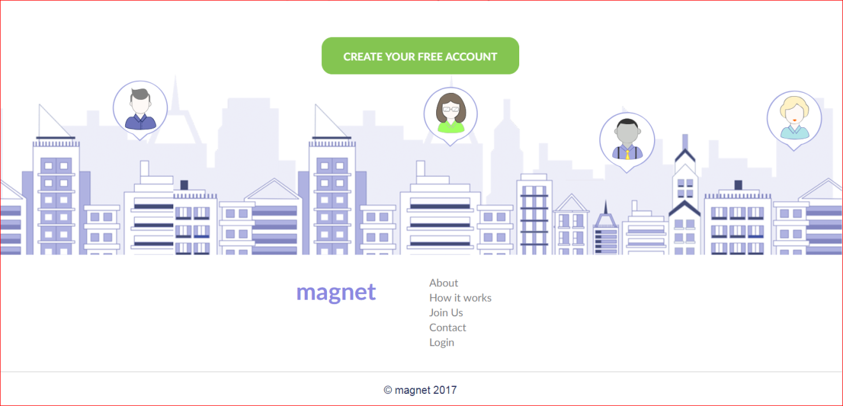

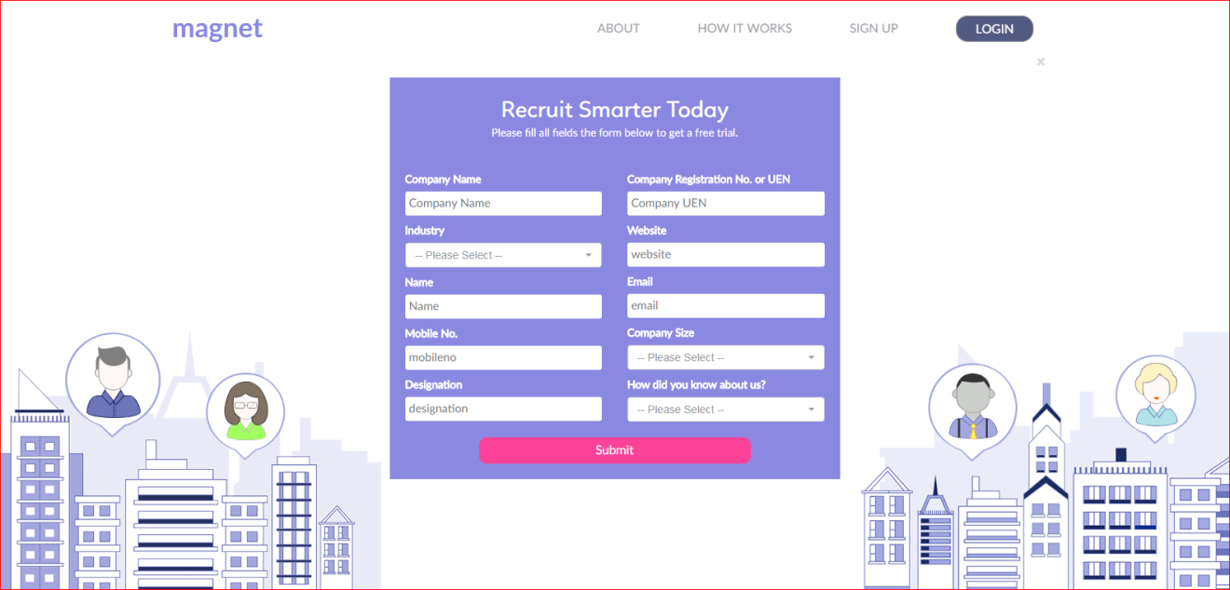

http://localhost:8080/magnet/contact.psg

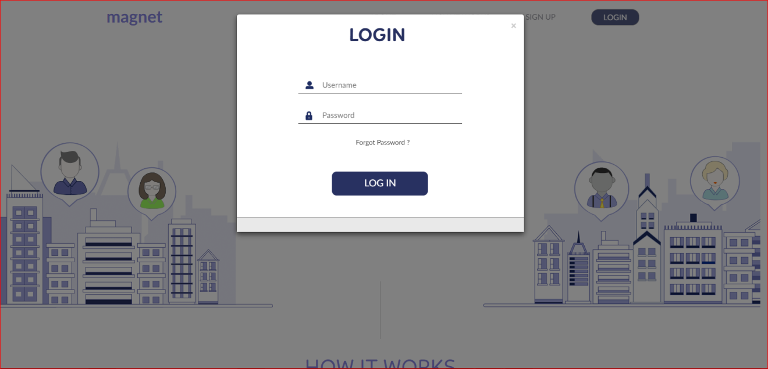

NEW_CAREER

**UAT**

UAT Workspace some added modules

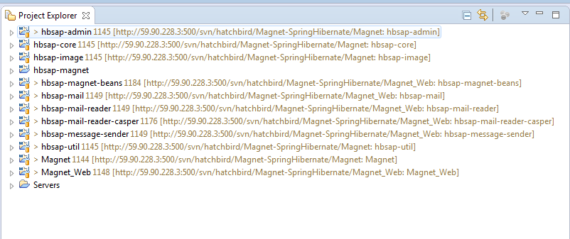

**Customer side**

**Menus**

DashBoard - Live/UAT

Positions - Live/UAT

Search - UAT

Calender - UAT

**Positions**

**Live** advertise screenshort view

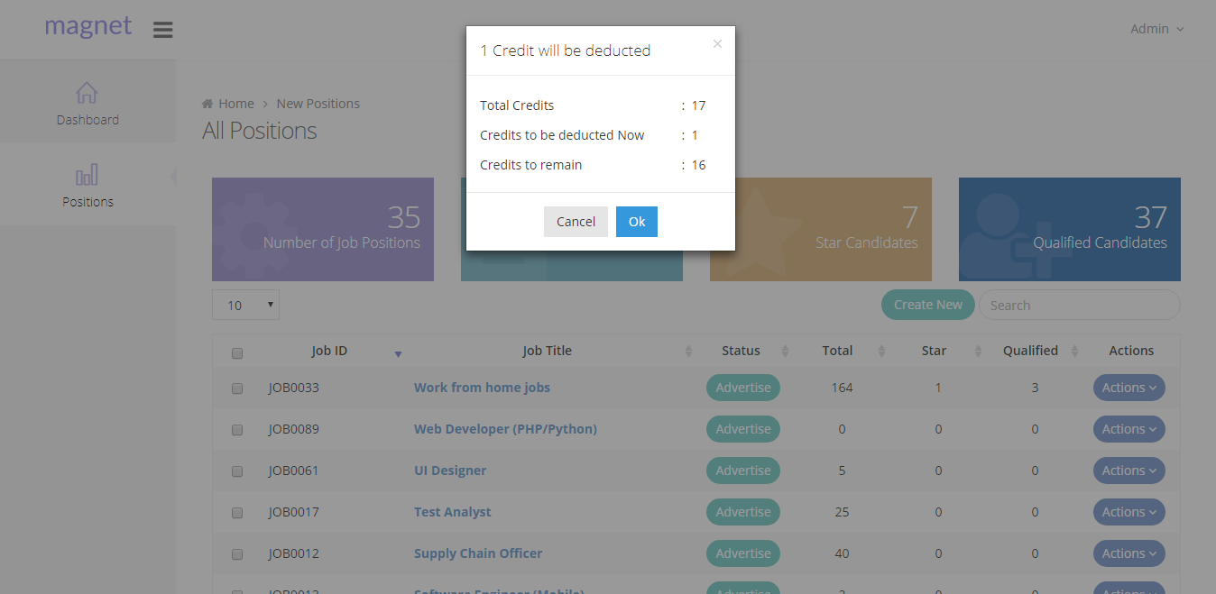

Positions -> added Advertise Button model box added informations **UAT**

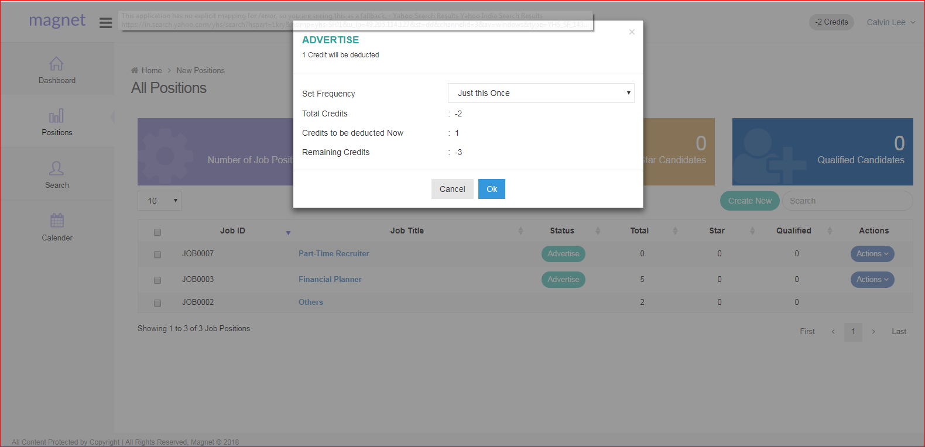

**Search in UAT**

Search menu is resumes filter some fields available are

Keywords, Gender, JobTitle, Expected Salary, Nationality, Highest Qualification

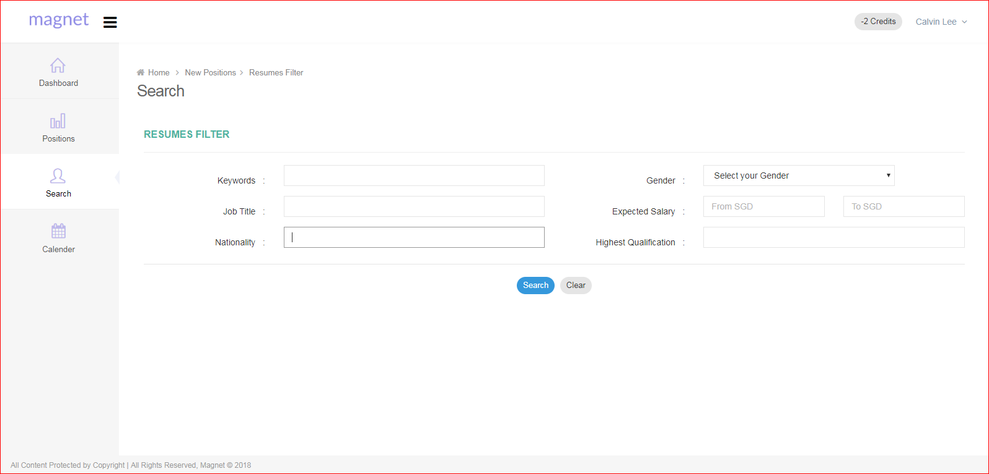

**Calendar in UAT**

Calendar view UI designed for scheduler interview and some other features

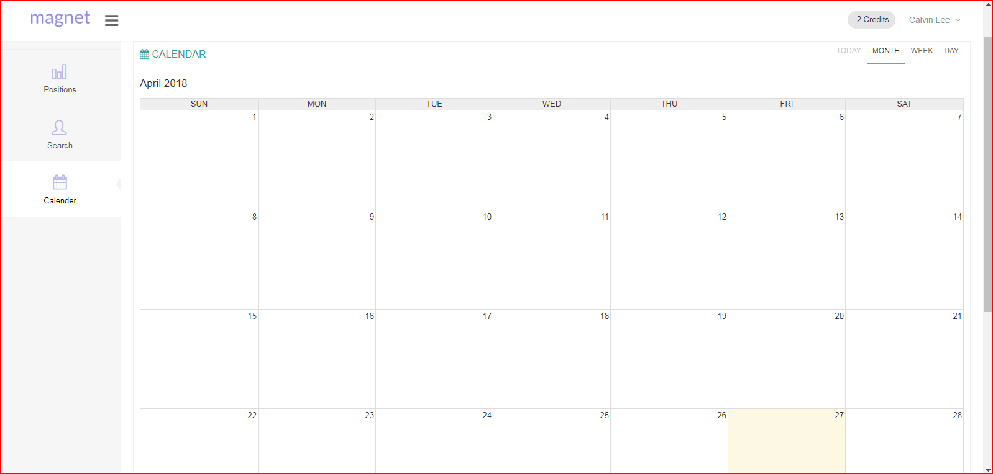

Job Title : Auto complite functionality used in text field 2 and 3 letter type is come

Job title display From database.

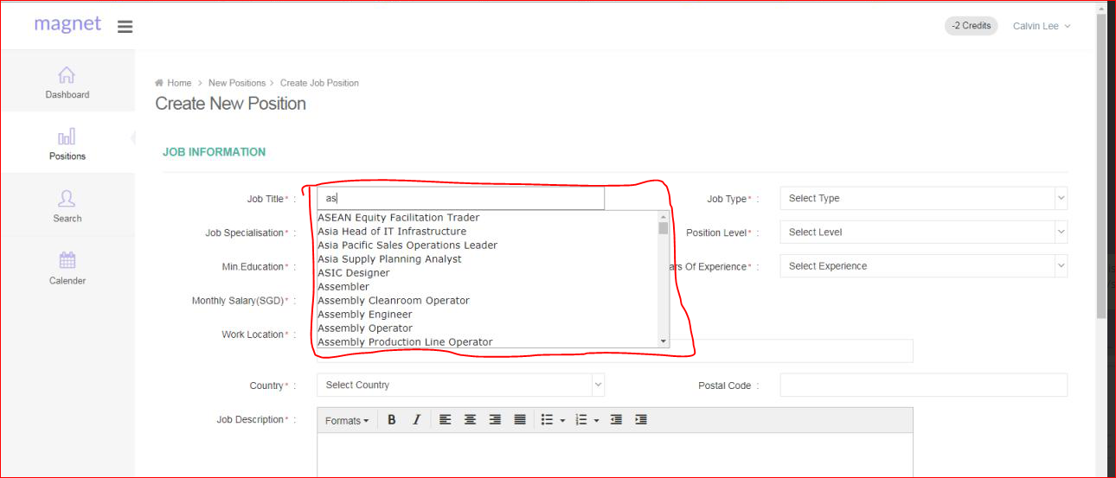

Live / UAT : new tab window in Browser used Resume URN link and symbols icons

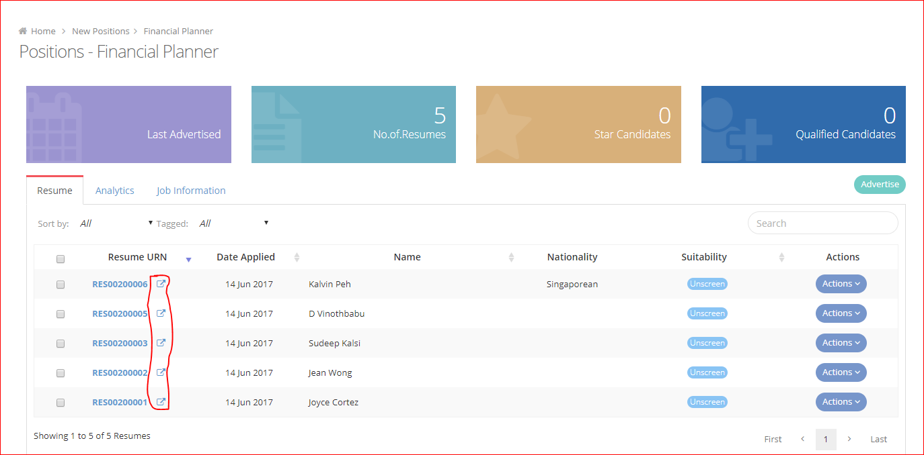

**Live:** Resume view Applicant Personal, Comments, Activity used tabs

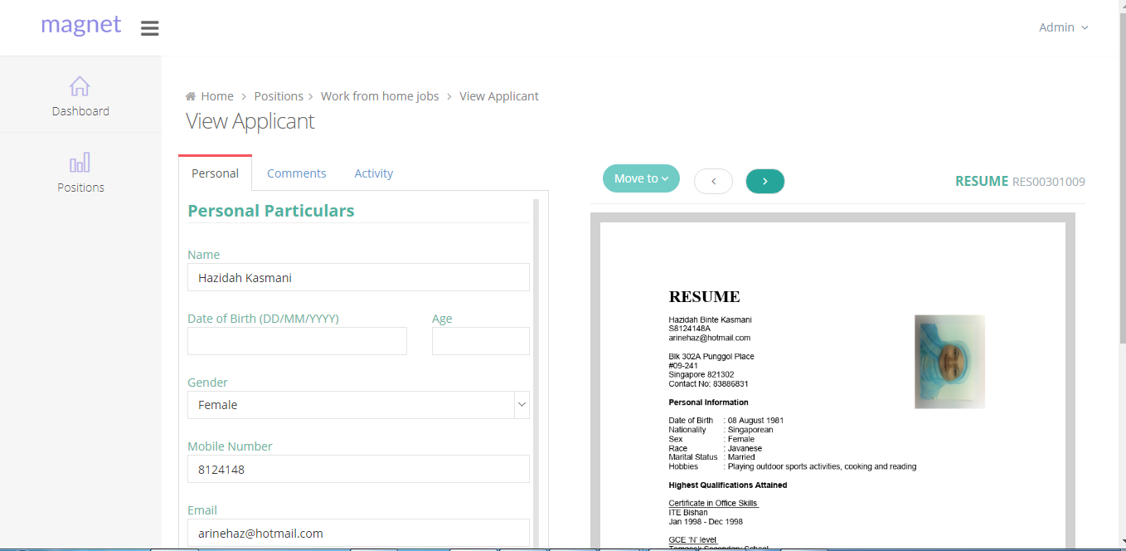

**UAT : View Applicant**

Personal, **Email**, **Schedule Interview**, Comments, Activity used Tabs

Email, Schedule Interview tabs are new created in UAT

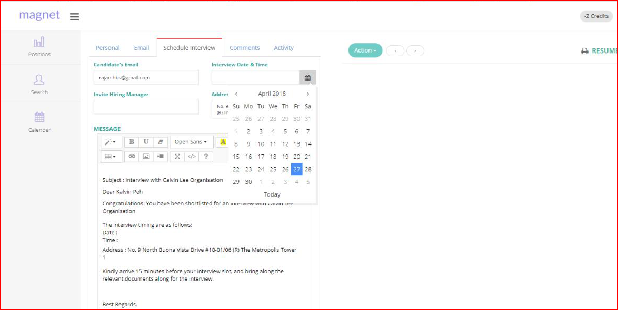

**Schedule Interview:**

Candidate’s Email field is mandatory this field value who will send interview schedule email id need it,

Interview Date & Time will allecate date to that candidate,

Invite Hiring Manager will enter Hiring Manager name

Address field that Customer’s company address is viewed or lets will change it.

Message Editor details display this part

**Live / UAT** Resume Move to Another job positions Options in Right side Blue tic mark

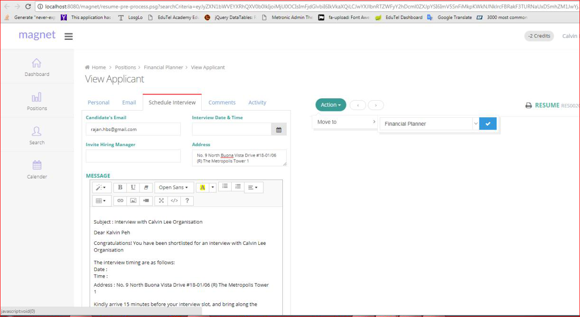

**Nationality and Highest Education** fields are particular values wanted that,

Changed to Live and UAT

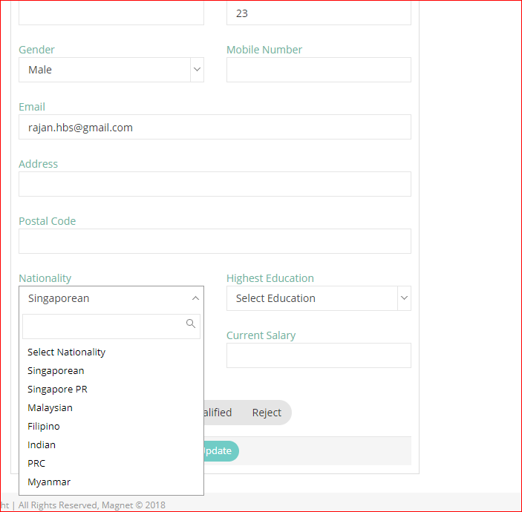

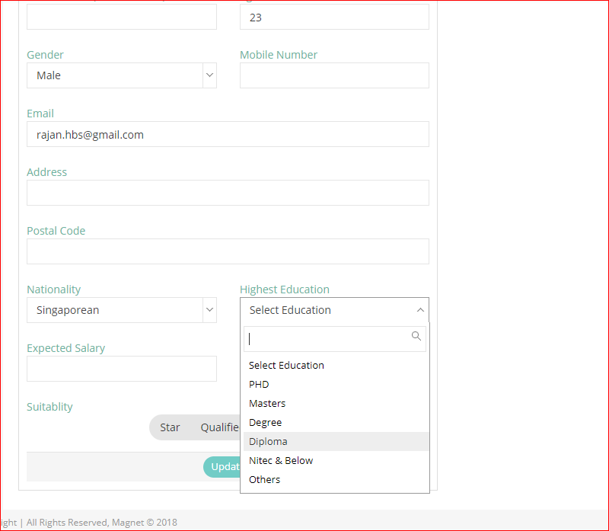

**Settings:**  Magnet career page viewed link used view field in **Live and UAT**

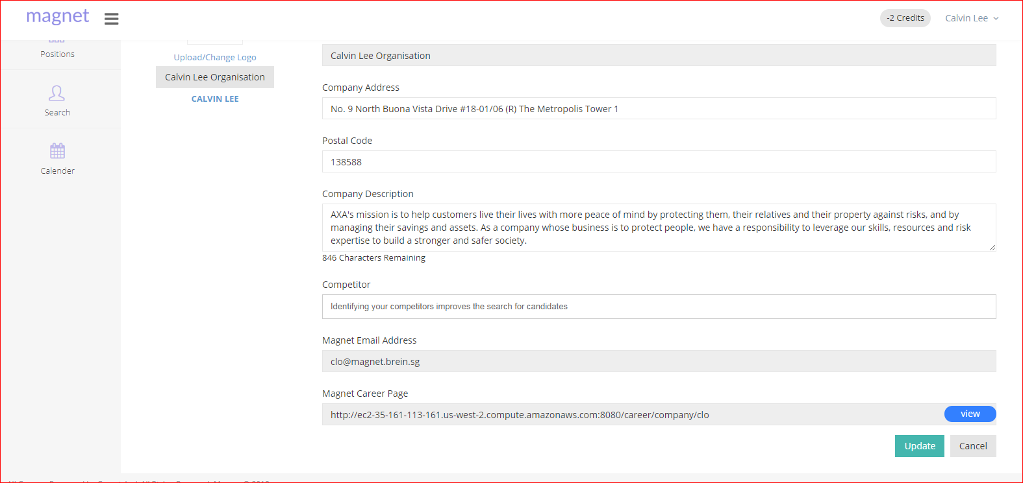

**Roles Module:**

1. *SuperAdmin – Admin Role*
2. *Admin – Admin Role*
3. *Manager – Employee Role*
4. *Executive – Employee Role*
5. *HR Manager – Customer Role*
6. *Hiring Member – Customer Role*
7. ***Super User _ Customer Role UAT***

**Admin Module:**

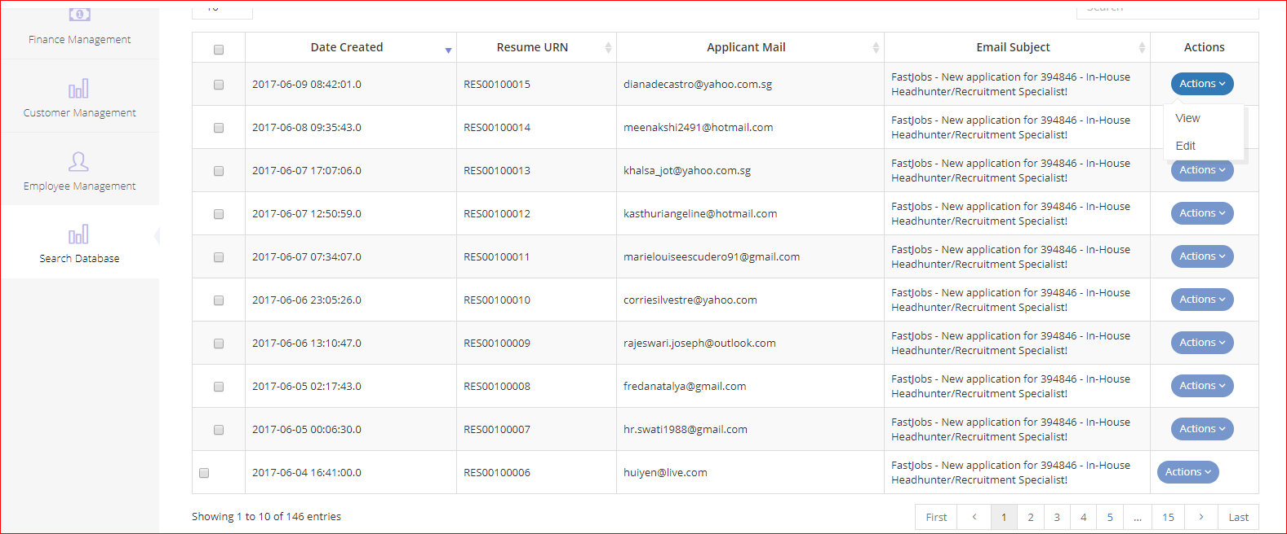

**Customer Management User Interface:**

* In this section, we will list all the customers, which were created by the Admin User or Employee Userwith status as “**Live**”.
* Admin User can Add, View, Edit, Credit Top Up and Change Customer Status periodically if it is required.

**Customer Management Image:**

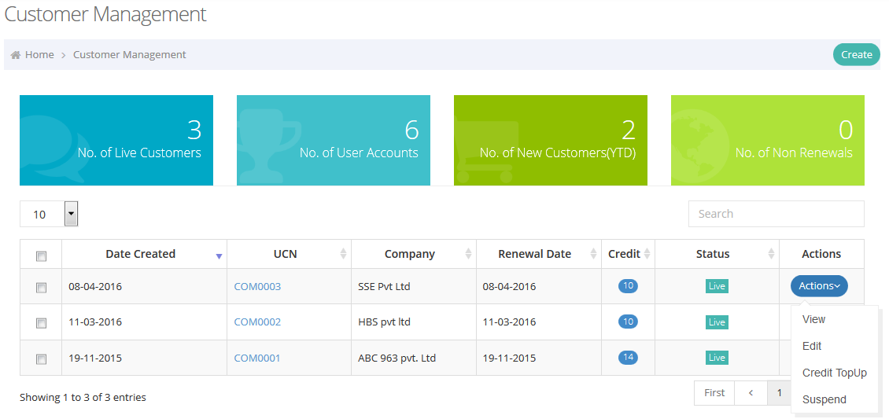

**Customer Management page**

Actions – added **DeActivated Email** and **view Credit logs**,

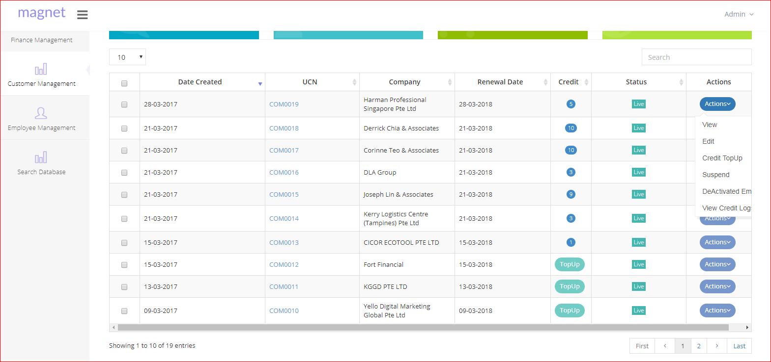

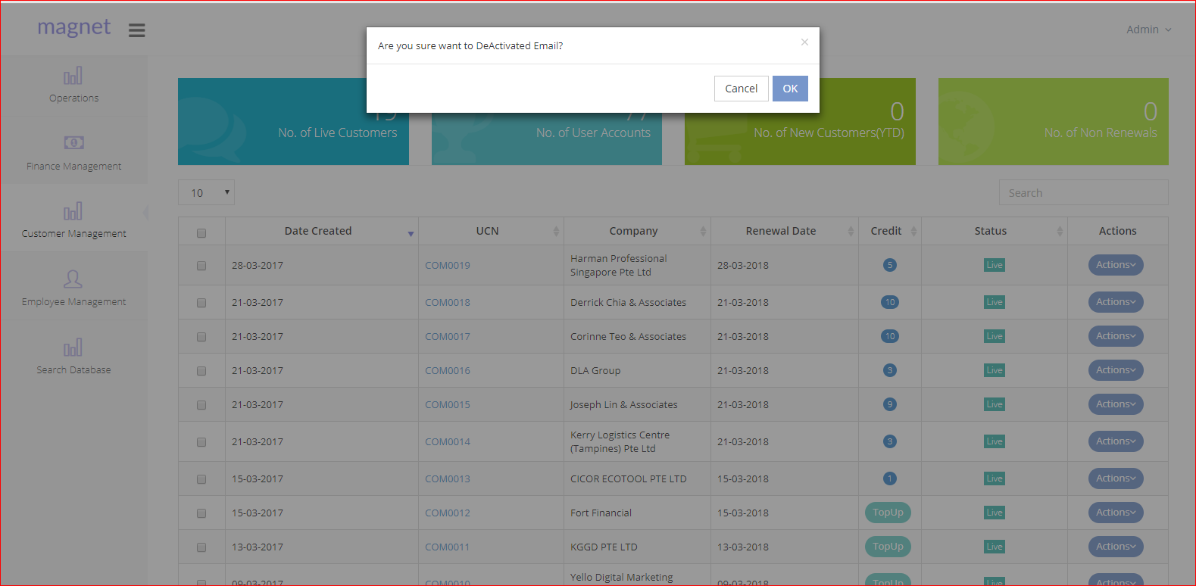

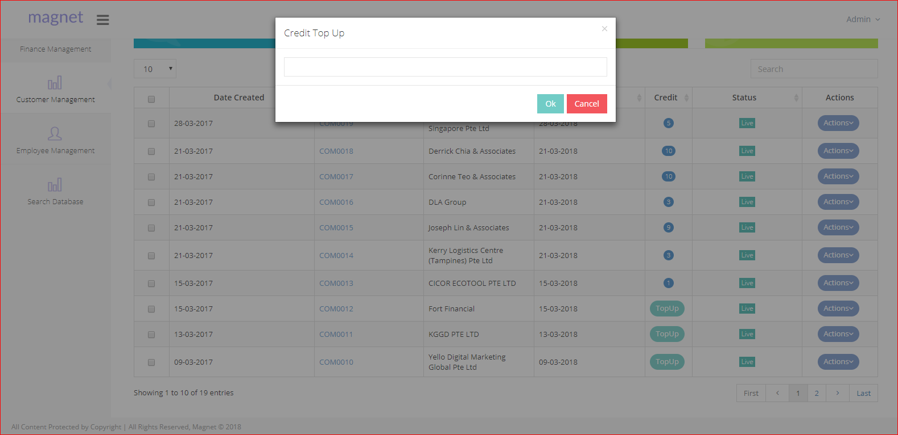

**View Credit Logs**

Viewing Every customer’s credit logs using datatable

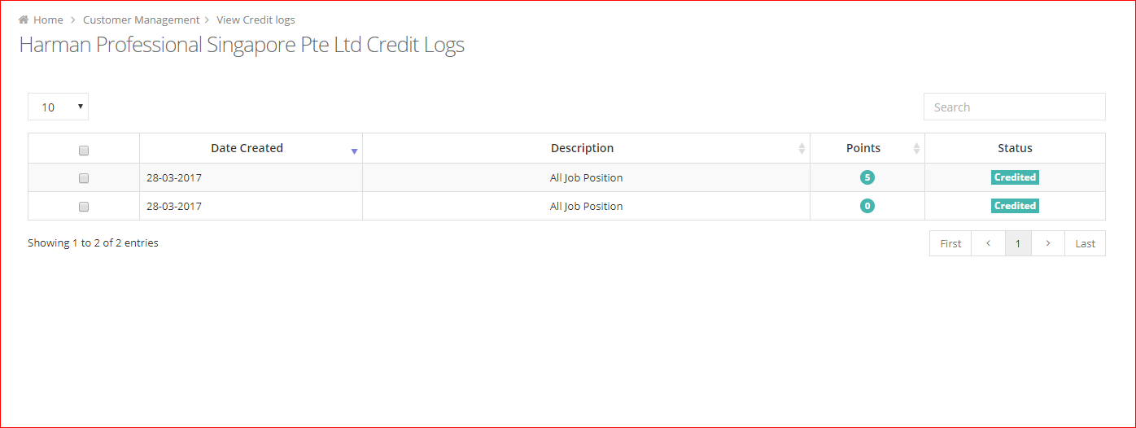

**Create Customers:**

To create the Customer, we need to get the following information from the Customer,

1. Company Information
2. Contact Person Information

