MAGNET

Version 1.0

User Manual

|  |  |  |  |  |
| --- | --- | --- | --- | --- |
| **S. No** | **Document Version** | **Updated By** | **Reviewed By** | **Release Date** |
| 1 | 1.0.1 | Vishnu Moorthy K | Hariharan | 21-May-16 |
|  |  |  |  |  |
|  |  |  |  |  |
|  |  |  |  |  |
|  |  |  |  |  |
|  |  |  |  |  |
|  |  |  |  |  |
|  |  |  |  |  |

***Magnet***

**Description:**

Magnet is a web application to process the Resumes who are looking for their respective jobs. Here the each customer has an unique account to create the Job Positions for their company and search the candidates for the corresponding job positions. The Customer can choose the candidates from the available resumes, which are assigned for the corresponding customers.

**Project Modules:**

* Login/Logout
* Roles
* Admin
  + Dashboard
  + Operation Management
  + Customer Management
  + Finance Management
  + Employee Management
  + Resume Management
* Client/Customer
  + Dashboard
  + Job Positions
  + Job Position Analysis
  + Resume Management

**Login / Logout Module:**

* We are providing the secured login mechanism with user password encryption method SHA.
* If the login success, it checks the user roles, If it is one or all the roles are admin roles, then it redirects the corresponding admin dashboard, otherwise if it has more than one role and if any one role is customer role then it lists the available roles to login.
* Providing the Forget Password.
* While logout we clear the temporary files from cache for the corresponding user for saving the server space.

**Process Flow Diagram:**

User Found

Password Match

Database

Login Page (User Id , Password)

Get User by User Id

Check Password Match

Check user role size

Authenticate

User Not Found

Password Not Match

Role size is one

Role size is more than one

All roles are Admin Role

Any one role is customer role

Shows corresponding role dashboard

Shows Role Based Login page

**Login Screen Shot Image**

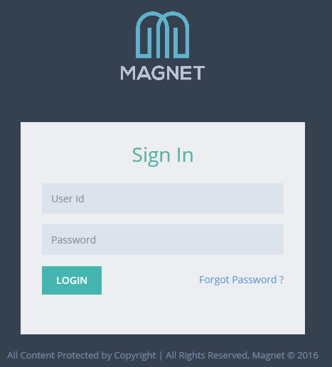

**Forgot Password:**

* Here we are providing the forget password link, through which user can reset his password.

**Forgot Password Image:**

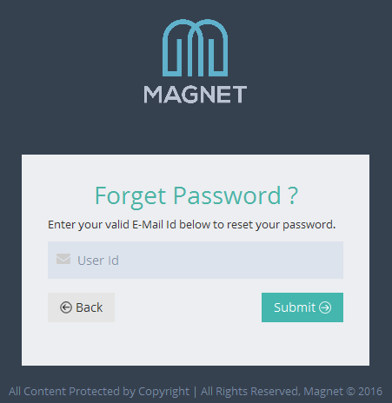

**Process Flow Diagram:**

Get user’s User Id to retrieve the password

**Database**

Get User by User Id

Create & set the new Password for the corresponding user

Authenticate

User Not Found

Encrypt the new password and update the User Object

Send Reset Password email to Corresponding user

Return login page

**Roles Module:**

1. *SuperAdmin – Admin Role*
2. *Admin – Admin Role*
3. *Manager – Employee Role*
4. *Executive – Employee Role*
5. *HR Manager – Customer Role*
6. *Hiring Member – Customer Role*

**Process Flow Diagram:**

Super Admin

Admin

Manager

Executive

HR Manager

Hiring Member

**Admin Module:**

**Operation Management User Interface:**

* In this module, we are showing all the Job Positions, which are created by the customers.
* Admin can View, Edit and Post the Job Positions in this User Interface.

**Operation Management Image:**

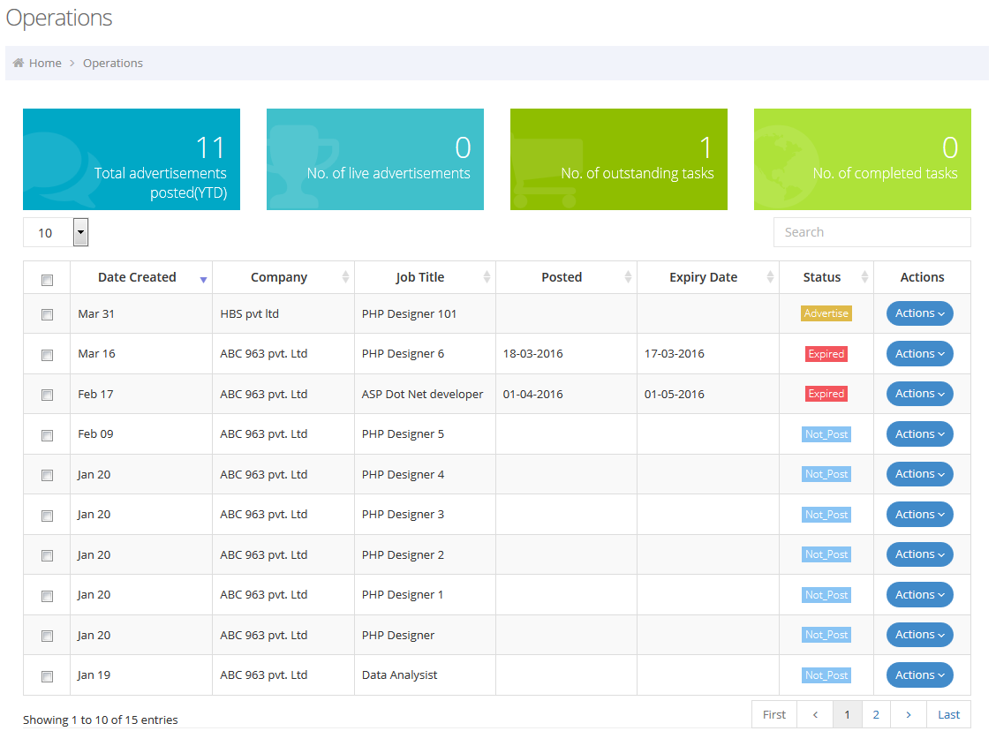

**Post Job Position:**

* Initially the job position advertisement status is mentioned “**Not_Post**” status, when it was created by customers.
* If customer wants to advertise the job position, then he needs click the “**Advertise**” button of the respective job position to intimate the Admin to Advertise or Post the job position.
* If it so, now the job position advertisement status changed to “**Pending**” state in the Admin view.
* If the Admin clicks the “Post” button to click the corresponding job position, then it automatically takes the advertisement period of one month (30 days a default period). Now the advertisement status changed to “**Advertise**”.
* After 30 days, the advertisement status changed to “**Expired**” state automatically.

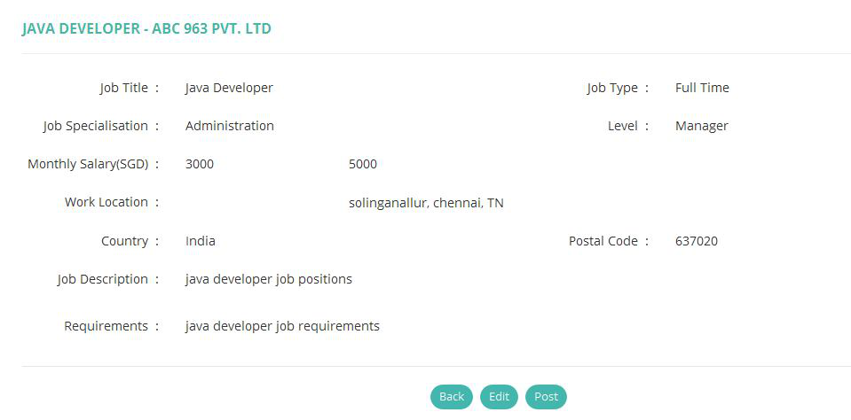

**Customer Management User Interface:**

* In this section, we will list all the customers, which were created by the Admin User or Employee User with status as “**Live**”.
* Admin User can Add, View, Edit, Credit Top Up and Change Customer Status periodically if it is required.

**Customer Management Image:**

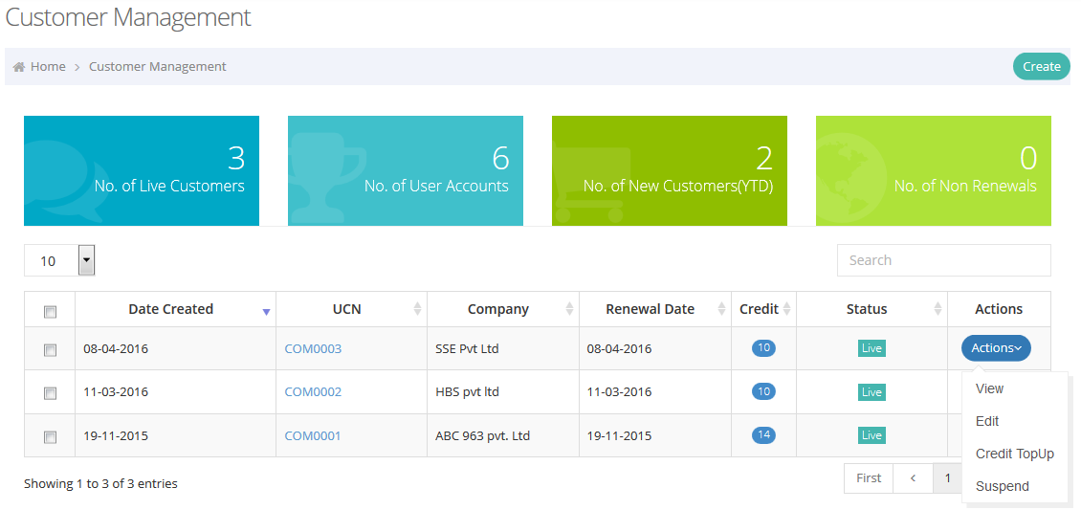

**Create Customers:**

* To create the Customer, we need to get the following information from the Customer,

1. Company Information
2. Contact Person Information
3. Package Information

* After filling all the fields and submit, then the application initiate the below operations and all the respective values will be persisted in the corresponding database table.
* Storing the Contact Person Information and assign **HRManager** role for the contact person.
* Storing the Company Information in the respective table.
* Assigning the default credits to the customer.
* Create a dummy job position in the position name as “Others”
* Send Customer Registration and User Registration Emails to the corresponding customer’s contact person.
* Create an Email Property from the customer’s **Account Id,** this email will be used to receive the resumes from the candidates and will be assigned for the specific customers.

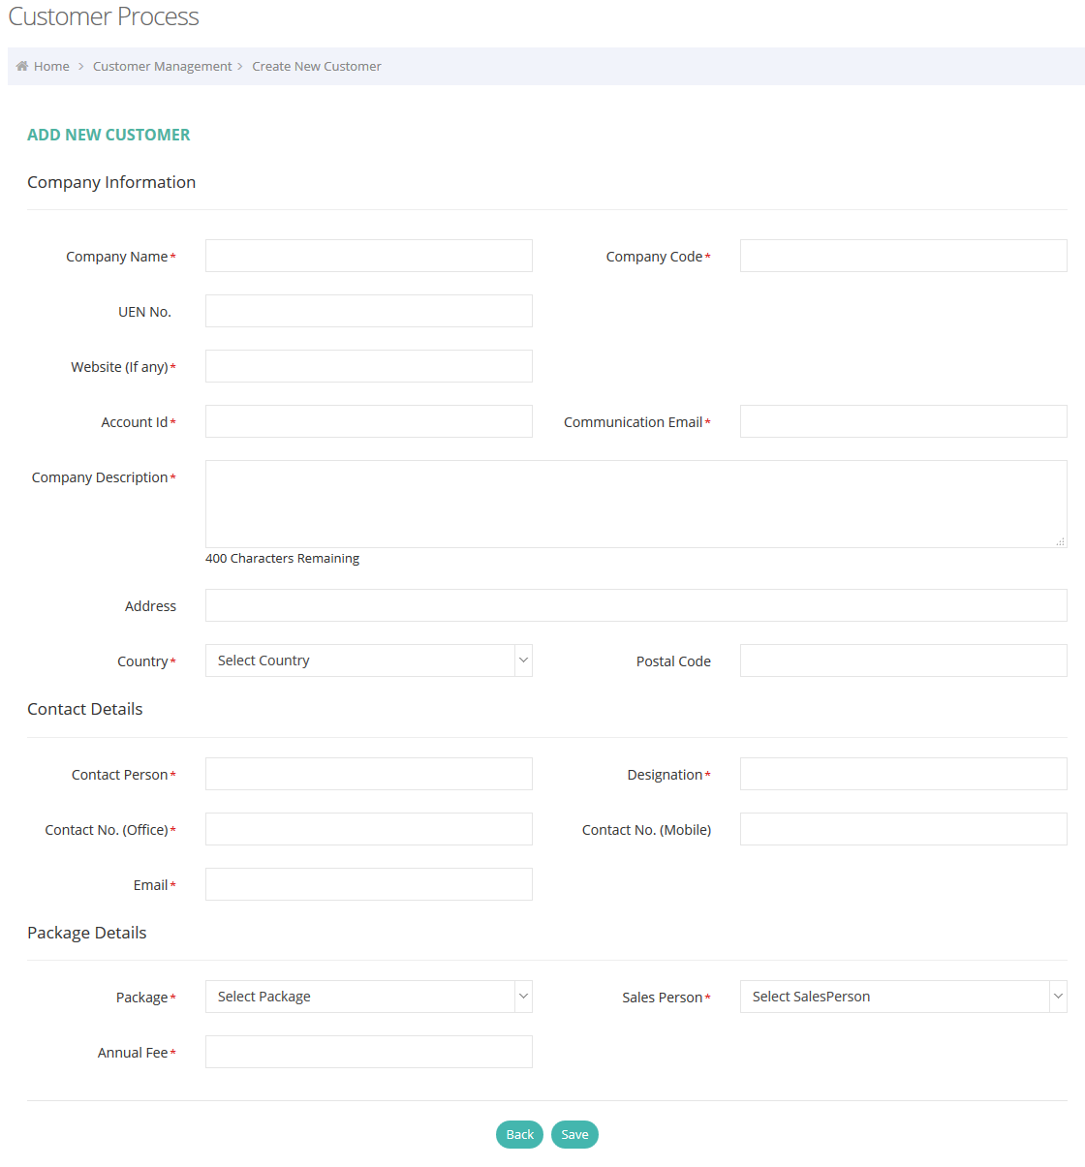

**Process Flow Diagram:**

Get Customer information, Contact User information & Package Information

Customer Controller

Create User Object with Contact Person Information and Assign Role as “HRMANAGER”

Send User Registration Email to contact user

Save Contact User Information, User Role & his/her Address

Save Customer, User Customer, Customer Address and Customer Package Mapping

**Database**

Create Customer Object with Customer Information and Package Information

Create and Save the Credit Object with default credit points

Create and Save Job Position Object with Dummy position “Others”

Send Customer Registration Email to contact user

Create and Save the Email Property with Customer’s Account Id

**Customer User Management User Interface:**

* In this UI, we will list all the users (customer side employees), who are assigned for the particular customer.
* Admin can Edit, View, Reset Password and Change the User Status from this UI.
* If Admin clicks the “Reset Password” button, then it reset the corresponding user password and sends Reset Password will be emailed to the customer’s user.

**Customer User Management Image:**

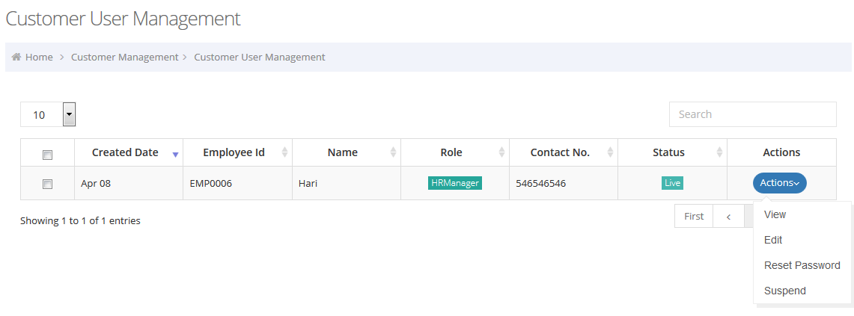

**Employee Management Module:**

* In this UI, it will list all the magnet users whoever is having Admin or Employee roles.
* Admin can Edit, View, Reset Password, Edit Roles and Change the Magnet User Status.
* If Admin clicks the “Reset Password” button, then it reset the corresponding user password and sends Reset Password email to user.

**Employee Management Image:**

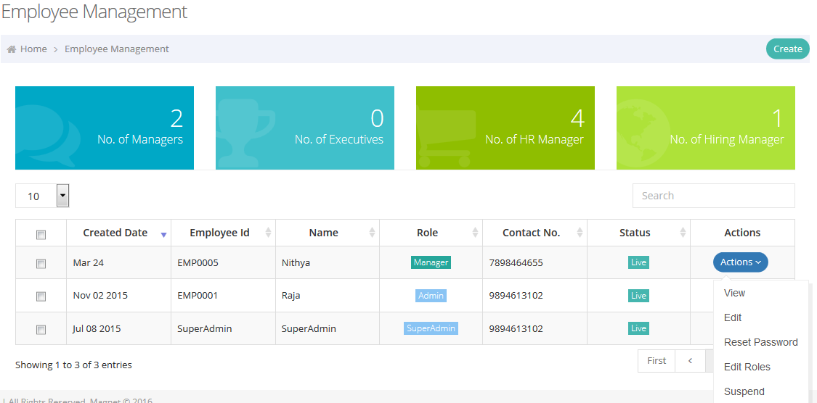

**Edit Roles:**

* This module shows the list of assigned Roles and Customers.
* Here Admin can Add/Remove the assigned Role and Customers from the list.
* Also can assign the new Role and Customer to the user.

**Edit Roles Image:**

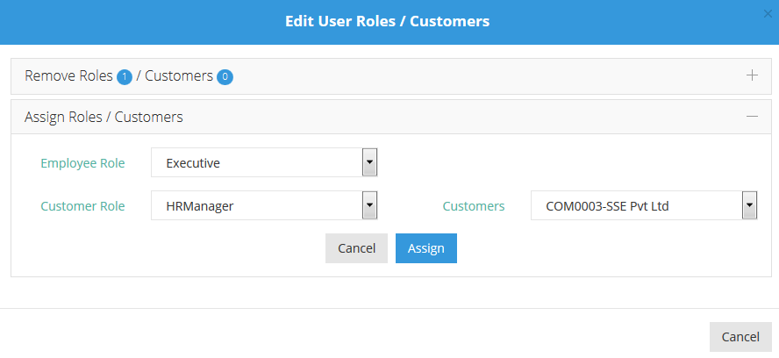

**Resume Management User Interface**

* This User Interface will list all the resumes, which are received from all customers’ account id email.
* Admin can Edit and View.
* Admin can also search the resumes using advanced keyword search.

**Resume Management Image:**

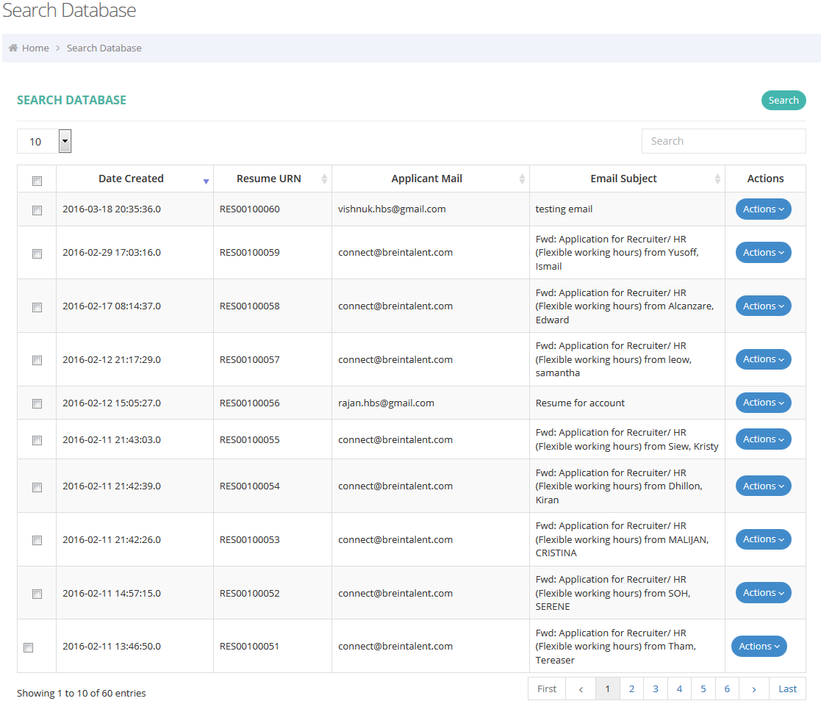

**User Profile Management:**

User profile module contains,

* User Profile Image uploads.
* Update user information.
* Change user password.

**User Profile Management Image:**

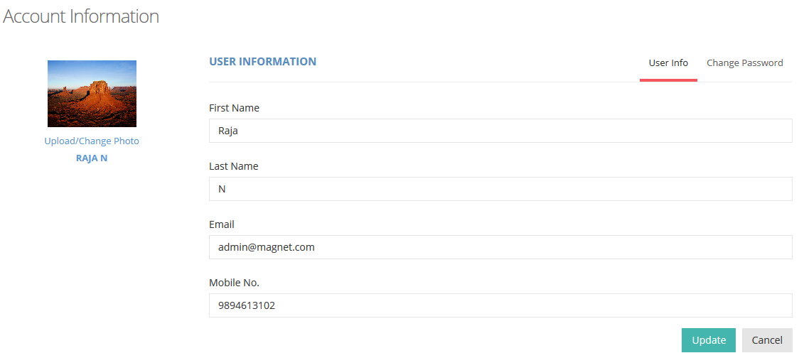

**Change User Password:**

* Check the current password is valid or not
* Check the new password and retype new password is match or not
* If it is satisfies the above 2 points, then it change the new password for the corresponding user and send emails.

**Process Flow Diagram:**

Yes

No

Check the Current password with Database

Current password match with database for the session user

Current password does not match with database for the session user

New Password and Retype new Password are match found?

Update new password to database for the session user

Show Warning

**Client User Interface:**

**Dashboard:** Client Dashboard contains the below sections.

* **Recent Activities** – it shows the recent activities of its own resume process

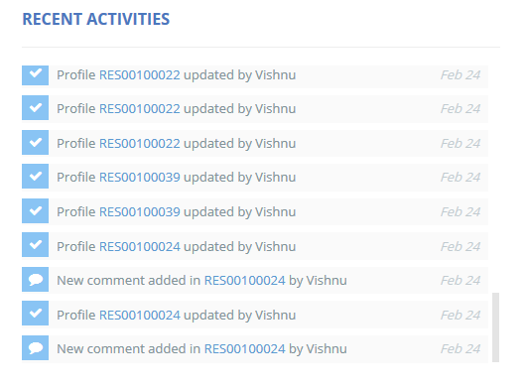

* **Resume Database** – It shows the Line Chart of resumes counts by month in order to cumulative base.

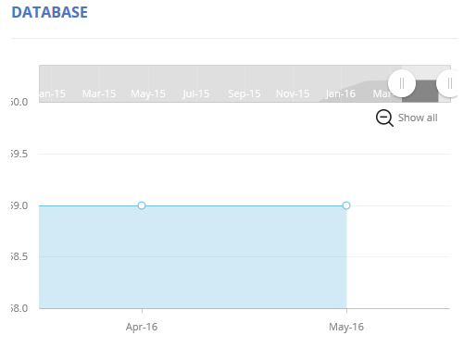

* **Application Trend** – It shows the Line Chart of resume counts by each month for the running year.

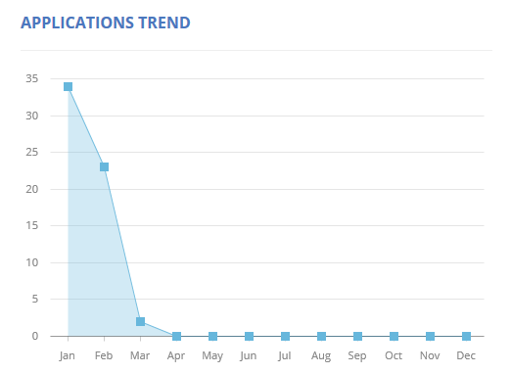

* **Talent Profile** – It shows the Pie Chart of Resume Count by Resume Status.

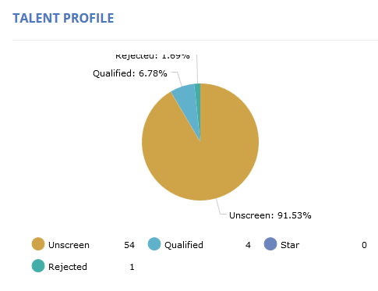

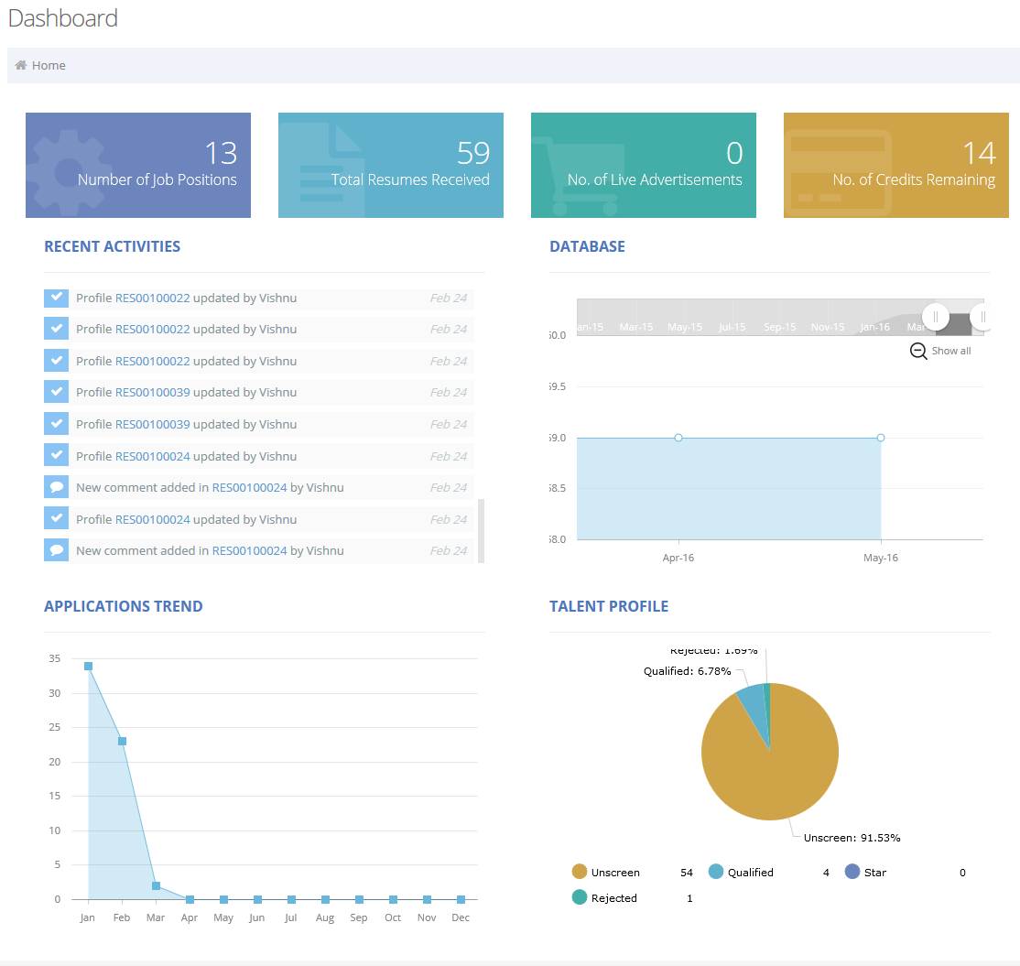

**Positions:**

* Here it shows the list of Job Position, which are created by the corresponding customer.
* Here the customer can Add, Edit, View, Delete, Advertise, Analysis and Assign Magnet Career for the corresponding job positions.

**Positions UI Image :**

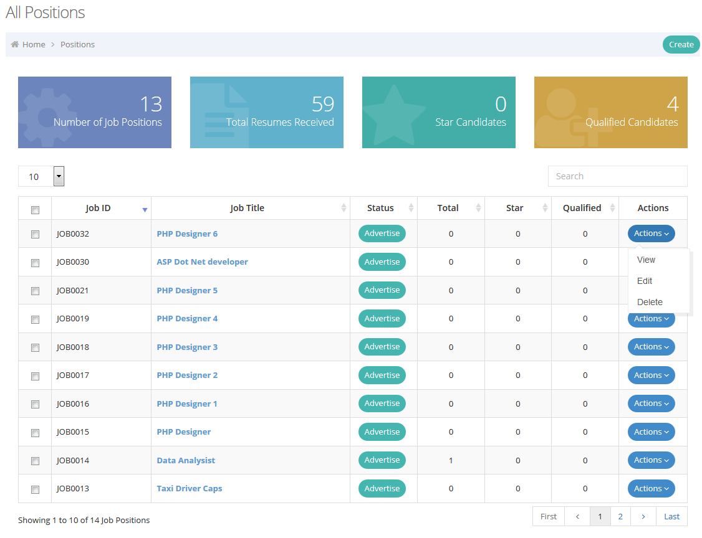

**Edit/View Job Positions:**

This Module mainly focuses the following process

* Job Information
* Reach Out
* Hiring Member

**Job Information UI:**

* It shows the selected job position’s job information to view or update the job details.

**Job Information UI Image:**

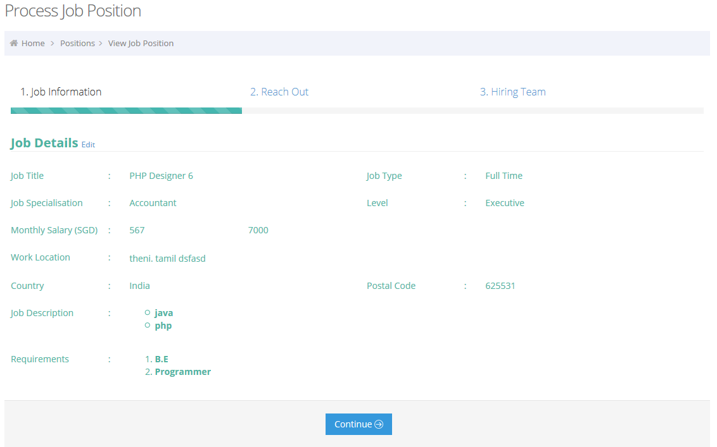

**Reach Out UI:**

It contains

* Magnet Career Portal – it is a YES/No option. If YES, the job position assign the magnet career portal list
* Advertise – To advertise the job position.
* Open to Recruitment Agencies - *Feature to be released in 2H 2016.

**Reach Out UI Image:**

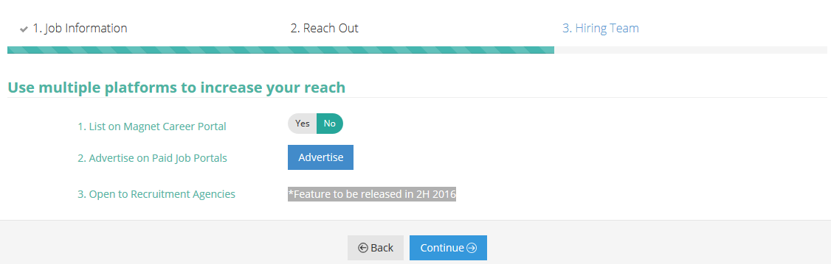

**Hiring Member UI:**

* It shows the list of Hiring Member Assigned for the corresponding job positions.

**Hiring Member UI Search Image:**

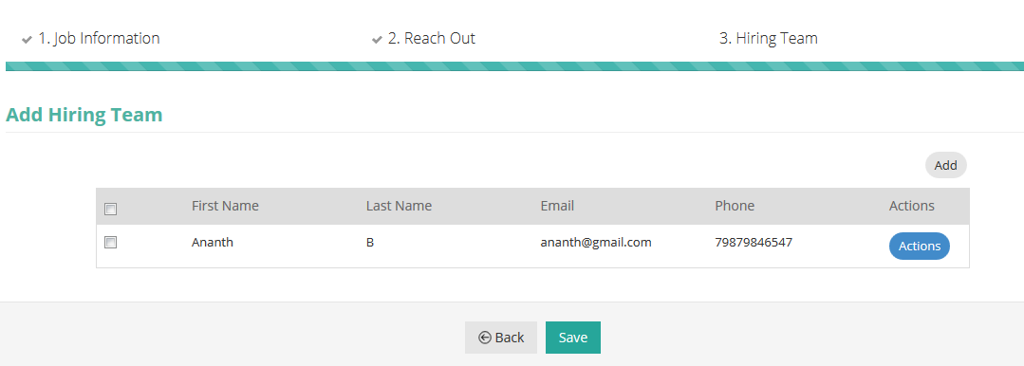

* It can Add the Hiring Member as,

**Adds Existing User as Hiring Member** – After Assign it sends the Job Position Assign email to the corresponding user.

**Hiring Member UI Add Image:**

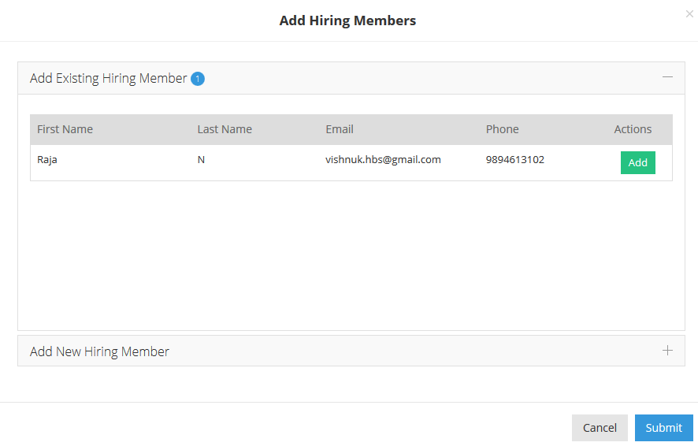

* **Add New User as Hiring Member** – After Assign it, it send the User Registration and Job Position Assign Email to the corresponding user.

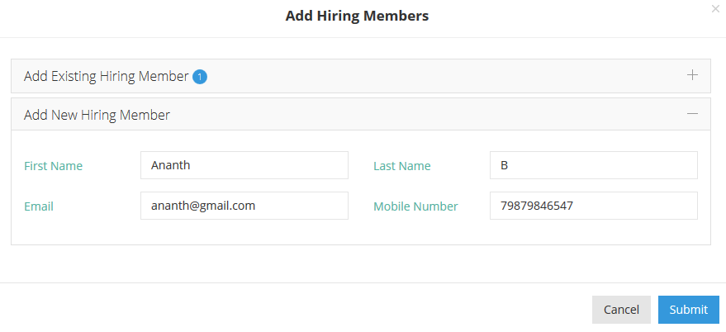

**Job Position Analysis:**

It mainly shows the following process

* **Resumes Tab**
  + It shows the corresponding resume list, which are received from customer’s account id using data table.
  + It provides the search option by Resume status.

**Job Position Analysis Resume Tab Image:**

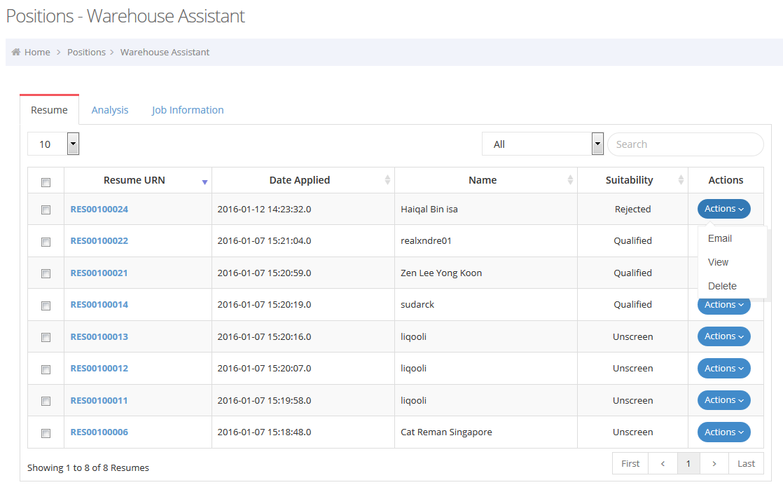

* **View Applicant Resume**

User Clicks the Resume URN to View the Corresponding Candidate Resume.

**Job Position Analysis View Applicant Tab Image:**

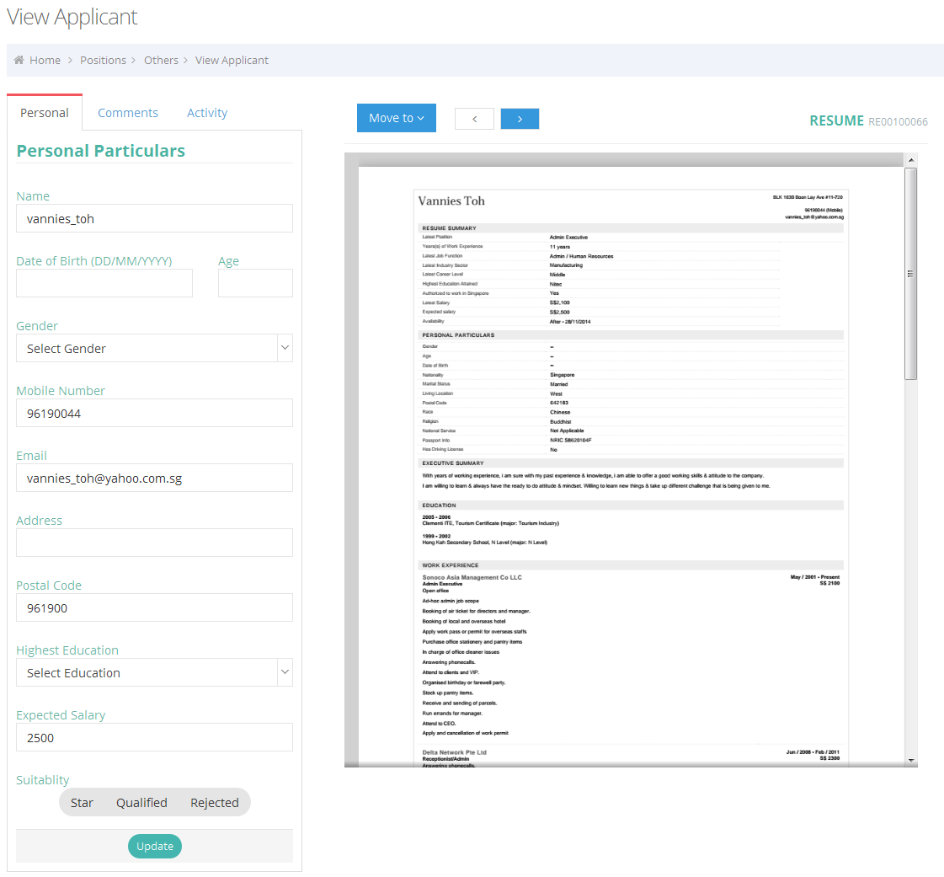

**Candidate Personal Information:**

* Update the Candidate information from the resume attachment
* Change the Resume Suitability.

**Resume Comments**

* Here we can enter the comments about the selected resume
* And also View the list of Comments for the corresponding resume with Date and commented person name.

**Comments UI Image**

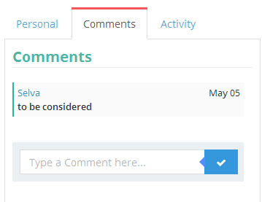

**Resume Activity:**

* Here we can view the list of Resume Activity, which are who are updated the corresponding resume and corresponding date.

**Resume Activity UI Image:**

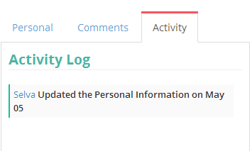

**Move to another Folders/Job Positions:**

* Here we can move the corresponding resume the selected Folder or Job Positions.

**Move to another Folders/Job Positions UI Image:**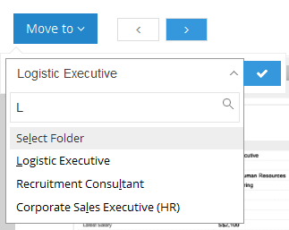

**View Resume Attachments:**

* Here we can view the Resume attachment files for the corresponding Resume URN. Each Resume URN have the one or more than on attachments.
* Using the “Previous” and “Next” button to view the previous attachment and next attachment.
* While loading the Resume attachment it checks the attachment file extension.
* It uses the “iframe” to view the “htm, html” files only.
* It uses the “Google Doc Viwer” to view the non html files like doc, docx, pdf, xls, ect…

**View Resume Attachments UI Image:** 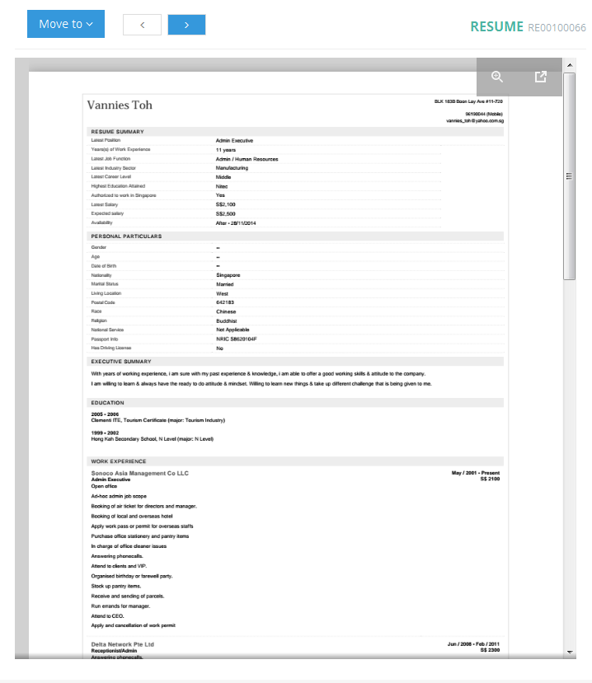

* **Analysis Tab**
* **Resumes Received** – It shows Bar Chart for the resumes count by last 12 months for the corresponding customer and corresponding job position.
* **Gender** – It shows the Pie Chart for the resumes count by Candidate’s Gender.
* **Salary** - It shows the Bar Chart for the resumes count by Candidate’s expected salary.
* **Age** - It shows the Bar Chart for the resumes count by Candidate’s Age.
* **Salary** - It shows the Pie Chart for the resumes count by resumes resume status.

**Job Analysis – Analysis Tab UI Image:**

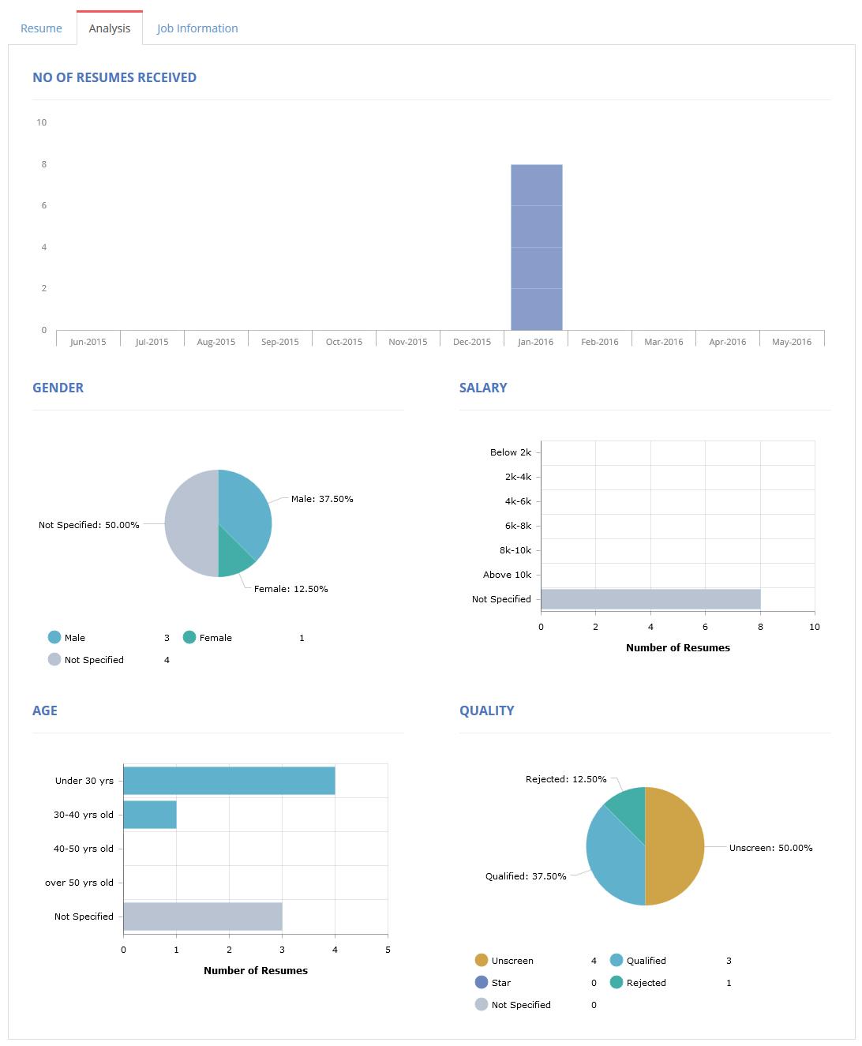

* **Job Information Tab**
* Job Details – It show the corresponding job position to Edit.
* Advertise – It shows the Advertise status of job position and Shows the Credit log of job position.
* Hiring Member – It shows the list of hiring member and Add hiring member button.

**Job Analysis – Job Information Tab UI Image:**

