SELFGURU-SIET

Version 1.0

User Manual

|  |  |  |  |  |
| --- | --- | --- | --- | --- |
| **S. No** | **Document Version** | **Updated By** | **Reviewed By** | **Release Date** |
| 1 | 1.0.1 | Vishnu Moorthy K | Hariharan | 21-May-16 |
|  |  |  |  |  |
|  |  |  |  |  |
|  |  |  |  |  |
|  |  |  |  |  |
|  |  |  |  |  |
|  |  |  |  |  |
|  |  |  |  |  |

***SelfGuru-SIET***

**Description:**

ESelfGuru is an Online Educational Tutorial Website for College Students. In Admin Side, they can Register Student, Create an Exam, Upload the Multiple Choice Questions, Monitoring the Students Activities and Conduct an Online Exam.

In Student Side, they can attend the Online Exams periodically and analysis their status and ranking by themself.

**MODULES:**

* Login/Logout
* Roles
* Admin Modules
  + Dashboard
  + User Module
  + Create Online Multiple Choice Assessment(MCA) Exams
  + Upload Multiple Choice Assessment(MCA) Questions
  + View Exam Result
* Student Modules
  + Dashboard
  + Exam Module

**Login / Logout:**

* We Providing the Secure login with user password encryption.
* Providing the Forget Password.
* While logout we clear the temporary files from cache for the corresponding user for saving the server space.

**SelfGuru Login Image:**

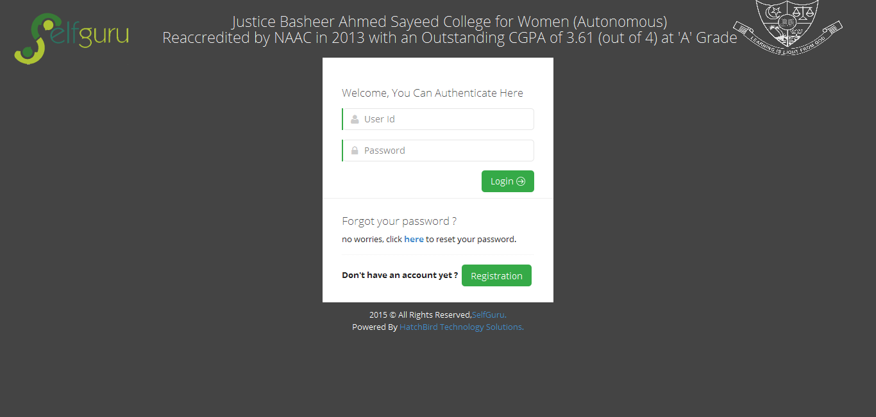

**Login Process Flow Diagram:**

Password Match

Password Not Match

User Found

User Not Found

Authenticate

Check Password Match

Login Success

Database

Login Page (User Id , Password)

Get User by User Id

**Roles:**

Here we are using the roles are,

* Admin Roles
  + Super Admin
  + Admin
  + Instructor
* Student

**Roles Flow Diagram:**

Super Admin

Admin

Instructor

Student

**User Roles Rights Table:**

* For creating MCA Exams and Upload MCA Questions can be done by SuperAdmin, Admin & Instructor, not by Student.
* We can able to flexible to modify any roles and its rights.

|  |  |  |  |  |  |  |  |  |  |  |
| --- | --- | --- | --- | --- | --- | --- | --- | --- | --- | --- |
|  | Add Admin | Update Admin | Delete Admin | Add Instructor | Update Instructor | Delete Instructor | Add Student | Update Student | Delete Student | View Result |
| Super Admin | Yes | Yes | Yes | Yes | Yes | Yes | Yes | Yes | Yes | Yes |
| Admin | No | No | No | Yes | Yes | Yes | Yes | Yes | Yes | Yes |
| Instructor | No | No | No | No | No | No | Yes | Yes | Yes | Yes |
| Student | No | No | No | No | No | No | No | No | No | No |

**Admin Modules:**

**Dashboard:**

* Dashboard in Admin View: we can monitor the currently login users on this system.
* Monitoring the child role user’s activities.
* Monitoring our own activities.

**Admin Dashboard Image:**

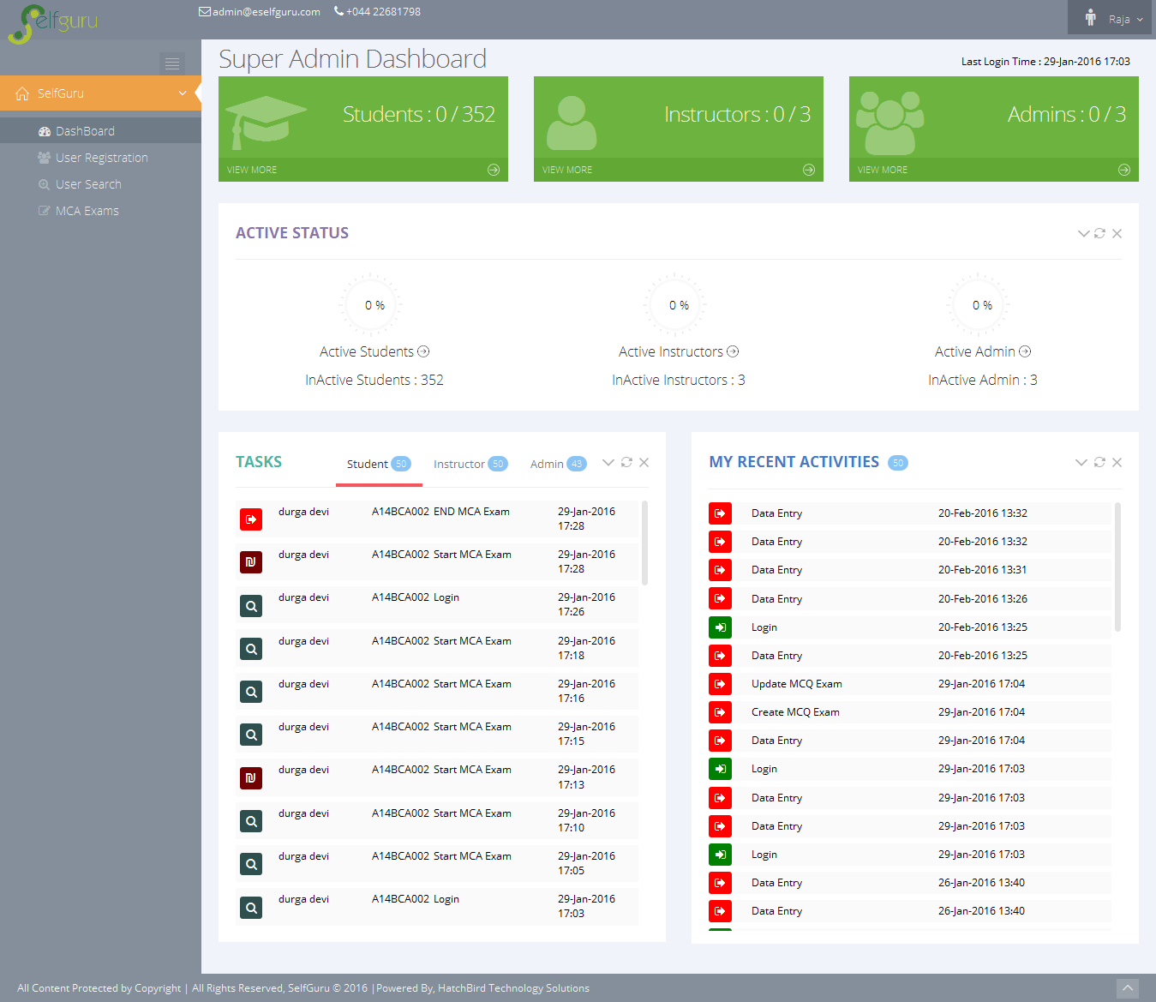

**User Modules:**

* Admin Role User can Register/Update their Child Role Users.
* Admin Role User can Delete and Reset their Child Role Users Password.
* Here the Student Registration is free for these college students only.
* We are checking the user is already exist or not, the user information (Email Id, Mobile No) is already exist or not and the Serial Key is already exist or not while User Registration from server side.
* Here we can Print the User’s List and Export the User’s list as pdf or MS-Excel.

**User Registration UI Image:**

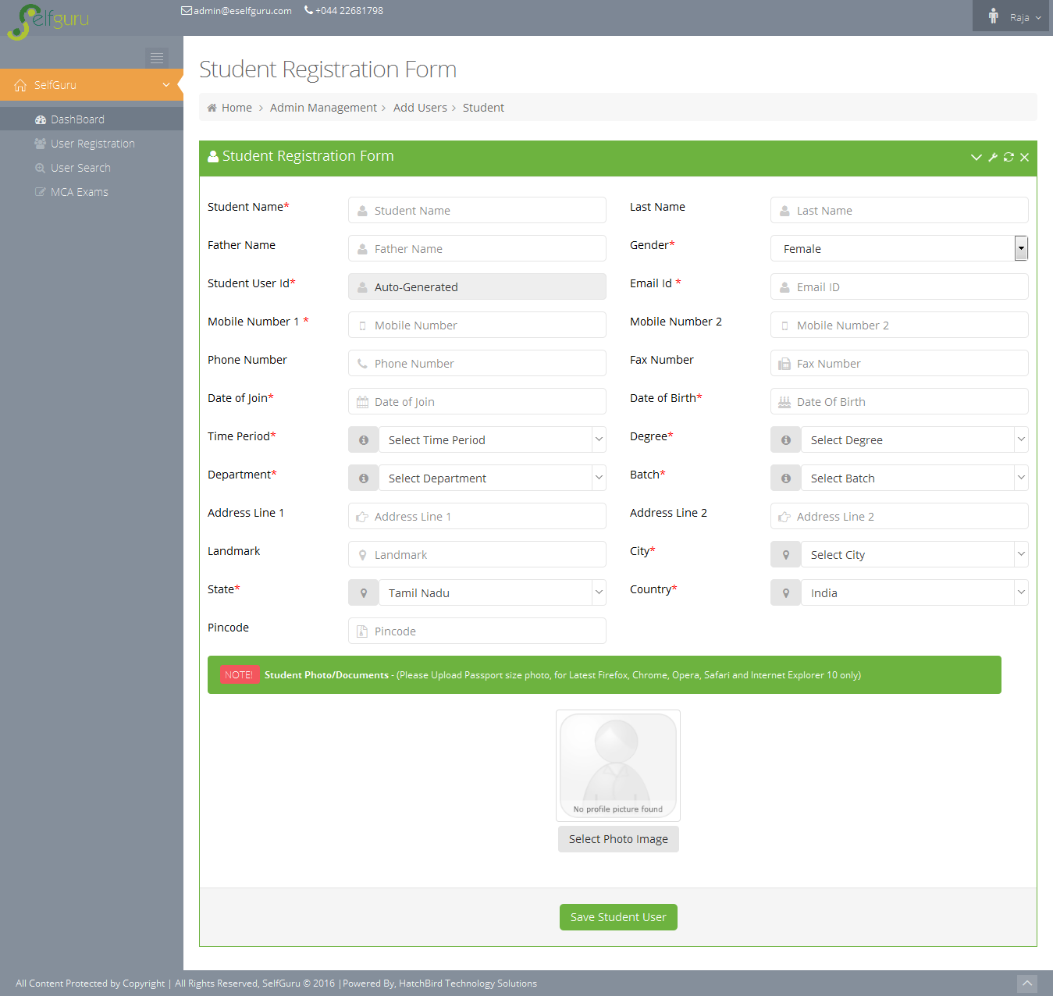

**User List UI Image:**

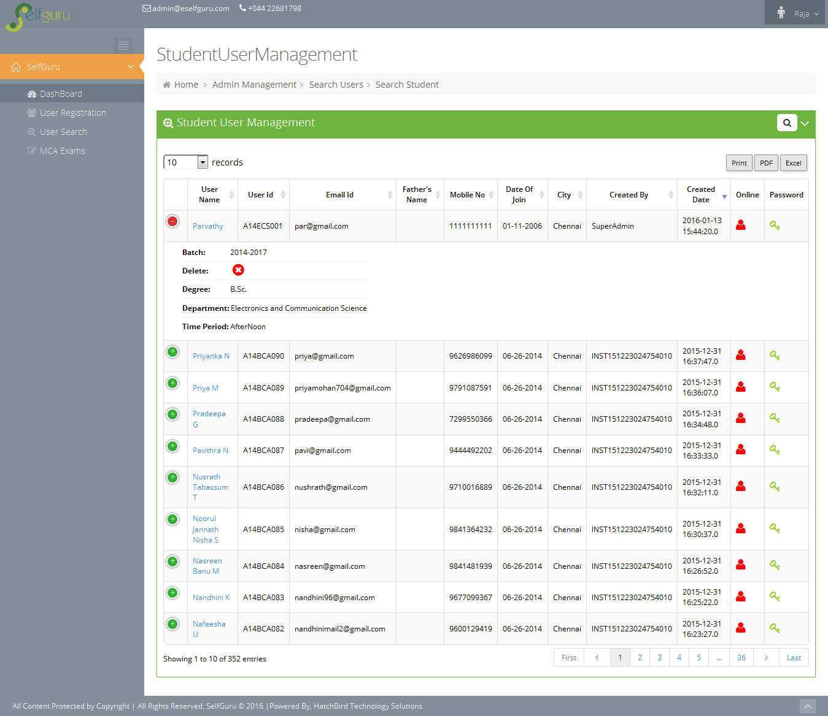

**Create Online Multiple Choice Assessment (MCA) Exams:**

* Here Admin Role User can Multiple Choice Assessment(MCA) Online Exam
* Admin can Create, Enable/Disable, Publish, Postpone the online exam.
* Admin creates the exam based on Time Period(Forenoon, Afternoon), Subjects & Chapters, Degree & Department and Batch in 2 ways,
  + Online Exam
  + Offline Exam
* Student can View only the Online Exam not the Offline Exam.
* An Offline Exam is mostly used for upload the questions for the corresponding Time Period(Forenoon, Afternoon), Subjects & Chapters, Degree & Department and Batch.
* Here we assign the 100 Questions per exam with some conditions depends on the Students Batch.

**Create Online MCA Exam:**

* Admin can create the Online MCA Exam with the following corresponding information,
  + Exam Name
  + Exam Date
  + Online Assessment or Not
  + Type Period
  + Exam Type
  + Degree
  + Department
  + Batch

**Exam Creation UI Image:**

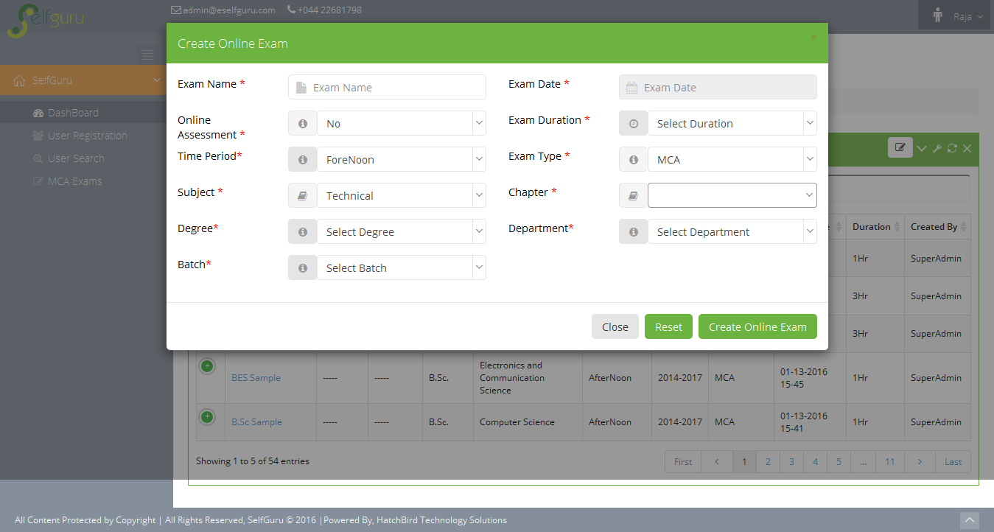

**Upload MCA Questions:**

* Admin can Upload & Delete the MCA questions for the corresponding online exam with respect to the Time Period (Forenoon, Afternoon), Subjects & Chapters, Degree & Department and Batch.
* The MCA Question contains Question, 4 Optional Answers & Explanation are uploaded via Text or Image.
* Here we can upload the MCA Question in 2 ways
  + Manual Upload
  + MCA Question Upload Using Snipping
* Admin mentions the Mark per Question and Correct Answer of the Corresponding Questions.
* Admin can upload any number of MCA Questions for the online exam.

**MCA Exam Question List UI Image:**

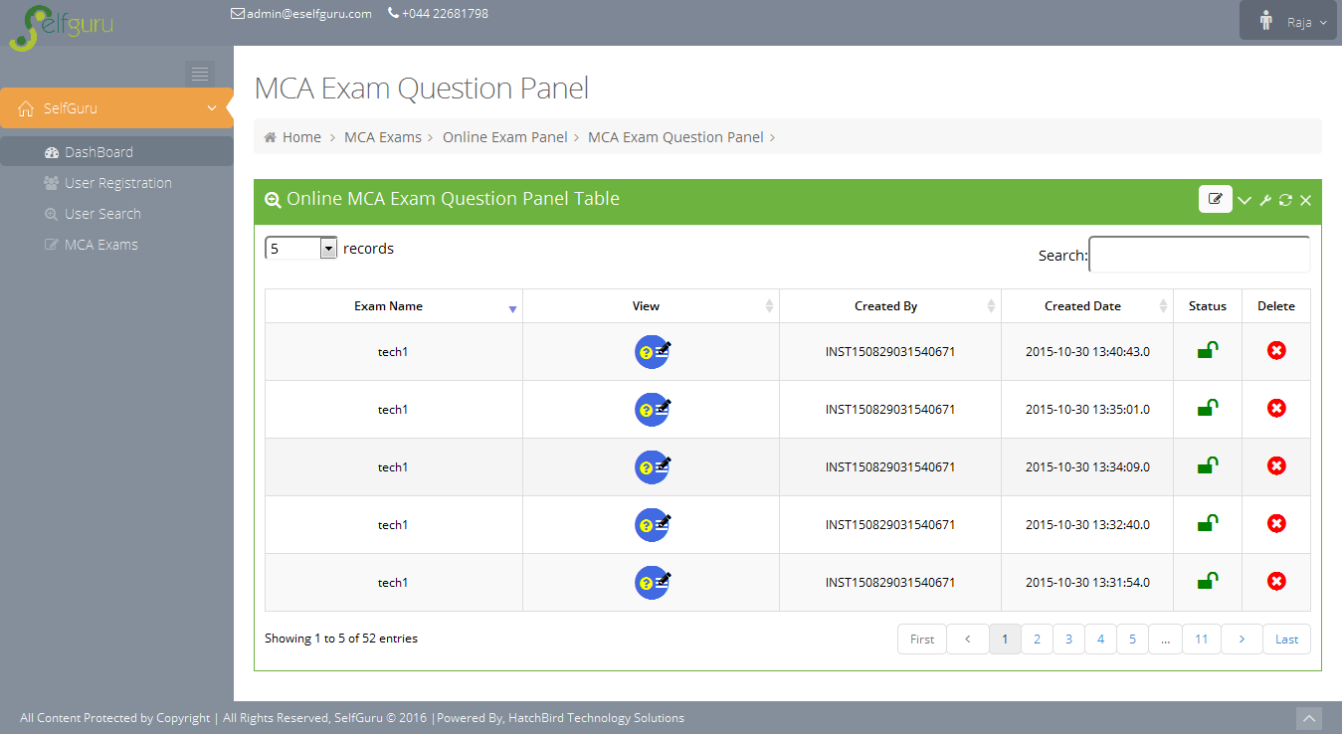

**View MCA Exam Question UI Image:**

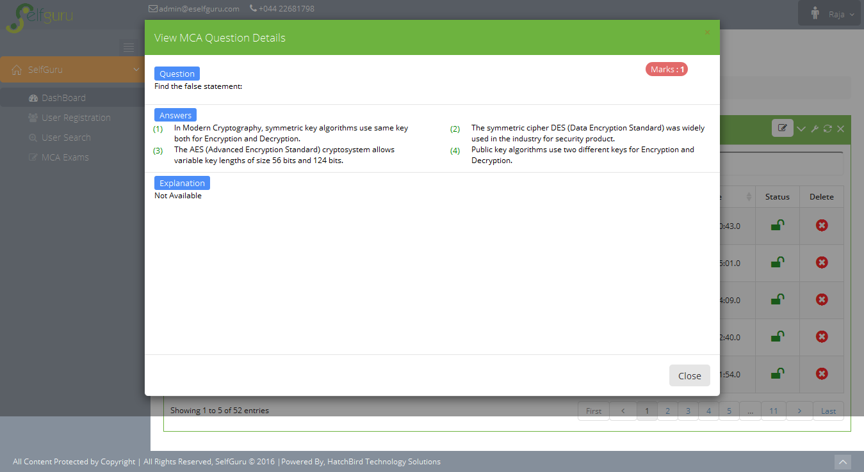

**MCA Questions Manual Upload:**

* Admin can Upload the MCA questions by text or image by manual upload
* Admin can View & Delete the created MCA questions.
* This type of upload can be done except Google Chrome browsers.

**Upload MCA Exam Question UI Image:**

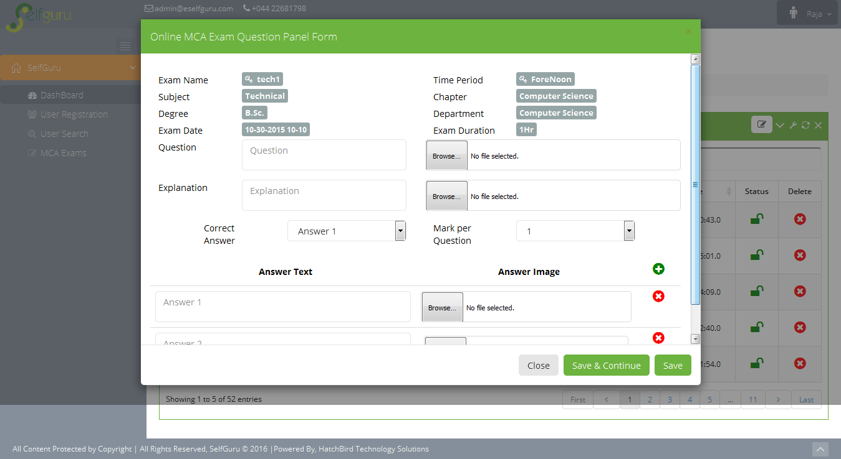

**Upload MCA Questions By Snipping:**

* This type of snipping method is working only on Google chrome only.
* First Admin should open the “Snipping Tool”
* Then Select the Questions from any file or web site and then paste it to the corresponding give area.
* Finally we click the “Save” button, the MCA question will be saved to Database.

**Upload MCA Exam Question by Snipping UI Image:**

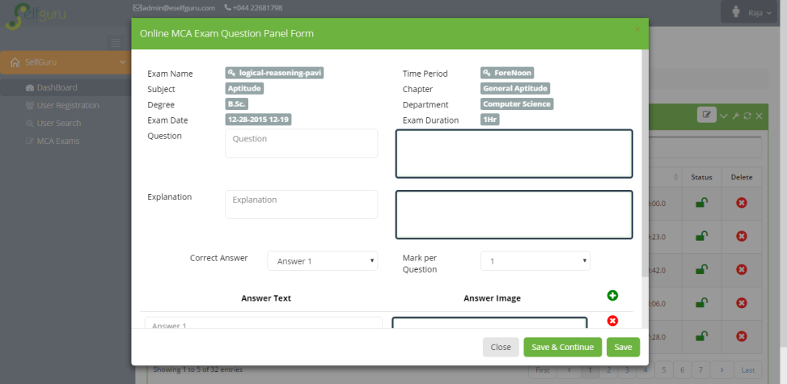

**View Student Result:**

* Admin can view the Student’s Exam Result for the selected Corresponding Exam
* Admin can print the Exam Result.
* Admin can Export the Exam Result as PDF or MS-Excel

**Exam Result UI Image:**

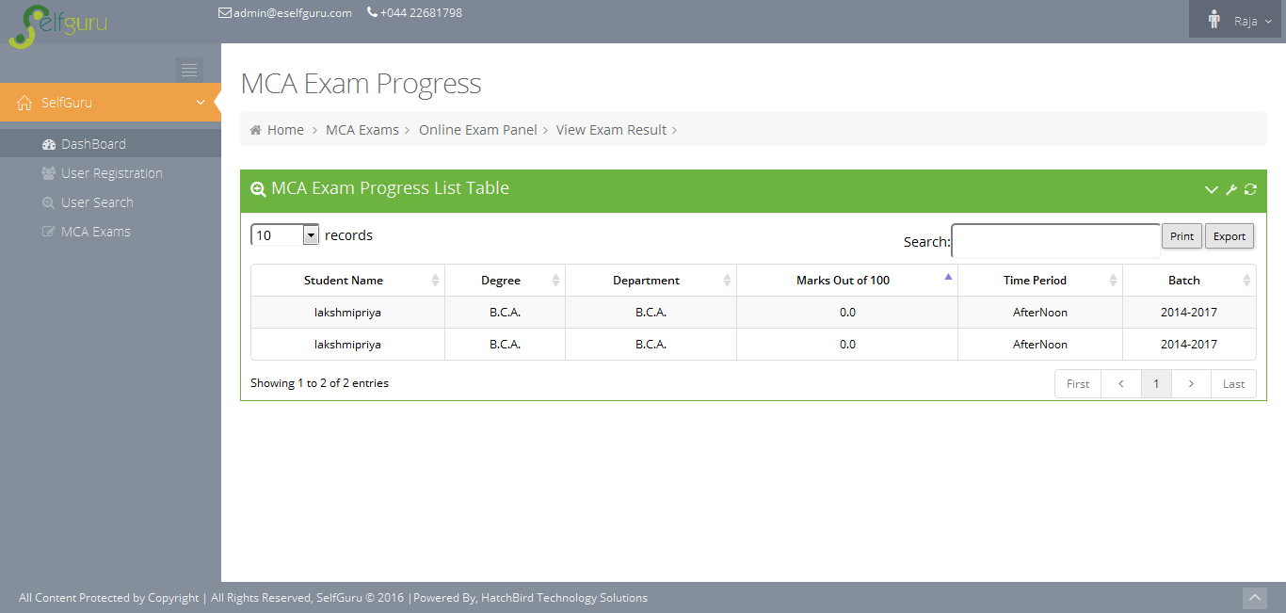

**Student Modules:**

**Dashboard:**

* Dashboard Shows List Online MCA Exams as Currently available exams and Missed Exams.
* List of Results of previously attended exams.
* List of Student Activities of Login and Exams.
* Shows Student’s Progress in Graphical Representation.

**Student Dashboard UI Image:**

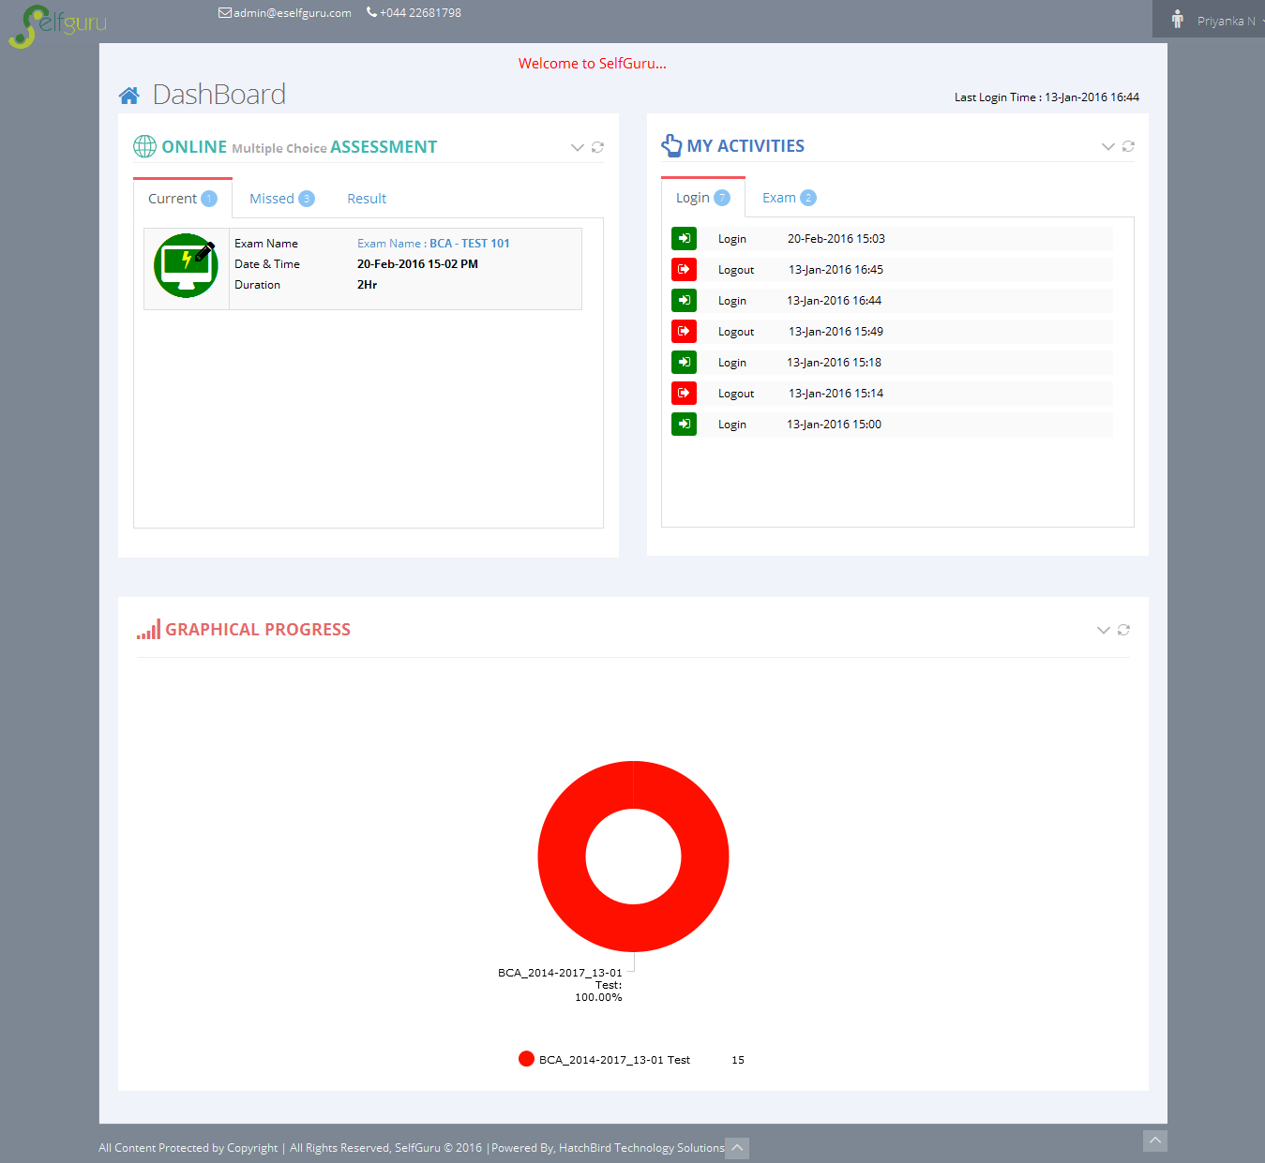

**Exam Module:**

* This exam is created by Admin.
* This exam can be attended at only one time.
* Here it takes the number of questions as randomly depends on the Time Period(Forenoon, Afternoon), Subjects & Chapters, Degree & Department and Batch.
* It shows the Timer – Admin the sets the time per question. It automatically calculate the actual exam duration (time per question * number of questions).
* If the Time is up, it automatically stop the exam.
* If student finish the exam before the exam duration, they can click the “Finish” button to complete the exam.
* After finish the exam it calculates the marks for the exam by automatically.
* For 1st Year Students
* Aptitude

1. General Aptitude – 20 Questions
2. Verbal – 20 Questions
3. Non-Verbal – 20 Questions
4. Logical – 20 Questions
5. Reasoning – 20 Questions

* For 2nd & 3rd Year Students, the MCA Questions comes under below scenario
* Aptitude

1. General Aptitude – 20 Questions
2. Verbal – 20 Questions
3. Non-Verbal – 20 Questions
4. Logical – 20 Questions
5. Reasoning – 20 Questions

* Technical
  + 1. Corresponding Department Core Subject – 50 Questions

**Exam Module Flow Diagram:**

Display Corresponding Questions for the Attended exam (5Questions per page)

* Aptitude
  + General Aptitude - 20
  + Verbal – 20
  + Non-Verbal – 20
  + Logical – 20
  + Reasoning - 20
* Aptitude
  + General Aptitude - 10
  + Verbal – 10
  + Non-Verbal – 10
  + Logical – 10
  + Reasoning – 10
* Technical
  + Corresponding Department Core Subject - 50

Attend Online Exam by Student

Get the Online MCA Questions from Database for the corresponding Exam along with Student’s Batch, Degree & Department

Check Student’s Batch Year

1st Year

2nd & 3rd Year

**Exam Module UI Image:**

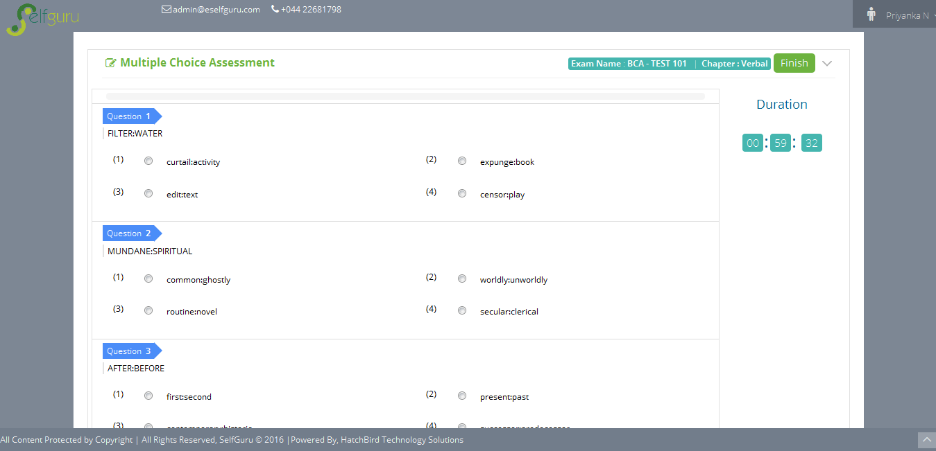

**Exam Finished UI Image:**

