**Screenshots of Questions & Solutions**

**Q1:** Instal Jupiter notebook and run the first program and share the screenshot of the output



**Q2:** Write a program which will find all such numbers which are divisible by 7 but are not a  
multiple of 5, between 2000 and 3200 (both included). The numbers obtained should be printed  
in a comma-separated sequence on a single line.

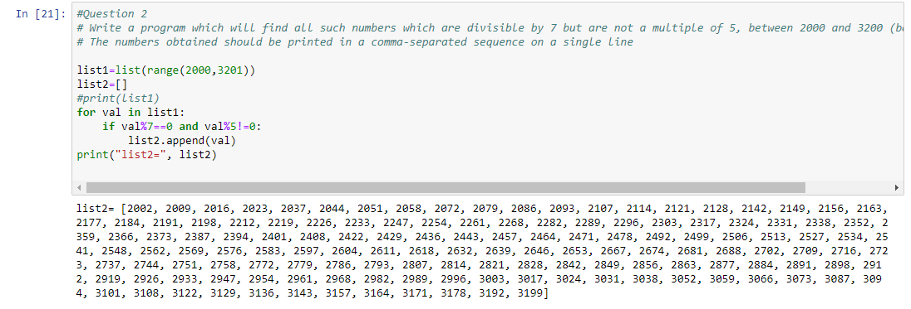

**Q3:** Write a Python program to accept the user's first and last name and then getting them printed  
in the reverse order with a space between first name and last name.

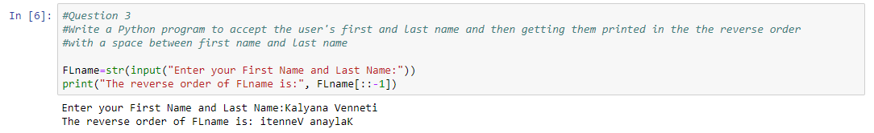

**Q4:** Write a Python program to find the volume of a sphere with diameter 12 cm.

Formula: V=4/3 * π * r 3

