Gann Square of Nine Daily Forecast
^NSEBANK forecast after 2026-09-11. This report converts the selected final closing price into Square-of-Nine levels. It treats sustained crosses and closes as confirmation; the levels are scenarios rather than guaranteed prices.

Forecast summary
Item | Value
Yahoo Finance symbol | ^NSEBANK
Selected final OHLC date | 2026-09-11
Historical bars used | 500
Adjusted closing price | 56,606.55
Automatic price multiplier | 1
Primary angle | +/-45 degrees
Primary projected high | 56,725.57
Primary projected low | 56,487.65
Fourteen bar average range | 478.78

Primary interpretation
- Above 56,725.57: price shows strength. A daily close above this level makes the next upside level relevant.
- Below 56,487.65: price shows weakness. A daily close below this level makes the next downside level relevant.
- Between 56,487.65 and 56,725.57: the primary Square-of-Nine zone is neutral.

Recent OHLC data
Date | Open | High | Low | Close
2026-09-07 | 57,343.30 | 57,426.85 | 57,002.95 | 57,088.30
2026-09-08 | 56,990.40 | 57,044.00 | 56,720.45 | 56,777.55
2026-09-09 | 56,498.85 | 56,743.05 | 56,295.55 | 56,295.55
2026-09-10 | 56,262.75 | 56,575.15 | 56,231.85 | 56,471.95
2026-09-11 | 55,970.15 | 56,645.85 | 55,699.45 | 56,606.55

Level guidance through 360 degrees
Read outward from the selected closing price. A touch alone is informational; sustained trade or a daily close beyond a level provides stronger confirmation. Probability is the percentage of historical next-day bars that touched or crossed that level: next-day High for upside and next-day Low for downside.
Side | Degrees | Level | Probability % | Angle family | Practical interpretation
Upside | 360 | 57,562.24 | 7.4% | 45-degree / 60-degree | Full-rotation objective and major reaction zone. A sustained close above is an exceptional full-rotation upside break; rejection can mark resistance or exhaustion. This is the outermost level shown.
Upside | 315 | 57,442.34 | 9.0% | Core 45-degree | Final major 45-degree step before a full rotation. A sustained trade or close above indicates strength and makes the next higher upside level relevant; rejection can act as resistance. This is an outer scenario level rather than the normal next-day range.
Upside | 300 | 57,402.40 | 10.2% | Secondary 60-degree | Late-stage 60-degree extension. A sustained trade or close above indicates strength and makes the next higher upside level relevant; rejection can act as resistance. This is an outer scenario level rather than the normal next-day range.
Upside | 270 | 57,322.56 | 13.0% | Core 45-degree | Major three-quarter-rotation boundary. A sustained trade or close above indicates strength and makes the next higher upside level relevant; rejection can act as resistance. This is an outer scenario level rather than the normal next-day range.
Upside | 240 | 57,242.79 | 16.4% | Secondary 60-degree | Fourth 60-degree extension. A sustained trade or close above indicates strength and makes the next higher upside level relevant; rejection can act as resistance. This is an outer scenario level rather than the normal next-day range.
Upside | 225 | 57,202.92 | 17.6% | Core 45-degree | Outer five-eighth-rotation level. A sustained trade or close above indicates strength and makes the next higher upside level relevant; rejection can act as resistance. This is an outer scenario level rather than the normal next-day range.
Upside | 216 | 57,179.00 | 19.0% | Special 144/216 | Special outer harmonic paired with 144 degrees. A sustained trade or close above indicates strength and makes the next higher upside level relevant; rejection can act as resistance. This is an outer scenario level rather than the normal next-day range.
Upside | 180 | 57,083.39 | 26.9% | 45-degree / 60-degree | Major half-rotation boundary. A sustained trade or close above indicates strength and makes the next higher upside level relevant; rejection can act as resistance.
Upside | 144 | 56,987.86 | 33.7% | Special 144/216 | Special Gann harmonic level. A sustained trade or close above indicates strength and makes the next higher upside level relevant; rejection can act as resistance.
Upside | 135 | 56,964.00 | 36.1% | Core 45-degree | Strong three-eighth-rotation extension. A sustained trade or close above indicates strength and makes the next higher upside level relevant; rejection can act as resistance.
Upside | 120 | 56,924.22 | 41.1% | Secondary 60-degree | Second 60-degree extension. A sustained trade or close above indicates strength and makes the next higher upside level relevant; rejection can act as resistance.
Upside | 90 | 56,844.72 | 53.9% | Core 45-degree | Major quarter-rotation support or resistance. A sustained trade or close above indicates strength and makes the next higher upside level relevant; rejection can act as resistance.
Upside | 60 | 56,765.28 | 65.3% | Secondary 60-degree | Secondary confirmation from the 60-degree overlay. A sustained trade or close above indicates strength and makes the next higher upside level relevant; rejection can act as resistance.
Upside | 45 | 56,725.57 | 72.9% | Core 45-degree | Primary reaction and breakout threshold. A sustained trade or close above indicates strength and makes the next higher upside level relevant; rejection can act as resistance.
Latest close | 0 | 56,606.55 | N/A | Starting point | Reference price used for every calculation. Levels above measure strength; levels below measure weakness.
Downside | -45 | 56,487.65 | 69.1% | Core 45-degree | Primary reaction and breakout threshold. A sustained trade or close below indicates weakness and makes the next lower downside level relevant; recovery above can act as support.
Downside | -60 | 56,448.05 | 63.3% | Secondary 60-degree | Secondary confirmation from the 60-degree overlay. A sustained trade or close below indicates weakness and makes the next lower downside level relevant; recovery above can act as support.
Downside | -90 | 56,368.88 | 49.9% | Core 45-degree | Major quarter-rotation support or resistance. A sustained trade or close below indicates weakness and makes the next lower downside level relevant; recovery above can act as support.
Downside | -120 | 56,289.77 | 41.9% | Secondary 60-degree | Second 60-degree extension. A sustained trade or close below indicates weakness and makes the next lower downside level relevant; recovery above can act as support.
Downside | -135 | 56,250.23 | 37.9% | Core 45-degree | Strong three-eighth-rotation extension. A sustained trade or close below indicates weakness and makes the next lower downside level relevant; recovery above can act as support.
Downside | -144 | 56,226.52 | 33.7% | Special 144/216 | Special Gann harmonic level. A sustained trade or close below indicates weakness and makes the next lower downside level relevant; recovery above can act as support.
Downside | -180 | 56,131.71 | 27.5% | 45-degree / 60-degree | Major half-rotation boundary. A sustained trade or close below indicates weakness and makes the next lower downside level relevant; recovery above can act as support.
Downside | -216 | 56,036.98 | 20.2% | Special 144/216 | Special outer harmonic paired with 144 degrees. A sustained trade or close below indicates weakness and makes the next lower downside level relevant; recovery above can act as support. This is an outer scenario level rather than the normal next-day range.
Downside | -225 | 56,013.31 | 19.2% | Core 45-degree | Outer five-eighth-rotation level. A sustained trade or close below indicates weakness and makes the next lower downside level relevant; recovery above can act as support. This is an outer scenario level rather than the normal next-day range.
Downside | -240 | 55,973.87 | 17.0% | Secondary 60-degree | Fourth 60-degree extension. A sustained trade or close below indicates weakness and makes the next lower downside level relevant; recovery above can act as support. This is an outer scenario level rather than the normal next-day range.
Downside | -270 | 55,895.04 | 14.0% | Core 45-degree | Major three-quarter-rotation boundary. A sustained trade or close below indicates weakness and makes the next lower downside level relevant; recovery above can act as support. This is an outer scenario level rather than the normal next-day range.
Downside | -300 | 55,816.26 | 11.4% | Secondary 60-degree | Late-stage 60-degree extension. A sustained trade or close below indicates weakness and makes the next lower downside level relevant; recovery above can act as support. This is an outer scenario level rather than the normal next-day range.
Downside | -315 | 55,776.89 | 11.2% | Core 45-degree | Final major 45-degree step before a full rotation. A sustained trade or close below indicates weakness and makes the next lower downside level relevant; recovery above can act as support. This is an outer scenario level rather than the normal next-day range.
Downside | -360 | 55,658.87 | 7.0% | 45-degree / 60-degree | Full-rotation objective and major reaction zone. A sustained close below is an exceptional full-rotation downside break; recovery can mark support or exhaustion. This is the outermost level shown.

Historical diagnostic
Item | Value
Primary test angle | +/-45 degrees
Next high at or below forecast | 27.1%
Next low at or above forecast | 30.9%
Entire next bar inside forecast band | 0.2%

These percentages describe the downloaded sample and do not establish a reliable forecasting edge. A wider angle naturally produces a higher containment rate.

Price chart
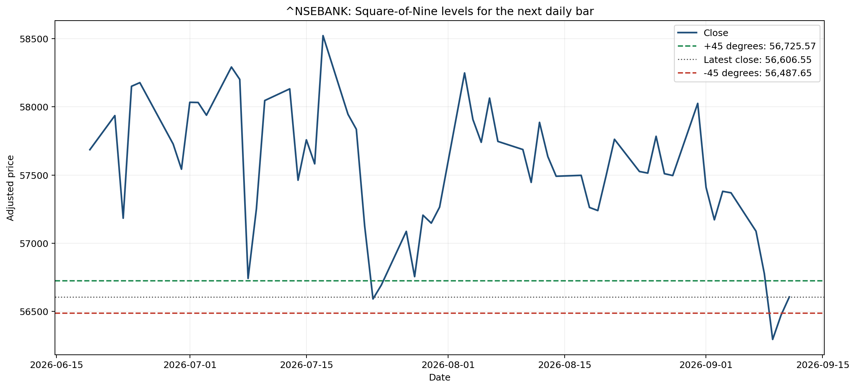
Last 60 daily closes through 2026-09-11, with the primary +/-45-degree levels.

Method and limitations
Projected level = (square root of scaled close + signed degrees / 180) squared, then divided by the price multiplier. Daily adjusted OHLC data comes from Yahoo Finance through yfinance. Data may be delayed, incomplete, or revised.
Square-of-Nine forecasting is experimental and has no established predictive edge. Use the report for research and scenario planning, not as a standalone trading instruction.

